Fresnel Lens Team Fall 2012 Final Report
Meghan Hilbert & Emma Lejeune

Background

Our objective this semester, based on our general work with Fresnel lenses throughout last year, was to pursue a more specific and relevant application of these lenses for Las Mujeres Solares in Nicaragua. Although Las Mujeres do utilize the box style solar ovens frequently, they lack a convenient way to cook food which would require opening and closing the solar oven multiple times during preparation. This includes one of the local diet staples--the tortilla, which the women cook daily for their families, as well as for El Restaurante Solar. Our research this semester has focused on exploring whether the lenses can provide a viable alternative for cooking tortillas, as well as other foods with preparation methods that don’t lend themselves to the box cookers.
During our trip to Nicaragua last March, we noted that cooking tortillas (and similar foods) was done on an indoor, wood-burning stove. These stoves are essentially steel sheets or griddles supported over burning sticks that heat the griddles up from below to the necessary temperatures. The slabs are relatively small (less than 1 ft²). Our goal this semester was to experiment with methods that would heat up similar sized pieces of metal rapidly using the energy from the sun concentrated and focused on them using Fresnel lenses. If the focus of the lens was directed on the griddle/plate, it would heat up and the tortilla could be cooked on a part of the plate outside the focus of the lens, since the heat would transfer to the rest of the cast iron. For testing this procedure, we eventually intend to use a cast iron skillet insulated on a wooden block, and position the lens to focus on the edge of the skillet.
Our research will hopefully overcome some limitations of solar ovens that we have noted and possibly mitigate the use of indoor wood-burning stoves, which present safety concerns to the women who use them daily and to their families, who often live in close quarters. In this report, we will give an overview of the tests we performed this semester and relate them back to the feasibility of their implementation in Nicaragua.

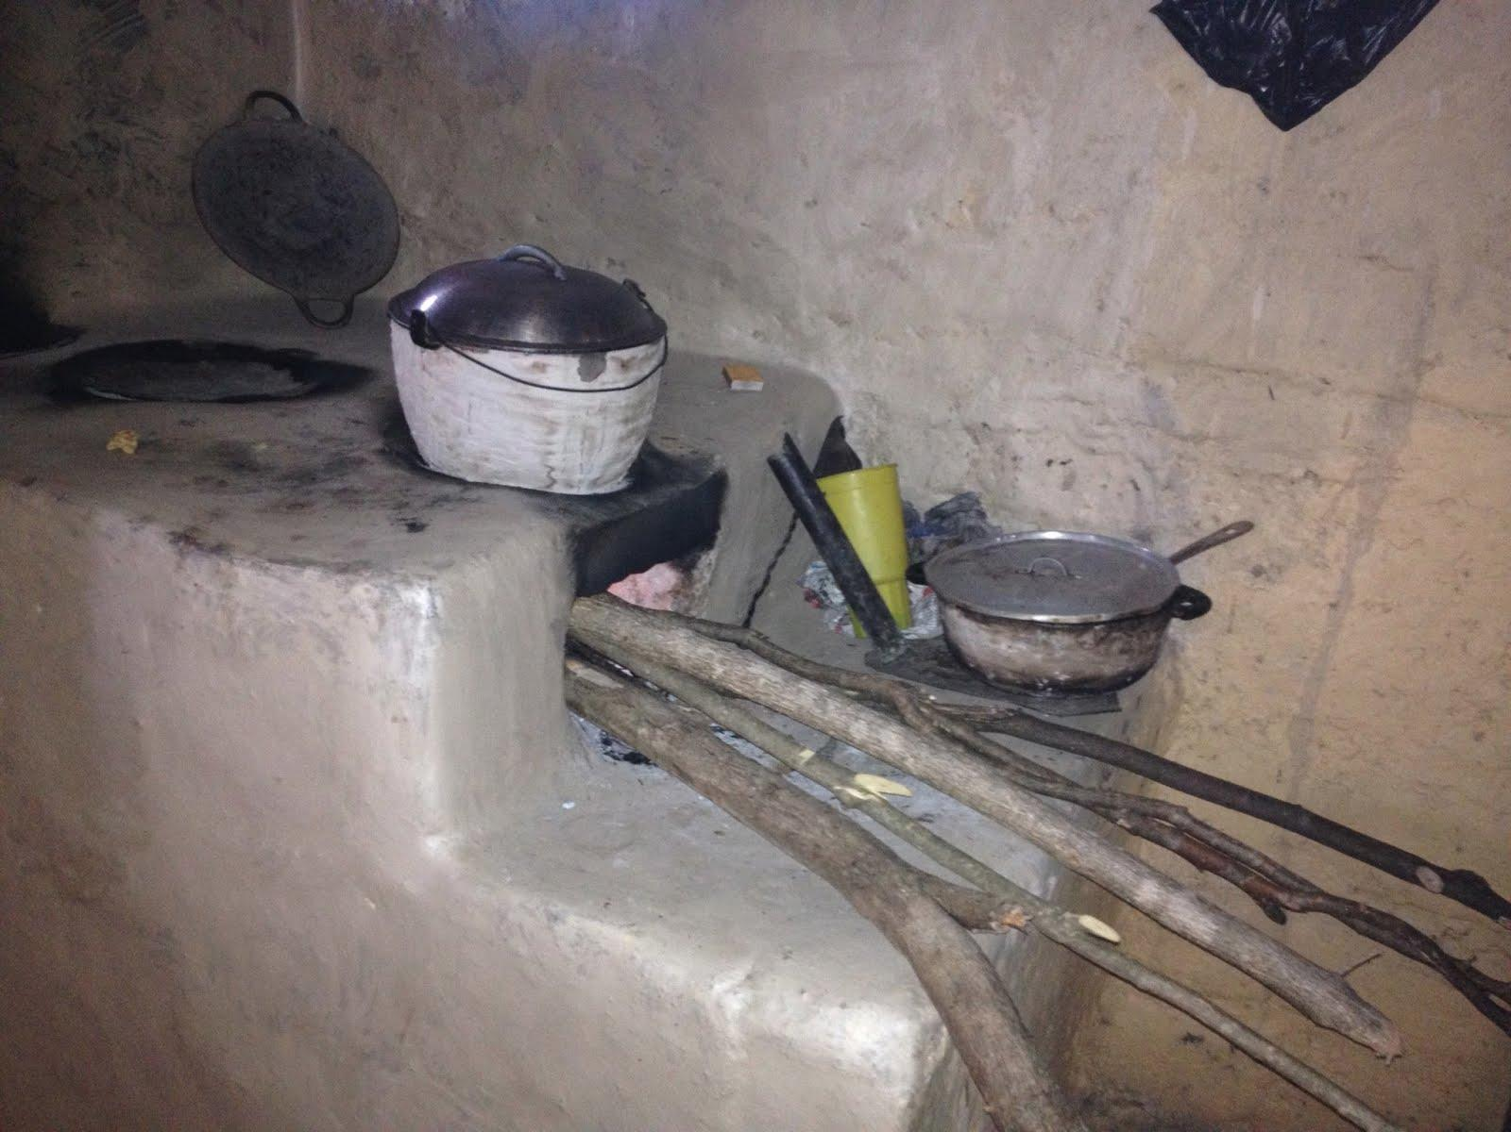
Wood burning stove used in Nicaragua; black slab at back left

Early Testing

Early on in the semester, we conducted some tests using the lens stand which another group had built last year. We focused on heating up pans or trying to boil water in pots to evaluate how powerful the lenses were and how we could apply this to tortilla cooking.
During this time, we experimented with a configuration which we referred to as the “pot-in-pot” setup. A small black pot in a larger glass pot, this setup created a slow-cooker effect and was very well insulated by the air around it, making testing more feasible as the ambient temperature dropped in Ithaca. [I’m not sure what you mean by a slow cooker effect, but think that this has the distinct advantage of preventing the wind from removing heat from the pot.]

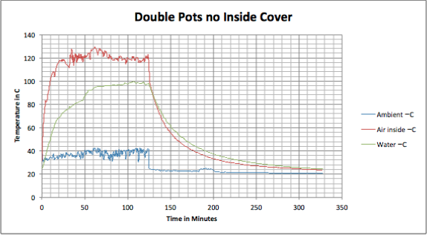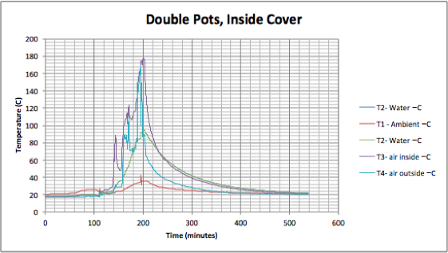
The weather conditions for the double pot with no inside cover were of consistent sun, which corresponds to the rapid rise in air temperature inside the glass container and the gradual rise in water temperature inside the inside pot. The graph has very few spikes and dips compared to the second graph of testing the double pots with an inside cover. [It would be easier to compare the two tests if the graphs were plotted with equal axes.]The day that the second test was conducted had passing clouds; drops in air temperature inside the glass container correspond to moments when the clouds passed over the sun. In order to compare the rise in water temperature and determine which set up is more efficient, two primary components were examined. First, we noticed that the final water temperature in both scenarios was about the same (just below 100 degrees C, the boiling point of water). We also noticed that the air temperature within the double pots was significantly higher, despite the lower ambient temperature.
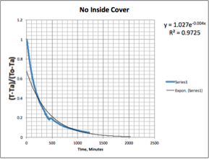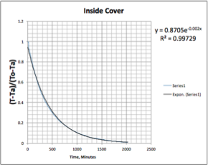
One component of the graphs that would be reasonable to compare, despite the different conditions, would be the portion where the water is cooling. In order to include the effects of ambient temperature, we fitted the curves to Newton’s Law of Cooling. Based on these curves and resulting fitted equations we saw that the double pot setup cooled at a slower rate. From this, and the observations listed above, we came to the conclusion that keeping the lid on the interior pot was a better approach. Although we went in a different direction with further testing, these tests are something we could pick up on in the future. [The plots on the graph below are not labeled. Which is which?]

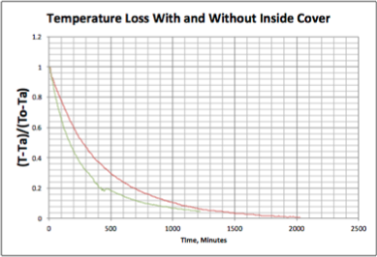
Based on our initial testing experience, as shown in the photos below, it was clear that in order to effectively use this lens stand, the pots or pans we tested with had to be propped up with cinder blocks to reach the appropriate level.[What is the appropriate level and why is it appropriate?] This provided some insight as to what changes we decided to make in the design for a new lens stand.

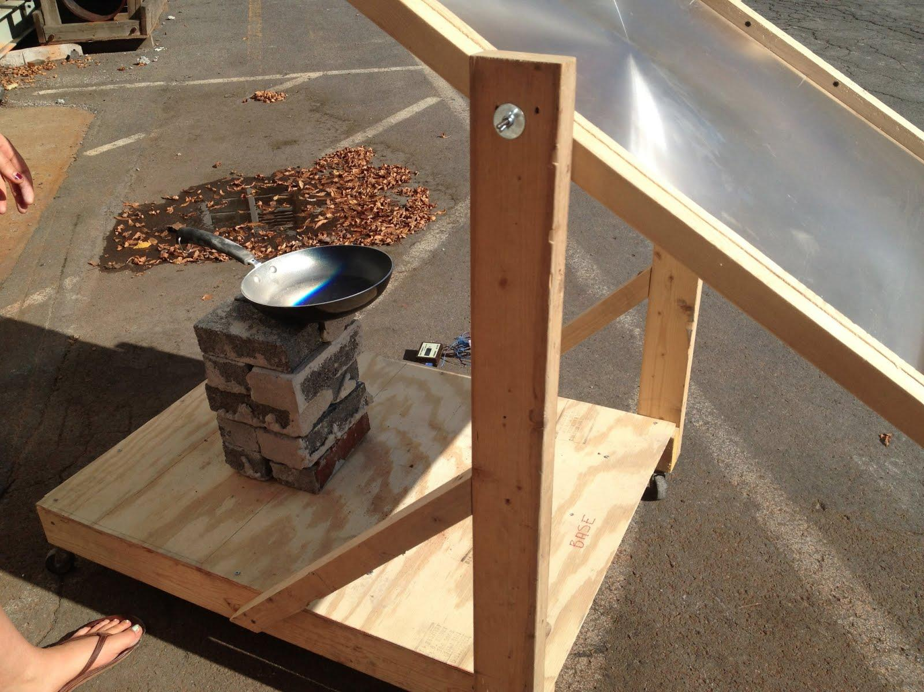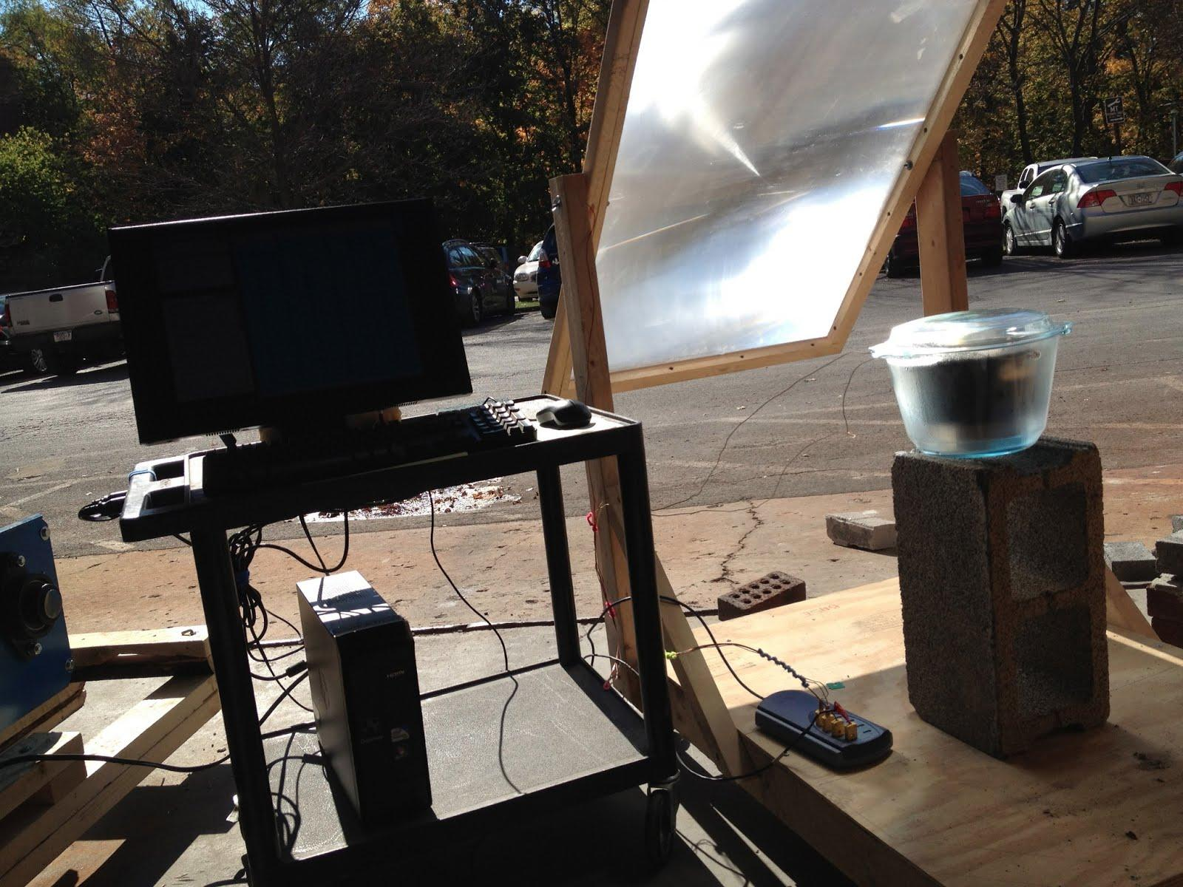
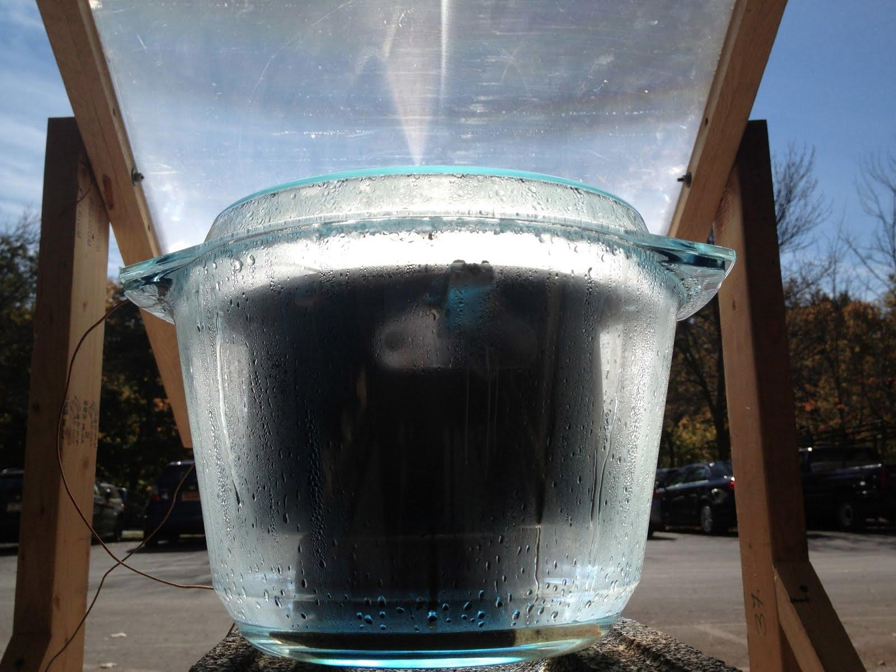

Lens Stand

A portion of this semester was spent designing and building a new lens stand. After our early tests, we felt the need to build a stand with slightly more sophistication to be more customizable for our needs. Important features included the mobility of the base and lens frame, the ability of the lens to remain fixed at a certain angle, durability, ease of movement [isn’t this the same as mobility?], and ease of construction; all were qualities that the old design did have. However, the major difference would be a movable platform base, so that the base would be adjustable to three different heights. Building the lens stand involved about ten hours of labor and the process of doing so was as follows:

Step 1 | Find, measure, mark and cut the wood pieces for the stand. Variation can easily exist but the basic structure of the stand we built was 4 posts, two plywood bases, and four strips of wood to stiffen the lower plywood base.
Step 2 | Attach four stiffening pieces to the plywood base using screws. (2 parallel in each direction).
Step 3 | Attach 4 castors to the bottom of the stand, 2 with 360 degree rotation in the back and 2 straight ones in the front.
Step 4 | Attach the posts to bottom stiffening pieces with screws.
Step 5 | Cut and attach metal angles to the posts so the base can rest on them. There should be four angles for each level, and the levels should be just below, at, and above the height of the focus of the lens when it’s in the stand (a quick test may be necessary)
Step 6 | Attach the lens to the two front posts of the stand such that it is wedged between them with butterfly screws.
Step 7 | Make sure that everything fits together and adjust and add stiffening members as necessary.

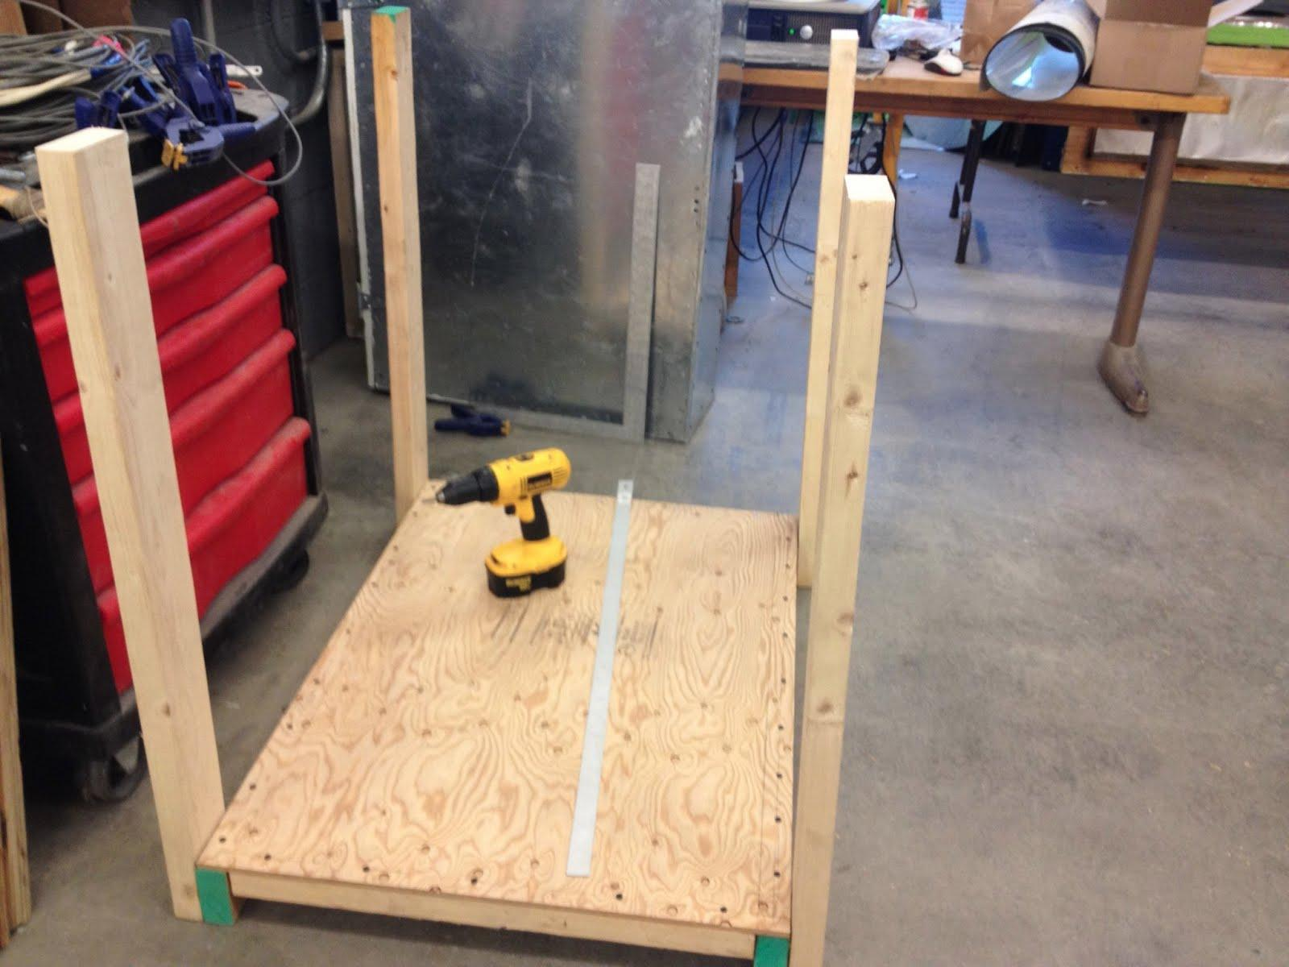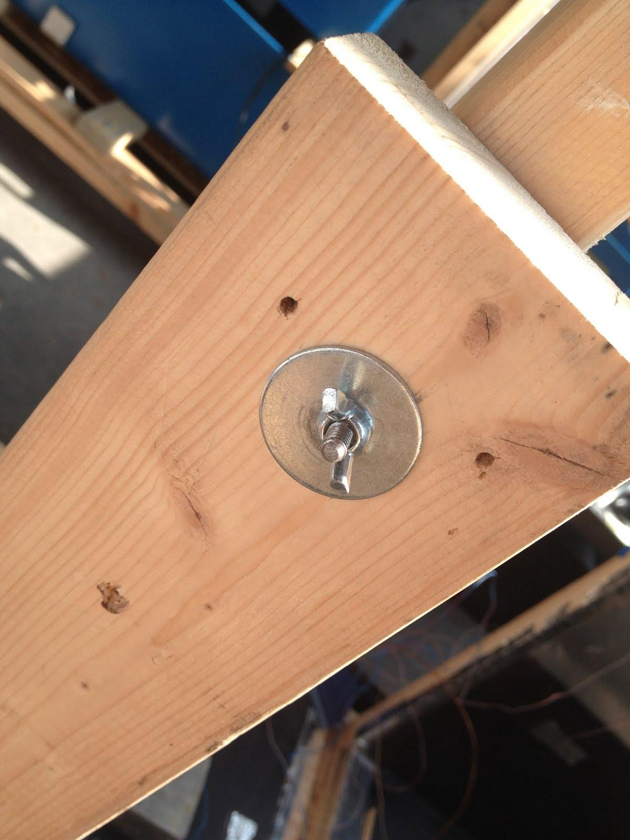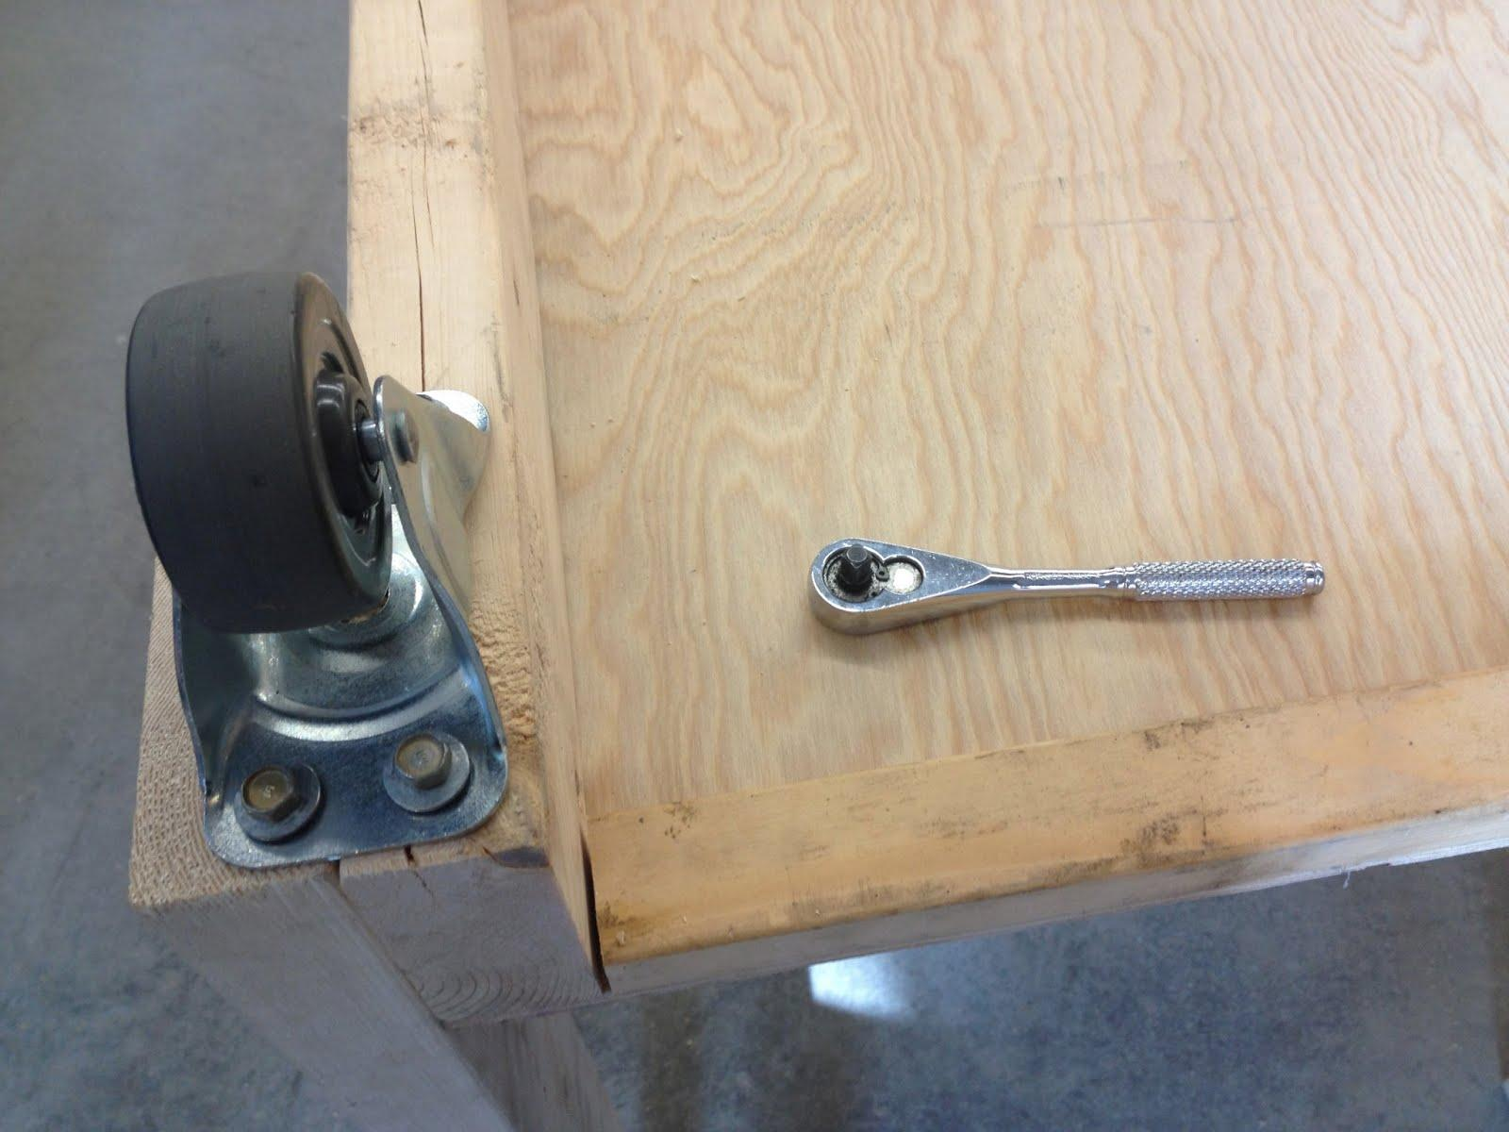
Assembling the stand
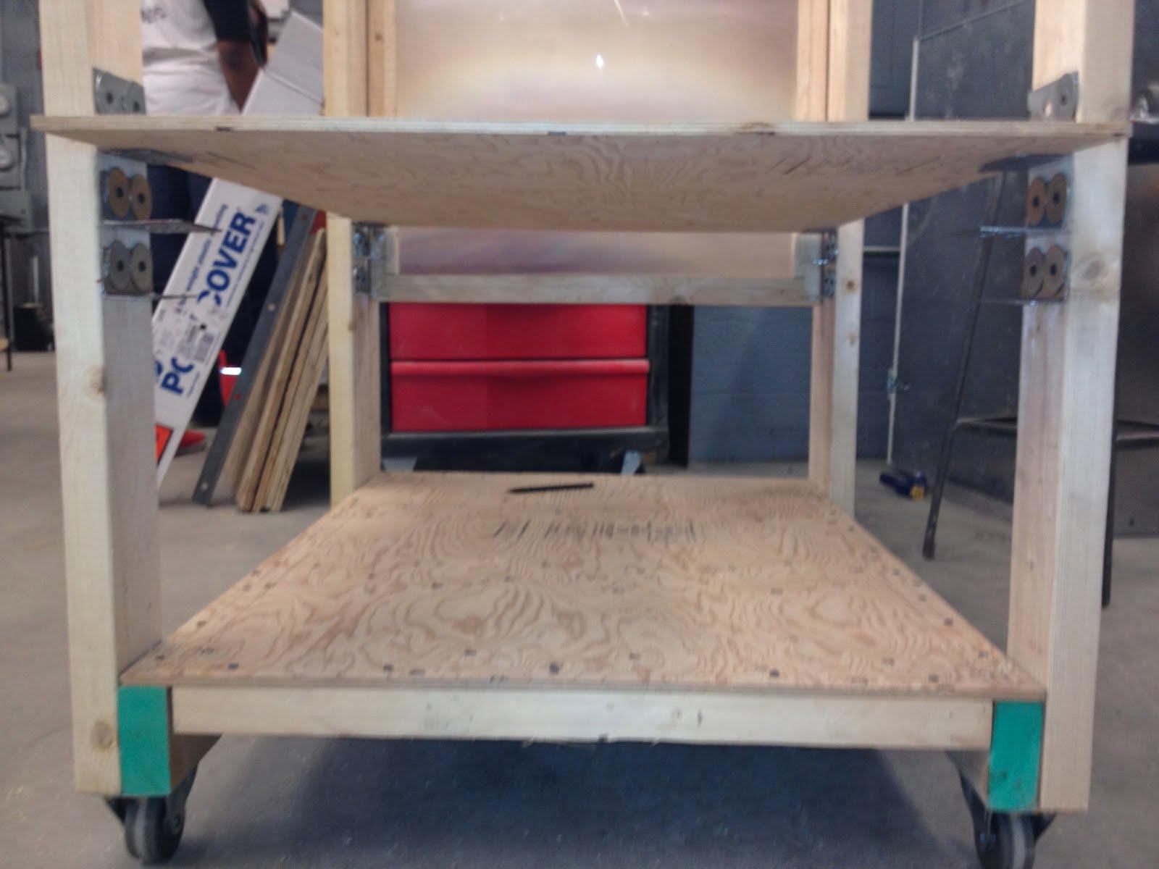
View of shelves

Component that we Used and Method of Construction | Analogous Component and Method that could be used in Nicaragua.
Moveable Base- Plywood, cut on a table saw (need to verify the name). | The price of plywood in Nicaragua is relatively greater than it is here. One potential alternative would be to use wooden planks across the stand instead.
Metal angles. | Comparable material is available in Nicaragua, another alternative would be to use blocks of scrap wood to balance the base on.
Screws. | Are available in Nicaragua, nails could be used as necessary.
Washers to protect the wood, butterfly (wingnuts) screws to secure the lens. | Availability (or lack of availability) in Nicaragua would dictate what materials to use to fulfill the same purpose.

Washers Testing

Overall, our testing this semester remained fairly general because we were still trying to get a feel for the lenses’ capabilities and practical applications. The first significant round of testing that we did was to compare air temperature inside of the glass container with one washer in the focus of the lens versus multiple washers in the focus of the lens.

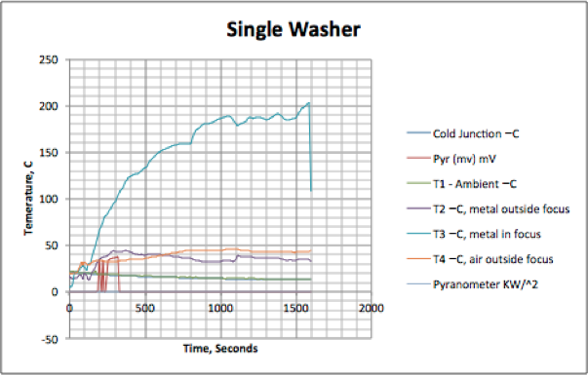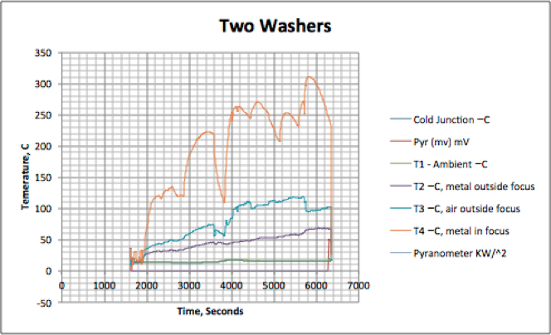
From this data, it is apparent that having more washers in the focus of the lens significantly increases the air temperature inside the closed container. This is encouraging because for our practical applications, we are interested in heating the material and air around the focus of the lens, in addition to heating the small point of the focus itself. This test implied that the surrounding temperatures significantly increased when more black surface was in the focus, converting more radiant energy to heat. In the tortilla tests, we planned to achieve this result by heating the black surface of a frying pan converting concentrated light energy into heat.
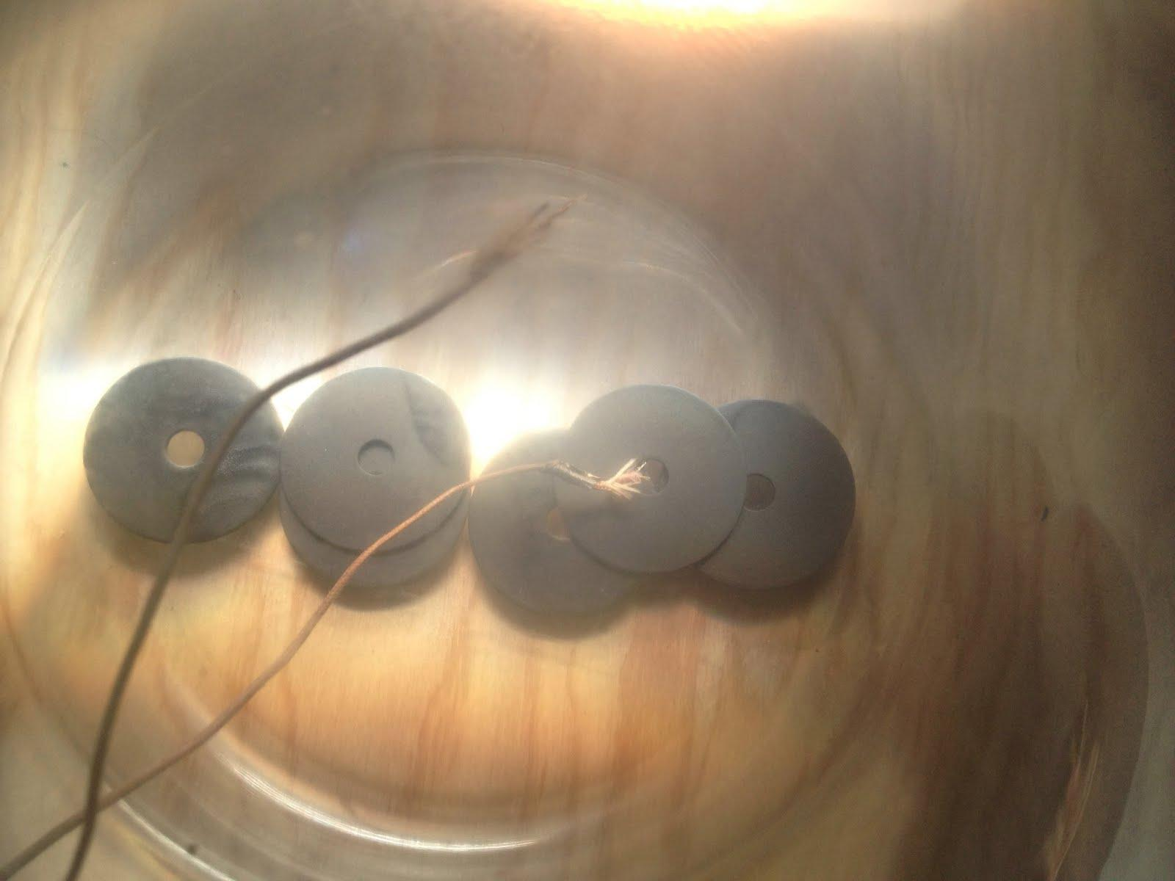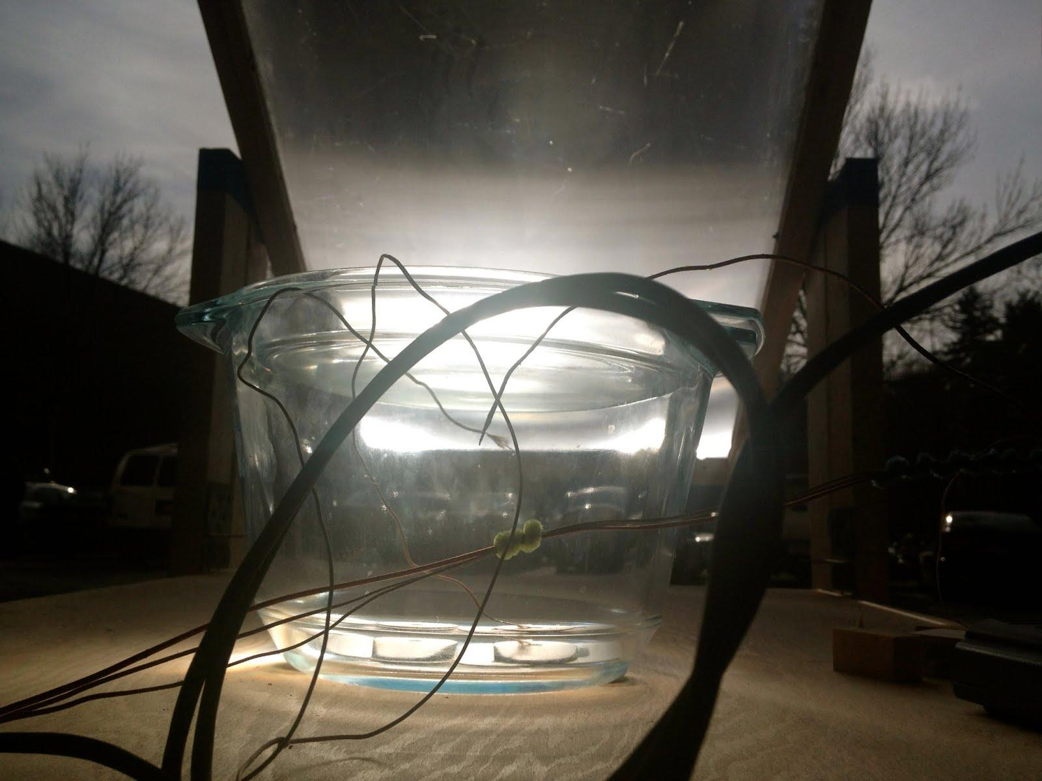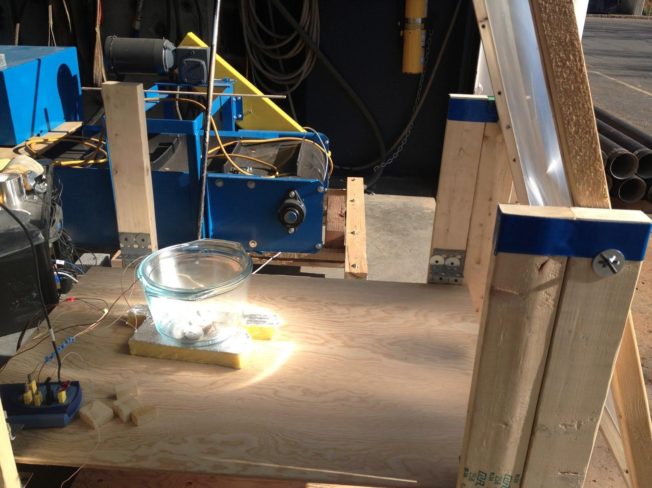

Tortilla Testing

The basic setup for cooking the tortillas involved setting the stand’s movable base at a height such that the focus of the lens would be on the pan. Then we prepared tortillas in the style of the women in Sabana Grande and cooked the tortillas on the pan in two separate tests. Two tortillas were cooked in the first batch, one placed to overlap with the focal point, the other placed just outside of it. The tortilla overlapping the focal point cooked faster. Some key temperature readings were as follows:
- Average pan temperature in the focal point: 200 C
- Average pan temperature near the focal point: 180 C
- Average pan temperature on the edge of the pot, in the shade: 63 C
- Tortilla temperature while cooking: around 70 C
The first batch of tortillas took 20 minutes to cook. The second batch took 10 minutes, probably because the skillet was already heated and the tortilla was placed more directly in the focus. The second round of tests yielded similar results.

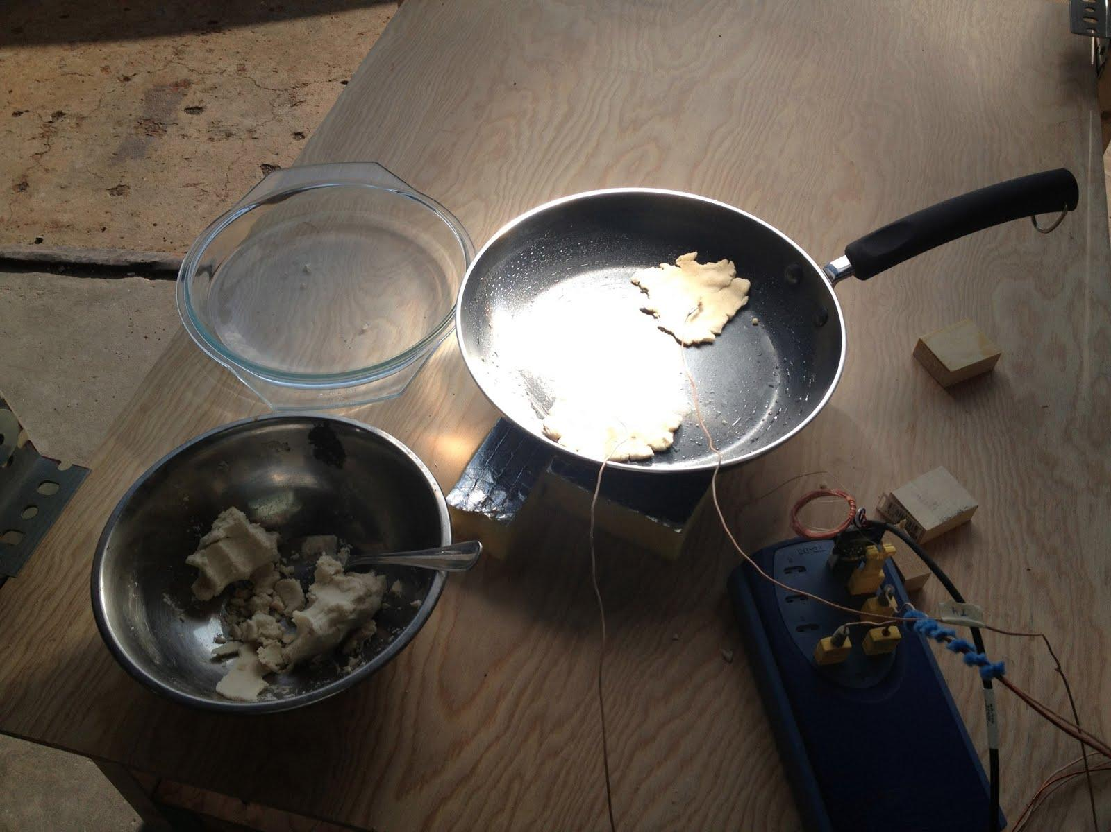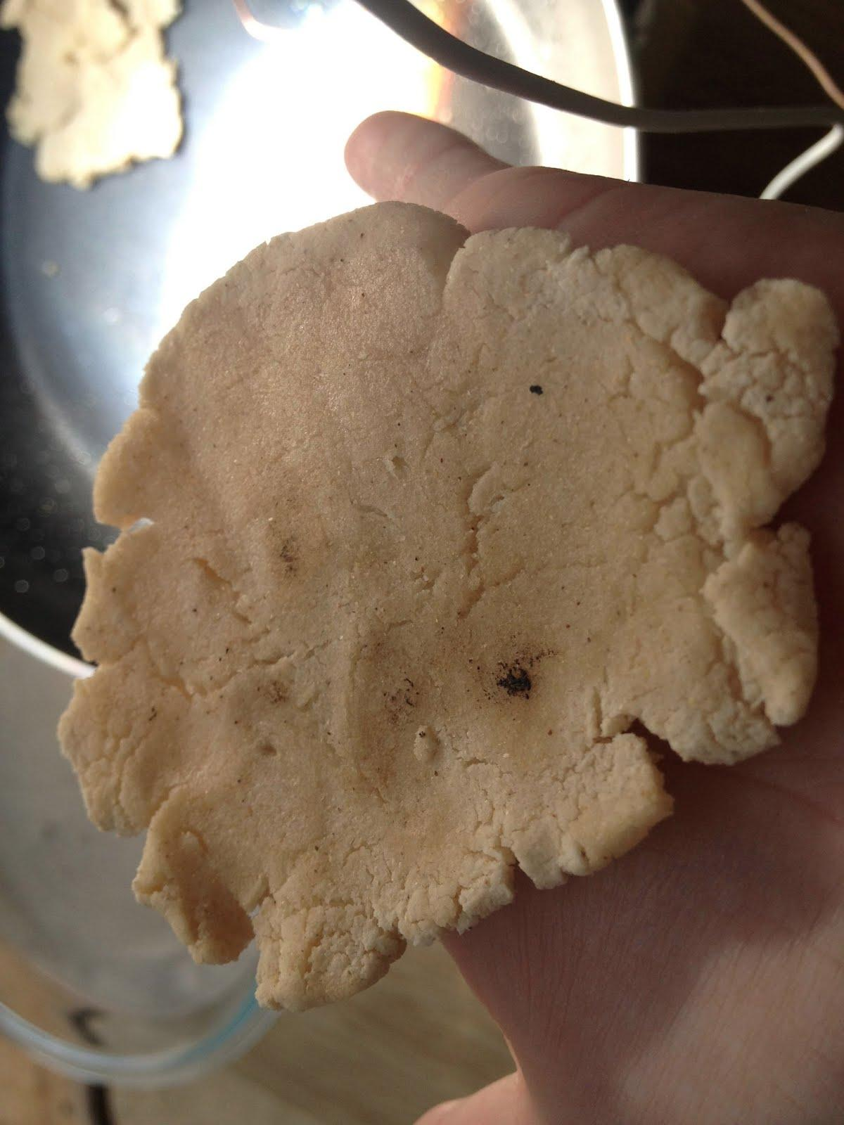

From these preliminary results, we have started to put together a basic understanding and intuition for how the Fresnel lenses can be used to cook tortillas. Next semester we plan to undertake a rigorous testing sequence wherein we will attempt to make tortillas when the weather allows. Some important components of our plan for next semester include:
- Measure and record the temperatures of the tortillas as they cook for every test.
- Measure and record the temperature of a tortilla as it cooks using a more traditional stovetop method, so we can see what the important benchmark temperatures are.
- Invent and quantify a scheme of insulating the frying pan or similar apparatus from heat loss. [Right now the only system we have set in place is putting it on a block of insulation. ]
- Invent and quantify a method which will insulate the pan from above. We may attempt to use the glass covering of the small pot cooker or a similar piece of equipment to do this. As the ambient temperature drops (we will begin testing again in either late January or early February), insulating the pan and protecting it from losing heat in passing wind will become vital for testing in Ithaca.
- Make a realistic analysis of whether using F resnel lenses to cook tortillas or similar types of food will ever be feasible in Nicaragua.
- Record our progress in detail, so future groups will be able to pick up where we left off.
Due to poor weather conditions and scheduling conflicts, we were not able execute as many tests as we would have liked this semester. Next semester we hope to be able to do many more tests and repeat basic tests many times to reduce the effects of variable weather conditions on our results.

General Schedule and Costing

The general semester schedule was as follows:
Early October: Initial testing done, i.e. focused lens on pan balanced on cinderblocks to find focal point and appropriate height for base.
Mid-October: Tested pot within a pot setup
Late October: Built lens stand.
Early-November: Tested black washers in glass pot
Late November: Made tortillas

Costs were limited and hard to quantify, as the lab already had most of the materials we required.

Risks

Using the lenses necessitates a considerable degree of caution at all times. During experiments we have been careful to ensure that nothing is overheated or set on fire, which has been a valid concern given the intensity of the lenses. A few times we have accidentally left the lenses focused on a spot for too long during tests, causing charring and smoking, but we have avoided any serious accidents. Special care is needed upon leaving the lenses in the lab after a test--sunlight can shine through the windows on the door and the lenses need to be left in a position such that they will not burn anything. Finally, oftentimes during testing, looking at the focal point proves to be extremely bright and taxing on the eyes, so procuring sunglasses for testing is one suggestion.

If the Fresnel lenses are ever to be used in Nicaragua, it is of upmost importance that any and all safety concerns be recognized and controlled. Similar to cooking with fire, cooking with the Fresnel lenses can cause fast and irreversible damage that can get out of control if caution is not exercised.

Conclusion

Now that we are halfway through the year, thinking about our future goals in a more specific manner becomes necessary. Next semester, time to test will be limited, not just because there will be few sunny days but also because the trip to Nicaragua is in early March. Early in the semester we hope to compare the washer tests and continue developing the tortilla-making process that we have just started. Like last spring, we may assist other subteams in the physical construction of any ovens that the group will bring to Nicaragua. And finally, we also want to leave behind enough concrete progress to allow for a future group to pick up our work. In this way, after we graduate, a new team can continue testing with the Fresnel lenses and expound upon the information and results we leave for them.

