Stacked Rapid Sand Filtration (SRSF)
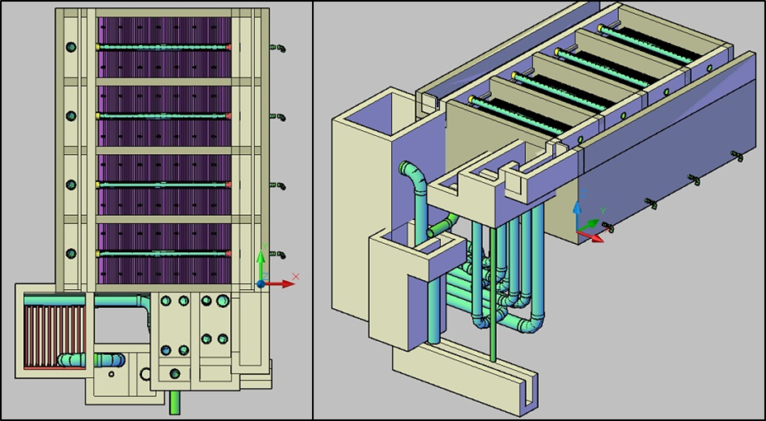
Figure 1. ( Left) Top view of the sedimentation tank and a single filter below it. (Right) Isometric view of the filtration unit and sedimentation tank.

Introduction
We have developed algorithms for the design and drawing of Stacked Rapid Sand Filters (SRSF) as a new unit process for AguaClara plants. Using the design parameters that result from the calculations, an automated design tool creates a drawing and associated documentation for the additional unit operation. The filters follow sedimentation in the flow through the plant. The goal is to add automated code to produce final designs that include SRSF in all future AguaClara plants.
The design file uses various head loss calculations and known or constrained heights to establish the different elevations at which tanks and weirs need to be in order for water to flow as desired. The AutoCAD drawing scripts will use these values to draw the actual tanks to the dimensions required.
Figure 2 and Figure 3 show the layout of the filter. Water from the sedimentation tank enters the entrance channel then into the Entrance Box over a weir, flowing into the inlet manifold pipes. During filtration, all four pipes are utilized to distribute flow evenly to each of the six sand layers in the Filter Box and flow exits through the exit manifold into the Exit Box. Once in the exit box, the filtered water flows over a weir and is then piped to a distribution tank.
Figure 3 more clearly shows the parts of the filter associated with backwash. For backwash operation, all water in the entrance channel will only flow through the bottom inlet manifold pipe. The dirty backwash water will then flow through the siphon into the Backwash Box. The backwash weir makes up one wall of the backwash box and controls the height of water throughout the filtration system. The dirty water flows over the weir from the backwash box into the backwash overflow box, then down a pipe to the drain channel.

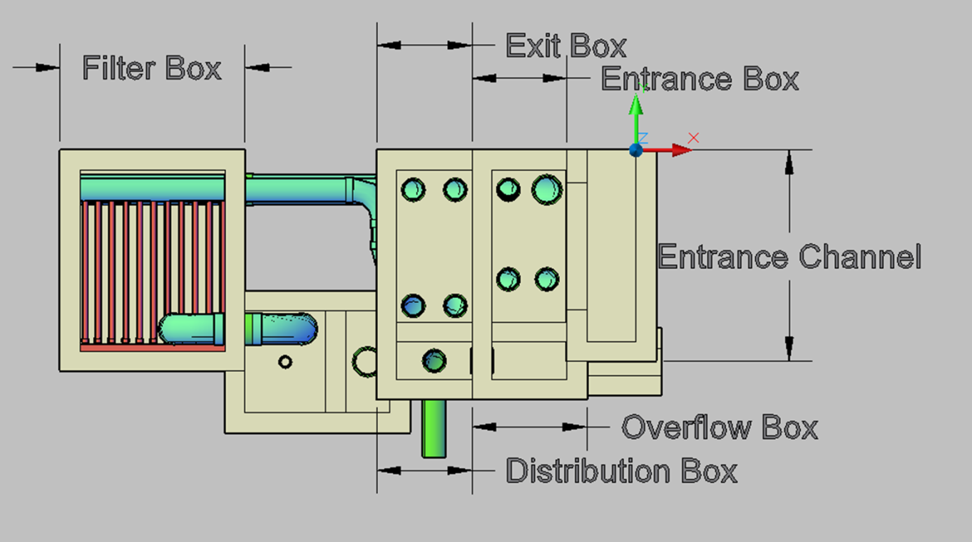
Figure 2. Top view of the filter labeled for filtration flow.
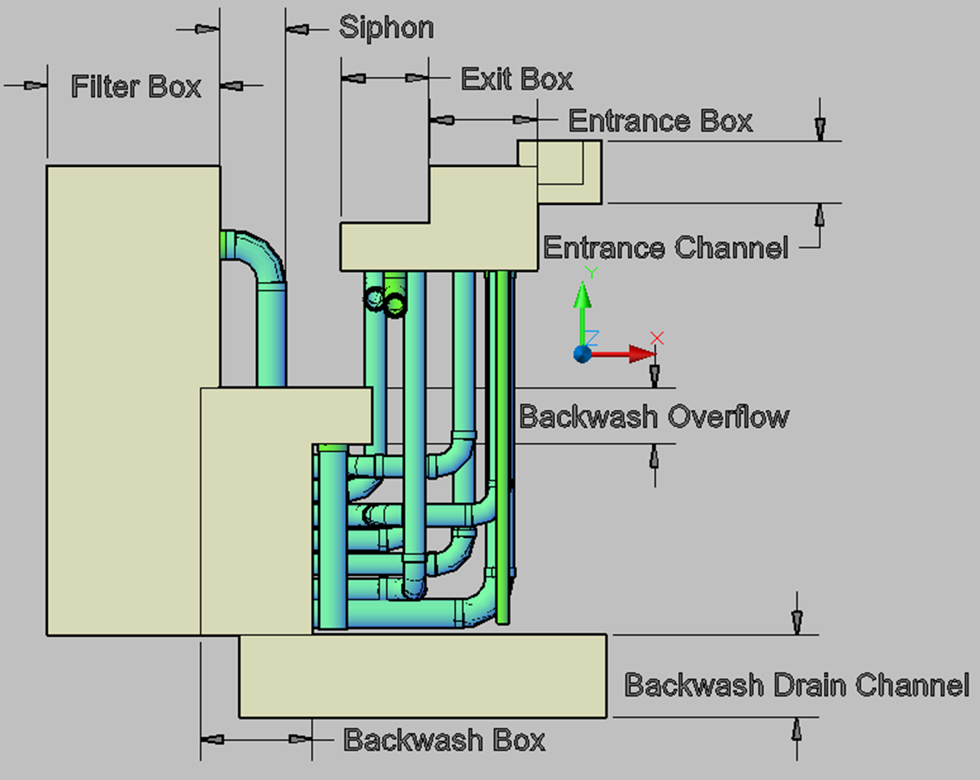
Figure 3. Front view of the filter.
With the addition of the filtration unit operation the placement of the plant relative to the distribution tank will change, because filtration will add to the total head loss through the plant. The effect on the automated design is that the sedimentation tank exit channel will need to be modified as well as the waste/distribution pipes currently at the end of that channel so that water flows into the filters instead. The filters are constructed just below the sedimentation tanks in plant layout viewed from above. The layout of the entire filter unit was designed so all of the piping going to and from the filter could be accessed in one area. This also means less excavation and a shorter path for any water going to waste.

Design Overview
- Elevation of the maximum acceptable water level in the entrance channel is given
- Entrance weir set to be as long as possible to minimize head loss
- Manifold branch sizes based on pressure recovery to ensure even flow
- Trunk line sizes based on pressure recovery and the maximum size that could fit in a sand layer
- Number of filters set based on the maximum flow one filter can treat
- Backwash determines filter box dimensions
- Head loss during backwash set by the fluidized bed, piping, and the weir
- Elevation of backwash weir set
- Elevation of bottom of filter box set relative to backwash weir
- Elevation of the bottom of the entrance, exit, overflow, and distribution boxes set by the entrance box, making it one slab of concrete
- Siphon sized based on filter flow and draining the water above the bed during backwash

Design Details
In the steps that follow, the naming scheme for each variable is standard. The first letter before the period indicates what type of information the variable calculated. Next, the unit of operation the variable applies to; in this case, “Fi,” for Filter. Then, the part of the filtration unit that the variable describes (backwash is abbreviated “Bw”).
H | Height | HL | Head loss
L | Length | T | Thickness
W | Width | SF | Safety factor
D | Diameter | HW | Height of Water
To be consistent with the other parts of the plant, the width dimension of each box will be parallel to the y-axis when the unit is viewed from above. Likewise, the length dimension will be parallel to the x-axis when the unit is viewed from above.

Number of Filter Boxes
The first step in designing the filtration section of the plant is determining how many filters are required. The width dimension of the filter bed is constrained be the requirement that pressure recovery in the manifold branch pipe not exceed 10% of the head loss through the clean bed, ensuring even flow distribution.

Head loss for filtration is calculated using the Carmen-Kozeny equation for head loss through a porous media:
$${HL}_{Kozeny}=\frac{k_{Kozeny}*L*υ}{g}\frac{{(1-ε)}^{2}}{ε^{3}}\frac{36}{D^{2}}V$$
Where
k_{Kozeny}= Carmen – Kozeny coefficient = 5
L= total height of the sand bed
υ=kinematic viscosity
g= acceleration due to gravity
ε= porosity of the bed
D= diameter of fluidized particles
V= velocity of particles
A layer thickness of 20 cm was chosen based on the capacity of the filter box and the goal of a 24-hour timeframe between backwashing, although this varies based on the influent turbidity. This equation reveals that the clean bed head loss is 15 cm.

The equation for the pressure recovery term is:
$$H_{PR}=\frac{V^{2}}{2g}$$
Where
V= Average velocity of the fluid at the upstream end of the manifold
g= acceleration due to gravity

V is solved for in this equation and with the constraint on pressure recovery, the maximum velocity in the manifold branches and trunk lines was calculated to be 54.5 cm/s. This constraint translates to larger pipes for bigger flows. The 20 cm sand layer constrains the largest pipe size that can fit in a sand layer to 6” for the manifold trunk lines.
Similarly, the backwash trunk line is constrained by the sand layer thickness. Because the backwash trunk line must carry the entire filter flow during backwash mode, the pipe must be larger to meet the pressure recovery constraint. To accommodate as large a pipe as possible, it was decided that the backwash trunk line would be embedded in the bottom of the filter so that its manifold branches lay perfectly even with the floor. The sand layer thickness limits the size of this trunk line to 8”. Calculations reveal that a single filter box can handle approximately 17 L/s of flow, constrained by the backwash trunk line size of 8”.
The number of filter boxes is determined by dividing the plant flow by the max flow (17 L/s) per filter. If the result is greater than 1 it is rounded up to the nearest even number. An even multiple of filters maximizes the shared wall space and minimizes the number of pipes and fittings, reducing the cost per L of water. If the plant flow is less than 17 L/s, a single filter box is used.
The layout for one filter will differ slightly than for larger-flow plants that have more than one. Figure 1 shows the layout for a single filter. The design has an overflow box attached to the entrance box in the event an operator has not backwashed the filters soon enough and also provides a means of bypassing the filters if there is a problem. In the single filter design, the overflow box will not be shared as it is in the design for more than one filter. It should be noted that all tanks and channels in the filter system design will be square, as opposed to cylindrical, for ease of construction.
With the number of filters calculated, the flow for a single filter can be used to design the entire unit. Because backwash requirements are more limiting, once the backwash weir height is determined, the elevations for the rest of the filter components can be calculated by summing the head losses through the flow paths in the filter, except for the filter box because it is independent of the weir height. For the purposes of these calculations, the backwash velocity was set to be 11mm/s based on the recommendation of a CEPIS guideline. We are also assuming there is a 30% bed expansion during backwash based on lab experiments from the filtration research team.

Plumbing
The plumbing is calculated first because the flow rates through it will determine the head loss and thus the backwash weir height. It is assumed that the spacing between the manifold branch pipes in the inlet and exit manifolds will be 10 cm. This constraint is based on the radial flow zone of a pipe and the volume that can pass through it and is a number verified by the experimental apparatus. The pressure recovery constraint addressed in the Number of Filter Boxes section applies to the trunk lines and the manifold branches, both of which have ports along their length to distribute water evenly. Additionally, in order to initiate backwash, the inlet pipe leading to the bottom of the filter must be able to handle the total flow through the filter, causing it to be larger in some cases.
The head loss through the plumbing was summed for each piece in the flow path using the fluids equations to calculate major and minor losses.

Siphon
The siphon must be large enough to allow for draining all the water in the filter in a reasonable amount of time, set to be 3 minutes as well as have less than 10 cm of head loss at steady state. The following equation is used to calculate the diameter:
$$D_{FiSiphon}= \sqrt[4]{K\frac{8}{g*π^{2}}*\frac{{Q_{FiSiphon}}^{2}}{h_{l}}}$$
Where
K= the sum of minor loss coefficients
Q_{FiSiphon}= the flow rate through the siphon
h_{l}= the maximum acceptable head loss through the siphon
For the maximum flow case, the Q used in the equation is the total flow through the filter plus the maximum flow rate for the height of water above the siphon inlet; the head loss is that for backwash initiation plus head loss through the inlet plumbing. Because the head loss through the siphon cannot be calculated yet, it is not used in this calculation. For the steady state case, the flow is the total filter flow and the head loss is set to 10 cm. With a diameter, the actual head loss will be calculated using the fluids equations for minor and major head loss.
The siphon must be long enough on the backwash box side to ensure that air is trapped. Because the backwash box will already extend to the same level as the filter bottom, the pipe will extend to one pipe diameter away from the floor. Additionally, the position at which the siphon exits the filter through the wall is important. Assuming negligible compression of air in the siphon pipe, the pipe in the filter must be longer than the height of water above it to ensure no water will leak out at the end of a filter run.

Backwash Box
The backwash box is designed around the weir height which is calculated as follows:

$Z_{FiBwWeir}=Z_{FiEntranceWeir}-({SF}_{Fi}+{{HL}_{FiInletPlumbing}+{HL}_{FiBwInitiation}+HL}_{FiBwWeir}+ {HL}_{SiphonSS})$

Since the height of the entrance weir is known, it is used for the basis of calculating the height of the backwash weir. This height is calculated by starting with the entrance box weir height and subtracting a safety factor for additional head to initiate backwash, the head loss through the plumbing, the maximum head loss required to initiate backwash, the head loss over the backwash weir, and the head loss through the siphon at steady state. HL_{FiBwInitation} is the head loss above steady state backwash head loss required to start the backwash process and has a value of 40 cm.
The backwash box extends to the base of the filters, providing a height for the box. The width is calculated by adding the minimum dimensions for the siphon pipe(s) and a drain pipe while ensuring that is at least the human minimum dimension so the box can be constructed. Similarly, the length is the minimum dimension for one of the siphon pipes while ensuring the human minimum dimension.

Filtration Box
With all the necessary head losses calculated, the height of the filter box can be calculated as follows:

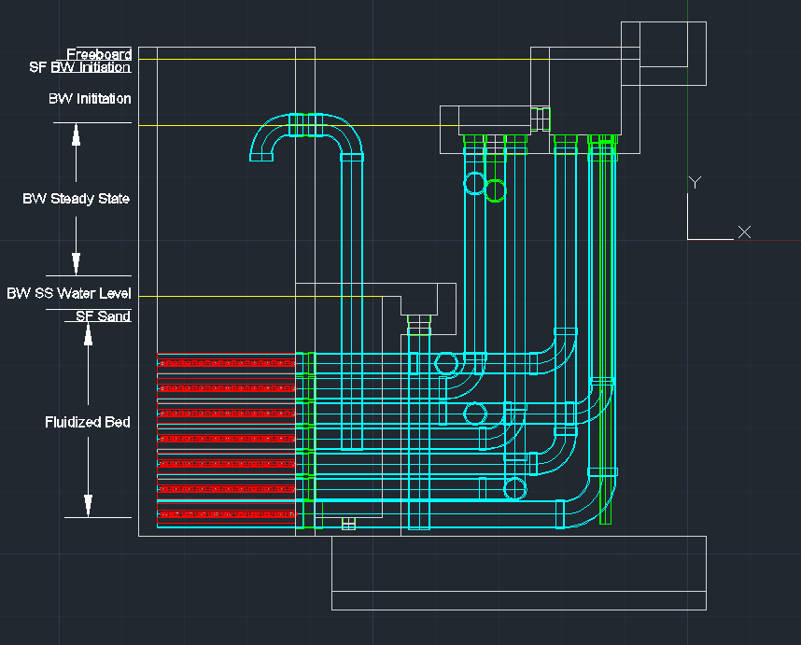
Figure 4. Side view of the filter with the dimensions labeled corresponding to the heights that make up the height of the filter box. Yellow lines show the heights of the weirs in the filter unit for reference.

$H_{FiFilterBox}=H_{FluidizedBed}+{SF}_{SiphonSuction}{ + H}_{SiphonInletBelowWater}+{HL}_{FiBwWeir}{ + HL}_{FiSiphon}{ + HL}_{FiBwSteadyState}+{HL}_{FiBwInitiation}+{SF}_{FiBwInitiation}{+H}_{Freeboard}$

The height of the filter box is determined by adding the height of the fully fluidized bed; plus a height for the suction zone so the siphon does not suck up sand (approximated as 10 cm); plus a minimum submergence of the siphon pipe during backwash corresponding to a distance below the backwash weir, the head loss over the backwash weir, and the head loss through the siphon composing the section labeled “BW SS Water Level” in the picture; plus head loss for backwash steady state; plus head loss for backwash initiation; plus the distance the siphon inlet is below the water height set to be 10 cm; plus free board (10 cm). For a typical design, the filter box is
As it relates to the filter box, the design of the entrance box ensures that it is not possible to have more than 30 cm of head loss above clean bed head loss through a dirty filter bed. This is accomplished by setting the maximum water level in the entrance channel to be equal to terminal head loss. The 30 cm of terminal head loss is based on a water quality standard. The width of the filter box is set with the pressure recovery constraint discussed in the Number of Filter Boxes section and the length is calculated based on the required filtration area after the width is determined. Additionally, the filtration box must satisfy a maintenance and construction constraint: plant operators need to be able to climb inside the filter to build it and for repairs. If this is not met with the calculated values, a minimum distance is used and the appropriate variables are recalculated.

Overflow and Distribution Box
The overflow box (or the distribution box on the exit box side) are the minimum width possible, just enough to allow for a coupling in the floor. The reason for this is to allow more room for the complicated plumbing beneath the entrance and exit boxes (explained in Entrance Box Dimensions). The length was set equal to the weir length, calculated based on the maximum of the human dimension and the space needed to fit the piping below the boxes, and the height set to be equal to the wall height in the respective boxes.

Entrance Box
The entrance and exit boxes are configured as shown in Figure 2 so they could be accessed easily from one location, to minimize the amount of earth that need to be excavated for construction, and to make the flow of wasted water more direct to the drain channel. This goal, however, causes the plumbing below the entrance and exit boxes to be complicated due to the need for two 90 degree elbows for some of the pipes, as shown in Figure 4 below.
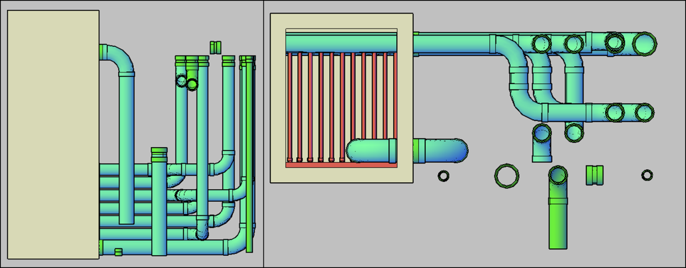
Figure . (Left) Front view of the plumbing without tanks drawn. (Right) Top view of the plumbing without tanks drawn.

Four of the seven pipes in each filter only require one 90 degree bend and line up with the couplings in the wall of the filter, but space needs to be allotted to allow for the double 90 degree bends on the remaining three pipes. Since the radius of these elbows is approximately equal to the diameter, any “extra” space is placed between the bottom two pairs of pipes in the entrance box, as shown in Figure 4. To achieve this, the bottom couplings in the exit box are the minimum distance from the wall and the couplings in the entrance box are that same minimum distance above those while the top couplings are the minimum distance from the wall above.
The calculation for the entrance box width takes the total length of two filter boxes and the wall they share, subtracts the width of the overflow/distribution box, and divides the remaining distance by two to arrive at the width of one entrance/exit box. It should be noted that for the single filter box, the width dimension is calculated for two filters; the second filter is not drawn, however. This was done because it will be efficient to build the filters in pairs and paired filters will be able to be plumbed to maintain pressure in the effluent piping during backwash to prevent contamination by backwash water.
The equation for the height of the bottom of the entrance box is:

$$Z_{FiEntranceBottom}={ Z}_{EntranceWeir}-\left({HL}_{FiBwInitiation}-{HL}_{FiBwSS}\right)- {2SF}_{Fi}$$

This calculates the relative height by starting with the entrance weir and subtracting the difference between head loss at backwash initiation and backwash steady state and two safety factors. The difference in backwash head loss corresponds to a drop in the height of water in the entrance box. The safety factors are: one to account for the potential of air getting trapped in the pipe during backwash, because air will clog the flow of the water, and the other to allow for extra head to ensure backwash initiation.
The height of the box is set to be freeboard distance above the overflow weir height with the length set to the weir length.

Exit Box Dimensions
The exit box in the filter system must ensure flow at the desired terminal head loss of 30 cm. That is, the bottom must be low enough so that it meets the required flow rates as head loss in the filter increases. The bottom must also be high enough to ensure that no backwash water flows into the exit box. For ease of construction and because the height meets both the constraints, the bottom is set equal to the entrance box bottom and the length and widths are identical as well. The only change is the height of the weir:

$$Z_{FiExitWeir}=Z_{FiEntranceWeir}-{(HL}_{FiTerminal}+H_{FiInletPlumbing}+{HL}_{FiOutletPlumbing})$$

The relative height of the exit weir is calculated from the entrance weir, subtracting from it the terminal head loss at the end of filtration, the head loss through the inlet plumbing, and the head loss through the exit plumbing. The top of the box is then freeboard distance above the water level above the weir. The height is simply the distance between the bottom of the tank and the top of the wall.

