Design Team – LAYOUTS
by Trang Pham and Bonnie Schiffman

We have been working on Layouts for the Automated Design Tool. Originally, the Automated Design Tool returned a 2D model view and several 2D layouts of a water treatment plant. The designed plant, as well as its main components, has a top, front, and left view layout. Our goals for this semester are to add new layouts, dimensions, and other clarifying features to the plant drawings received by engineers.
First, we added new layers that depict the sedimentation tank during different processes throughout plant use and maintenance. Originally, the sedimentation tank layout included three pieces (chimney stops, launder cap, and orifice cap) that are all never actually on the tank at a given moment. During operation, all three pieces are not present. During drainage, only the chimney stops and the launder cap are in place. During refill, only the orifice cap is in place. We added code for a top view, a front view, and a left view of each of these three stages of the sedimentation tank. In each code paragraph, we added line that freezes up the component that is not needed in the layout.
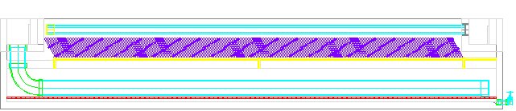
Sed tank in operation
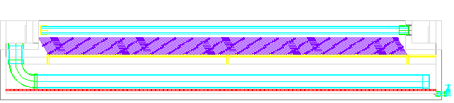
Sed tank during refill

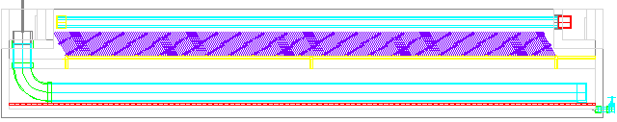
Sed tank during draining

We then changed the model view. The model of the plant, and the first component that the receiving engineer sees, was originally displayed in a top view. It was unclear that the model was actually three dimensional. We altered the stack at the end of the layouts code to include changing the model to a southwest isometric view, so that the model is now more obviously a three dimensional perspective and engineers will immediately know that the model is 3D.
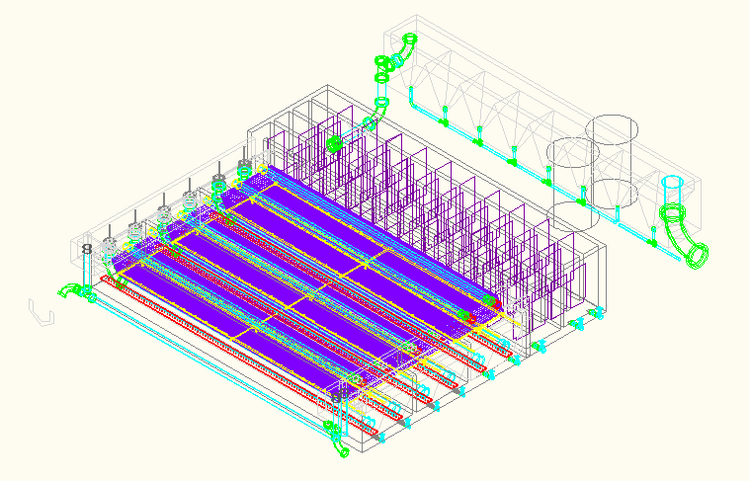
To make the designs more standard and professional looking, we are adding an AguaClara template to each layout. We obtained the AguaClara logo from the website and imported the jpeg file into an AutoCad file. We then scaled the logo down to 20% its original size and created a template with the logo and fields for information about the layout. After researching and studying various standard templates, we created an AguaClara template including the name of the plant, name of the drawing, date drawing was created, scale of drawing, person who ordered the drawing, revision number of the drawing, and location of the plant. The template is saved as an AutoCAD template file and will be set as the default so that each new layout contains the template in paper space. We inserted fields into the template that display the date, the scale of the view being displayed, and the name of the Autocad file. These fields automatically update every time the template is opened in a new drawing. We just need to find a way to save user input information about the plant and place it in the template as well – such as for the plant location and name of the person who ordered the design. Future work could look into putting these variables into MathCAD. Then we could add those variables as text to the template file, using the mtext function in AutoCAD. That newly changed template would then be used as the default in each layout of the new plant.
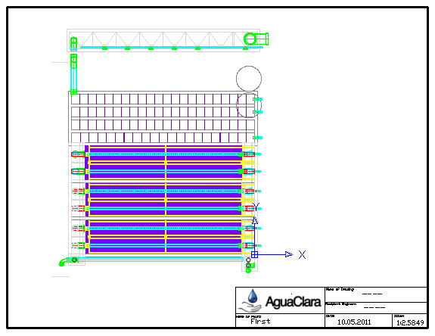
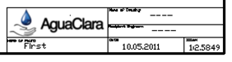
The top left hand corner of each box says what the box contains in plain text (Name of Plant, Name of Engineer, Location of Plant, Date, and Scale), and the text groups in the boxes are fields containing the changeable text.
To make the drawings clearer to recipient engineers, we worked on adding dimensions to the drawings. Unfortunately, we can only turn parts of the drawing off in different layouts; we cannot turn part of the plant off in the model space (the main drawing) and have it shown in the layouts. For now, we put all the dimensions in a separate layer called Dimensions. After the drawing is finished, we will turn it off but leave a note for the user so they know the dimensions are available also. We added a LinearDim function into the MToatranslater MathCAD file that would take in point of origin as first point and second point at a certain dimension relative to the first point, and how far from the object we want the dimension line to be. We have put a few basic dimensions for the Sedimentation Tank. As of now, the dimensions are in meters. Each layout needs a different set of dimensions. This requires that each layout have its own dimension layer, so that it can be frozen in other layouts. There are lots of dimension to be added and we have been looking for a more efficient way to do this; maybe incorporate the dimension code into the drawing code. For example, when a tank is drawn, the code would also put in dimensions of the tank. This works for basic geometry like boxes but we don’t know yet if it is feasible for other pieces.

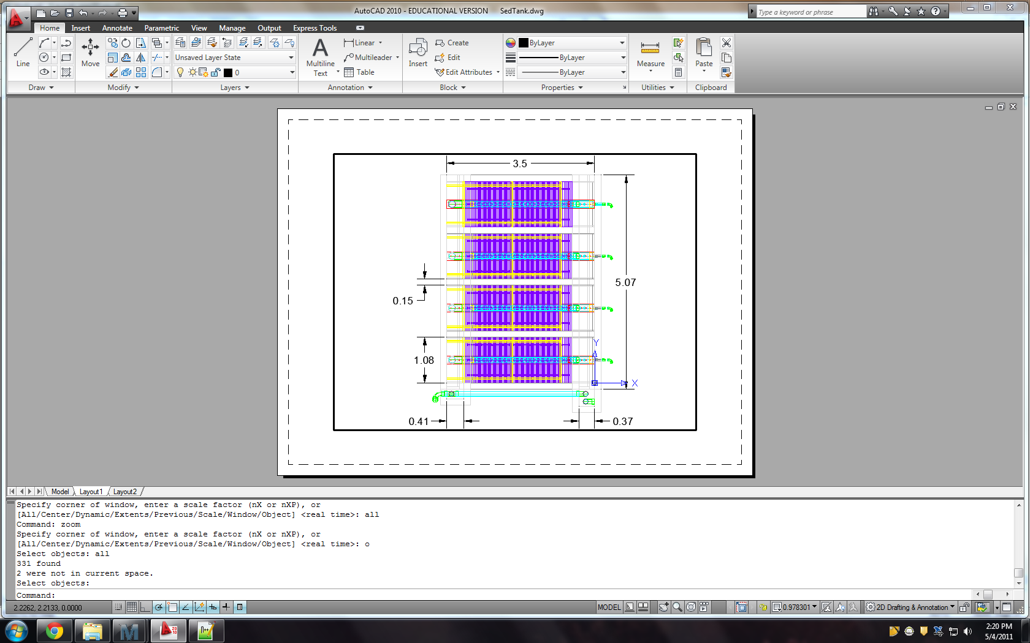

Future goals include finding a way to add dimensions to the layouts without having to manually turn them on. The template also needs to be tested so that it automatically updates the correct information when necessary in the title block. There should be a way to create variables in MathCAD that stores the name of the plant, the name of the engineer who ordered the plant, and location of the plant as text. In addition, there might be a way to add text right into different layouts that include important information about each drawing. Finally, there might be a way to create a list of layers and a new layer naming system so that when old layers are no longer used and new layers are created, the layout code will automatically be updated. As the plant is continually updated and new layers are created, the layouts code needs to adjust so that the correct layers are viewed and hidden in the appropriate drawing. When a new layer is being created, the name of the layer could be appended to a MasterLayouts list together with the rest of the layers. The problem so far is how to append the new name to the list and is MathCAD capable of doing that.

