Annual Conference NC AFCS, April 7-9, 2016, New Bern, NC
On Saturday, 9 April 2016, the Food and Nutritional Sciences Program at North Carolina A&T State University organized a symposium for high school teachers who are interested in food safety and nutrition education. The symposium was held during the North Carolina Association of Family and Consumer Science annual meeting. The topics that were covered are from food safety, food safety practices, and healthy foods for healthy family and how to practice healthy food for healthy life style.
Topic: Healthy Foods for Healthy Families and Communities
- ORAL PRESENTATIONS
Presenters | Titles
- Dr. Salam A. Ibrahim | Safety and health benefits of dairy products
- Abdulhakim Sharaf-Eddin | Seven Steps for A Healthy Life
- Temitayo Obanla | Common Family Medicines and Your Health.
- Aseel Issa | Development of a Novel Antibacterial Nanocomposite Film for Food Safety Applications
- Samirah Alotaibi | Edible Coating for food safety application in shrimp
- Priscilla Randolph | Painting our Community Green, One Thumb at a Time
- Nwadiuto Nwamaioha | Moringa oleifera: a food plant with multiple food safety and health benefits.
- Dr. Reza Tahergorabi | Fish and Shellfish (food safety and human health)
- Dr. Hye Won Kang | Effect of Turmeric in High Fat Induced Fatty Liver using Mice Model
- Dr. Tahl Zimmerman | Food as medicine: The Effects of Diet on Cancer

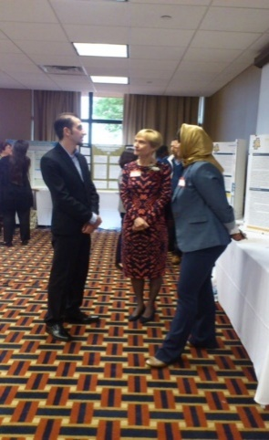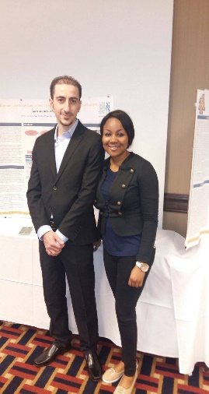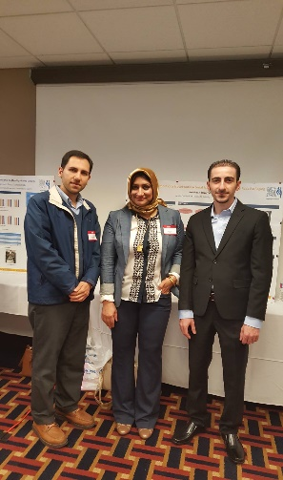

- RESEARCH POSTER PRESENTATIONS: (April 8, 2016)

1. Amira A. Ayad, Deiaa Gad El-Rab, Abolghasem Shahbazi, Mulumebet Worku, Valerie L. Giddings, Salam. A. Ibrahim

- . Date palm (Phoenix dactylifera L.) as a primary constituent in developing a medium for cultivation of lactic acid bacteria

2. Rabin Gyawali, Nadia Y. Idris, Mulumebet Worku, Valerie L. Giddings, Salam A. Ibrahim. Effects of hydrocolloids on acid whey production of nonfat Greek yogurt
3. Belal J. Muhialdin, Salam A. Ibrahim. Growth inhibition of three spoilage fungi by novel antifungal peptides produced by Lactobacillus plantarum TE10
4. Temitayo Obanla, Imani Grimes, Mulumebet Worku, Valerie L. Giddings, Salam A. Ibrahim. Impact of aspirin on growth and functionality of Lactobacillus rhamnosus (ATCC 53103) after 12 weeks of exposure using natural selection

