Southern Guilford High School of Greensboro, NC

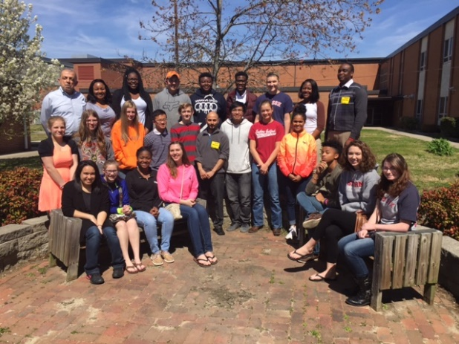
On Wednesday, 23 March 2016, the Food Microbiology & Biotechnology Laboratory students of Dr. Salam Ibrahim traveled to Southern Guilford High School of Greensboro, NC to train 11th and 12th grade students and teachers about Food Safety/technology. The discussion begin with a brief introduction of all graduate students who work under the advising of Dr. Ibrahim.

Students present several aspects of food science/safety. Each students briefly discussed individual research topic and explain the significance of research in Food safety and agriculture-related disciplines. The numerous career opportunities and key institutions for education were also presented. We also reviewd Cornell food safety site and the food safety wiki ((https://confluence.cornell.edu/pages/viewpage.action;jsessionid=0D8AC07B63139BAB06B5E803F0E6740B?pageId=145761389))
Opportunities for agriculture-related scholarships was presented with an offer to join the NC A&T State University Summer high school program sponsored by the School of Agricultural & Environmental Science at North Carolina A&T State University.
Presentations:

Dr. Salam A. Ibrahim: Introduction to food safety
Tematayo Obanla: what is food safety and why to study food safety? (Food Science/safety Careers)
Rabin Gyawali: how to control bad bacteria in foods
William Rowe: food safety of dairy foods and lactose intolerance
Imani Grimes: Basic microbiology techniques.

Laboratory demonstrations; Basic techniques in food microbiology and safety

