Gene Deletion Using I-SceI coupled with Lambda Red Recombination

FILE NAME: Salmonella Scarless Lambda Red.doc

TABLE OF CONTENTS

- INTRODUCTION 3
Purpose
Scope
Definitions
Safety

- MATERIALS 4

- PROCEDURE 5

- TROUBLESHOOTING 13

- REFERENCES 14

- METHOD REVIEWS & CHANGES 15

SECTION 1 INTRODUCTION

  - Purpose

The purpose of this document is to create a protocol for generating Salmonella mutants using the λ-Red Recombinase coupled with Sce-I cleavage as described by Kim et al. 2014 BMC Genomics 14:84. The method allows for introduction of mutations (insertions, deletions, tagged-constructs, etc.) without retention of the FRT sites, as necessitated by the λ Red Recombinase developed by Datsenko and Wanner (FSL-MQIP SOP 8.5.22).

  - Scope

This SOP applies to the Food Safety Lab and Milk Quality Improvement Program.

  - Definitions

Plasmid containing TT-SceI-kan^{R} cassette: pT2SK in FSL M8-0605 (E. coli Mach1)
Plasmid containing λ Red Recombinase: pSLTS in FSL M8-0606 (E. coli Mach1)

  - Safety

Salmonella enterica contains approximately 2600 serovars, nearly all of which are pathogenic to humans and some of which can cause serious illness. S. enterica is a BSL-2 level organism, and all necessary precautions (personal protective equipment such as lab coat, gloves, and when dealing with concentrated amounts, face shields/eye protection, should be worn; all laboratory BSL-2 regulations must be followed, etc.
SECTION 2 MATERIALS

Media
- LB (5 g NaCl + 5 g yeast extract + 10 g Tryptone, per L) agar plates and broth
  - LB agar plates without antibiotics
  - LB agar plates containing 100 µg/mL Ampicillin
  - LB agar plates containing 50 µg/mL Kanamycin
  - LB agar plates containing 100 µg/mL Ampicillin and 10 ng/mL anhydrotetracycline (catalog no. A1200000 from Sigma Aldrich)

Materials for cloning of PCR constructs
- pUC19 plasmid, digested with EcoRI
- Gibson 2X Assembly Mastermix (NEB: E2611S)
- NEB 5α chemically competent cells (NEB: C2987H)
- ThermoFisher GeneJET PCR Purification Kit (catalog no. K0702)
- Q5 DNA polymerase (NEB: M0491S)

Materials for genetic manipulations in Salmonella
- 20% Arabinose, filter sterilized with 0.2 µM filter
- 10% (v/v) glycerol in PBS.
- ThermoFisher GeneJET Plasmid Miniprep Kit (catalog no. K0503)
- ThermoFisher GeneJET PCR Purification Kit (catalog no. K0702)

3.1. Plasmid DNA.

- Streak out the following strains on agar plates with their necessary antibiotic added:
FSL M8-0605 E. coli Mach1 with pT2SK on LB + Amp (100 µg/mL) => 37°C
  - FSL M8-0606 E. coli Mach1 with pSLTS on LB + Amp (100 µg/mL) => 30°C
  - FSL M8-0625 E. coli with pUC19 on LB + Amp (100 ug/mL) => 37°C
- Grow overnight cultures from single colonies inoculated into 5 mL of LB containing 100 µg/mL Ampicillin and grow shaking at 37°C (for M8-0605, M8-0625) or 30°C (for M8-0606).
- Perform a plasmid extraction from each strain using the ThermoFisher GeneJET plasmid purification kit as directed in the manufacturer’s instructions. Quantify with the nanodrop and store plasmid preps at -20°C.

3.2 Design primers to amplify homologous regions and kanamycin resistance cassettes
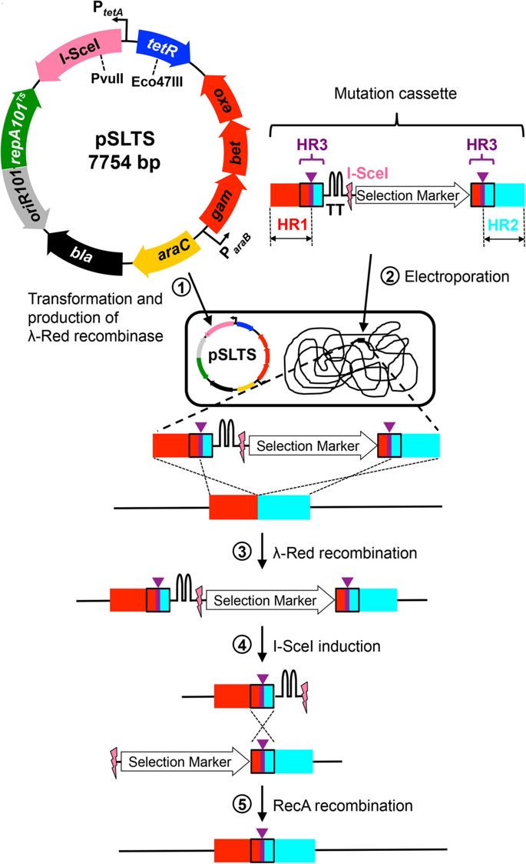
(1) Design primers to selectively amplify the HR1, HR2, and HR3 sites as shown in the diagram below.
HR1_F
HR2_F
HR2_R
HR1_R

You will need to design the following sets of primers:
- HR1 Forward (with homology to pUC19) and HR1 Reverse (with homology to Kan^{R} forward primer)
- HR2 Forward (with homology to Kan^{R} reverse primer) and HR2 Reverse (with homology to pUC19)
- Primers without the pUC19 overhang for PCR amplifying the entire cassette from your pUC19 in E. coli

HR1 and HR2 should be between 200 – 300 bp, and primers HR1_F and HR2_R should be designed accordingly to allow for the amplification of HR1 and HR3. It is recommended that you use Gibson Assembly to assemble the mutation cassette, therefore you will need to include 10-20 nt homology with the 5’ or 3’ sequences of the components that will flank your sequence (i.e. allow for ligation of the sequences). Use standard guidelines to amplify these regions and check that primers:
- Have a predicted AT between 60-65°C (NOTE: make sure you are using the reaction conditions for Q5 polymerase for this calculation [Olig Conc 0.5 µM, Na⁺ Conc 50 mM, Mg²⁺ Conc 2 mM, and dNTPs Conc 0.2 mM]
- Don’t form hairpins at temperatures above 40°C
- Don’t form self-dimers with Delta G: less than -10 kcal/mole
- Are specific (18-25 nt long; use Blast to ensure that they only bind at target sequence)

For primers HR1_R and HR2_F, you will need to incorporate regions of homology of the KanR cassette, to allow for amplification of the KanR cassette. For this, you will need to add the following sequences to the 5’ ends of your primers:

Primer | 5’ => 3’ Sequence
HR1_R | TCACTAACGACATTGGGTTC
HR2_F | CCTTTTGCTCACATGTTCTT

You will also need the following primers for amplification of the kanamycin cassette:
Primer | 5’ => 3’ Sequence
RM301_pT2SKcassettedown | CCTTTTGCTCACATGTTCTT
RM302_pT2SKcassetteup | GAACCCAATGTCGTTAGTGA

In total, this will require 4 primers to amplify the regions upstream and downstream of your desired mutation, and 2 primers (RM301 and RM302) to amplify the kanR cassette. You will also need 2 primers to check the integrity of the mutations made.

NOTE: If your gene of interest is in the reverse orientation (i.e. gene is anti-sense) you will need to switch the sequence of the primers added to the 5’ end of your HR1_R and HR2_F primers:

Primer | 5’ => 3’ Sequence
HR1_R | AAGAACATGTGAGCAAAAGG
HR2_F | TCACTAACGACATTGGGTTC

It is a good idea to check your constructs with the primers that you designed using the assembly tool from NEB: http://nebuilder.neb.com/#!/

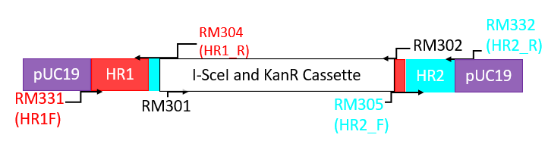
EXAMPLE: The following primers were designed and used to delete artB from Salmonella. Underlined portions of the primer represent sections of the primer that bind to target DNA (i.e. not flanking regions).

RM304_deltaArtB_HR1R | TCACTAACGACATTGGGTTCACCCAGCAACATTTAATTTGTCAACATAGGTAATTTCTTTTTCATAATCCACTCCA
RM305_deltaArtB_HR2F | AAGAACATGTGAGCAAAAGGGGATTATGAAAAAGAAATTACCTATGTTGACAAATTAAATGTTG
RM331_deltaartB_pUC19_HR1_F | ttgtaaaacgacggccagtgAGACAATAGTTTCTACAGCCTT
RM332_deltaartB_pUC19_HR2_R | atccccgggtaccgagctcgTGACAGTATCTGCGGCATT
RM303_deltaArtB_HR1F | AGACAATAGTTTCTACAGCCTT
RM306_deltaArtB_HR2R | TGACAGTATCTGCGGCATT

3.3 PCR Amplification of HR1-HR3, HR2-HR3, and KanR fragments.

Perform PCR amplification of HR1, HR2 and KanR fragments using a high-fidelity enzyme such as Q5 polymerase. Follow the manufacturer’s instructions for concentrations of each component. It is recommended that you perform one 50 µL reaction for amplifying each DNA target.

Below is the recommendation for Q5 polymerase:
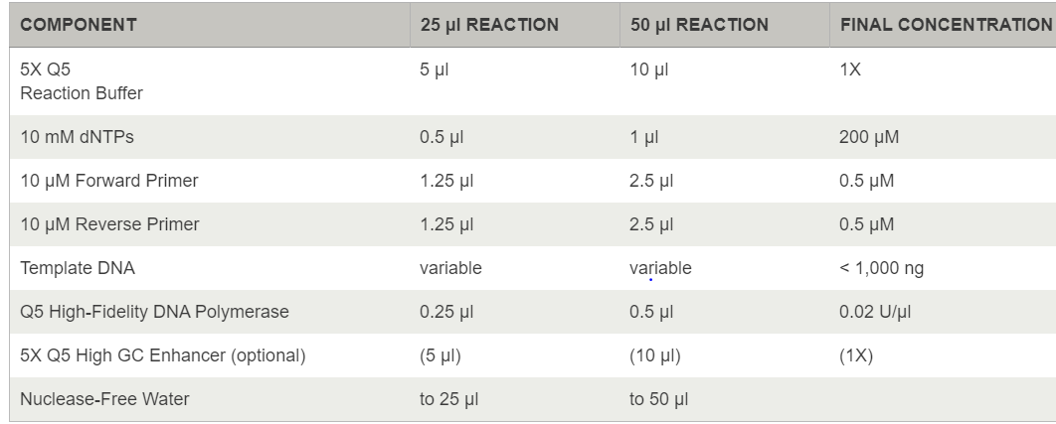

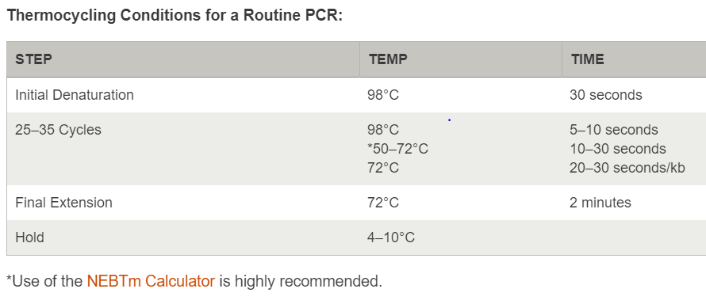

Following PCR amplification, electrophorese your PCR product on a 1.5% agarose gel and check for specific amplification of your intended PCR product. If a single product is amplified, use the ThermoFisher GeneJET PCR clean up kit to purify your PCR product and quantify with a Nanodrop.

  - Gibson Assembly of mutation cassette and transformation into NEB 5α

- Linearize pUC19 by digesting with a single restriction endonuclease. EcoRI-HF is a good option because it has a single restriction site within lacZ, to allow for blue-white screening. Below are the reaction conditions for digesting with EcoRI-HF, but other restriction enzymes may be used.

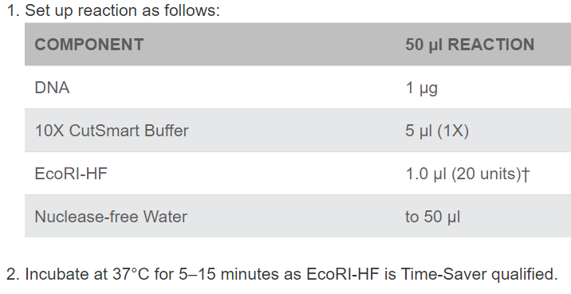
- Use the ThermoFisher GeneJET PCR clean up kit to purify digested pUC19 and use a nanodrop to quantify the amount of digested DNA.

- Perform Gibson Assembly using the following reaction composition:
Component | uL to Add
DNA Fragments | X uL of:  0.1 pmols each HR1 and HR2  0.3 pmols KanR
2X Gibson Assembly Master Mix | 10 uL
dI H₂O | 10 – X uL
Total | 20 uL

Use the following reaction parameters:
Incubate samples in a thermocycler at 50°C for 60 minutes. Reactions may be stored at -20°C if not using directly. Otherwise, use 2 uL of Gibson Assembly to transform NEB 5α cells chemically competent cells.

  - Transform Gibson Assemblies into NEB 5α
- Thaw a tube of NEB 5-alpha Competent E. coli cells on ice until the last ice crystals disappear. Transfer 25 uL of high efficiency cells to a clean microcentrifuge tube.
  - Warm LB-kan₅₀ agar plates to 37°C.
  - Turn on 42°C heat plate
  - Put SOC medium at room temperature
- Add 2 µl of Gibson assembly DNA to the cell mixture. Carefully flick the tube 4-5 times to mix cells and DNA. Do not vortex.
- Place the mixture on ice for 30 minutes. Do not mix.
- Heat shock at exactly 42°C for exactly 30 seconds. Do not mix.
- Place on ice for 5 minutes. Do not mix.
- Pipette 950 µl of room temperature SOC into the mixture.
- Place at 37°C for 60 minutes. Shake vigorously (250 rpm) or rotate.
- Mix the cells thoroughly by flicking the tube and inverting.
- Spread 100 µl of cells onto LB-kan₅₀ and incubate overnight at 37°C.

  - PCR amplify mutation cassettes from pUC19.
  - Using Q5 high-fidelity polymerase, PCR amplify your mutation cassettes with primers HR1_F and HR2_R. Note: you will use the version of these primers that does NOT contain the homology to pUC19.
  - Following PCR amplification, electrophorese your PCR product on a 1.5% agarose gel and check for specific amplification of your intended PCR product. If a single product is amplified, use the ThermoFisher GeneJET PCR clean up kit to purify your PCR product and quantify with a Nanodrop.
  - Perform a DpnI digest of your purified PCR product using the following reaction set up and thermocycling parameters:
Component | Amount
PCR product | 1 ug
10X CutSmart Buffer | 5 uL
DpnI | 1 uL
H20 | Up to 50 uL
Incubate at 37°C for 60 min, then at 80°C for 20 min to heat-inactivate the enzyme.

Use the ThermoFisher GeneJET PCR clean up kit to purify your PCR product and quantify with a Nanodrop. Store purified PCR product at -20°C.

3.7 Make competent Salmonella cells for transforming with pSLTS.
(1) Grow your Salmonella strain overnight in 5 mL of LB broth, incubated at 37°C (shaking or non-shaking).
(2) The next morning, sub-culture your strain 1:1000 into 5 mL fresh LB, and grow shaking at 37°C until the OD₆₀₀ reaches 0.4 – 0.6.
(3) Have on ice: sterile dH2O, sterile 10% glycerol in H₂O, cuvettes.
(4) Pellet an aliquot of ~1.9 mL of culture in a 2.0 mL Eppendorf tube by centrifuging at 10,000 rpm for 3 minutes at 4°C.
(5) Decant supernatant by pipetting medium off with a P1000 pipette.
(6) Resuspend the pellet with 1 mL of ice-cold H2O.
(7) Centrifuge the culture, again at 10,000 rpm for 3 min, and decant supernatant. Perform this wash step for an additional two times.
(8) Resuspend pelleted Salmonella in 150 µL of ice cold 10% glycerol in water.

3.8 Electroporate pSLTS into competent cells
(1) Have on ice: cuvettes, plasmid DNA and competent cells. Pipette 900 µL of SOC medium into sterile 1.5 mL Eppendorf tubes and let equilibrate to room temperature (1 per sample).
(2) Pipette 90 µL of cells to a new Eppendorf tube containing 0.1 - 1 µg plasmid (not to exceed 10 µL or 10% of total volume) DNA. Pipette up and down several times to mix, and then transfer the cells + plasmid to a pre-chilled cuvette. Hold on ice for 10 minutes.
(3) During the 10 min chilling period, plate a loopful of your cells (from the remaining 50 µL of cells that were not mixed with the plasmid) on LB-amp, to serve as a negative control.
(4) Electroporate cells using the following settings (note that this is the E. coli preset setting; from the home menu select “Option 4: Pre-set protocols” then “1: Bacterial” then “E. coli”):
Volts: 1800 V
Cap: 25
Res: 200
Distance: 1 mM
(5) Immediately transfer the SOC medium into the cuvette to resuspend the electroporated cells, and then transfer the suspension back to the same Eppendorf tube. Place in an Eppendorf tube rack.
(6) Shake cells in a rack taped horizontally into a 30°C incubator, shaking at 70 rpm for 2 hrs. Pre-warm antibiotic containing plates in a 30°C incubator.
(7) Spread 20, 50, and 100 µL of culture onto LB-Amp₁₀₀ agar plates and incubate plates at 30°C overnight. Retain the remaining ~800 µL of transformed cells at 4°C in case no transformants are obtained.
(8) Streak a putative transformed colony onto a fresh LB-Amp₁₀₀ agar plate and incubate at 30°C for 24 hrs.

3.6 Induce λ-Red recombination for transformation with mutation cassettes
(1) Inoculate 5 mL of LB-Amp₁₀₀ with a single colony of your Salmonella carrying pSLTS. Incubate overnight at 30°C. Pre-heat 30 mL of LB broth overnight at 30°C in a sterile flask.
(2) To pre-heated LB, add 30 µL of Ampicillin stock (100 mg/mL), and 300 µL of 20% Arabinose (final concentration of 0.02%), and a 1:100 dilution of your overnight culture. Grow shaking (170 – 200 rpm) at 30°C until the OD₆₀₀ reaches between 0.4 – 0.6.
(3) Perform washes as in Section 3.7 steps 3-8 above, except that you will centrifuge the total volume of the Salmonella culture (~30 mL) using the floor centrifuge. Centrifuge at 8,000 rpm for 5 minutes each time and resuspend cells in 10 mL of sterile ice-cold water. Resuspend washed cells in 100 µL of 10% glycerol in PBS.
(4) Keep cuvettes and PCR amplified cassettes on ice. Aliquot 900 µL of SOC in 1.5 mL Eppendorf tubes and hold at room temperature.
(5) Add 0.1 – 0.5 µg of each construct to a 1.5 mL Eppendorf tube and keep on ice. Pipette 70 µL of competent cells (one construct per competent cell aliquot) into each Eppendorf tube containing the DNA construct.
(6) Pipette up and down several times to mix, and then transfer the cells to a cuvette. Hold on ice for 10 min.
(7) During the 10 min chilling period, plate a loopful of your cells (from the remaining cells that were not mixed with the DNA construct) on LB-amp, to serve as a negative control.
(8) Electroporate cells using the following settings (note that this is the E. coli preset setting):
Volts: 1800 V
Cap: 25
Res: 200
Distance: 1 mM
(9) Immediately after the electroporation has finished, use a P1000 pipette to transfer the room temperature SOC media into the cassette to recover your electroporated cells. Transfer the SOC media back into the 1.5 mL Eppendorf tube and place in a microcentrifuge tube rack. Repeat for all constructs to be electroporated.
(10) Incubate cells at 30°C in a shaking incubator, shaking at 70 rpm for 2 hr.
(11) Collect cells by centrifuging 8000 rpm for 3 min. Remove ~900 uL of supernatant and discard. Resuspend pelleted cells in the final ~100 uL in the bottom of the microcentrifuge and transfer onto an LB kan₅₀ amp₁₀₀ plate. Incubate overnight at 30°C.

  - PCR screening to confirm successful integration of KanR cassette
- Patch partial colonies to a fresh LB kan₅₀ amp₅₀ agar plate with a sterile toothpick. Use the same toothpick to inoculate 100 uL of sterile water in a 0.2 mL PCR tube; this will be used as template for PCR screening colonies for KanR cassettes. Incubate agar plates at 30°C.
- PCR amplify KanR cassettes from patched colonies using a primer that binds 5’ of the KanR cassette as your forward primer, and RM324 (reverse) that binds within the KanR cassette. An example set-up is provided below, however multiple different polymerases and primer sets may be suitable.

Component | µL per rxn
2X GoTaq Green  Master Mix | 10 µL
H20 | 7 µL
Primer F | 1 µL
Primer R  (RM318) | 1 µL
Total Volume | 19 µL

- After aliquoting the mastermix into clean 0.2 mL PCR tubes, add 1 µL of lysate to each respective tube.
- Use the following thermocycling conditions:

Thermocycling:
94C - 2 min
94C - 30 sec |
60C* - 30 sec| X 30 cycles
72C** - 30 sec |
72C - 5 min
4C - hold
* the annealing temperature will depend on the specific primer set used; it is recommended that you calculate the recommended AT for your primer set and mastermix used
** the extension time will depend on the expected size of your PCR product. The reverse primer listed above binds ~150 bp internal to the 5’ end of the kanR cassette. If your upstream primer binds >500 bp upstream, increase the extension time to 45 sec.

- Electrophorese 3 µL of PCR product on a 1.5% gel at 120 V for 40 minutes. Use standard procedures to stain, de-stain, and visualize your electrophoresed gel. If the PCR products are the expected size, proceed to 3.8.

3.8 Induce SceI cleavage to remove KanR cassette
(1) After confirming successful integration of your cassette at your intended integration locus, streak your cells onto a fresh LB-Kan₅₀-Amp₁₀₀ agar plate to obtain isolated colonies, and grow overnight at 30°C.
(2) Streak one individual colony onto LB LB-Amp₁₀₀ plates containing 10 ng/mL anhydrotetracycline. Incubate plates at 30°C overnight.
(3) Screen colonies for loss of the mutation cassette by patching onto both LB-Amp₁₀₀ and LB-Kan₅₀ to screen for loss of kanamycin resistance. Incubate plates at 30°C overnight.
(4) For mutants that have growth on LB-Amp₁₀₀ but no visible growth on LB-Kan₅₀ plates, streak for isolation onto a fresh LB-Amp₁₀₀ agar plate.
(5) Perform PCR screening with primers upstream and downstream of your target to confirm loss of the mutation cassette (this can be done with your primers: HR1F and HR2R) as outlined in section 3.7, except with a new set of primers.
(6) For mutants that have lost the KanR cassette, purify the PCR product following the steps outlined in the SOP “ExoSAP” and submit the PCR product for Sanger Sequencing to check the sequence for the correct construct.

3.9 Loss of pSLTS plasmid.
(1) If no further genetic manipulations are to be performed using the scarless λ-Red method, streak your strain with the confirmed mutation onto LB without antibiotic. The plasmid is temperature sensitive, and can therefore be cured by incubating the strain at 42°C overnight.
(2) To check for successful loss of the plasmid, patch a colony onto a LB-Amp₁₀₀ plate to test for loss of pSLTS.
SECTION 4 TROUBLESHOOTING

Poor yield with Plasmid preps. This is more or less to be expected. These plasmids are low copy number. Use more broth and grow a larger culture (i.e. try 10 mL instead of 5 mL).

Poor recovery of Salmonella with kanamycin resistance gene: Recover cells with SOC (purchased from NEB) after electroporation. Warm media to room temperature (NOT 37°C).

Poor transformation yield after Sce-I induction
The original protocol used 100 ng/mL anhydrotetracycline. We have successfully used 10 ng/mL anhydrotetracycline to complete this step, with >50% of screened colonies containing the desired loss of the KanR cassette. If transformation efficiency is too low, the concentration of anhydrotetracycline may be increased to 100 ng/mL.

If successive mutations are desired: Be sure to PCR screen all previous mutations, and Sanger Sequence the amplicons. Previously, the author experienced off-target recombination, resulting in the complete loss of an entire islet that had been mutated previously using this method.

SECTION 5 REFERENCES

https://bmcbiotechnol.biomedcentral.com/track/pdf/10.1186/1472-6750-14-84

SECTION 6 METHOD VERSION & CHANGES

VERSION | DATE | EDITOR | COMMENTS
Version 1 | 01/28/2020 | Rachel Cheng | Original SOP
Version 2 | 04/24/2020 | Maureen Gunderson | Updated SOP to new standard lab template.

