SYBR Green qRT-PCR

FILE NAME: 8.8.13-SYBRGreenRT-qPCR.docx

TABLE OF CONTENTS

- INTRODUCTION 3
Purpose
Scope
Definitions
Safety

- MATERIALS 4

- PROCEDURE 5-7

- TROUBLESHOOTING 8

- REFERENCES 9

- METHOD REVIEWS & CHANGES 10

SECTION 1 INTRODUCTION

  - Purpose

The purpose of this protocol is to assay transcript levels using SYBR Green.

  - Scope

This SOP applies to the Food Safety Lab, including the Laboratory for Food Microbiology and Pathogenesis of Foodborne Diseases.

  - Definitions

  - Safety

SECTION 2 MATERIALS

- SYBR® Green PCR Master Mix (Applied Biosystems®) Catalog Number 4309155 (Size 1 x 5 mL)
- TaqMan® Reverse Transcription Reagents (InvitrogenTM) Catalog Number N8080234 (Size 200 reactions)
- MicroAmp® Optical 96-Well Reaction Plate (Applied Biosystems®) Catalog Number N8010560 (Size10 plates)
- MicroAmp® Optical Adhesive Film (Applied Biosystems®) Catalog Number4360954 Size25 covers.

SECTION 3 PROCEDURES

Step 1. Reverse Transcription (From TaqMan® Universal PCR Master Mix)
A 100-μL RT reaction efficiently converts a maximum of 2 μg total RNA to cDNA. Perform multiple RT reactions in multiple wells if you are using more than 2 μg total RNA. For a 10-μL RT reaction you can use up to 500ng of RNA in ≤ 3.85μl of water.
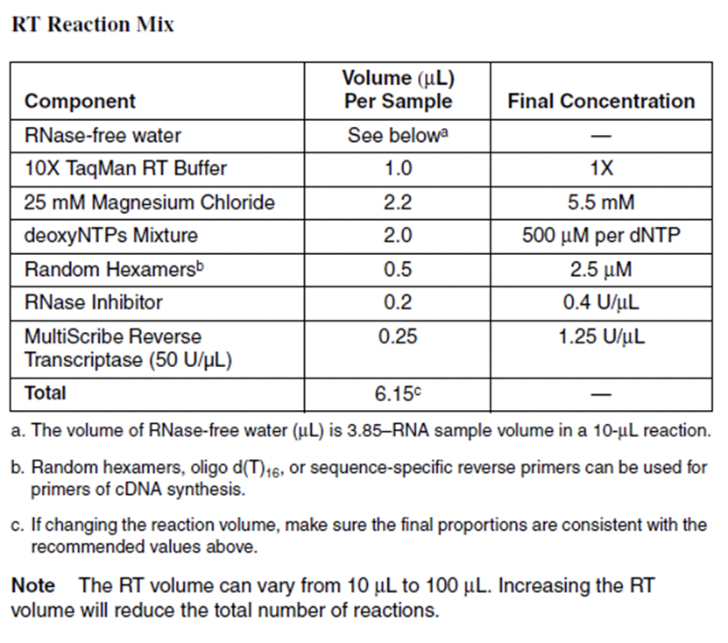
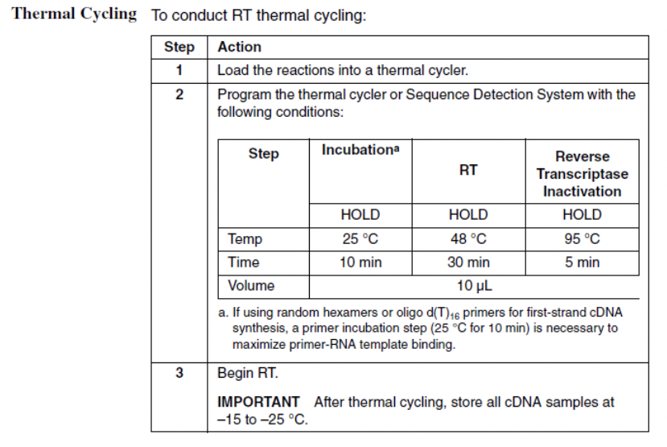
Step 2. qRT-PCR using SYBR Green.
- Dilute your cDNA 1/10 in water.
- Prepare master mix for each primer set. Final volume per well= 25 μl.
Reagent | Volume
2X SYBR Green Master Mix | 12.5 μL
Water | 10.5 μL
10 μM F primer | 0.5 μL
10 μM R primer | 0.5 μL
Tempalte (1-5 ng) | 1 μL

Step 3. Assay and Analysis.
- Load Optical 96 Well Reaction Plate
- Pipet 24 μL from master mix into appropriate well
- Pipet 1 μL each template into appropriate well
- Load 25 μL from leftover master mix tubes as no-template-controls (NTC). Load at least one NTC for each primer pair.
- Cover the plate with optical adhesive cover film. Handle only by the edges and do not touch the surface of the film.
-Spin the plate for 2 min. in the benchtop swing bucket centrifuge (1000 rpm for one minute).
-Run standard real time PCR in the QuantStudio 6 system.
SECTION 4 TROUBLESHOOTING

- Contamination is very common. Always make sure to use fresh water and make master mixes in the PCR room.
- Keep SYBR green on ice and make sure to protect it from light.

SECTION 5 REFERENCES

TaqMan Reverse Transcription: https://www.thermofisher.com/order/catalog/product/4304134#/4304134

SYBR Green: https://www.thermofisher.com/us/en/home/brands/product-brand/sybr.html

SECTION 6 METHOD VERSION & CHANGES

VERSION | DATE | EDITOR | COMMENTS
Version 1 | Unknown | Unknown | Original SOP
Version 2 | 05/11/2020 | ARC | Moved protocol into SOP template and added references and troubleshooting

