RDA training session - Creating RDA bibs, Sept. 15
Presentation by Tracy:
Open for use: RDA Toolkit; CUL Wiki RDA sessions (RDA Sessions at Cornell/Homework Surrogates)
Cheat sheet available for use in the RDA Toolkit under Tools/Workflows/Shared Workflows:
LC Staff: Simple Book (MARC)

Book title: I Feel So Good
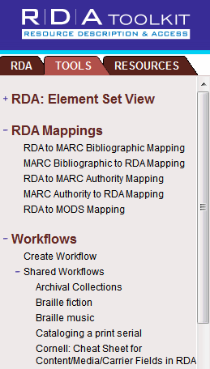
Steps to catalog using RDA Tab (a.k.a. eating your vegies):

Recording attributes of manifestation – Chapter 2
Section 1 of RDA, identifying manifestations
2.3.2 – Title proper
2.4.2 – Statement of responsibility
2.5 – Edition statement, this book does not have one
2.8 – Publication statement
2.8.2 – Place of publication; use the first given. You may use second if you like.
2.8.4 – Recording place of publication name, e.g. The University of Chicago Press – transcribe as found on piece. See 1.7 – Transcription
2.8.6.3 – Publication date
2.11 – Copyright date. Read 2.11, go to the LCPS; to get back to RDA, click on the RDA tab. Note: in 008 is “t” for “Publication date and copyright date” followed by the two dates respectively.
2.15 – Identifier for the manifestation, the isbn. Both alkaline paper and alk. paper are acceptable. The infinity symbol denotes alkaline paper
3.2 – Media type describes the carrier (physical thing). Tools tab/ Workflows/Shared Workflows/Cornell cheat sheet for content/media/carrier fields in RDA
3.4 – Extent and pagination – reminder, no period after cm unless followed by a series statement
Section 2 of RDA, work and content are referred to in chapters 6 and 7
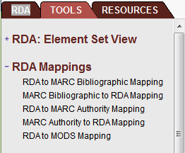
6.9 – Content type
7.15 – Illustration
7.16 – Bibliographic references
17, under section 5 – Work manifested, access point for the work
19, under section 6 – Recording relationships
19.2 – Creator, is it a 1XX? Go to Tools tab/RDA Mappings/RDA to MARC Bibliographic Mapping
20, under section 6 – Contributors adding content. Qualifier: Can their added content be taken away and it is still the same book?
18.5 – Relationship designator (‡e). See Appendix I
I.2 for creator
I.3 for contributors, ie. ‡e writer of commentary
Relationship designators are optional but recommended, particularly for the author and all must come from the list in Appendix I unless there is none considered appropriate, then “use a term indicating the nature of the relationship as concisely as possible.” (RDA Toolkit)

Presentation by Jean:
Book title: Law in Many Societies
Type of publication: collaboration vs. compilation? (remember Sarah’s illustrations)  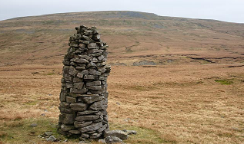
008 – Publication status now “t”
040 – ‡e rda, sometimes seen capitalized and can be anywhere in the string
CIP – We now sometimes see these in RDA with “pages” and “editors” spelled out
300 – Publication date is a CORE element. For this book Jean went to the Stanford University Press website and confirmed the date of publication in order to avoid not having the publication date, in which case you could say “[date of publication not identified]” although you could say “[2011?]”.
33X’s – CORE elements, although you will sometimes see their order reversed and this is allowed.
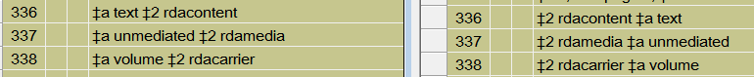
504 – CORE for mongraphs, RDA 7.16
505 – Contents notes. Applicable also for chapters of related works because it is a compilation.
25.1
25.1.1.3 – Structure description of a related work, LCPS states, unless it becomes burdensome.
7XX – Editors are contributors to an expression, not creators
Appendix I – editor, but for this book, ‡e editor of compilation
Names with open ended dates, you don’t need a comma before the designator
Names without dates, you do have a comma before the designator.
Authority work – check Friedman’s name in the authority record and notice the 700 field in the authority record which was created during the test period. Will the AACR2 and RDA flip some day?

Presentation by Jean:
Book title: The Reeducation Trials in Communist Romania (1952-1960)
Type of publication: translation – type of expression

6.11, under section 2 – Language of expression
6.2.2.4 – works created after 1500

What about the added parentheses around dates in the title? The 245 is a transcription field.

17.3, under section 5 – the 245 reflects the work manifested
260 field – the place of publication is not found in the item. Jean went to the publisher’s web page to find it. [Boulder] Include both the local and larger jurisdictions if present. The distributor is not required unless the publisher is missing.
264 field is upcoming.
490 field – has Roman numerals, but the authority has Arabic so they are used in the 830.
700 field – translator; see 20.2 and its LCPS
Presentation by Tracy:
Videodiscs title: Frank Sinatra concert collection
Type of publication: sound and video
Videos will follow AACR2 rules for now until RDA rules are more firmly established. The information in the 538 for RDA has not been established. There is no clear guidance in RDA to MARC mappings.
Compare “Requiem for Detroit”
Video is completely in flux.

9/19/2011

