Water Pump Team Reflection Report

Authors: Michael Liu, Patrick Farnham, Weiling Xu, Dominick Amador

AguaClara Reflection Report
Cornell University
School of Civil & Environmental Engineering
Ithaca, NY 14853-3501

Date Submitted: 05/14/11

Abstract
The purpose of the water pump team’s research is to design a manual water pumping system that can be used by an operator to lift water two to three meters from the settled water channel to the chemical stock tanks while striking an optimal balance between cost and efficiency. We have done research on several types of water pumps and narrowed our options down to foot- and arm-operated piston and diaphragm pumps. In making this decision, mechanical feasibilities, simplicity of repair, access to materials in resource-poor communities, and possible failure modes are considered. At this point we have calculated both the discharge rate head loss of several pump designs using MathCAD. With the current design specifications we have come to the conclusion that a diaphragm pump is the most ideal pumping system available for the specified job.

Experimental and Pump Designs
In order to determine the optimal design for transporting water two to three meters in elevation, our first step was to identify the following constraints for an AguaClara pump designed to fill the chemical stock tanks:
-Head change – 2 or 3 meters
-Self-priming
-Human powered (ergonomic)
-Easily constructed, maintained, and repaired in Honduras
-Process easily understood and performed
-Target flow rate of no less than 0.63 L/s to fill a standard 208 liter drum in approximately five minutes
We evaluated a variety of systems, but found that certain restrictions prevented these designs from being a part of AguaClara. The vane pump, which has a mounted rotor made of vanes inside its cavity, which rotates to create centripetal force and thus displace fluid in the pump from the inlet toward the outlet, is an example that we looked at extensively. We concluded that we could not use the vane pump because of difficulties involved in price, construction, and repair.
In order to maintain the AguaClara design philosophy of being able to operate without electricity, have few moving parts, and be able to be fabricated on site with readily available materials, we have concluded that due to these restrictions the optimal systems that would best serve our needs are the lever-powered piston pump, the treadle pump, or the diaphragm, pump each of which will be described later in this section. We used MathCAD modeling and then conducted experiments with constructed prototypes of each pump to narrow down our options.
We developed a system of equations to model pumps and ensure that we attain the desired flow rate. The variables of the system we focus on in this case are as follows, each of which is displayed in Figure 1:
-Pump Chamber Diameter
-Outflow Pipe Diameter
-Piston material and configuration (or membrane material)
-Piston range of motion
-Cycle Rate

Figure 1: Figure showing different variables in a pumping system
In order to develop relationships between these variables, we are using MathCAD to relate human-generated power and forces to required power and pressures. Here is the solution process that we are going through to create our pump design:
1. Given the human operator power of 75 W (as given by the Food and Agricultural Organization of the United Nations), we calculate for pump discharge with Equation 1:
(1)

2. We took head loss, calculated in Equation 5 below to be 0.149 meters, into account by adding it to our ∆z and multiplied our applied pressure by 0.5 in order to account for a 50 percent pump efficiency. Ultimately we calculated our pump discharge to be 1.78 L/s.

3. With the flow rate calculated, we used the head loss functions from the MathCAD Fluids Function reference and calculate for the head loss throughout the whole pumping system.
4. Using Fluids Functions we solved for nominal pipe size given Q, pipe length, minor loss coefficient and maximum reasonable head loss.
5. As can be seen in equation 2, stroke length and chamber area are directly related to the flow rate and cadence at which the system is being operated. With this flow rate and cadence being held constant we acknowledge that it would be most confortable for the operator to have a small as stroke length as possible. This requires the area of the chamber to be larger in order to facilitate this. Subsequently, the cost of the chamber also quickly rises as its diameter increases. Thus, considering our monetary constraints we chose to run our calculations with an assumed six inch piston diameter.
(2)
We created a graph comparing the force that the operator must apply to the lever to move the piston with the length of the lever using Equation 3. From here we could pick a comfortable length for the pump to be operated with:

$$F_{operator}=\frac{P_{operator}}{L_{lever}*C_{cadence}}$$
(3)

The following are rough sketches of pump systems we have worked on:

Lever Piston Pump

In the lever piston pump design the operator pulls the lever down, which in turn lifts the piston up (Figure 6). This creates a pressure difference, bringing water into the PVC pipe from the inlet pipe. When the operator pushes the lever back up, the water is pushed through the outlet pipe.

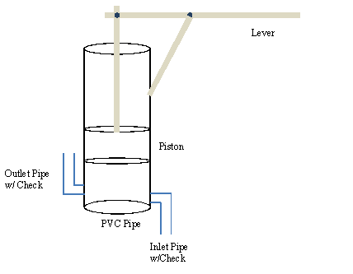

Figure 2: Lever Piston Pump Working Principle

Treadle Pump Design

In this treadle pump design (Figure 3) the operator steps on the levers, pushing the piston up and down. The concept is similar to the lever pump design, but is foot-operated.

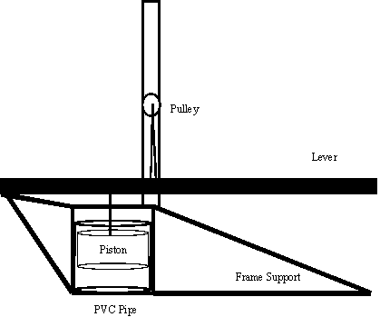

Figure 3: Treadle Pump Design
Diaphragm Pump
The diaphragm pump is designed similarly to the lever-operated piston pump, with the exception that the piston is replaced with a diaphragm membrane (Figure 4). Pressure difference is created not by a moving piston but by the flexible membrane. Note that, due to pressure, the diaphragm will deform differently than how it is drawn in the diagram.

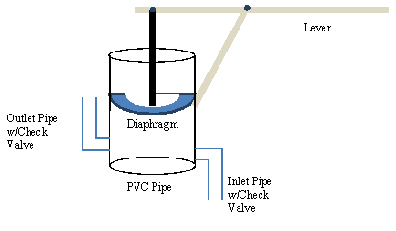

Figure 4: Diaphragm Pump Design

Pumps Currently Available
The goal of the water pump team’s research was to either find a readily available system currently on the market or design and fabricate a human-powered water pump that is capable of lifting water two to three meters using as little effort from the operator as possible.
There are two manual pumps available in Honduras. Both are detailed in a document issued by the Water and Sanitation Program (WSP 2004).
The first, the EMAS-flexi Hand Pump, consists of a small sliding PVC piston assembly that can achieve a discharge rate of 0.17 liters per second (WSP, Figure 1).

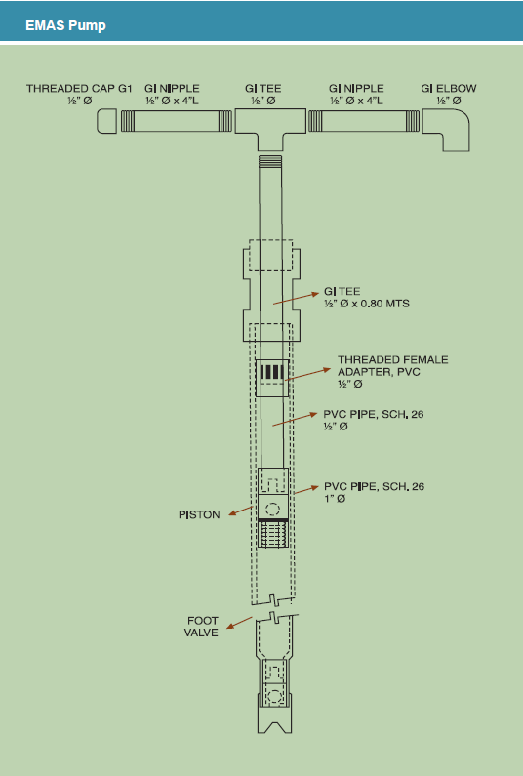

Figure 5: EMAS-flexi Hand Pump
This relatively low flow rate would likely be prohibitive, requiring a continuous operation time of over 20 minutes to fill a 208 liter AguaClara stock tank. Some positive attributes of the EMAS pump include its low price (Honduran materials would average 10 USD), its ability to overcome more than ten meters of elevation head, and the infrequent replacement required (it is designed to have a four to nine year operational life).
Another pump available in Honduras is a rope pump (Figure 6).

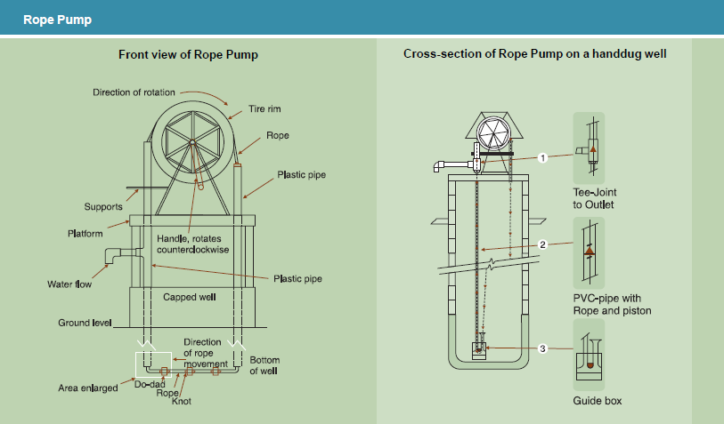Figure 6: Traditional Rope Pump

This pump is cited to have a cost of over 100 USD, plus annual maintenance and repair costs (WSP). The rope pump works by capturing packets of water between knots in the rope, much like a modern peristaltic pumps, and lifts the water vertically inside of the return pipe with a diameter equal to the rope's knots. It is cited as having a potential discharge rate of 42 L/s when operating at 10 meters of elevational head. Though this pump's flow rate is high relative to the EMAS model, the problem of space constraints renders this pump too clumsy for use in a typical AguaClara plant. Additionally, we believe it would be very difficult to ensure that the knots needed to move the packets of water would be able to be made such that there would not be huge losses of efficiency generated due to leakage. Although these two options would work to a certain degree, we feel that we can produce a better pumping system than either of these options.
Two designs in particular that appealed to our team from the beginning of our research are the lever- and pedal-operated PVC piston pumps.
When pedal-operated, the piston pump design is referred to as a “treadle pump” (Figure 7 and Figure 8). All design pictures and parameter citations for this pump have been taken from a synthesis report compiled by the International Programme for Technology and Research in Irrigation and Drainage (IPTRID 2000).

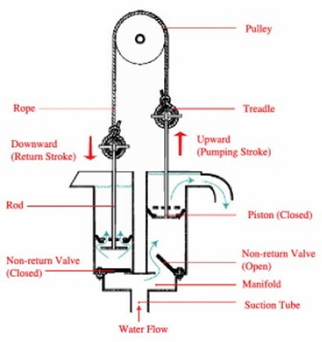

Figure 7: Treadle Pump Operating Principles

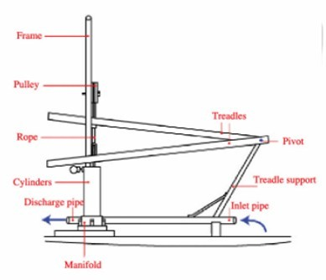

Figure 8: The Basis Components of a Treadle Pump
Treadle pumps built in this style for similar rural applications have been shown to achieve discharge rates of 1.5 liters per second for two meters of head, which far exceeds that of the EMAS pump.
Commercially-available treadle pumps, such as the KickStart Super Moneymaker, are already used in more than 20 African nations for irrigation purposes, but were difficult to research due to the company’s reluctance to ship to the United States (KickStart 2009). We have contacted KickStart regarding possible help with our water pump challenge, but as yet have received no response after more than a month of waiting. Our attempts to contact Cornell alumnus Martin Fisher, who founded KickStart, have been similarly unsuccessful.
We also investigated a standard hand-operated diaphragm pump purchased from McMaster-Carr called "The Guzzler" (Figure 9), part number K332K33, at a price of $61.70. Our primary reason for the purchase of this pump was to take it apart and study how the diaphragm mechanism works. The pump seems to perform well for its function, but after testing we found the discharge rate of 0.25 liters/ second was not high enough. It would also have to be imported from the United States if used in Honduras, which may pose a problem with obtaining and regularly maintaining it.
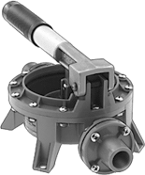

Figure 9: Picture of "The Guzzler", a hand-operated diaphragm pump

Materials
In choosing the materials for our pump, ease of access in Honduras, robustness, and durability of the system were our main concerns. For the frame support and lever systems, the material options included steel, wood and aluminum. Considering the fact that a strong support will be needed for both the lever piston pump and treadle pump such that the variability of the angle between the lever and piston is minimized between each stroke, and taking price into account, we think steel will be the best choice.
For pipe and chamber materials, due to economic concerns (PVC is cheaper than steel pipe) we think PVC will be the best choice by far. This is because PVC does not rust and is readily available, even though it has a higher coefficient of friction than steel piping. Angle iron is placed alongside the PVC pipe in order for steel pipes to be welded on to create a support frame for the lever. Thus, we have decided to use a mixture of PVC pipe, steel, and angle iron for the construction of both the lever piston pump and treadle pump. In our initial designs, the pump casing will primarily be made of PVC pipe, the frame support will be made of angle iron, and lever systems will be made of steel. We purchased some other miscellaneous materials such as a piston rod, pulley, PVC plastic sheeting, concrete, and rope as needed to complete our prototype.

In order to achieve ease of manufacturability in Honduras, constraints limit the membrane material to only a few options in the diaphragm pump. The difficulty of finding a working membrane is that in order to attain the best results the membrane has to have a good degree of elasticity and the ability to maintain a pressure differential equivalent to two to three meters of head. Our initial choice for the membrane, due to its availability, was an inner tube from a motor vehicle’s tire. We could also use the materials from swimming or rafting tubes. This ended up being more difficult to find and utilize than we expected, so we tried a few different options that more readily available.
Inspired by the materials used for commercial diaphragm pumps, we found that butyl rubber has been used in many applications requiring an airtight environment. It is used for the bladders in basketballs, footballs, soccer balls and other inflatable balls. Subsequently we have hypothesized that using a soccer ball or basketball by taking the bladder of the ball and sealing it on the top of the pump would allow us access to a membrane that would serve our purposes in the diaphragm pump. This could be the basis for further research that could make our pump more accessible in Honduras.
Santoprene, another potential membrane material, is used in commercial pumps for potable water. Santoprene is a mixture of rubber and polypropylene and has similar elasticity and flexibility to rubber, which fulfills the requirements for our diaphragm pump. More importantly, it is uniformly created for purposes similar to ours and is not expensive. Thus we decided to use Santoprene as the membrane for testing instead of looking for a soccer ball bladder. We purchased a few pieces of varying thickness from McMaster-Carr, and it appeared to be a suitable material for our diaphragm pump until the folds in the sheet lead to a small hole during initial testing.
Silicone is another possible material for the diaphragm membrane and can be purchased through McMaster-Carr if needed.
We have tested for the durability and feasibility of our current materials. We checked the availability of materials, especially supply of our membrane material, in Honduras. At the same time, we checked out the feasibility of other plastic materials, such as heavy duty plastic bags, and looked for the materials that have the desired concave shape that can be fitted into the pipe without folding over the membrane.

Experimental Apparatus

In order to test our calculations and designs, we used a 283 liter container to act as both our initial and final reservoir (Figure 11). With this system in use we will be able to test flow rates at multiple heads by simply altering the level of water in the reservoir. Other than the water’s initial and final locations, the system we are constructing will be identical to the pump system we hope to implement in future AguaClara plants; as such, both the pumps and piping are to scale.
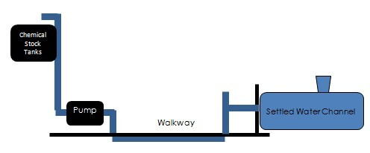

Figure 10: Schematic showing pump in relation to an AguaClara settled water channel

In our experimental apparatus (Figure 11) water is pumped up 1.9 meters in height to simulate the hydraulic head against which the pump will be operating in the water plants. The water is then dumped back into the reservoir, keeping the head in the reservoir constant. We keep the head loss caused from the water flowing from the reservoir to the pump low by using large diameter piping. With our 2.5 inch piping we have a total head loss of 0.149 meters.

Tank Support

Check Valves

208 L Tank (open top)

2.5” Return Pipe

6” Pump Chamber

Santoprene membrane

Pipe Clamps

Water

Figure 11: Schematic showing the pump system design for experiment

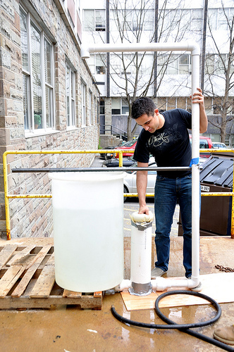

Figure 12: Picture of Water Pump Team Member Dominick Amador with Pump Apparatus.

P

reliminary Design Results

Using the pump equation (Equation 1) we have calculated our pump discharge as a function of operator power input and effective head (including losses).

We calculated the varying head losses based on different system pipe sizes using the head loss equations from the Fluids Functions MathCAD file (Equation 5) in conjunction with tabulated minor head loss values for pipe system components. We estimated a total minor loss factor for each pipe size by summing these individual losses, and then added the calculated major losses for each pipe size as well.
Table 1. Minor Loss K ValueChart *
Nominal Pipe | Elbow |  | Check Valve
Diameter (in) | K-Value |  | K-Value
0.75 | 0.53 |  | 4.00
1.00 | 0.50 |  | 2.90
1.50 | 0.45 |  | 2.50
2.00 | 0.39 |  | 2.10
2.50 | 0.36 |  | 2.05
3.00 | 0.35 |  | 2.00
Table 2. Head Loss K Values Independent of Pipe Diameter *
-- for all d<<D
Sudden Expansion |  | 1.00
sudden Contraction |  | 0.40
Table 3. Pipe Roughness Coefficient(mm) *
Polyvinyl Chloride |  |  |  | 0.010
Smooth Mild Steel |  |  |  | 0.012
Stainless Steel |  |  |  | 0.015
* Obtained from Frank M. White's Fluid Mechanics, 6th Edition

(5)

With the resulting total head loss of 0.149 meters, our head loss coefficients given above, and other constant values related to water we were able to use an iterative function (Equation 6) found within the MathCAD Fluids Functions to find an optimal pipe size.
(6)

With a flow rate of 1.78 L/s and a head loss of 0.149 m, we decided on 2.5 inch pipe as a good balance between minimization of losses and materials costs, because the calculated head loss of 0.149 meters represents a loss of only about 6% of the elevation head. If AguaClara plants are unable to attain this size of pipe, we recommend that they attempt to build the system using 2 inch pipe, though this would raise the total head loss in the system to 0.52 meters.

Our next step was to get a rough estimate of how large our pump chamber was going to be in relation to stroke length. To do this we estimated the stroke length of the piston with Equation 7:
(7)
In order to use this relationship, we had to come up with a reasonable cadence for our operator to work at. After much discussion amongst the team we agreed that a comfortable pace for a person to work with his legs is no faster than 30 revolutions per minute; in almost all circumstances people prefer a slower cadence if it produces the same amount of work. We tested this by having teammates walk up flights of stairs at a leisurely rate and timing the process. Because of this, we would like to increase the size of the piston such that the operator can work at the more comfortable pace. The downside to this approach is material cost. The price of PVC greatly increases in with diameter. We are aiming to use six inch diameter PVC and a stroke length of 19.6 cm, because this gives a comfortable cadence rate of 30 rpm. This PVC pipe size is also a good choice because the stroke length we calculated, 19.6 cm, is close to a human leg's stroke length.
Our last task was to calculate the lever lengths of the lever-operated piston pump and the treadle pump. Here we used a moment balance around a pivot point for both pumps to create a graph between the forces that the operator must apply to the lever arm (Figure 13 & Figure 14).

Figure 13: Graph of Piston Size vs. Stroke Length

Figure 13 and 14 compare the distance between the pump and the operator when he stands on the treadle and the force needed to be applied to push the piston. Since the distance from the pivot to the pump is one meter, the distance the operator stands from the pump is actually from 0 m to 0.3 m.

Figure 14: Graph of the force required to operate the pump as a function of lever length.

Figure 15: Graph of the force required to operate the pump as a function of lever length.

(lever length from 1m to 1.3m)

One key part of determining pump efficiency is the leakage of water around the piston. Using the piston system we have planned for this project, we assume that the primary cause of this will be roughness of the PVC pipe’s inner wall. In order to approximate this loss we measured a few six inch pipes to determine the greatest diameter differential. In this case the largest difference was 0.406 mm; with this being taken into consideration, the loss of water around our piston is 0.783 liters per second seen in Equation 7.
(7)
Although this is a very conservative estimate, since this would assume that there is a constant gap around the entire circle and not just at its greatest point, by using this value we have a significant amount of water loss that can account for a nearly 40% loss in efficiency. We are currently looking into testing different types of seals, with a leather seal looking the most favorable.

Results
We have tested the diaphragm pump with different membrane materials, including various thicknesses of Santoprene, garbage bags, and bread bags. Unfortunately, garbage bags and bread bags are not able to handle the pressure from the water reservoir and ruptured almost immediately as the pump was primed. The 0.79 mm Santoprene worked for the majority of the testing phase, although it did end up rupturing after most of our testing was conducted.
Below is a table indicating the discharge rates of each membrane material that we tested:

Table 4 - Table indicating measured discharge rates with different membrane materials
Membrane Material | Discharge Rate (L/s)
Santoprene (.79 mm) | 0.63
Santoprene (1.6 mm) | 0.88
These results are very promising, as the 1.6 mm Santoprene did not rupture and produced a discharge rate of 0.88 L/s (14 gpm). This would fill a 100 gallon tank in less than ten minutes.
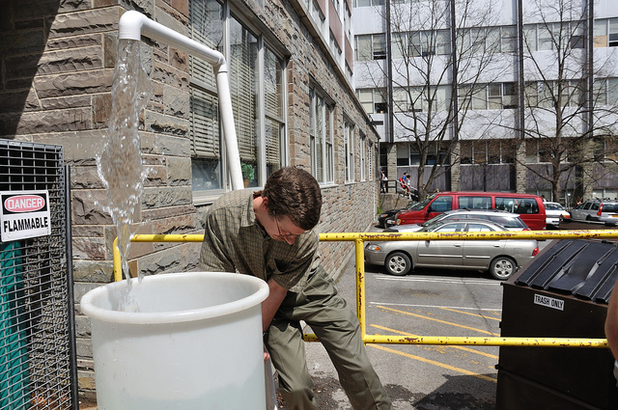

Figure 16: Team Leader Monroe Weber-Shirk testing Diaphragm Pump

We also tested our piston pump, with poor results. The piston pump failed to operate without a proper seal. When testing began, we immediately noticed that the small gap between the piston's outer edge and the wall's inner surface was generating too much leakage. Thus we were not able to pump across the required two meters of height. While all other mechanisms seem to be functional, the pump itself will not function without a proper seal. Future teams may look further into developing a seal for our piston pump.
We have finished construction of the frame of our treadle pump; because our piston pump has failed to work without a seal, we are fairly confident that our treadle pump will not operate correctly either. However, since our diaphragm pump is operating well, we are looking into ways of converting our treadle pump frame to work with diaphragm pumps.
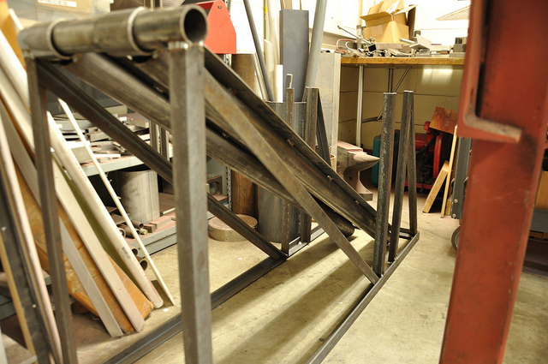

Figure 17: Picture of Treadle Pump Frame- this frame may be adapted for use with the diaphragm pump

Future Work
With this semester drawing to a close we would like to offer advice for any future students who desire to continue on with our efforts to create an ideal water pump for the AguaClara program.
Detailed Task List:
- With the end goal to improve our current system we would first recommend that a good deal of research go into finding a more ideal membrane material. The material needs to be able to meet the following qualifications:
  - The material needs to be robust enough to withstand constant use without fracturing or leaking.
  - The material needs to be able to be able to withstand several meters of head without deforming or ripping.
  - The material should be cylindrically shaped such that there can be a decent stroke length without there being too much overlap when attaching the material to the outside of the pump casing.

4” diameter PVC

Pipe clamps

Santoprene sleeve

6” diameter PVC chamber

Plunger rod

Figure 18: Diagram of plunger-based diaphragm pump
- Once a good membrane is found, we would recommend that there be efforts made to fit the membrane system to a treadle pump, as a treadle pump has the potential for much greater flow rate with less stress on the operator.
- Test to see if the additional cost and size requirements of the treadle pump are worth the additional flow rate generated and come to a conclusion on which design to use, the lever diaphragm pump or the treadle pump.

- Look at the plant layout and come to a conclusion on the pump's positioning and how it will be implemented in the plant overall.

Team Reflections
The past semester has been marked by alternating periods of excitement and frustration. In the early stages of brainstorming for the basic pump type, we cycled through numerous designs before settling on a choice between a hand- or foot-operated piston pump and a diaphragm pump. At a superficial level, piston and diaphragm pumps seemed like foolproof designs, as they are mostly free of moving parts and easily operated.

However, further analysis proved frustrating. Our team contains a mixture of students who have not taken fluid mechanics and students who took fluid mechanics over a year prior to this semester, so our grasp on fundamental equations is tenuous at best. Modeling the flow through each pump design is dependent on knowledge covering several areas of fluid mechanics and has been undertaken using class notes from CEE 4540 and a fluid mechanics textbook. However, after several methods and attempts, we were able to model the basic aspects of our pump and calculate certain dimensions for all of our pump types.

Another source of early concern was the potential pricing of materials; advertised prices in the McMaster-Carr catalogue seemed prohibitive to the construction of our pump due to their desired material pricing when it came to both steel and PVC pipe. However, we were able to circumvent this issue by purchasing our steel supply from Ben Weitsman & Son Inc., which was able to provide us with all of our steel at nearly 20 percent of what we had previously planned. After the pump analysis and design, our concern for pricing was significantly relieved when we were told that our budget for materials was larger than what we had previously thought.

Purchasing the materials was slightly hectic because we needed to be sure of all of the materials we were purchasing. However, the experience was generally positive as the materials were shipped to Hollister Hall relatively quickly and construction started immediately afterwards.

The early construction phase was very exciting for our team in many respects. It seemed as if the team had a lot more fun working in the shop rather than working in the computer labs, struggling with the analysis. We made efficient progress in our prototype design, aided by Dominick's expertise with welding and the rest of the team willing to pick up on new shop techniques in order to move forward quickly.
The initial prototype of the piston pump, the first of our designs completed, failed during initial testing; this was due to the extensive leak between the piston and the inner wall of the cylinder. We were unable to achieve a flow rate at all, and concluded that the problem of a consistently robust piston seal would be prohibitively difficult to overcome.
After this setback, we converted the piston prototype into a working model of our diaphragm design, using the 0.79 mm Santoprene material as our diaphragm. We operated the pump using our hands directly on the membrane, instead of a lever, and achieved a flow rate of 0.88 L/s. Though we continued our development of the treadle piston design, this breakthrough seemed to indicate that the diaphragm pump was a more realistic option, whether it is operated by a piston, treadle, or other operating device.
Further testing led to a small hole in the diaphragm, so we replaced it with a 1.6 mm Santoprene sheet that we had on hand. We must next overcome the problem of making the diaphragm air- and watertight, which we are currently attempting to do by finding a more form-fitting membrane, such as an inner tube or custom Santoprene sheet. Once stress on the material due to folding is reduced, we think that we will have a suitably robust membrane.
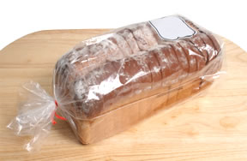

Figure 18-Form fitting membranes similar to a bread bag are optimal for the diaphragm pump.

Bibliography

International Programme for Technology and Research in Irrigation and Drainage. “Treadle pumps for irrigation in Africa”. Fao.org. 2000. February 16th, 2011. <ftp://ftp.fao.org/docrep/fao/005/x8293e/X8293E01.pdf>

KickStart. “MoneyMaker Irrigation Pumps”. Kickstart.com. 2009. March 17th, 2011. <http://www.kickstart.org/news/KickStart_B2B_BrochureJan09.pdf>

Water and Sanitation Program. “Low cost pump alternative for rural communities in Honduras”. RWSN.ch. 2004. February 16th, 2011. <http://www.rwsn.ch/documentation/skatdocumentation.2005-11-15.3234222147/file>

