Water Pump Team Reflection Report

Authors: Michael Liu, Patrick Farnham, Weiling Xu, Dominick Amador

AguaClara Reflection Report
Cornell University
School of Civil & Environmental Engineering
Ithaca, NY 14853-3501

Date Submitted: 04/27/11

Abstract
The purpose of the water pump team’s research is to design a manual water pumping system that can be used by an operator to lift water two to three meters from the settled water channel to the chemical stock tanks while striking an optimal balance between cost and efficiency. We have done research on several types of water pumps and narrowed our options down to foot- and arm-operated piston pumps and diaphragm pumps. Mechanical feasibilities, simplicity of repair, ease of access to base materials in Honduras, and possible failure modes are considered. In the future, we will analyze the discharge rate of the pump and head loss using MathCAD. If the conclusion is made that our pump does not significantly outperform or cost less than commercially available designs, we will select the most viable pump on the market.

Introduction
The goal of the water pump team’s research is to either find or design and fabricate a human-powered water pump that is capable of lifting water two to three meters using as little effort from the operator as possible.
There are two manual pumps available in Honduras. Both are detailed in a document issued by the Water and Sanitation Program (WSP 2004).
The first, the EMAS-flexi Hand Pump, consists of a small sliding PVC piston assembly that can achieve a discharge rate of 10 liters per minute (WSP, Figure 1).

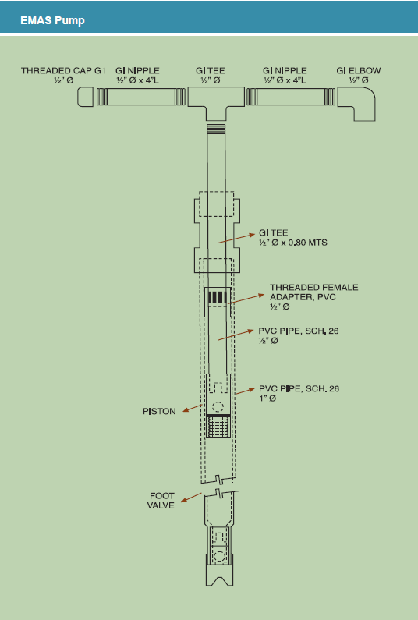

Figure 1. EMAS-flexi Hand Pump
This relatively low flow rate would likely be prohibitive, requiring a continuous operation time of over 20 minutes to fill a 55-gallon AguaClara stock tank. Some positive attributes of the EMAS pump include its low price (Honduran materials would average 10 USD), ability to overcome more than ten meters of elevation head, and infrequent replacement required (it is designed to have a 4- to 9-year operational life).
The other pump in consideration is the traditional rope pump (Figure 2).

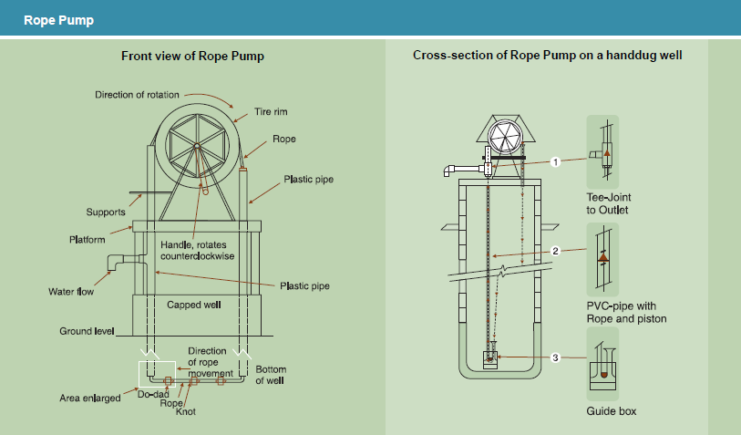Figure 2. Traditional Rope Pump

This pump is cited to have a cost of over 100 USD, plus annual maintenance and repair costs (WSP). Though consistently higher flow rates could likely be achieved with this pump relative to the EMAS model, the problem of space constraints renders this pump too clumsy for use in a typical AguaClara plant.
Other pump designs do exist, however, and we are considering numerous variations as possibilities for AguaClara. Two designs in particular that have appealed to our team from the beginning of our research are the lever- and pedal-operated PVC piston pumps.
When pedal-operated, the piston pump design is referred to as a “treadle pump” (Figure 3 and Figure 4). All design pictures and parameter citations for this pump have been taken from a synthesis report compiled by the International Programme for Technology and Research in Irrigation and Drainage (IPTRID 2000).

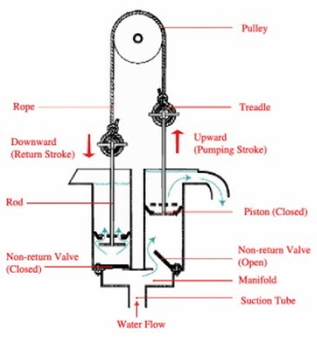 Figure 3. Treadle Pump Operating Principles

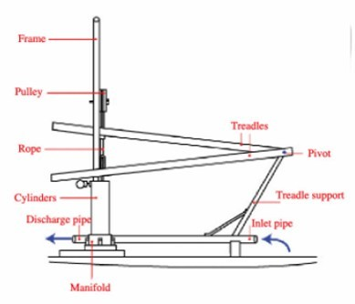

Figure 4. The Basis Components of a Treadle Pump
Treadle pumps built in this style for similar rural applications have been shown to achieve discharge rates of 1.5 liters per second for two meters of head, which far exceeds that of the EMAS pump. At 50% efficiency, this discharge rate would only require about 60 W of power, which is feasible.
Commercially-available treadle pumps, such as the KickStart Super Moneymaker pressure irrigation pump, are already used in more than 20 African nations for irrigation purposes, but have been difficult to research due to the company’s reluctance to ship to the United States (KickStart 2009). We have contacted KickStart regarding possible help with our water pump challenge, but as yet have received no response after more than a month of waiting. Our attempts to contact the Cornell alum who founded KickStart have been similarly unsuccessful.
We have also investigated a standard hand operated diaphragm pump purchased from McMaster-Carr. This could be another alternative to the selection of purchasable pumps. The pump seems to perform well for its function but we believe that its discharge is not high enough. It would also have to be imported from the United States if implemented in Honduras. The primary purpose for the purchase of this pump was to take the diaphragm pump apart to study how the mechanism works.
We are unable to find existing information on lever-operated PVC piston pumps, but are confident that the basic design of a treadle pump could be easily modified to include a simple pivoting lever or possibly a rotary assembly consisting of a gear shaft operated by manually turning a handle, which would be a bit more difficult.

Experimental Design

In order to determine the optimal pump design for transporting water two to three meters in elevation, it was first necessary to develop the general style of delivery. When first approaching this idea we had several specific points on which we wanted to focus to create the ideal pump for the job. For this particular project, we decided to focus on the following constraints while optimizing outflow:
- Head change – 2 or 3 meters
- Self-Priming
- Human powered (ergonomic)
- Easily constructed, maintained, and repaired in Honduras
- Process easily understood and performed
There were a variety of systems we evaluated, but we found that certain restrictions inhibited these designs from being a part of AguaClara. The vane pump is an example that we looked at extensively but concluded we could not use because of difficulties involved in price, construction, and repair. We have concluded that, due to these restrictions (mainly those imposed by plant layout), the optimal systems that would best serve our needs are the lever-powered piston pump, the treadle pump, and the diaphragm pump. Each of these bring their own advantages and disadvantages, and over the next few weeks we will be finishing up MathCAD modeling and possibly conducting experiments to further narrow down our options. These experiments would require the construction of each pump and testing of each pump’s ease of use, flow rate, durability.
At this point we have been working to develop a system of equations to model our designs such that we can use them to optimize several parameters and ensure that we attain the desired flow rate. The variables of the system we focus on in this case are as follows:
- Reservoir Diameter
- Outflow Pipe Diameter
- Piston material and configuration (or membrane material)
- Piston range of motion
- Cycle Rate
In order to develop relationships between these variables, we are using MathCAD to relate human-generated power and forces to required power and pressures. Here is the solution process that we are going through to create our pump design:
- Given the human operator power of 75 W, using Equation 1, we calculate for pump discharge with:
(1)

We took head loss into account by adding it to our ∆z and multiplied our P.applied by .5 in order to account for a 50 percent pump efficiency. Ultimately we calculated our pump discharge to be 1.78 L/s.
- With the flow rate calculated, we used the head loss functions from the Fluids Function reference and calculate for the head loss throughout the whole pumping system.
- Using a iterative function from Fluids Functions we can solve for nominal pipe size given Q, pipe length, minor loss coefficient and maximum headloss.
- Assuming a pump chamber of 6 in diameter we then calculate for the stroke length to get an estimate of how long the pump chamber should be:
(2)
- We create a graph comparing the force that the operator must apply to the lever to move the piston with the length of the lever using Equation 3. From here we can pick a length comfortable for the pump to be operated:
$$F_{operator}=\frac{P_{operator}}{L_{lever}*C_{cadence}}$$
(3)

The following are rough sketches of pump systems we are working on:
Lever Piston Pump
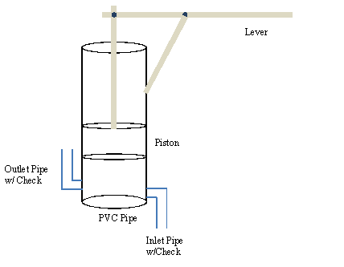

Figure 5. Lever Piston Pump working principle.
In the lever piston pump design the operator pulls the lever down, which in turn lifts the piston up. This creates a pressure difference, bringing water into the PVC pipe from the inlet pipe. When the operator pushes the lever back up, the water is pushed through the outlet pipe.

Treadle Pump Design
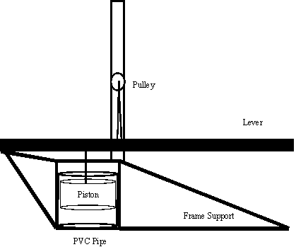

Figure 6. Treadle Pump Design.
In this treadle pump design the operator steps on the levers, pushing the piston up and down. The concept works similarly to the lever pump design, but is foot-operated.

Diaphragm Pump
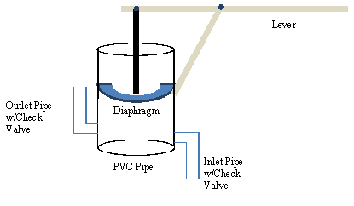

Figure 7. Diaphragm Pump Design

This pump is designed similarly to the lever-operated piston pump, with the exception that the piston is replaced with a diaphragm membrane. Pressure difference is then created not by a moving piston but by the flexible membrane. Note that due to pressure the diaphragm will deform differently than how it is drawn in the diagram.

Materials
In choosing the materials for our pump, ease of access in Honduras, robustness, and durability of the system are our main concerns. For the frame support and lever systems, the material options included steel, wood and aluminum. Considering the fact that a strong support will be needed for both the lever piston pump and treadle pump such that the variability of the angle between the lever and piston is minimized between each stroke, and taking price into account, we think steel will be the best choice.
For pipe and chamber materials, due to economic concerns, we think PVC will be the best choice by far, even though it has a higher friction than steel piping. Angle iron is placed alongside the PVC pipe in order for steel pipes to be welded on to create a support frame for the lever. Thus, we have decided to use a mixture of PVC pipe, steel, and angle iron for the construction of both the lever piston pump and treadle pump. In our initial designs the pump casing will primarily be made of PVC pipe whereas the frame support will be made of angle iron and lever systems will be made of steel. We purchased some other miscellaneous materials such as a piston rod, pulley, PVC plastic sheeting, concrete, and rope as needed to complete our prototype.
In order to keep our aim at the ease of manufacturability in Honduras, constraints limit the membrane material to only a few options in the diaphragm pump. The difficulty of finding a working membrane is that in order to attain the best results the membrane has to have a good degree of elasticity and the ability to maintain a pressure differential equivalent to 2 to 3 m of head. Our initial choice for the membrane, due to its availability, was an inner tube from a motor vehicle’s tire. We could also use the materials from swimming or rafting tubes.
Inspired by most materials used for commercial diaphragm pumps, we found that butyl rubber has been used in many applications requiring an airtight environment. It is used for the bladders in basketballs, footballs, soccer balls and other inflatable balls. Subsequently we have hypothesized that using a soccer ball or basketball by taking the bladder of the ball and sealing it on the top of the pump would allow us access to a membrane that would serve our purposes in the diaphragm pump. This could be the basis for further research that could make our pump more accessible in Honduras.
Santoprene, another potential membrane material, is used in pumps for potable water. Santoprene is a mixture of rubber and polypropylene and has similar elasticity and flexibility to rubber, which fulfills the requirements for our diaphragm pump. More importantly, it is uniformly created for purposes similar to ours and is not expensive. Thus we decided to use santoprene as the membrane for testing instead of looking for a soccer ball bladder. We have purchased a few pieces of varying thickness from McMaster-Carr, and will test for its feasibility in our prototype diaphragm pump.
Silicon is another possible material for the diaphragm membrane and can be purchased through McMaster-Carr if needed.
In the future when we have tested for the durability and feasibility of our current materials, we will check the availability of materials, especially supply of santoprene, in Honduras. If santoprene is unfeasible, we will continue the research on materials and see if there are any better options.

Experimental Apparatus

We will test our prototypes using a simple hydraulic test station. We are using a 75 gallon container to act as both our initial and final reservoir (Figure 9). With this system in use we will be able to test flow rates at multiple heads by simply altering the level of water in the reservoir. Other than the water’s initial and final locations, the system we are constructing will be identical to the pump system we hope to implement in future AguaClara plants; as such, both the pumps and piping are to scale.
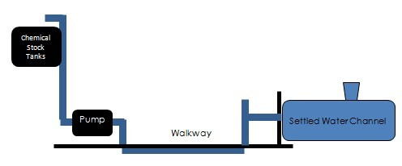

Figure 8. Schematic showing the pump is connecting with the Sedimentation Tank with the Chemical Stock Tank.

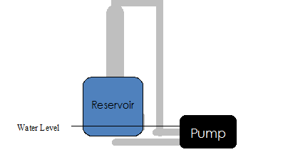

Figure 9. Schematic showing the pump system design for experiment
In our experimental apparatus (Figure 9) water is pumped up 6-8 feet in height to simulate the head of water that the pump will be pumping against in the water plants. The water is then dumped back into the reservoir keeping the head in the reservoir constant. We will try to keep the head loss caused from the water flowing from the reservoir to the pump low by using large diameter piping.

P

reliminary Design Results

Using the pump equation (Equation 4) we have calculated our pump discharge as a function of operator power input and effective head (including losses):
$Q_{pump}=\frac{P_{applied}}{γ_{water}*∆h}=1.78\frac{L}{s}$
(4)
We calculated the varying head losses based on different system pipe sizes using the head loss equations from the Fluids Functions MathCAD file (Equation 5) in conjunction with tabulated minor head loss values for pipe system components. We estimated a total minor loss factor for each pipe size by summing these individual losses, and then added the calculated major losses for each pipe size as well.
Table 1. Minor Loss K ValueChart *
Nominal Pipe | Elbow |  | Check Valve
Diameter (in) | K-Value |  | K-Value
0.75 | 0.53 |  | 4.00
1.00 | 0.50 |  | 2.90
1.50 | 0.45 |  | 2.50
2.00 | 0.39 |  | 2.10
2.50 | 0.36 |  | 2.05
3.00 | 0.35 |  | 2.00
Table 2. Head Loss K Values Independent of Pipe Diameter *
-- for all d<<D
Sudden Expansion |  | 1.00
sudden Contraction |  | 0.40
Table 3. Pipe Roughness Coefficient(mm) *
Polyvinyl Chloride |  |  |  | 0.010
Smooth Mild Steel |  |  |  | 0.012
Stainless Steel |  |  |  | 0.015
* Obtained from Frank M. White's Fluid Mechanics, 6th Edition

(5)

With our total head loss we were able to use an iterative function (Equation 6) found within the MathCAD Fluids Functions to find an optimal pipe size
(6)

We decided on 2.5 inch pipe as a good balance between minimization of losses and materials costs, because the calculated head loss of 0.149 meters represents a loss of only about 6% of the elevation head. If AguaClara plants are unable to attain this size of pipe, we recommend that they attempt to build the system using piping as close to this size as possible with the knowledge that if pipe diameter is lowered pumping will take more effort. This is because flow rate will go down, and if they choose to raise diameter material then costs will rise above projected values.

Our next step was to get a rough estimate of how large our pump chamber was going to be in relation to stroke length. To do this we estimated the stroke length of the piston with Equation 7:
(7)
In order to use this relationship, we had to come up with a reasonable cadence for our operator to work at. After some research we learned that a comfortable pace for a person to work at is no faster than 30 revolutions per minute as in almost all circumstances people prefer a slower cadence if it produces the same amount of work. Because of this, we would like to increase the size of the piston to as large as possible so that the operator can work at the more comfortable pace. The downside to this approach is material cost. The price of PVC greatly increases in relationship to diameter. Therefore we are aiming to use 6 inch diameter PVC since it is already commonly used in the construction of AguaClara plants. If this size is ultimately adopted then with a cadence of 30 rpm the stroke length shall be no longer than 19.6 cm. This PVC pipe size is also a good choice because the stroke length we calculated, 19.6 cm, is close to a human stroke length.

Figure 10. Graph of Piston Size vs. Stroke Length

Our last variable was to calculate the lever lengths of the Lever-Operated Piston Pump and the Treadle Pump. Here we used a moment balance around a pivot point for both pumps to create a graph between the forces that the operator must apply to the lever arm (Figure 11 & Figure 12).

Figure 11. Graph of stroke length as a function of pump discharge, area of the chamber, and cadence

Figure 12. Graph of stroke length as a function of pump discharge, area of the chamber, and cadence

(lever length from 1m to 1.3m)
Figure 12 compares the distance the operator will be away from the pump when he stands on the treadle pump and the force needed to be applied to push the piston. Since the distance from the pivot to the pump is 1m the distance the operator is away from the pump is actually from 0 m to 0.3 m
One key part of determining pump efficiency is the leakage of water around the piston. Using the piston system we have planned for this project, we assume that the primary cause of this will be roughness of the PVC pipe’s inner wall. In order to approximate this loss we measured a few six inch pipes to determine what the greatest difference of diameter was between them. In this case the largest difference was 0.406 mm and with this being taken into consideration the loss of water around our piston is .783 liters per second as can be seen below.
(7)
Although this is a very conservative estimate, since this would assume that there is a constant gap around the entire circle and not just at its greatest point, by using this value we have a significant amount of water loss that can account for nearly a 40% loss in efficiency. We are currently looking into testing different types of seals to help lower this with a leather seal looking the most favorable.

Future Work
Detailed Task List:
- We will continue to construct our diaphragm prototype using the PVC, iron, and santoprene membrane that we purchased. We will try to figure out a way to alter the santoprene shape to optimally pump water.
- We will then run this prototype through several tests, looking at flow rate, operator power, and general viability for use within AguaClara.
- After testing our diaphragm pump, we will convert it into a single-chamber piston pump in order to see if our piston design will work.
- After running tests of the piston pump design similar to those performed with the diaphragm pump, we will again convert our prototype, this time into a two-chamber pedal-operated treadle pump.
- We will then test this treadle pump’s performance as well as its structural stability.
- After all tests have been completed, we will compare the recorded data and performance analyses in order to select a viable pump from either our designs or something commercially available.
- After this optimal pump has been selected, we will move on to the compilation of our findings over the course of this semester and put together a plan for next semester.

Team Reflections
The past several weeks have been marked by alternating periods of excitement and frustration. In the early stages of brainstorming for the basic pump type, we cycled through numerous designs before settling on a choice between a hand- or foot-operated piston pump and a diaphragm pump. At a superficial level, piston and diaphragm pumps seemed like foolproof designs, as they are mostly free of moving parts and easily operated.

However, further analysis proved frustrating. Our team contains a mixture of students who have not taken fluid mechanics and students who took fluid mechanics over a year prior to this semester, so our grasp on fundamental equations is tenuous at best. Modeling the flow through each pump design is dependent on knowledge covering several areas of fluid mechanics and has been undertaken using class notes from CEE 4540 and a quality textbook. However after several methods and attempts we were able to model the basic aspects of our pump and calculate certain dimensions for all of our pump types.

Another source of early concern was the potential pricing of materials; advertised prices in the McMaster-Carr catalogue seemed prohibitive to the construction of our pump due to their desired material pricing when it came to both steel and PVC pipe. However, we were able to circumvent this issue by seeking our steel supply from Ben Weitsman & Son Inc., which was able to provide us with all of our steel at nearly 20 percent of what we had previously planned. After the pump analysis and design, our concern for pricing was significantly relieved when we were told that our budget for materials was larger than what we had previously thought.

Purchasing the materials was slightly hectic because we needed to be sure of all of the materials we were purchasing. However, the purchasing experience was generally positive as the materials were shipped to Hollister Hall relatively quickly and construction started immediately afterwards.

We are currently in the construction phase, working on our pumps and the experimental apparatus. It seems as if the team has a lot more fun working in the shop rather than working in the computer labs struggling with the analysis. We are making fast progress in the pump construction and have high hopes for the prototype. At this point we will just need to fix any problems that we have missed in our analysis and test the pumps for their efficiency.

Bibliography

International Programme for Technology and Research in Irrigation and Drainage. “Treadle pumps for irrigation in Africa”. Fao.org. 2000. February 16th, 2011. <ftp://ftp.fao.org/docrep/fao/005/x8293e/X8293E01.pdf>

KickStart. “MoneyMaker Irrigation Pumps”. Kickstart.com. 2009. March 17th, 2011. <http://www.kickstart.org/news/KickStart_B2B_BrochureJan09.pdf>

Water and Sanitation Program. “Low cost pump alternative for rural communities in Honduras”. RWSN.ch. 2004. February 16th, 2011. <http://www.rwsn.ch/documentation/skatdocumentation.2005-11-15.3234222147/file>

