
Kuali Project

Kuali Security Request Application

Functional Specification

___________________________________________________________________________________________
January 18, 2011

Version 1.0

Table of Contents
Revision History 4
Functional Description 5
Business Requirements and Assumptions 5
Assumptions 5
Terminology 5
Requirements 6
Required Components 6
1. Security Request Wizard 6
Administration Menu 7
2. Security Group Maintenance Document (SGSM) 7
Document Design 7
Permissions 8
3. Kuali Provisioning Maintenance Document (KPMD) 8
Validation 9
4. Security Request Document 10
Document Design 10
Validation 11
Permission 12
Routing 12
Post Processing 13
Process Flow 14
Questions and Issues 14
Appendix A – KFS Role Types 14
Appendix B – KC Role Types 17

Revision History

Version | Date | Author | Description
0.0 | 12/14/2010 | Sarah Christen | Initial Draft
1.0 | 01/18/2011 | Keiko Takahashi | Revised after meeting at Cornell (Sarah Christen, Barb Sutton. Aaron Godert)
1.1 | 01/20/2011 | Sarah Christen | Revision
1.2 | 01/22/2011 | Keiko Takahashi | Added Wizard and Appendix for KC roles
1.3 | 01/23/2011 | Aaron Godert | Edits on Wizard and others; changed application name
1.4 | 01/25/2011 | Keiko Takahashi | Incorporated revised flowchart; added the requirement about the process to work with or without Access Security

Functional Description
The Kuali Security Request Application is a standalone application built with Kuali Rice that provides a place for campus to request access to needed roles within KIM. This will include only specific KIM roles..

End users will be able to select the roles required from a list of individual roles. Once initiated, each document will route to distributed college authorizer role, additional authorizer role and central authorizer role based on rules defined in the document’s maintenance table (see maintenance table details below). Once approvals are obtained, all roles will be granted and an fyi will be sent to the initiator. This document should simplify the provisioning process and save on resource time for manual provisioning. This allows a functional resource in the Finance Office to monitor and approve access requests rather than an IT (resource manually entering roles. The IT resource would still be needed to help troubleshoot problems, administer new roles and change permissions etc on existing roles but the time needed would be significantly less.

Business Requirements and Assumptions

Assumptions
- The security request application builds hooks to the KIM security model in Rice and only manages Rice applications roles.
- The security request application assumes that the following roles are already created in the system prior to the users being able to initiate a document.
  - Distributed Authorizer Roles
  - Additional Authorizer Roles
  - Central Authorizer Roles
  - Any Rice application specific roles authorized by this security request application.
- The application DOES
  - Create role members and role attributes (qualifiers)
- The application DOES NOT
  - Create roles in the system except for roles defined by the access security models
- The security request application should work with or without access security module
- If no authorizers are defined in the security request application, the user access will be granted without any approvals.
- ‘Approval on document assumes approval of all roles. Disapproval on document causes the document to stop – none of the roles will be granted.

Terminology
- Security Group: Rice application such as KFS, KC and any other local custom Rice applications.
- Home organization: Home organization is derived from the “Primary Department” of the principal requesting access (attribute of a KIM record). (Note: at Cornell, the primary department is set at the college level.)
- Distributed Authorizer: A role, which resides at the unit/college level to approve access to the user requesting the system access. The distributed authorizer includes “home department authorizer,” who approves system access for the specific unit or colleges as well as “external organization/unit authorizer,” who approve system access for the specific unit or colleges outside of the user’s home organization or unit.
- Additional Authorizer: Any role, which can be an intermediate level approver in the system.
- Central Authorizer: A role, which resides at the central level to approve access to the user requesting the system access.

Requirements
- The Security Request document can be initiated by a wizard OR directly with a link that passes in the security group id as a URL parameter.
- There should be one dynamic document to authorize several applications
- The security request application will be integrated with Access Security module. However, if ENABLE_ACCESS_SECURITY parameter is set to “N”, none of the Access Security related features should not be displayed in the application.

Required Components
- Security Request Wizard
- Security Group Maintenance Document (SGSM)
- Kuali Provisioning Maintenance Document (KPMD)
- Security Request Document (SR)
- Parameters

1. Security Request Wizard

A web page that dynamically presents the list of Security Groups that the user can choose from to request access for. The choice here is passed along to the Security Request document via a URL query string parameter so that the document knows which group to render itself with. When the requester clicks the submit button a System Request for the one respective application will be created. The requester will then complete and initiate the document. The point is that each Security Group must maintain its own independent approval workflow not impacted by any others.

This whole application should be a completed self-contained, Kuali Rice built, application and should not be built “into” any of the Kuali applications including Rice. Consider this its own application that is built using Kuali Rice. The wizard would just be a static JSP page within this self-contained app.

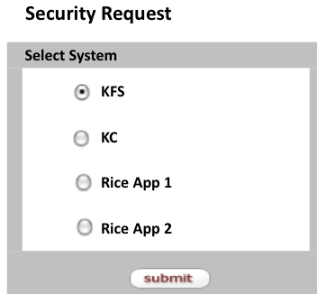

Administration Menu
- Create the Provisioning sub-group
- Following two menus will be placed under this sub-group
  - Kuali Security Group Maintenance Document
  - Kuali Provisioning Maintenance Document

2. Security Group Maintenance Document (SGSM)
The Security Group maintenance document maintains the reference tables for the Security Request document, namely, Security Groups and Tabs.

Document Design

Edit Security Group Tab
- The Edit Security Group tab holds security group information.
- The Security Group ID will be auto generated from the database sequence object

Edit Tabs Tab
- The Edit Tabs tab defines the tab names, which will show in the Security Request document. The Tab Name is a collection.
- At least one tab must be entered for each security group.
- The tab order will define the order of tab appearance on the Security Request document.

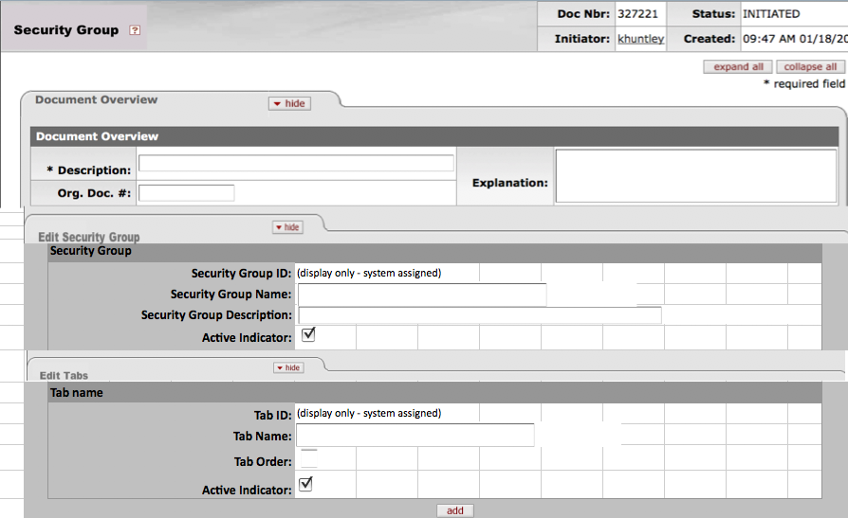

- The supporting table structure will include:

Security Group Table
Column Name | Type | Required? | Comment
Security Group ID | Number | Not null | PK
Security Group Name | Char (40)
Description | Char (400)
Active Indicator | Char (1) |  | Y or N

Security Group Tab Table
Column Name | Type | Required? | Comment
Security Group ID | Number | Not null | FK
Index | Number | Not null
Tab Name | Char (40)
Tab Order | Number
Active Indicator | Char (1) |  | Y or N

Permissions
- This document can be maintained by the 51-Technical Administrator role

3. Kuali Provisioning Maintenance Document (KPMD)
- The Security Group and Tab Locations are supported by the Security Group Maintenance Document.
- Upon selection of the Security Group, populate the Tab Location drop-down menu. The Tab Location drop-down will display the Tab ID – Tab Name.
- Authorizer fields are optional.
- If the role type is “Constraint, Operator, & Value” (Security Definition), the user must select an allowed or denied operator. (If ENABLE_ACCESS_SECURITY parameter is ‘Y’)
- The allowed or denied operator should be grayed out for the role type that is not “Constraint, Operator, & Value” (If ENABLE_ACCESS_SECURITY parameter is ‘Y’)

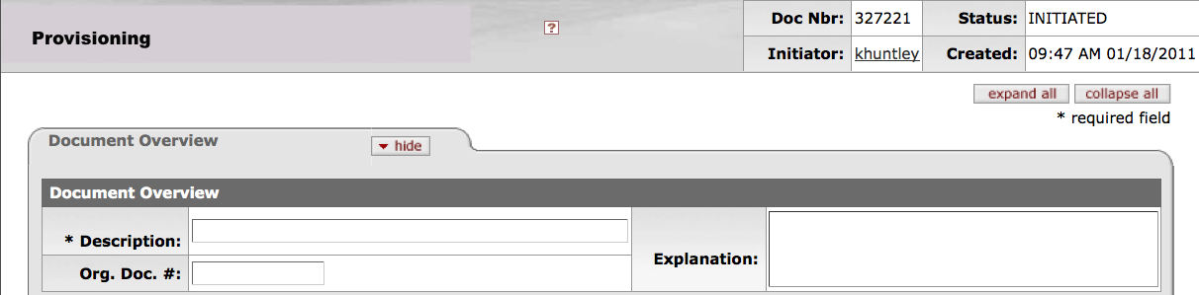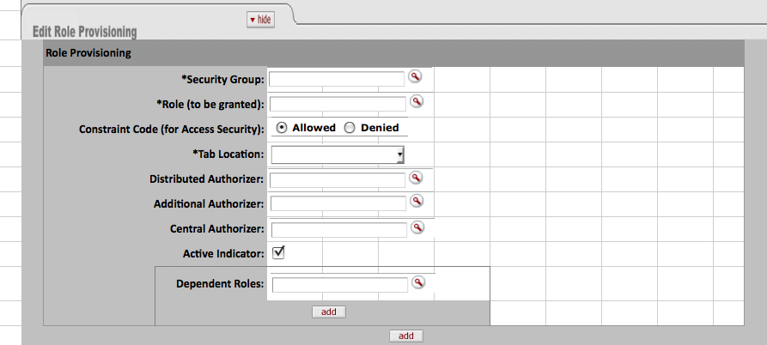

Validation
- If the user selects a derived role, display a hard error, “ You cannot select a derived role.”
- If the dependent role is selected, validate to make sure that the dependent role is also added to the Role (to be granted).
- Distributed, Additional and Central Authorizer cannot be the same.

Following is a sample scenario:

Security Group | Role Name | Distributed Authorizer Role | Additional Authorizer Role | Central Authorizer Role | Tab ID
KFS | User (Role Type: Default) | KFS Unit Authorizer (Role Type: Chart-Org) |  |  | 1
KFS | Labor User (Role Type: Chart-Org) | KFS Unit Authorizer (Role Type: Chart-Org) |  | KFS Central Authorizer (default) | 1
KFS | Service Billing (Role Type: Account) | KFS Unit Authorizer (Role Type: Chart-Org) |  | KFS Central Authorizer (default) | 1
KFS | Sub-Fund Reviewer (Role Type: Sub-Fund) |  |  | KFS Central Authorizer (Default) | 2
KC | KC User (Role Type: Default) | KC Unit Authorizer (Role Type: KC Unit) |  | KC Central Authorizer (Default) | 1
APP1 | User Role (Role Type: Default) | Service Authorizer (Role Type: Default) |  |  | 1

4. Security Request Document
The Security document allows the principals defined in KIM to request access for a specific Security Group. The document will not combine different security groups. The document may be initiated by a person needing access (grantee), or, someone requesting the access on behalf of the grantee.

- Security Request document will lookup Security Group Table
- Upon selection of the principal name, populate the document with full name, primary department and current role membership for the roles that are defined for the specific security group.
- This document should be a transactional document supported by the security request table. The security table should store history of transactions for audit trails.
- Once a security request is fully approved, the specific permissions requested and subsequently granted will be provisioned into KIM.

Document Design

Access Requested For Tab
- The Title Bar (“Access Request for xxx”) will be derived from the wizard selection or specified security group (passed in via the URL query string parameter).

- The primary department will be displayed from the KRIM_PRMRY_DEPT_ID stored in the KRIM_ENTITY_EMP_INFO_T

Dynamically Generated Tabs
- The tabs below the Access Requested For: tabs will be generated from using the Tab Name and Tab order defined by the Provisioning Maintenance document.
- For each tab, the list of roles pre-determined by the Provisioning maintenance document will be listed vertically with the active indicator.
- If the role is not a default type, display the role qualifier type (Account, Organization, etc) and each row will display up to three input boxes for role qualifiers. If the user requires more than three input boxes, the user will click on the add button, and another three input boxes will be displayed in the next row.
- If the role type is “Constraint, Operator, & Value” (Access Security) then the constraint code (denied or allowed) will be also displayed. (If ENABLE_ACCESS_SECURITY parameter is ‘Y’)

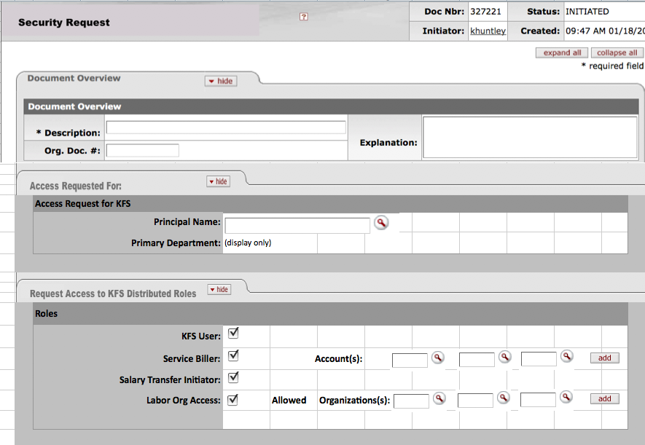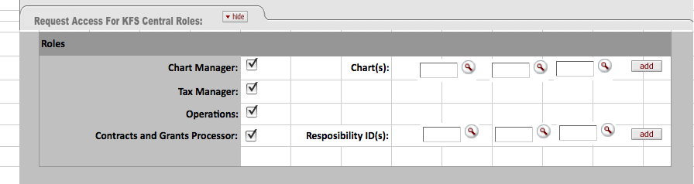

Validation
- If the user does not select the dependent roles defined in the Provisioning table for the role being requested, display an error message, “xxx requires yyy role” where xxx is the role being requested and yyy is the role being required (dependent).

- If the role being requested in qualified, at least one qualifier must be entered. If no qualifiers are entered, display a hard error, “At least one attribute is required for this role.”

- The role attributes must be validated against the appropriate reference table based on the KIM Type.

- The document should not be initiated unless at least one node is completed.

Permission
- The document can be initiated by any User (Role ID 1 – Derived Principal)
- Once the document is initiated, approvers should not make any changes to the document.

Routing
- The routing of the document will be dynamically defined based on the Kuali Provisioning Maintenance Document.

- Compare the organizations being requested to the Primary Department of the principal, if the requested organization is the same as the Primary Department, route the document to the Distributed Authorizer Role of the Primary Department. If the requested organization is not the same as the Primary Department, then the document must route to the Distributed Authorizer Role of the non-Primary Department in addition to the Primary Department approver.

  - Derive organization from its attribute for the following qualifiers:
    - Account: Organization is an attribute of an account (for example, Service Biller’s qualifier is an account. The related organization should be derived from the organization code associated with an account).

    - Sub-Account: The related organization should be derived from the organization code associated with an account to which the sub-account belongs to (for example, Sub-Account Reviewer’s qualifier is a sub-account).

    - Responsibility ID: Responsibility ID is an attribute of an account. The organization is an attribute of an account (for example, Award Processor qualifier is a responsibility ID. The related organization should be derived from the organization code associated with an account to which the Responsibility ID is assigned).

  - The Distributed Authorizer approver must be derived based on the organization or unit hierarchy: you must traverse up the hierarchy until you find the authorizer who is equal to or higher than the organization or unit being requested for access. There can be multiple distributed authorizers in the same organization hierarchy.

- The document will not route to the home department authorizer, if the distributed authorizer role is a default type (no qualification). For example, if the local Rice application does not have to evaluate college/unit level access in granting access, the distributed authorizer could be a default role type.

Developer note: if the authorizer role is not a “default” type, then aggregate on the qualifier. Otherwise, aggregate on the role to determine who to route in the next node.

- The document will route to the home department authorizer, if the distributed authorizer role is qualified.

- The document will route to the organization/unit authorizer, if a user’s request contains the roles with a role type that can be associated with an organization or unit. (See appendix for these roles).

- The document does not become FINAL unless all of the approvers have approved the document (if one approver denies the request, the request for all roles will be denied).

Post Processing
- When the document is FINAL, the post processor must provision data of record changes into KIM such that you can pull up a person in KIM and see the KIM perspective.

- For Access Security (security definition) role, create security models for the definition using the constraints entered in the roles section of the Request Access tab and create the roles from the security model (If ENABLE_ACCESS_SECURITY parameter is ‘Y’).

- Populate the following audit table.

Security Request Document (Also include standard transactional document info required by KNS transactional documents)
Column Name | Type | Required? | Comment
Principal ID | Number | Not null | PK
Primary Department | Char |  | Will contain as of Primary Department information
Document ID | Number

Security Request History
Column Name | Type | Required? | Comment
Document ID | Number | Not null | FK
Role ID | Number | Not null
Active Indicator | Char(1) |  | Y or N

Security Qualifier History
Column Name | Type | Required? | Comment
Document ID | Number | Not null | FK
Role ID | Number | Not null | FK
Role Type | Number | Not null | KIM Type
Qualifier Value | Char

Process Flow
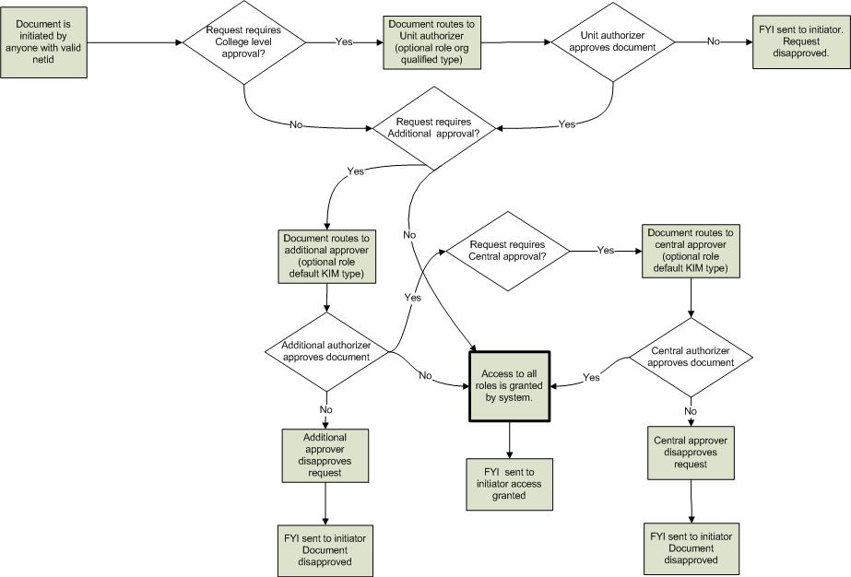

Questions and Issues

Appendix A – KFS Role Types

NMSPC_CD | ROLE_ID | ROLE_NM | NM
KFS-FP | 13 | Service Bill Processor | Account
KFS-BC | 81 | Processor | Account Organization Hierarchy
KFS-CAM | 5 | Manager | Campus
KFS-FP | 11 | Cash Manager | Campus
KFS-FP | 12 | Disbursement Manager | Campus
KFS-PDP | 20 | Processor | Campus
KFS-PURAP | 26 | Purchasing Processor | Campus
KFS-FP | 1002 | PCard Administrator | Campus
KFS-SYS | 37 | Chart Manager | Chart
KFS-PURAP | 79 | Budget Reviewer | Chart
KFS-PURAP | 23 | Commodity Reviewer | Commodity & Document Type
KFS-PURAP | 25 | Contract Manager | Contract Manager
KFS-SYS | 39 | Contracts & Grants Processor | Contracts & Grants Responsibility
KFS-PDP | 18 | Customer Contact | Customer
KFS-AR | 3 | Manager | Default
KFS-FP | 15 | Travel Manager | Default
KFS-SYS | 16 | Treasury Manager | Default
KFS-GL | 17 | Interdepartmental Billing Processor | Default
KFS-PDP | 19 | Manager | Default
KFS-PURAP | 22 | Accounts Payable Processor | Default
KFS-SYS | 29 | Accounts Payable Manager | Default
KFS-SYS | 31 | Accounts Receivable Manager | Default
KFS-SYS | 34 | Asset Manager | Default
KFS-SYS | 35 | Asset Processor | Default
KFS-SYS | 36 | University Administration Budget Manager | Default
KFS-SYS | 38 | Contracts & Grants Manager | Default
KFS-SYS | 40 | Contracts & Grants Project Director | Default
KFS-SYS | 44 | Manager | Default
KFS-SYS | 45 | Operations | Default
KFS-SYS | 46 | Plant Fund Accountant | Default
KFS-SYS | 47 | Purchasing Manager | Default
KFS-SYS | 49 | Tax Identification Number User | Default
KFS-SYS | 50 | Tax Manager | Default
KFS-SYS | 51 | Technical Administrator | Default
KFS-SYS | 55 | Workflow Administrator | Default
KFS-SYS | 62 | System User | Default
KR-SYS | 63 | Technical Administrator | Default
KFS-SYS | 65 | Regional Budget Manager | Default
KR-SYS | 90 | System User | Default
KFS-FP | 96 | Financial Processing Manager | Default
KUALI-CR | 1000 | Check Recon User | Default
KUALI-TAX | 1001 | 1099 Tax User | Default
KFS-COA | 1304 | Account Opener | Default
KUALI-PRJE | 5000 | PRJE User | Default
KFS-SYS | 9 | Account Supervisor | Derived Role: Account
KFS-SYS | 41 | Fiscal Officer | Derived Role: Account
KFS-SYS | 42 | Fiscal Officer Primary Delegate | Derived Role: Account
KFS-SYS | 43 | Fiscal Officer Secondary Delegate | Derived Role: Account
KFS-SYS | 72 | Award Project Director | Derived Role: Account
KFS-AR | 2 | Biller | Derived Role: Accounts Receivable Organization
KFS-AR | 4 | Processor | Derived Role: Accounts Receivable Organization
KR-WKFLW | 59 | Approve Request Recipient | Derived Role: Action Request
KR-WKFLW | 88 | Acknowledge Request Recipient | Derived Role: Action Request
KR-WKFLW | 89 | FYI Request Recipient | Derived Role: Action Request
KR-WKFLW | 97 | Non-Ad Hoc Approve Request Recipient | Derived Role: Action Request
KFS-CAM | 74 | Asset Borrower | Derived Role: Asset Document
KFS-BC | 75 | Document Editor | Derived Role: Budget Construction Document
KFS-BC | 80 | Document Viewer | Derived Role: Budget Construction Document
KFS-FP | 92 | Cash Receipt Initiator | Derived Role: Cash Receipt Initiator
KFS-SYS | 53 | University Chart Manager | Derived Role: Chart
KFS-SYS | 32 | Active Faculty or Staff | Derived Role: Employee
KFS-SYS | 33 | Active Professional Employee | Derived Role: Employee
KFS-SYS | 93 | Active Employee & Financial System User | Derived Role: Employee
KFS-SYS | 94 | Active Professional Employee & Financial System User | Derived Role: Employee
KFS-AR | 91 | Invoice Recurrence Creator | Derived Role: Invoice Recurrence
KFS-PURAP | 86 | Payment Request Hold / Cancel Initiator | Derived Role: Payment Request Hold / Cancel Initiator
KR-NS | 66 | Document Editor | Derived Role: Permission (Edit Document)
KR-SYS | 95 | Document Initiator | Derived Role: Permission (Initiate Document)
KFS-SYS | 82 | Batch Job Modifier | Derived Role: Permission (Modify Batch Job)
KR-NS | 83 | Document Opener | Derived Role: Permission (Open Document)
KUALI | 1 | User | Derived Role: Principal
KFS-FP | 99 | Procurement Card Reconciler | Derived Role: Procurement Card Reconciler
KFS-FP | 98 | Procurement Cardholder | Derived Role: Procurement Cardholder
KFS-PURAP | 69 | Source Document Router | Derived Role: Purchasing Document
KFS-PURAP | 85 | Sensitive Related Document Initiator Or Reviewer | Derived Role: Purchasing Document
KR-WKFLW | 60 | Initiator | Derived Role: Route Log
KR-WKFLW | 61 | Initiator or Reviewer | Derived Role: Route Log
KR-WKFLW | 67 | Router | Derived Role: Route Log
KFS-SYS | 54 | User | Financial System User
KFS-FP | 1300 | DV_USERS | Financial System User
KFS-PURAP | 24 | Content Reviewer | Organization
KFS-SYS | 30 | Accounts Receivable Lockbox Manager | Organization
KFS-AR | 76 | Invoice Recurrence Instance Reviewer | Organization
KFS-SYS | 7 | Organization Reviewer | Organization: Always Hierarchical & Document Type
KFS-SYS | 28 | Accounting Reviewer | Organization: Always Hierarchical, Document Type & Accounting
KFS-CAM | 6 | Processor | Organization: Optionally Hierarchical
KFS-FP | 70 | Disbursement Method Reviewer | Payment Method
KFS-CG | 8 | Research Risk Reviewer | Research Risk & Document Type
KFS-PURAP | 27 | Sensitive Data Viewer | Sensitive Data
KFS-PURAP | 84 | Potentially Sensitive Document User | Sensitive Document Indicator
KFS-PURAP | 68 | Sub-Account Reviewer | Sub-Account & Document Type
KFS-SYS | 48 | Sub-Fund Reviewer | Sub-Fund & Document Type
KFS-VND | 56 | Reviewer | Vendor Type

Appendix B – KC Role Types

NMSPC_CD | ROLE_ID | ROLE_NM | NM
KC-WKFLW | 1101 | OSPApprover | Default
KC-WKFLW | 1107 | IRBApprover | Default
KC-SYS | 1139 | Manager | Default
KR-SYS | 63 | Technical Administrator | Default
KR-SYS | 90 | System User | Default
KC-WKFLW | 1103 | COI | Derived Role - COI
KC-WKFLW | 1104 | KP | Derived Role - KeyPerson
KC-WKFLW | 1105 | CustomReviewer | Derived Role - KeyPerson
KC-WKFLW | 1106 | DepartmentReviewer | Derived Role - KeyPerson
KC-WKFLW | 1102 | PI | Derived Role - PI
KC-IP | 1140 | Proposal Log PI | Derived Role - Proposal Log PI
KC-IP | 1145 | Unit Administrator | Derived Role - Unit Administrator
KR-WKFLW | 59 | Approve Request Recipient | Derived Role: Action Request
KR-WKFLW | 88 | Acknowledge Request Recipient | Derived Role: Action Request
KR-WKFLW | 89 | FYI Request Recipient | Derived Role: Action Request
KR-WKFLW | 97 | Non-Ad Hoc Approve Request Recipient | Derived Role: Action Request
KR-NS | 66 | Document Editor | Derived Role: Permission (Edit Document)
KR-SYS | 95 | Document Initiator | Derived Role: Permission (Initiate Document)
KR-NS | 83 | Document Opener | Derived Role: Permission (Open Document)
KUALI | 1 | User | Derived Role: Principal
KR-WKFLW | 60 | Initiator | Derived Role: Route Log
KR-WKFLW | 61 | Initiator or Reviewer | Derived Role: Route Log
KR-WKFLW | 67 | Router | Derived Role: Route Log
KC-UNT | 1108 | Proposal Creator | Unit
KC-PD | 1109 | Aggregator | Unit
KC-PD | 1110 | Narrative Writer | Unit
KC-PD | 1111 | Budget Creator | Unit
KC-PD | 1112 | Viewer | Unit
KC-PD | 1113 | unassigned | Unit
KC-PROTOCOL | 1117 | Protocol Aggregator | Unit
KC-PROTOCOL | 1118 | Protocol Viewer | Unit
KC-PROTOCOL | 1121 | Protocol Unassigned | Unit
KC-PD | 1126 | approver | Unit
KC-AB | 1170 | Award Budget Modifier | Unit
KC-AB | 1171 | Award Budget Viewer | Unit
KC-ADM | 1114 | OSP Administrator | UnitHierarchy
KC-ADM | 1115 | Proposal Submission | UnitHierarchy
KC-UNT | 1116 | Protocol Creator | UnitHierarchy
KC-UNT | 1119 | IRB Administrator | UnitHierarchy
KC-UNT | 1120 | IRB Reviewer | UnitHierarchy
KC-AWARD | 1124 | Award Modifier | UnitHierarchy
KC-AWARD | 1127 | Application Administrator | UnitHierarchy
KC-AWARD | 1129 | Award Documents Maintainer | UnitHierarchy
KC-AWARD | 1131 | Award Viewer | UnitHierarchy
KC-AWARD | 1133 | Award Documents Viewer | UnitHierarchy
KC-AWARD | 1134 | Departments Awards Viewer | UnitHierarchy
KC-AWARD | 1135 | Template Viewer | UnitHierarchy
KC-AWARD | 1136 | Award Unassigned | UnitHierarchy
KC-IP | 1142 | Institutional Proposal Viewer | UnitHierarchy
KC-IP | 1143 | Institutional Proposal Maintainer | UnitHierarchy
KC-IP | 1144 | Intellectual Property Review Maintainer | UnitHierarchy
KC-AB | 1166 | Award Budget Administrator | UnitHierarchy
KC-AB | 1167 | Award Budget Maintainer | UnitHierarchy
KC-AB | 1168 | Award Budget Aggregator | UnitHierarchy
KC-AB | 1169 | Award Budget Approver | UnitHierarchy
KC-IP | 1186 | Create Temporary Proposal Log | UnitHierarchy
KC-IP | 1187 | Create Proposal Log | UnitHierarchy
KC-IP | 1188 | Modify Proposal Log | UnitHierarchy
KC-IP | 1189 | View Proposal Log | UnitHierarchy

