Stock Tank Centrifugal Pump 2011 Spring
Author: Boyang Mao

Primary Editor: Boyang Mao

AguaClara Reflection Report
Cornell University
School of Civil & Environmental Engineering
Ithaca, NY 14853-3501

Date Submitted: 24/05/2011

Date Revised: DD/MM/YYYY

Abstract
The stock tank mixing team have identified that the major issue of mixing the stock tank solution of PACl is to eliminate the concentration gradient. Vertical movement of the liquid is required to eliminate the concentration gradient. The aim of the stock tank centrifugal pump is to generate the greatest vertical movement through the tank, which is lifting the highest concentration solution at the bottom to the lowest concentration solution at the top. And the high concentration solution that is lifted will settle down and, on its way to the bottom, mixed with the low concentration solution. If the diameter of the pump is designed carefully, a high energy dissipation rate could also be obtained, thus enhace the mixing efficiency.
The pump idea has already been proved passible through mathematic calculations. However, more experimental results are needed to support and check the theoritical calculations. This report include the experimental design and related results.

Keywords: stock tank, mixing, centrifugal pump, concentration gradient, density.

Introduction
Both the theoretical calculation and the experiment are base on the worst case scenario assumption of concentration gradient. The stock solution is assumed formed by a lower layer of concentrated solution and a higher layer of clean water.
The sketch of the stock tank centrifugal pump is shown in Figure 1.
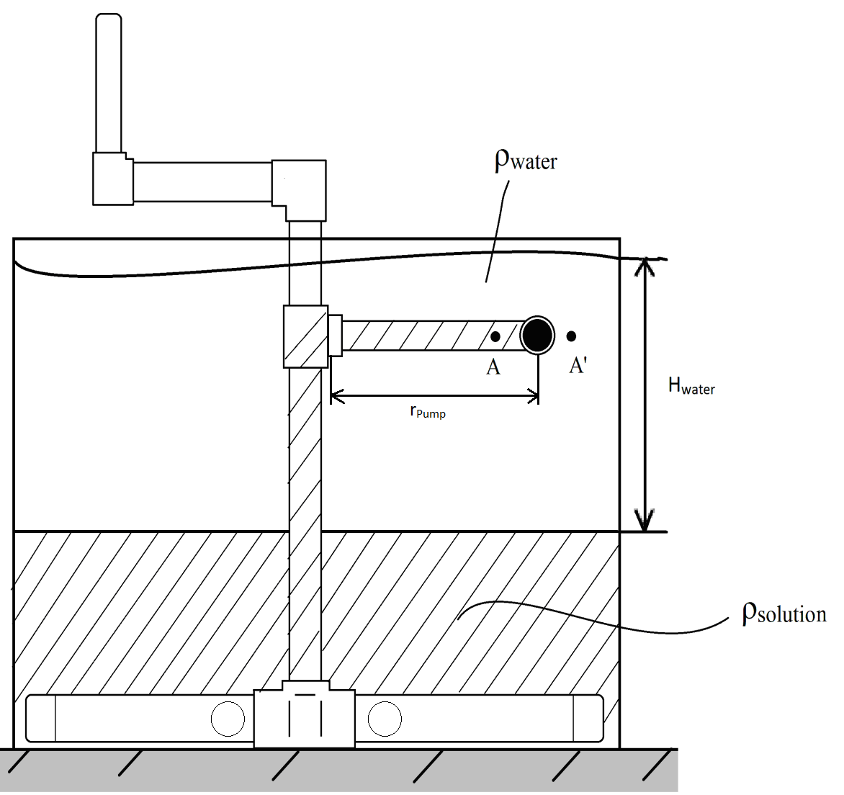

Figure 1. Sketch of Stock Tank Centrifugal Pump.

When the pump is first put into the tank, the height of the two layers inside the pump would be the same as the height outside, to create a flow, the solution need to be lifted inside the pump first. Figure 1 shows a no flow condition with the pump filled with concentrated solution. Under this situation, the pressure drop inside the pump would be greater than outside, since the density of the solution inside the pump is greater than water. The pressure difference (ΔP) between point A (inside the pump) and point A’ (outside the pump) is calculated as a function of the height of the pure water layer (H_{Water}), the density of the high concentrated solution (ρ_{Solution}) and the density of water (ρ_{Water}) (Equation 1).
(1)
To convert this pressure difference, the horizontal pipe of the pump should move at certain speed (V), and it is calculated as a function of the density of the liquid inside the horizontal pipe (ρ_{Liquid})(Equation 2).
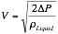 (2)
Initially, the horizontal pipe is filled with water, ρ_{Liquid} = ρ_{Water} should be plot in to calculate the velocity to reach this no flow condition. When the condition is reached, ρ_{Liquid} = ρ_{Solution} should be plot in to calculate the velocity to maintain this no flow condition. Since the density of water is less than the density of the solution, it would require higher velocity to reach the condition than to maintain it. Thus, for any velocity that is higher than or equal to the velocity requirement to reach this no flow condition, there would be extra energy to generate the flow.
And this linear velocity could be transfer to angular velocity (ω) dividing by the length of the horizontal pipe (r_{Pump}) (Equation 3).
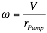 (3)

Experimental Design

The experiment was using the sugar as the solute to make the concentrated solution. Experiment was conduct in a standard sized 5gallon bucket. The diameter of the pipe used to construct the pump is 0.75inch. At certain revolution speed, this diameter could maintain the same ratio of the stock volume and the flow rate between the bucket and the 55gallon drum, based on the assumption that the diameter of the pump for 55gallon drum is 1.5 inches.

Measurement of the Density of Sugar Solution
Different concentration of sugar solution was made using 100ml volumetric flasks. The weight of the solution is measured to get the correspond density. Five different concentration (100, 200, … ,500gm/L) solution was investigated. And for each concentration, three samples were made for measuring and the result would be the average of the samples.

Experiment of the Velocity Requirement for Generating Flow
The aim of this experiment is to prove whether a flow of the solution could be obtain with the pump and check if the lowest velocity to get the flow correspond to the calculation result.
In order to better visualize and take pictures of the experimental result, red dye was put into the sugar solution, and a white bucket (not the standard 5gallon bucket) was used for non-quantified experiment. 200gm/L sugar solution was made and inject under a pre-filled layer of clean water in the bucket. (Figure 2.)
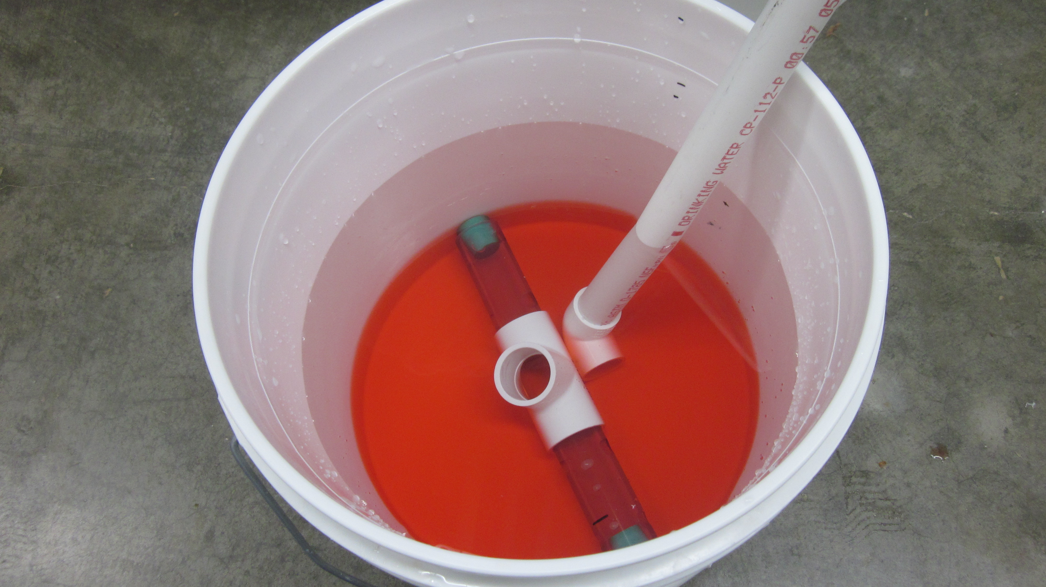

Figure 2. Picture of Injection of Concentrated Solution.

The pump was rotating at 30rpm, and the flow of the red solution could easily be seen at the exit of the pump. (Figure 3.)
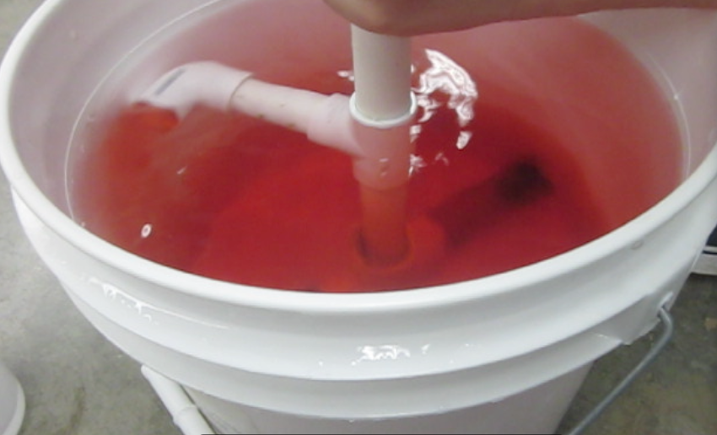

Figure 3. Picture of Flow Coming Out of the Pump.

To compare the experimental result with the theoretical calculation, the same experiment was conduct in the 5gallon bucket with 6L of 200gm/L solution and 11L of water. This time, 10 rpm, 15 rpm and 20 rpm angular velocity is tried to find out the lowest speed for creating flow.

Experiment of Mixing Solution
The concentration of the solution used for this experiment was 425gm/L, which could give the density of 1150gm/L. This is the density of the liquid PACl. The 5gallon bucket is again filled with 6L of solution and 11L of water. The 30rpm and 60rpm of rotating speed is selected. 30rpm is the highest speed that could be humanly reached in the 55gallon drum and same volume to flow rate ratio could be achieved in the bucket with same rotating speed. And with 60rpm, similar energy dissipation rate could be achieved as the energy dissipation rate in 55gallon drum with 30rpm rotating speed.
Samples of the solution at the surface of the bucket and 5cm below the surface were taken after certain revolutions to measure the densities. The samples were 100ml each taken by the measuring pipette. If the density matches the target density, which is the density of the solution mixed with the 425gm/L solution and clean water, it would be reasonable to conclude the solution in the bucket is fully homogenized.

Results and Discussion

Measurement of the Density of Sugar Solution
The density data obtained form the experiment is shown in Table 1.

Table 1. Density of Sugar Solution at Different Concentrations
Concentration (gm/L) | Density 1 (gm/L) | Density 2 (gm/L) | Density 3 (gm/L) | Average  (gm/L)
100 | 1031 | 1033 | 1028 | 1031
200 | 1070 | 1068 | 1074 | 1071
300 | 1106 | 1106 | 1109 | 1107
400 | 1144 | 1141 | 1148 | 1144
500 | 1178 | 1173 | 1181 | 1177

This gives a linear relationship between the concentration and the density of sugar solution (Figure 4.)
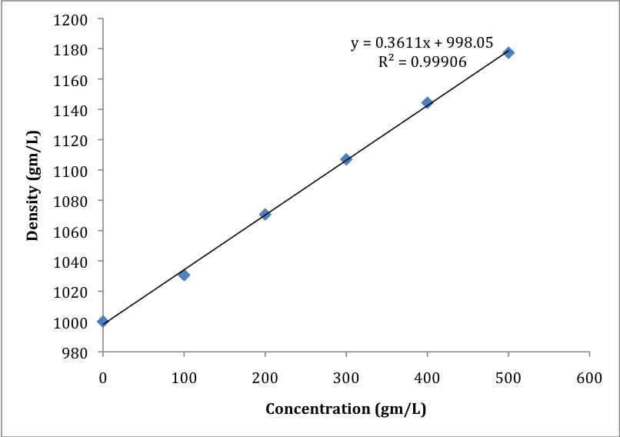

Figure 4. Plot of Experimental Results of Density vs. Concentration of Sugar Solution

And the density of sucrose solution from the Internet source^{[1]} is provided in Table 2.

Table 2. Density of Sucrose Solution at Different Concentrations
Concentration (gm/L) | Density (gm/L)
0 | 998
50.9 | 1018
103.8 | 1038
158.9 | 1059
216.2 | 1081
275.9 | 1104
338.1 | 1127
402.9 | 1151
470.6 | 1176
541.1 | 1203

This gives a linear relationship between the concentration and the density of sugar solution (Figure 5.)
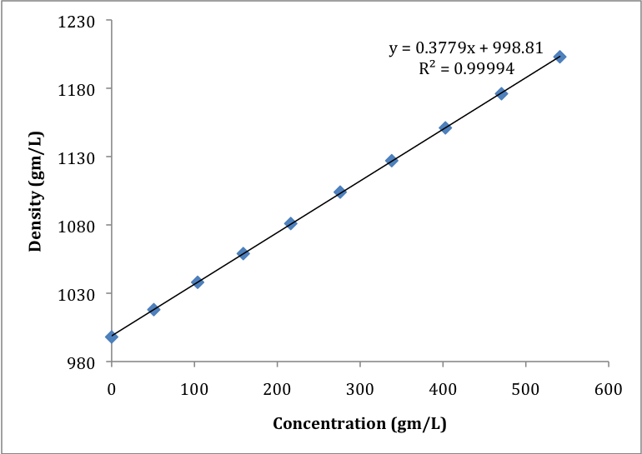

Figure 5. Plot of Density vs. Concentration of Sucrose Solution

By comparing the experimental data with the Internet data of sucrose solution, they provide similar result of the density vs. concentration function. This proved that even though the method used to measure density in this experiment is not a accurate way, it is accurate enough for the experiment and calculation.

[1] http://lclane.net/text/sucrose.html

Experiment of the Velocity Requirement for Generating Flow
The visualized experiment showed the flow could be obtained with a relatively slow rotating speed. And the out-coming red solution would mixed with clean water very fast, thus no trace of red solution could be seen beyond short distance of the exit of the pump. This means the energy dissipation rate at the exit of the pump should be high enough for rapid mixing process.
The quantified experiment result in about 20rpm was the lowest angular velocity to create a flow, while the theoretical calculation showed it should be 7rpm. One possible explanation to this result might be related to the rotation of the fluid in the bucket. As the revolution of the pump, the entire bucket of liquid would rotate together. This will end up with a concave surface region of the liquid (Figure 6.)
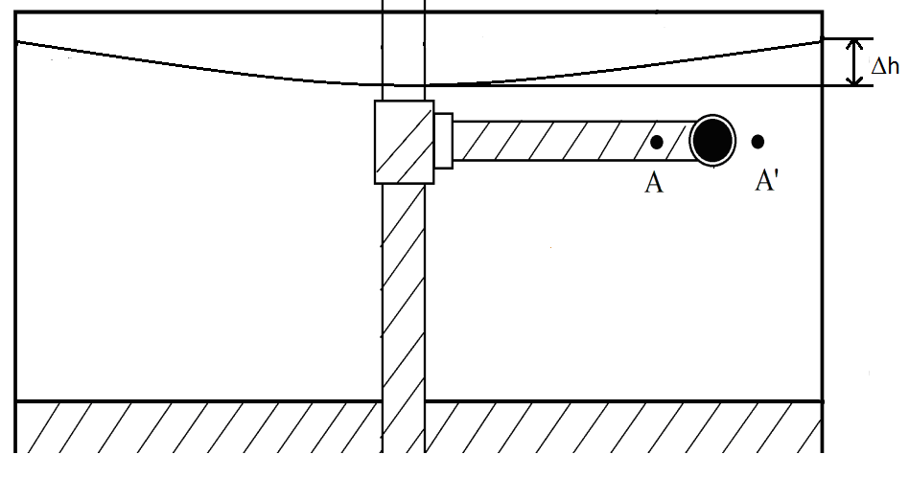

Figure 6. Sketch of the Concave Region Formed by Rotating Fluid.

With the calculation explained in the instruction, the pressure difference between A and A’ is only due to the greater pressure drop inside the pump as the solution inside the pump is denser than water. However, pressure is uniform at the bottom of the bucket. Thus, the pressure at the two points was dropping from same pressure. Now with the concave region of the surface layer, the pressure at the bottom is no longer uniform, but higher at the side and lower at the center. Therefore, the pressure at point A would drop from lower center pressure at the bottom, while the pressure at point A’ would drop from higher side pressure. This makes the pressure difference even greater between these two points. Thus, it would be harder to lift the solution and create the flow.
The pressure difference between A and A’ due to the concave liquid surface (ΔP’) is a function of the height difference between side and center (Δh), the density of the surface solution (ρ_{Surface}) and the density of air (ρ_{Air}) (Equation 4.)

(4)

Although Δh is likely to be really small, since the density difference between the surface solution and air is great, the pressure difference will end up to be significant. For example, the 5gallon bucket experiment, the pressure difference due to the pressure drop would be,
And the pressure diffenrent due to a Δh = 1cm would be,
Thus, twice as much energy input is needed to lift the solution. However, as the energy input is linear changed with V², twice energy requirement should end up with 1.4 times of rotating speed. Therefore, this may not be the only factor that makes the actual rotating speed requirement as 3 times higher than the calculation result.

Experiment of Mixing Solution
If the 6L of solution is fully mixed with 11L of water, it would form the solution concentration of 150 gm/L, and the correspond density of the solution would be 1052 gm/L.
The first experiment with 30 rpm rotating speed fail to create the flow. And after 30 revolutions, the density of the surface layer was still the density of water 997 gm/L.
The second experiment with 60 rpm rotating speed succeed in creating the flow. And the concentrations of the surface layer and the layer 5 cm below the surface were both 1041 gm/L after 60 revolutions. And with another 30 revolutions, the target density of 1052 gm/L was reached both at the surface layer and 5 cm below the surface. This showed the high efficiency of the pump not only for lifting the solution to the top, but also to help the solution mixing with water.

Future Work
The calculation and the experiment both showed that the stock tank centrifugal pump is a promising method of mixing the concentration gradient. However, there is not enough experiment data to fully understand the pumping action of this device. To get a better understanding of the pump, it is necessary to construct a transparent system, with both the bucket and the pipe of the pump to be transparent. Thus, we could observe the mixing process in the bucket and the solution level inside the pump at different rotating speed.
If red dye is added into the lower layer of concentrated solution, we would be able to estimate the flow rate of the pump by observing the volume decreasing of the solution at different rotating speed. Thus, a series of data could be collaborated to adjust the calculation.
And it seems a full-scale test is necessary after small-scale test, since the change in scale could lead to the change of the dominated factor.
Finally, define the trade-off between the flow rate, rotating speed, pipe diameter, and energy dissipation rate for the full-scale device.

