Stock Tank Mixing Spring 2011 Final Report
Primary Author: Christopher Inferrera
Secondary Authors: Jae Lim, Boyang Mao
Primary Editor: Jae Lim
Secondary Editor: Christopher Inferrera, Boyang Mao

AguaClara Final Report
Cornell University
School of Civil & Environmental Engineering
Ithaca, NY 14850-3501
Date Submitted: 05/04/2011
Date Revised: 15/04/2011

Abstract
The Spring 2011 Stock Tank Mixing Team is tasked with improving coagulant stock tank mixing process currently used in many AguaClara plants. The team has determined the major properties differences of Aluminum Sulfate (alum) and Polyaluminum Chloride (PACl) and has experimented with the ‘double bucket,’ ‘constant upflow,’ ‘simple stirrer (stick),’ and ‘centrifugal pump’ designs. The team has also developed a MathCAD file which calculates the potential energy required to mix a PACl solution inside a stock tank, the density of a salt solution given its concentration, and the energy input of stick stirring and centrifugal pump mixing. The final goal of this team is to create stirring guideline for AguaClara plant operators in Honduras.

Keywords: stock tank, mixing system, polyaluminum chloride, alum, stick stirring, centrifugal pump, concentration, density

Introduction
AguaClara plants rely on a source of coagulant solution for the flocculation of solids found in a given source water. This solution is typically water and either PACl or aluminum sulfate (alum). Most of the AguaClara plants currently use alum coagulant but this coagulant is being gradually replaced with PACl.
The current method of homogenizing alum or PACl with water is to simply pour the appropriate amount of either coagulant into of the coagulant stock tank filled with water. The operator then stirs the solution with a length of PVC pipe until the initially visible grains are no longer visible and seem to be dissolved. The stock solution is often cloudy or murky, and it is often impossible to see the bottom of the tank. This means knowing when the solution is completely homogenized is almost impossible. Currently, the operators simply rely on their intuition to know when to stop mixing. This is a factor we would like to remove. Also, the operators waste much of their effort while stirring. The reason for this is because stirring with a PVC pipe will cause the system to undergo horizontal mixing (mixing inside different concentration layers), but very little vertical mixing (mixing between concentration layers). We would like to decrease the amount of effort that is wasted and instead use that effort for productive mixing. Another fault with the current method of mixing is that it does not guarantee complete dissolution of the coagulant. This is important, as if coagulant is sitting at the bottom of the tank, it is not doing anything and is essentially wasted coagulant. The Spring 2011 Stock Tank Mixing Team has been tasked with improving this system so that 1) full homogenization is always achieved and 2) operator effort is minimized.
A factor that we had to consider as we brainstormed many mixing designs is that both coagulants will tend to settle and fully saturate the layer of water at the bottom (but not the top) of the stock tank. Any coagulant granular particles that settle to the bottom will therefore require more input of energy to completely dissolve. Also, the solution is not guaranteed to be homogeneous and a concentration gradient may exist within the tank: the bottom-most layer being the most concentrated and the top-most layer being the least. This led to the identification of two distinct phases of the mixing process. Phase one is the dissolution of granular coagulant into water. Phase two is the complete homogeneous mixing of the concentration layers that form after phase one (a highly concentrated solution will form at the bottom, while a less concentrated solution will form at the top. Phase two is considered complete when the entire volume of solution is homogenized, and the distribution of coagulant is 100% random.
After much deliberation and discussion, our team settled on our first design which we dubbed the ‘double bucket’ apparatus. A diagram of this mixing device is shown below:
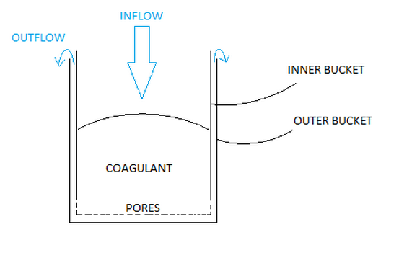

Figure 1. Schematic showing the 'double bucket' experiment.
One of the reasons we favored this design is because this would ensure that the alum coagulant would always be completely saturated with water. This would help prevent moist alum from drying as this usually turns the alum to become a taffy-like substance which makes dissolving it much harder.
The next design we decided to try is a mixing reactor that would incorporate a constant up-flow of water through the bottom of a tank that would interact with the downward force of gravity to fluidize the bed of coagulant and cause it to mix with the surrounding volume of water. This type of mixing was termed upflow mixing and focuses on dissolving granular coagulant,.
Halfway through the semester we were informed that alum will be discontinued for use at AguaClara plants in the near future and will be replaced with PACl. This change of coagulants meant that we had to reconsider the reactor designs we were planning on testing. At this point in the semester, our goal of designing a mixing reactor was modified slightly to designing a mixing reactor that would specifically be used for PACl.
Granular PACl is much finer and the higher specific surface area increases the dissolution rate.The density of granular PACl is lower than the density of water (density of PACl - 0.65 g/cm³).
These properties ultimately dictate our end design and, to that end, we no longer considered the alum mixing reactor we had been working on (i.e. the ‘upflow mixing reactor’) to be relevant. There are two main reasons for this. One, the dissolution of PACl in water is extremely rapid, and therefore, our main concern is dealing with concentration gradients. Secondly, as PACl is less dense than water, assuming that all of the granular PACl would settle to the bottom was presumptuous. Hence, the upflow mixing reactor was no longer relevant, as it works by mixing a layer of granular material that is sitting on the bottom of the tank with the water above. With the use of PACl in mind, we began work on designing a new stirring system better suited to PACl’s unique properties.
We spent a considerable portion of the semester debating and discussing different mixing designs before we received more information regarding the current mixing system used in Honduras from Mr. Antonio Elvir, an AguaClara technician. Mr. Elvir’s new information significantly changed our focus of attention. Mr. Elvir informed us that the mixing tool (a length of PVC pipe) for the 55 gallon drums was, in his opinion, adequate enough and there was no need to design a new mixing device. Due to this information, we decided to concentrate on creating a mixing device that could be used on any sized tank (not just 55 gallon drums and similar sized tanks) and for PACl coagulant. We were very hesitant to spend more time on creating a mixing system which was extremely cheap (a PVC pipe) made of a material readily available, required no assembly, and which, according to our source in Honduras, performed adequately.
We were also informed that PACl used at AguaClara plants is not always the same brand. Depending on where the PACl was manufactured, there is the possibility of a variation in the size, shape, etc. of the PACl granules.
Due to the current shortage of PACl in our labs, the team has used salt (NaCl) to experiment stirring (Figure 3).
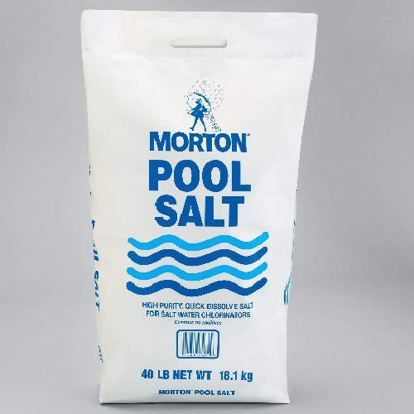

Figure 3. Picture of Morton Pool Salt used in the stirring experiments.
To calculate the theoretical approximation for energy required to fully homogenize a solution of salt--and therefore the amount of revolutions required for a given design--our team has created a MathCAD file which calculates the density of a salt solution given a salt concentration, the potential energy difference between a volume of unmixed solution and the same volume fully homogenized, and the theoretical number of stirs required for total homogenization for a given mixing design. The equations utilized for these calculations are shown below:
The potential energy of the concentrated salt layer ($E_{SaltSoln}$) is a function of the salt density ($ρ_{ConcSoln}$), area of the tank ($A_{Tank}$), the ratio of the concentrated solution volume and the total volume ($r_{Soln}$), the height of the tank ($H_{Tank}$), and gravity ($g$) (Equation 1).
$E_{SaltSoln}=ρ_{ConcSoln}*A_{Tank}*r_{Soln}*H_{Tank}*g*\frac{r_{Soln}*H_{Tank}}{2}$
(1)
The potential energy of pure water layer ($E_{Water}$) is a function of the density of water ($ρ_{Water}$), area of the tank ($A_{Tank}$), the ratio of the concentrated solution volume and the total volume ($r_{Soln}$), the height of the tank ($H_{Tank}$), and gravity ($g$) (Equation 2).
$E_{Water}=ρ_{Water}*A_{Tank}*\left({1-r}_{Soln}\right)*H_{Tank}*g*(r_{Soln}*H_{Tank}\frac{{(1-r}_{Soln})*H_{Tank}}{2})$
(2)
The total potential energy ($E_{Total}$) is a function of the potential energy of the concentrated salt layer ($E_{SaltSoln}$) and the potential energy of the pure water layer ($E_{Water}$) (Equation 3).
$E_{Total}=E_{SaltSoln}+E_{Water}$
(3)
After mixing the two layers, the potential energy of the homogenized mixture ($E_{mix}$) is a function of the final mixed density ($ρ_{final}$), area of the tank ($A_{Tank}$), height of the tank ($H_{Tank}$), and gravity ($g$) (Equation 4).
(4)
$$E_{mix}=ρ_{final}*A_{Tank}*H_{Tank}*g*\frac{H_{Tank}}{2}$$
The MathCAD file can also calculate the density of a solution of NaCl ($ρ_{ConcSoln}$) given its concentration ($C_{ConcSoln}$) (Equation 5).
(5)
$$ρ_{ConcSoln}=0.6365*C_{ConcSoln}+1001.4\frac{g}{L}$$
The equation above was derived by taking different concentrations of salt solution and measuring the density. The data points were obtained from Mettler-Toledo—http://us.mt.com/us/en/home/supportive_content/application_editorials.Sodium_Chloride_de_e.twoColEd.html. The resulting data points were then graphed, and a linear interpolation was carried out. The R² value for this interpolation is .995, indicating a high degree of confidence that the relationship between density and concentration is linear.
The equations utilized for the ‘stick stirring’ experiments (otherwise known as the simpler stirrer) are as follows:
The Reynolds number of the stick (${Re}_{Stick}$) is a function of the linear velocity of the stick (${Vel}_{Stick}$), the diameter of the stick ($D_{Stick}$), and the kinematic viscosity of water ($ν_{Water}$) (Equation 6).
${Re}_{Stick}=\frac{{Vel}_{Stick}*D_{Stick}}{ν_{Water}}$
(6)
The drag force ($F_{Drag}$) is a function of the final mixed density ($ρ_{Final}$), the linear velocity of the stick (${Vel}_{Stick}$), the drag coefficient ($c_{D}$), and the area of the cross section of the stick ($A_{CrossSection}$) (Equation 7).
(7)
$$F_{Drag}=0.5*ρ_{Final}*{{Vel}_{Stick}}^{2}*c_{D}*A_{CrossSection}$$
The energy per stir ($E_{Stir}$) is a function of the drag force ($F_{Drag}$), the diameter of the tank ($D_{Tank}$), and $π$ (Equation 8).
(8)
$$E_{Stir}=F_{Drag}*D_{Tank}*π$$
Experimental Design
After testing multiple designs over the semester, some of these designs were considered to be unsatisfactory and discarded. A brief outline of the experimental setup for each design is given below:
Double Bucket
Our first design, the ‘double bucket’ was a variation from the solution feeder presented from the book, Surface Water Treatment for Communities in Developing Countries by C. R. Schulz and D. A. Okun:
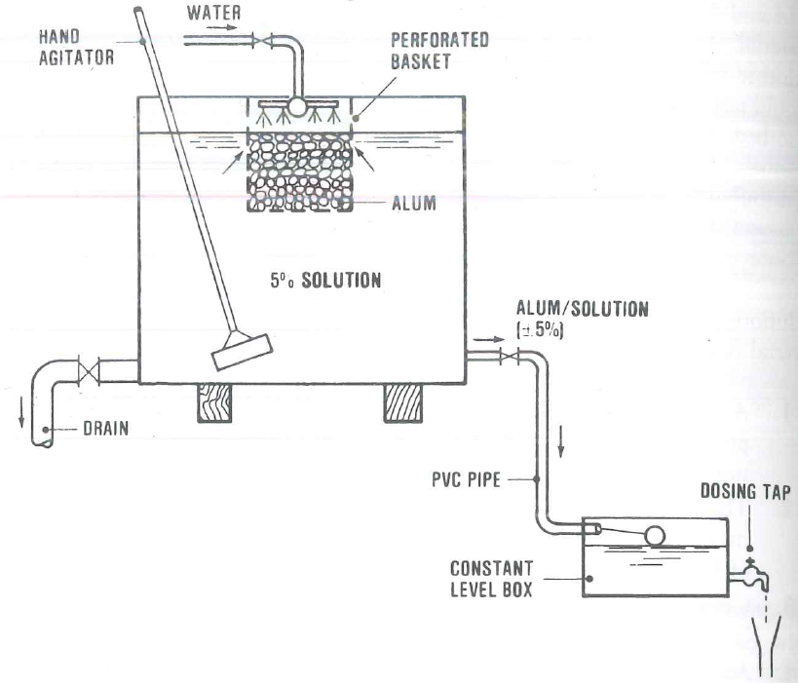

Figure 4. Schematic of bucket design by Schulz and Okun.
The first step of the ‘double bucket’ design (Figure 1) is filling a holding container, which has pores that line the bottom and the sides, with coagulant. This holding container is then placed inside a larger container. This biggest advantage of this setup is that the alum is always submerged, allowing for continuous contact with water.
Variables that affect the efficiency of the mixing process in the device include the following:
- Pore size of the filter
- The thickness of the layer of coagulant
- The diameter of the “bucket”
- Water level
- Rate of Inflow
- Type of coagulant (PACl vs. alum)
Our primary method of testing was to use a PVC pipe with varying sizes of filter paper attached to the bottom of the holding container. The alum was then placed inside the pipe. Then, keeping the water flow constant, we measured what concentration was ultimately achievable with this design.
As detailed in Reflection Report 1 and 2, this mixing design is not suitable for AguaClara plants. The head pressure required to force the solution through the pores is too large and therefore cannot be reasonably achieved in AguaClara plants. Thus, our focuses turned towards other designs.
Upflow Mixing
The purpose of this experiment was to experiment whether pumping water into the bottom of the tank and forcing the water upwards was a viable mixing design. The water being forced upwards would counteract gravity to create a turbulent flow that would stir the coagulant solution.
Our experimental setup for this design is as follows:
- A layer of granular alum is first placed at the bottom of a PVC pipe set upright until the layer of the alum is 20 cm thick. This pipe has an inner diameter of ⅞” and extends vertically 50 cm in height.
- Pressure sensors are set at the top and bottom of the pipe to be recorded by the process controller.
- A filter is attached at the top of the pipe to prevent undissolved granular alum from flowing out of the pipe.
- After starting the experiment, the process controller would gather pressure readings at the bottom and the top of the pipe.
- Using the data gathered from the pressure sensors, calculate the concentration measurements in the pipe over a measure of time.
- Continue to test with different flow rates and different thicknesses in alum.
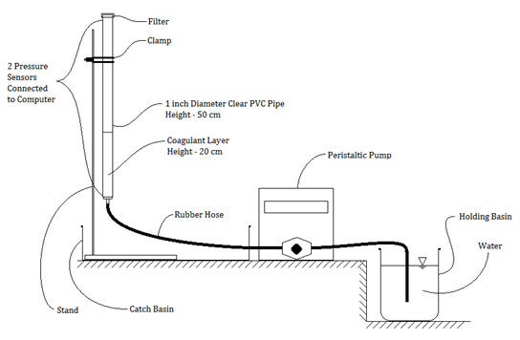

Figure 2. Schematic showing the upflow experiment.
We stopped experimenting with this design after being informed that AguaClara is switching to PACl in the near future for all plants. Since PACl has very different properties from alum, we have decided this mixing design is ineffective for PACl since PACl is less dense than water. Alum is denser than water and tends to sink in water. On the other hand, PACl is not only less dense, but also PACl granules are much finer than alum granules and PACl dissolve much more readily than alum. These changes in properties mean that a simpler mixing design that did not rely on upflow mixing would be a better choice for PACl mixing.
Mixing for PACl
As PACl dissolves much more readily than the alum granules, dissolving the granular PACl is not considered a big issue. However, the dissolved PACl solution is denser than water. The PACl solution will tend to settle to the bottom of the tank and create a layer of highly concentrated PACl solution. Therefore, the system will end up to have higher density (higher concentration) solution at the bottom and lower density (lower concentration) solution at the top. Mixing will be required to homogenize the resulting solution.
Worst Case Scenario
To use MathCAD to calculate and evaluate each the mixing systems, we created the ‘worst case scenario’ for a given target concentration. Simply put, the worst case scenario is the case that would require the most energy input to achieve full homogenization. This worst case scenario is achieved in a theoretical sense for use in MathCAD the following way:
- The final desired concentration for the fully homogenized solution is decided.
- For the desired tank volume, the mass of salt needed for the desired concentration is calculated.
- The volume of a salt solution at its solubility limit is found that, when mixed with a volume of pure water, would result in the creation of a solution at the desired concentration and volume.
- This salt solution at its solubility limit is placed at the bottom of the tank, and the rest of the tank is filled with pure water. No mixing between the water layer and the salt concentration is assumed.
Even though we are using salt in our experiments, we believe we are getting an accurate representation of what would happen with PACl solutions. This is so because we are analyzing concentration gradients, and not the actual dissolving of granular particles. As PACl dissolves very readily in water, we feel this is a safe assumption to make. In addition, molecular diffusion is negligible compared to the amount of mixing the turbulence created by the stirring reactor creates. Although molecular diffusion will ultimately be responsible for reaching a 100% mixed state, it will not provide a strong enough mixing force to eliminate the concentration gradient. To do this, we introduce. The magnitude of the turbulence is the key factor that determines the mixing speed. Thus, the difference in molecular diffusivity between different types of salts will not significantly affect the experiment results. Therefore, other types of salts can be used for experimenting instead of PACl as long as the salt solution can reach same density of the PACl solution.
Simple Stirrer
The next mixing design we tested was the simple stirrer design. This design is simply a length of PVC pipe (1.25 cm in diameter) that is inserted vertically into the bucket and used for stirring. For this experiment, a set of four 5-gallon buckets were used. Each bucket was filled with 8 liters of a concentrated salt solution (2 buckets with a 100 g/L solution, 2 buckets with a 200 g/L solution). These buckets were then carefully filled with 8 more liters of water in such a way as to not disturb the concentrated solution. The buckets were then allowed to sit undisturbed for a period of time. Each of these buckets was in turn carefully stirred with the PVC pipe. The density of the solution of the bucket being mixed was periodically checked, and when it matched the target density (the density of a fully homogenized solution) mixing would be considered completed. In order to measure the density of the solution, we used a pipet to obtain a sample. The mass of this solution was then taken. With the mass and the volume, the density could easily be found (density = mass/volume).
Centrifugal Pump
The reason the simple stirrer is found to have very low efficiency is primarily because the stick generates a horizontal mixing of the fluid rather than vertical. For the worst case scenario, most of the movement ends up mixing either the solution (which is already homogenized) or the pure water rather than mixing the two layers of liquid. Thus, most of the energy input is wasted. Also, much of the kinetic energy is turned into thermal energy without causing any significant vertical transport of high density fluid into the lower density fluid or vice versa. In order to enhance the efficiency of the mixing system, we need to use the energy input to generate vertical transport. The centrifugal pump is a design that uses energy input to carry concentrated bottom solution from the bottom layer to the pure water found on the top layer.
The sketch of the centrifugal pump design is shown below in figure 5. The aim of the horizontal pipe at the bottom of the tank is to keep the pump at the center of the tank by attaching the both ends to the wall of the tank. The vertical pipe has a larger diameter than the bottom tee. This allows the vertical pipe to be set into it and rotated freely. There are holes on the bottom horizontal pipe to allow solution to flow into the pipe. By rotating the pump, centrifugal force will pump the water out through the open end on the side arm. As this liquid in the upper horizontal pipe is pulled out, it will lower the pressure inside the pump. This will in turn cause the higher pressure at the bottom of the pump to push in more solution. Thus, if the centrifugal pump is kept rotating at a minimum angular velocity, a steady flow can be obtained.
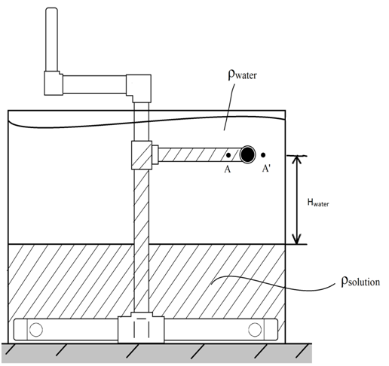

Figure 5. Sketch of Centrifugal Pump Mixer.
Rotating Speed Required to Prime the Pump with Concentrated Solution:
When the concentrated solution is primed to the top—meaning that the concentrated solution has risen to the top of the pump but does not have quite enough energy to exit—the pressure drop inside the pump is greater than that outside the pump since there is a larger concentration of solution inside the pump across the range of the water layer. The pressure difference between the outside and inside of the pump (between point A and A’) at the top ($∆P$) is a function of the height of the pure water layer ($H_{Water}$), the density of the high concentrated solution ($ρ_{Solution}$) and the density of water ($ρ_{Water}$) (Equation 9).
$∆P=H_{Water}(ρ_{Solution}-ρ_{Water})$ (9)

Therefore, an increase of pressure is created by rotating the pump in order to prime the solution. Since initially the liquid in the horizontal exit pipe is pure water, the speed required to prime the solution ($V_{PumpPrime}$) is a function of the pressure difference between the outside and inside the pump ($∆P$) and the density of water ($ρ_{Water}$) (Equation 10).
${ V}_{PumpPrime}= \sqrt{2\frac{∆P}{ρ_{Water}}}$ (10)
Rotating Speed Required to Maintain the Concentrated Solution after Prime:
After the pump is primed, the liquid in the horizontal pipe of the pump is the high density solution. Thus, the speed required to maintain the solution level would be slower, the speed required to maintain the solution level inside the pump ($V_{PumpOperate}$) is a function of the pressure difference between the outside and inside the pump ($∆P$) and the density of the high concentrated solution ($ρ_{Solution}$) (Equation 11).
$V_{PumpOperate}= \sqrt{2g\frac{∆P}{ρ_{solution}∙g}}$ (11)
The Flow Rate Calculation:
Therefore, given any speed of rotating $V$ that is faster than $V_{PumpPrime}$, a flow will be expected to come out of the horizontal exit pipe. The total head provide by rotating($H_{Total}$) is a function of the given rotating speed ($V$) (Equation 12).
$H_{Total}= \frac{V^{2}}{2g}$ (12)
Subtract the head used to maintain the solution level, and what is left would be the head that could generate the flow (Equation 13).
$H_{Flow}= H_{Total}-\frac{∆P}{ρ_{solution}∙g}$ (13)
Assuming that minor losses are the most significant source of head loss in the pipe, we can calculate the flow rate that corresponds with major losses through the pipe. This will be
equal to $H_{Flow}$.

Results and Discussion
As stated in previous Reflection Reports, the ‘double bucket’ design and the ‘upflow mixing’ design are unsatisfactory for PACl and are no longer being considered as potential future mixing designs. The analysis of the centrifugal pump and the simple stirrer designs are below:
Simple Stirrer Experiment
A perfect system with no losses to friction, heat, or any other source would require about 2 stirs in the 55 gallon tank to fully homogenize the solution. This result was calculated using the following initial values:
Diameter of Stirrer= 0.025 m
Initial Salt Concentration = 360 g/L
Volume of Concentrated Solution = 60 L
Final Mixed Salt Concentration = 110.504 g/L
Total Volume = 295.5 L
The simple stirrer experiments were intended to prove the inefficiency of stick mixing. We conducted the simple stirrer experiments with the “worst case scenario” setup; meaning, we created two distinct layers of different concentrations with the bottom layer consisting of salt concentration solution and the top layer consisting of pure water. As we did not have access to a 55 gallon drum for testing, we used a 5 gallon bucket and scaled all measurements accordingly. The data on the table and graph shown below was obtained by conducting the experiment with a rotation speed of 1 revolution per second. Density measurements were taken every 30 stirs. The theoretical homogeneous density was 1052.5 g/L and this density was achieved after 120 stirs. Through potential energy difference calculations and the theoretical energy put in per revolution, these experiments prove that the simple stirrer stick is highly inefficient and a better mixing apparatus is needed.

Table 1: Simple Stirrer Data (1 revolution/second)
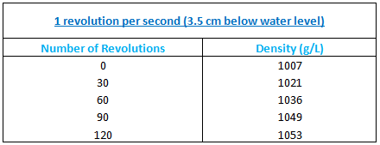

Figure 7. Graph of Data from Simple Stirrer Experiment

It should be noted that the first 90 stirs of the total 120 were done at a rate of 1 revolution every 2 seconds, while the final 30 stirs were done in a rapid mixing fashion; the rapid mixing fashion basically entails mixing as fast as practical in random directions, and therefore try to mix the solution as thoroughly as possible. This amount of stirs is drastically different than the calculated theoretical value. The efficiency factor is approximately 1.2% at 1 revolution per 2 seconds. Because we were not testing at full scale, nor were we using a fully saturated solution of NaCl, we expect the efficiency of the simple stirrer design to be even worse when utilized with the 55 gallon drums. Because of this, we recommend that the simple stirrer design be replaced with a mixing device that can achieve a higher efficiency.

Centrifugal Pump Experiment
Based on the flow rate calculation described previously, the flow rate we can get through the pump (built from 1.5 inch PVC pipe) as a function of rotating speed (in rpm) is shown in Figure 6:

Figure 8. Graph of flow rate through the pump vs. the rotating speed
The power input that is used to pump up the solution consists of three parts:
1) the power used to prime the pump.
2) the power used to overcome the head loss in the pump.
3) the power used to force concentrated solution out of the exit pipe.
The power that is needed to pump the water is shown in Figure 7:

Figure 9. Power Input Requirement vs. the Rotating Speed
From Figure 7, given the limiting power of 75W (the maximum power output for an average human), we can pick approximately 32 rpm as the rotating speed. However, this does not take into account the drag force on the horizontal pipe.
For the calculation of the drag force on the horizontal member, we assume that the velocity of the entire length of pipe is the same. The rate used is that of the end of the member. Therefore, we model the entire member as moving at its fastest actual rate. This is the most conservative rate to use for the calculation of the drag force. For a 30 rpm rotating speed, this drag force power is smaller than the pumping power by the factor of 10 (3.2 Watts for the drag force vs. 62.8 Watts for pumping). Thus, 30 rpm is the maximum speed that could be applied to a centrifugal pump scaled to a 55 gallon drum.
The energy dissipation rate at the exit of the pump can also be plotted as a function of rotating speed, as it is shown in Figure 8 below:

Figure 10. Energy Dissipation Rate at the Exit of the Pump vs. the Rotating Speed
Figure 8 shows that for a rotating speed faster than 14 rpm, the energy dissipation rate will be high than 1 W/kg, which means molecular diffusion will mix the solution with the water before the solution is able to settle to the bottom of the tank.
Other Useful Pieces of Information
The Stock Tank Mixing team has confirmed that alum that is saturated with water can become a taffy-like substance that is difficult dissolve. To prevent this from occurring, we have concluded that alum should always be submerged.
Future Work
The team of students that will replace the current one will have the opportunity to do many experiments. The first set of future experiments will involve testing the centrifugal pump and it’s efficiency. Afterwards, experimenting with an impeller design should be on the next team’s list of things to do, as there are many articles dealing with this type of mixing. However, the future team should keep in mind that these experiments are done to create a set of mixing guidelines for AguaClara operators to use.
Also, finding a reliable supplier of granular PACl is important. The current team, unfortunately, was not able to find a willing supplier of granular PACl in the U.S. or in China. This supply of PACl will allow the future Stock Tank Mixing team to conduct experiments with PACl instead of salt as well as giving other teams the opportunity to use PACl in research.
Team Reflections
Our team has done a great job working hard all semester long, even during times when our team’s direction was not clear or when faced with setbacks (and there have been many setbacks). From the almost weekly flow of information that kept changing our team’s goals, to the inability to acquire PACl for research, the Stock Tank Mixing Team has faced many problems throughout the semester. Fortunately, our team has learned to adapt to the dynamic goals, and changes that may drastically affect other teams are taken by the Stock Tank Mixing Team in stride. Jae Lim has done an excellent job of keeping the team focused to the best of his abilities given the circumstances, Christopher Inferrera has consistently pushed the team towards experimentation that could give results that could be applied in Honduras, and Boyang Mao has concentrated on the theory behind the mixing systems our team has come up with.
If taken at face value, the progress our team has made all semester long may seem to be lacking, but when considered alongside all of the issues we have encountered, it will be seen that we actually have made quite a lot of progress in improving AguaClara’s mixing system for stock tank solutions.

Literature Review

Chandratilleke, G.R., et al. "Effects of blade rake angle and gap on particle mixing in a cylindrical mixer." Powder Technology. 193 (2009): 303-311.

Using the Discrete Element Method (DEM), this work examines how the mixing performance of a cylindrical mixer is affected by two design parameters: blade rake angle and blade gap at the vessel bottom. The flow and mixing performance are quantified using the following: velocity fields in vertical cylindrical sections, Lacey’s mixing index, inter-particle forces in vertical cylindrical sections through the particle bed and the applied torque on the blade. Simulation results show that the mixing rate is the fastest for a blade of 90° rake angle, but interparticle forces are large. Conversely, the inter-particle forces are small for a blade of 135° rake angle, but the mixing rate is slow. The simulation results also indicate that the force applied on particles, velocity field and mixing are interrelated in that order. This source will be very useful if an impeller type mixing system is designed for AguaClara plants.

Hartmann, H., J. J.. Drkesen, and H.E.A. Van der Akker. "Numerical simulation of a dissolution process in a stirred tank reactor." Chemical Engineering Science. 61 (2006): 3025-3032.

This journal illustrates a set of experiments done using large eddy simulation (LES). They used a cylindrical tank with equi-spaced baffles and 6-bladed Rushton turbine and they divided the mixing was divided into five stages: mixing and dispersing, quasi steady state, resuspension, dissolution, and homogeneous suspension. However, this article does not go deeply into diffusion of molecules and concentration gradient throughout the tank. This article would be more useful to research the mixing process of alum than PACl.

Min, Jian, and Zhengming Gao. "Large eddy simulations of mixing time in a stirred tank."Chinese J. Chem. Eng. 14 (2006): 1-7.

Large eddy simulations (LES) of mixing process in a stirred tank of 0.476m diameter with a harrow blade hydrofoil CBY impeller are discussed in this paper. The turbulent flow field and mixing time were calculated using LES with Smagorinsky-Lilly subgrid scale model. The impeller rotation was modeled using a sliding mesh technique. The results show that LES is a reliable tool to investigate the unsteady and quasi-periodic behavior of the turbulent flow in stirred tanks. Mainly theoretical, this paper is primarily a study on the behavior of turbulent flow in tanks that undergo mixing. It may be somewhat useful in the design of an impeller type system for AguaClara plants.

Pernitsky, David J., and James K.. Edzwald. "Solubility of polyaluminum coagulants."Journal of Water Supply: Research and Technology - AQUA. 52.6 (2003): 395-405.

The study outlined in this paper investigates the solubility characteristics of several polyaluminium coagulants with different chemistries. Solubility in deionized water was studied at 20 and 5 degrees Celsius between pH 4 and 9 for seven coagulants. These coagulants include alum, and PACl, among others. Solubility diagrams are provided. However, the data collected correlates the solubility with pH, not with concentration. The information provided in this study may be useful if the a study is done for AguaClara that takes into account the pH of solutions used (perhaps for corrosion purposes).

Chandratilleke, G.R., et al. "Effects of blade rake angle and gap on particle mixing in a cylindrical mixer." Powder Technology. 193 (2009): 303-311.

Using the Discrete Element Method (DEM), this work examines how the mixing performance of a cylindrical mixer is affected by two design parameters: blade rake angle and blade gap at the vessel bottom. The flow and mixing performance are quantified using the following: velocity fields in vertical cylindrical sections, Lacey’s mixing index, inter-particle forces in vertical cylindrical sections through the particle bed and the applied torque on the blade. Simulation results show that the mixing rate is the fastest for a blade of 90° rake angle, but interparticle forces are large. Conversely, the inter-particle forces are small for a blade of 135° rake angle, but the mixing rate is slow. The simulation results also indicate that the force applied on particles, velocity field and mixing are interrelated in that order. This source will be very useful if an impeller type mixing system is designed for AguaClara plants.

Hartmann, H., J. J.. Drkesen, and H.E.A. Van der Akker. "Numerical simulation of a dissolution process in a stirred tank reactor." Chemical Engineering Science. 61 (2006): 3025-3032.

This journal illustrates a set of experiments done using large eddy simulation (LES). They used a cylindrical tank with equi-spaced baffles and 6-bladed Rushton turbine and they divided the mixing was divided into five stages: mixing and dispersing, quasi steady state, resuspension, dissolution, and homogeneous suspension. However, this article does not go deeply into diffusion of molecules and concentration gradient throughout the tank. This article would be more useful to research the mixing process of alum than PACl.

Min, Jian, and Zhengming Gao. "Large eddy simulations of mixing time in a stirred tank."Chinese J. Chem. Eng. 14 (2006): 1-7.

Large eddy simulations (LES) of mixing process in a stirred tank of 0.476m diameter with a harrow blade hydrofoil CBY impeller are discussed in this paper. The turbulent flow field and mixing time were calculated using LES with Smagorinsky-Lilly subgrid scale model. The impeller rotation was modeled using a sliding mesh technique. The results show that LES is a reliable tool to investigate the unsteady and quasi-periodic behavior of the turbulent flow in stirred tanks. Mainly theoretical, this paper is primarily a study on the behavior of turbulent flow in tanks that undergo mixing. It may be somewhat useful in the design of an impeller type system for AguaClara plants.

Pernitsky, David J., and James K.. Edzwald. "Solubility of polyaluminum coagulants."Journal of Water Supply: Research and Technology - AQUA. 52.6 (2003): 395-405.

The study outlined in this paper investigates the solubility characteristics of several polyaluminium coagulants with different chemistries. Solubility in deionized water was studied at 20 and 5 degrees Celsius between pH 4 and 9 for seven coagulants. These coagulants include alum, and PACl, among others. Solubility diagrams are provided. However, the data collected correlates the solubility with pH, not with concentration. The information provided in this study may be useful if the a study is done for AguaClara that takes into account the pH of solutions used (perhaps for corrosion purposes).

Numerical simulation of a dissolution process in a stirred tank reactor
H. Hartmann∗, J.J. Derksen, H.E.A. van den Akker.

1. Intro

Mainly about dissolution (“multi-phase processes”) , not sure if it covers diffusion yet.

Mainly use large eddy simulation (LES) including passive scalar transport and particle tracking.

“On macroscopic scale, the hydrodynamics control e.g. residence time and circulation time in the specific flow system (e.g. a stirred tank).

“On a microscopic scale, rate-limiting processes
such as mass transfer (needed for nucleation and growth in
crystallization), agglomeration and attrition (a major source for
secondary nucleation), collisions, and the yield of a chemical
product (in case of competitive chemical reactions) are largely
determined by the smallest-scale flow phenomena.” which we’re not going to worry about.

2. Flow System

“cylindrical tank of diameter T, with four equi-spaced baffles of width 0.1T mounted along the perimeter of the tank.”

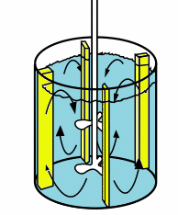

Rushton turbine (6 blades, seems the blades are completely vertical): 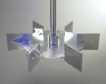

Dimensions of tank in article.

3. Simulation procedure

LES methodology references in article.

they take into account the diameter of particles.

“The particles are released in a quasi steady-state flow field.”

lattice cells?

4. Results

Nt = Impeller velocity * time (Fig. 2) (Interesting way to quantify mixing)

They took snapshots of concentration distributions (Fig. 3) How???

Illustrates particle motion per some number of revolutions.

Hmmm.... They divided the mixing system into 5 parts:

Stage 1: mixing and dispersing
Stage 2: Quasi steady state
Stage 3: Resuspension??? (see Fig.4: compare Nt=20 and N=40).
Stage 4: Dissolution
Stage 5: Homogeneous suspension

Might be more useful with alum than PACl.

This journal illustrates a set of experiments done using large eddy simulation (LES). They used a cylindrical tank with equi-spaced baffles and 6-bladed Rushton turbine. The mixing was divided into five stages: mixing and dispersing, quasi steady state, resuspension, dissolution, and homogeneous suspension. However, for our purposes, this
A model of transient mixing in stirrer tank

Frank G. Smith III using fluid mechanics modeling methods to simulate the mixing of particles in fluid.The mixing system they based on is a two blades stirrer with a propeller blade to create vertical flow in the center layer of the liquid and a turbine blade to create horizontal flow at the bottom of the liquid. The stirrer is set in a Their simulation showed that at 100rpm speed of stirring, the maximum radiate flow velocity of about 1.0 m/s at the lower turbine and maximum axial flow velocity of about 0.5 m/s would be obtained.

The system could generate a down-flow in the center of the tank and up-flow by the wall of the tank. The simulation showed that within 240s, the particles in the liquid would be spread through out the tank, however not uniformly distributed, with highest particle density to the corner at the bottom. The simulation also showed that the highest energy dissipation rate (1W/kg) at steady state would appear at the region next to the turbine blade. And the lowest energy dissipation rate (0.4 W/kg) would appear near the surface of the tank.

The research by Smith showed that with two blades at 100rpm rotating speed, which is much higher than manual limit, the mixing could not be done in short period. And the energy dissipation rate is just enough at the bottom of the tank, and lower in the rest regions of the tank. Thus, this system is not efficient enough to apply to manual mixing.

Smith, Frank G. "A model of transient mixing in a stirred tank." Chemical Engineering Science. 52.9 (1997): 1459-1478.
Chandratilleke, G.R., et al. "Effects of blade rake angle and gap on particle mixing in a cylindrical mixer." Powder Technology. 193 (2009): 303-311.
Hartmann, H., J. J.. Drkesen, and H.E.A. Van der Akker. "Numerical simulation of a dissolution process in a stirred tank reactor." Chemical Engineering Science. 61 (2006): 3025-3032.
Min, Jian, and Zhengming Gao. "Large eddy simulations of mixing time in a stirred tank."Chinese J. Chem. Eng. 14 (2006): 1-7.
Pernitsky, David J., and James K.. Edzwald. "Solubility of polyaluminum coagulants."Journal of Water Supply: Research and Technology - AQUA. 52.6 (2003): 395-405.

Effects of blade rake angle and gap on particle mixing in a cylindrical mixer
G.R. Chandratilleke, A.B. Yu, R.L. Stewart, J. Bridgwater

Using the Discrete Element Method (DEM), this work examines how the mixing performance of a cylindrical mixer is affected by two design parameters: blade rake angle and blade gap at the vessel bottom. The flow and mixing performance are quantified using the following: velocity fields in vertical cylindrical sections, Lacey’s mixing index, inter-particle forces in vertical cylindrical sections through the particle bed and the applied torque on the blade. Simulation results show that the mixing rate is the fastest for a blade of 90° rake angle, but interparticle forces are large. Conversely, the inter-particle forces are small for a blade of 135° rake angle, but the mixing rate is slow. The simulation results also indicate that the force applied on particles, velocity field and mixing are interrelated in that order. This source will be very useful if an impeller type mixing system is designed for AguaClara plants.

Large Eddy Simulations of Mixing Time in a Stirred Tank
Min, Jim and Gao, Zhengming
Beijing University of Chemical Technology
College of Chemical Engineering

Large eddy simulations (LES) of mixing process in a stirred tank of 0.476m diameter with a harrow blade hydrofoil CBY impeller are discussed in this paper. The turbulent flow field and mixing time were calculated using LES with Smagorinsky-Lilly subgrid scale model. The impeller rotation was modeled using a sliding mesh technique. The results show that LES is a reliable tool to investigate the unsteady and quasi-periodic behavior of the turbulent flow in stirred tanks. Mainly theoretical, this paper is primarily a study on the behavior of turbulent flow in tanks that undergo mixing. It may be somewhat useful in the design of an impeller type system for AguaClara plants.

Solubility of Polyaluminium Coagulants
David J. Pernitsky and James K. Edzwald
The study outlined in this paper investigates the solubility characteristics of several polyaluminium coagulants with different chemistries. Solubility in deionized water was studied at 20 and 5 degrees Celsius between pH 4 and 9 for seven coagulants. These coagulants include alum, and PACl, among others. Solubility diagrams are provided. However, the data collected correlates the solubility with pH, not with concentration. The information provided in this study may be useful if the a study is done for AguaClara that takes into account the pH of solutions used (perhaps for corrosion purposes).

