Fabrication Team, Fall 2014
Carl Talsma, Adrian Cobo, Sara Sanz

Abstract
The fabrication sub team tasks for Fall of 2014 include creating a hydraulically similar model of the stacked rapid sand filter(SRSF) inlet removable weir system. The weir system controls how the flow is divided amongst multiple SRSF and into different inlet pipes of the SRSF. The weir system incorporates a weir that is to be removed during backwash processes in order to ensure sufficient flow when operating at lower than maximum flow rates. The team must also determine how to build the removable weir for a full size plant. The team’s third task is to solve the awkward installation problems regarding the sedimentation tank inlet manifold.

Table of Contents
Abstract
Table of Contents
Task List
Task Map
Task Details
Introduction
Design Details
Future Work
References

Task List

Task Map
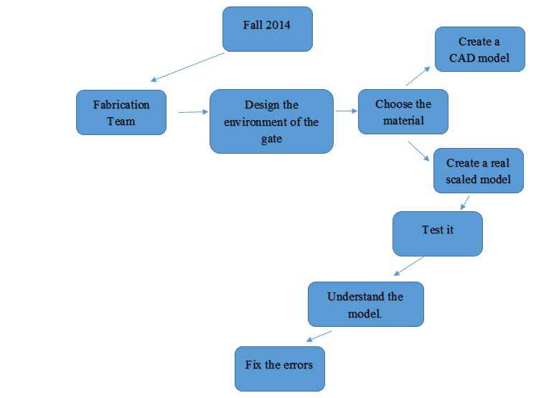

Task Details
Blue text represents tasks that are currently being completed while red text represents tasks that have been completed

Priority 1: Challenge II: SRSF Weir Model
- Understand the purpose of the removable weir within the SRSF weir and the challenges in designing a removable weir (easily removable and watertight, durable/long-lasting)
- Design the dimensions for the model such that the model is hydraulically similar to a full size plant. The model should be able to demonstrate the purpose of the weir system and the flushing process.
  - Scale down Full sized autocad plant (9/26) Adrian
  - Determine Flow through scaled model(10/6) Carl
  - Determine Flow through the outlet tubing(10/6) Carl
  - Determine Hydraulic Similarity (10/8) Carl
  - Determine Weir Flow (10/20) Carl
  - Design model siphon system(11/5) Sara
    - Calculate Area of exit orifice (10/27)
    - determine pump power for recycle
    - design removable pipe fitting
    - design backwash system
      - Determine pipe fitting to weir box
      - Determine general design
      - determine area/length of piping
- Determine how the model will be made including the materials, assembly, disassembly, and storage. The model should be easy to transport and assemble so that it can be used in a classroom like setting to demonstrate the weir system.
  - Choose Material for tank box(9/26)
  - Determine how to achieve targeted outflow using tubing(10/13) Adrian
- Build Model 11/1-30?
  - Talk to Paul Charles and Tim Brock about building the model (10/29) Carl
  - Break Cad Model down to Individual Parts (10/29) Adrian
  - Determine PVC Wall Thickness (11/3) Carl
  - build tank box
    - order pvc siding(11/5) adrian
    - cut walls out of pvc(grooves for weirs, holes for flow) (12/3?) Carl
    - glue walls together (12/3?) Carl
  - Build weirs
    - order pvc (11/5) adrian
    - cut out weir shapes(12/3?) Carl
  - Install outflow tubing
    - thread holes in wall
    - order tubing
    - install tubing
  - Build siphon system
    - order pump
    - install pump with tubing system
- Test the model to ensure that it mimics the functioning of the weir system and determine if any problems will arise in the

Introduction
- The first task is to build a hydraulically similar model of the SRSF inlet weir system for demonstration. The newest design of the SRSF incorporates a removable weir in the backwashing process. Model will demonstrate how that weir system is supposed to work and whether it will actually be feasible to operate in a full scale plant.

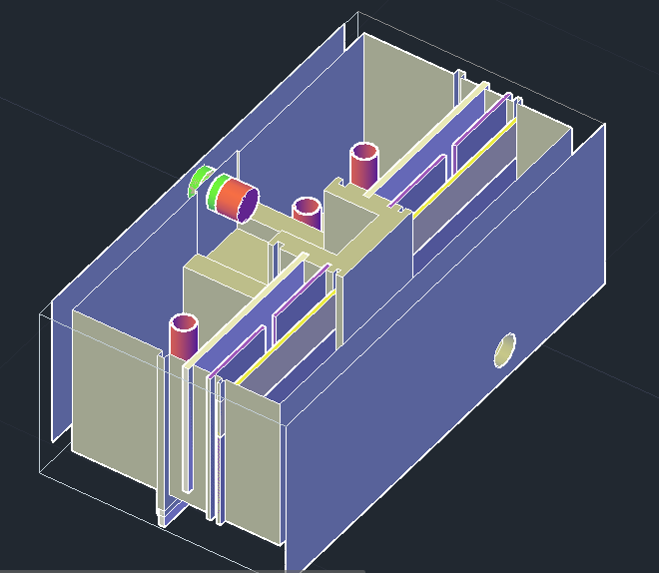
- CAD drawing of the removable weir system
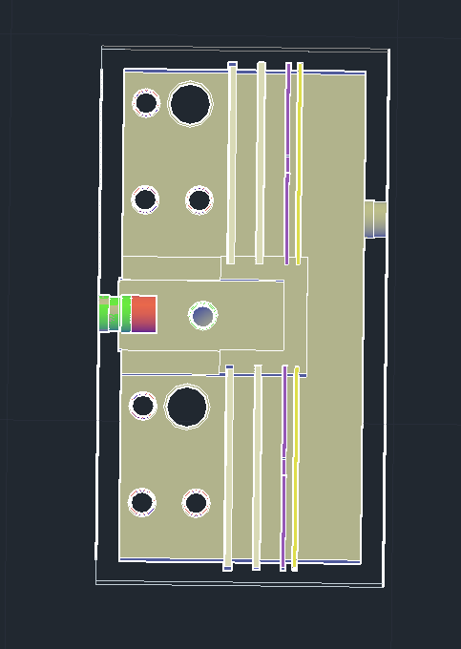

- Overhead view of the removable weir system CAD drawing

Design Details
The Stacked Rapid Sand Filter system is designed to control the flow into multiple filters for both filtration and backwash modes. This is achieved in two ways: the removable weir system and the siphon pump. The siphon pump is engaged during backwash to increase the flow rate through the sand filter and consequentially lowers the water level in the weir box such that the water only flows into the bottom exit pipe and not in the three standing exit pipes. The removable weir system sets the backwash flow rate by incorporating a series of two weirs. The first is a standard rectangular weir with a removable segment which diverts the flow between the filters while the second weir diverts flow into a rectangular slit in the weir’s center. During backwash, the removable segment from the first weir is removed to divert a greater flow rate to the filter in backwash. The second slotted weir controls the flow rate that is allowed into the filter to be around 80% of the total flow. The remaining twenty percent continues to flow in regular filtration mode through the alternate filter.
This system allows the operator or engineer to easily set the backwash rate of the filter and allows the plant to operate at less than the design flow rate and still backwash the filters. However, the hydraulics of the model are complicated to a point where having a working model will allows us to demonstrate the process easily and experiment with alternative weir system designs. The model will focus on demonstrating the hydraulics of the weir system rather than that of the siphon as the siphon system is easily explained and is more involved with the SRSF as a whole.
The largest hurdle in designing the model of the weir system will be in achieving hydraulic similarity. The model should be sufficiently small so that it is readily portable and easy to store but simply scaling down the model could cause errors in hydraulic similarity by increasing the proportionality of molecular forces to kinematic forces. In order to determine if the model is hydraulically similar a design is needed in which surface tension and viscosity are not dominating forces. The forces of surface tension and viscosity act on very small scales so that the forces become increasingly important as the model becomes smaller. The Froude number offers an elegant solution to to determining whether inertial forces are significant in the model. The Froude number is defined as a ratio of the inertial force on a fluid element compared to the weight of the element.(1)
$Fr=V/\sqrt{g*l}$ (1)
The Froude number is thus dependent on the parameters of velocity(V), length scale(l), and the gravitational constant(g=9.8m/s^2). Thus a length scale of 1/5th of the plant flow rate is establish, the velocity must increase by a factor of 1.23 to maintain the same ratio of inertial forces to the weight of the fluid.
The Froude number can be manipulated by substituting the flow multiplied by the square of the length scale for the velocity.(2) The resulting equation allows us to calculate the flow of the model knowing the flow of the full size plant to be 50L/s. (3)
$Fr=Q/(A*\sqrt{g*l)}⇒Fr=Q/(l^{5/2}*g)$ (2)
$Q{}_{model}=Q{}_{plant}*l^{5/2}$ (3)
Using a 1/5th scale physically reasonable for the model, the flow of the model would have to accommodate a 0.89L/s flow rate to maintain hydraulic similarity. This is a rather large flow rate and the decision was made to change the scale length to ⅛ in an attempt to lower the flow rate of the model while not sacrificing the ability of the model to demonstrate the weir processes. The change in scale cuts the flow rate down to 0.28 L/s which should be manageable with the use of a centrifugal pump which will be discussed later.
Another concern is whether the weirs maintain hydraulic similarity when scaled down to a smaller size. If surface tension or inertial forces were to have an effect it would be in the small channels created by the weir system. This effect is most prominent in the slotted weir which can be approximated by the flow through a rectangular weir. The flow through a rectangular weir is found using the Kindsvater-Carter equation below.(4)

$Q=C_{e}*2/3*\sqrt{2*g}*(b+K_{b})*(h+K_{h})^{3/2}$ (4)

$C_{e }$is the coefficient of discharge and can be calculated using the ratio of the channel width(B) compared to the weir notch width(b) and the ratio of the head of the weir(h) to the crest height of the weir(H). Using the graph below the discharge coefficient is calculated to be around 0.6.
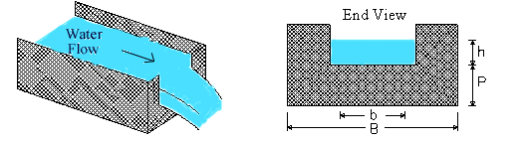
d.) Rectangular weir general dimension views.
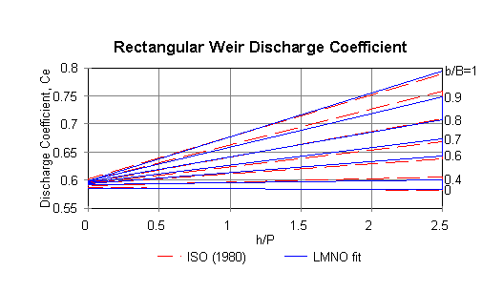
e.) Rectangular Weir Discharge Coefficient Chart

$K_{b}$and $K_{h}$account for the effects of viscosity and surface tension and thus determine the hydraulic similarity of the model. Together $b+K_{b}$and $h+K_{h}$determine the effective width and height of the weir respectively. $K_{h}$is dependent on the gravitation constant and has the value .001 m for earth. $K_{b}$depends again on the ratio of the channel width compared to the notch width and can be determined using the graph below.
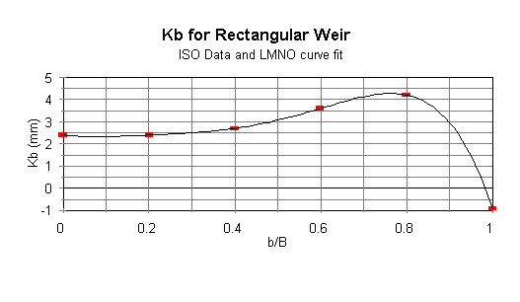
f.)Kb values for Rectangular Weir

Using the values found with equation 4, it is found that the maximum flow through the slotted weir to be 4.94 L/s which is well above the target flow rate of .224L/s. The maximum flow rate was calculated by setting the head of the weir equal to the height of the slot in the weir. Since the target flow rate is so much less than the maximum rate, it can be safely assumed that the weirs will allow ample flow for the system.
The tank box contains the bulk of the system and we plan on constructing the box such that we can interchange many of the other aspects of the design. The weirs will be able to slide in and out of the box so that we can experiment with weir configuration. Although it would have been nice to have a clear model for demonstration, the box will be made out of gray PVC. This decision was made because PVC will be easier to work with than plexiglass or acrylic and unfortunately, clear PVC is nearly twice the price of gray PVC. It would be interesting to consider making one or two sides of the box from clear PVC in order to view the two separate draining tanks and the weir system. This would cut the cost of the box without sacrificing the view of the changing head during backwash mode.
The 50 L/s autocad file for an aguaclara plant was scaled down according to the froude number calculations to create a model for the weirbox that would match the calculations to achieve hydraulic similarity. The model was also scaled from meters to inches so that the units matched those of the ordered materials the box would be made from.
To prepare for construction of the weir box the autocad file was broken up into individual wall pieces to be machined separately. In the process of determining the dimensions for the individual pieces of the weir box several questions and constraints arose concerning the design of the box. One decision that had to be made was the design constraint of the width of the PVC siding to be used in the manufacture of the box. The plant weir box also has several aspects to it that could be ignored for the purposes of demonstrating the backwash system.
The width of the siding of the weir box is an important factor in the structural integrity of the box as it must be able to withstand the pressures of the flowing water. The place most susceptible to a failure would be at the grooves where the weirs are allowed to slide in. If the PVC was too weak, a bending weir or wall could cause the weirs to slip out of their grooves. Thus the pvc must be thick enough to accommodate large grooves in the wall of the box and also withstand bending under pressure. It was decided that a 3/8th inch thickness for the PVC would be a sufficient size to machine grooves into the wall and would be more than sufficient to withstand bending from the pressure of the water.
The concerns over the weirs slipping from their grooves led to questioning of the grooves themselves and whether an alternative existed for installing and removing the weirs. One option discussed was tapping screws into the walls such that the screw would not create a puncture through the wall but would hold pvc fittings in place that the weirs would slide in between. This option would be compelling because it would not require the machining of the grooves and would allow us to move and experiment with the placement of the weirs. Ultimately, machining grooves was decided as the best option for holding the weirs in place because of the simple design and the ease of fabricating the grooves.
A large portion from the middle of the weir box was also removed from the model drawing. In the plant autocad drawing, there is a large overflow channel in the middle of the weir box designed to drain overflow from the exit tank as well as the backwashed water from the stacked rapid sand filter. Including this channel would not have benefited the demonstration of how the weir box itself works and had the potential to cause confusion as to its presence in the system. The overflow channel was removed by condensing the middle of the box to include only the walls of the overflow channel. This would mean that a wall of ¾ inch thickness(twice as thick as a normal wall) would divide the two exit tanks within the weir box. The wall must be thicker than the standard wall because it must accommodate grooves on either side of the wall. This change in the design does not affect the dimensions of the exit tank or weir channels but only affects the dimensions of the inlet tank before the flow is split by the primary weirs. Thus the hydraulics of the model should not be affected by the condensing of the inlet tank.
Three of the four outlet orifices for each side of the box were removed from the drawing as well. This exclusion from the model cuts down on the material cost of the model and removes redundancies in understanding how the weir system works. The role of having more than one orifice is more concerning the function of the SRSF than that of the weir channel. Including extra orifices would complicate the outflow system and require unnecessary work and materials. However, the pipes do convey effectively the change in head that occurs when the siphon is engaged. To show this process it has been suggested that a removable stand pipe is constructed that could show the water level during backwash and filtration modes. While including the standpipe is helpful in demonstrating the processes of the weir box, it is not integral to the design and has been designated as a last priority inclusion to the design.
In changing the thickness of the walls and the removal of the overflow channel, the outer dimensions of the walls required adjustment. The final dimensions for each wall/weir are listed below.

 | L (in) | H (in) | W (in)
Dividing Wall | 9.43 | 9.11 | 0.75
Long Wall *2 | 19.68 | 9.11 | 0.375
Short Wall *2 | 12.65 | 9.11 | 0.375
Bottom Wall | 20.43 | 12.65 | 0.375
Weir 1 *2 | 10.3 | 5.7 | 0.375
Removable Weir | 10.3 | 2.23 | 0.375
Weir 2 *2 | 10.3 | 9.11 | 0.375
Weir 3 *2 | 10.3 | 7.99 | 0.375

Construction on the weir box has begun with cutting out pieces for the box wall from 3/8th inch PVC sheets. The walls will be held together with PVC glue and grooves will be milled into the side of the walls to a depth of 1/8 of an inch and made water-tight with a silicon lining. The decision to use milled grooves to hold the weirs in place was made because it was the easiest option from a fabrication standpoint. The weirs will be made out of ¼ inch PVC rather than ⅜ inch to conserve space within the box and so that the box walls are not as structurally impacted by the grooves.
The exit and inlet orifices will be threaded for easy fitting to PVC piping rather than using bulk head fittings. Using threaded pvc pipes allows for easy removal, allows for a wider range of pipe diameters, and doesn’t have the added monetary cost that the bulk head fittings would.

Three different ways of installing the pipes have been analyzed:
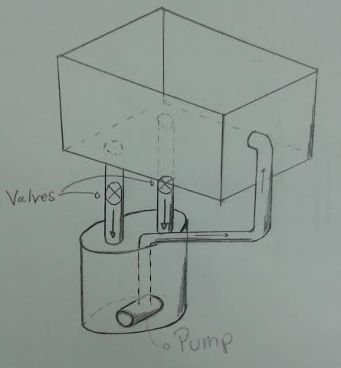
The first one consist in having two different pipes from the filters to a bucket. Then a centrifugal pump will be installed in the bucket to pump water to the filter again. The aim of the bucket is to always have a constant inlet flow because it will not depend on the amount of water that goes through the outlet pipes. In order to simulate the backwash mode a valve will be installed on each pipe to regulate the amount of water that goes though.
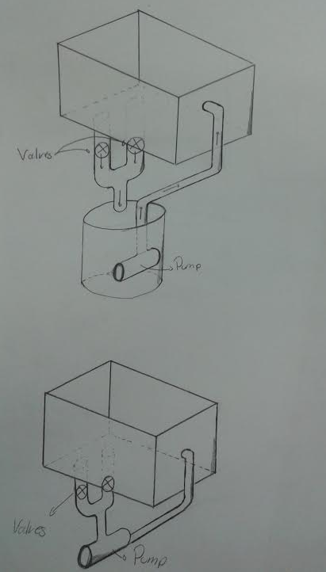
Two alternatives to the first one were proposed. The first one is exactly the same design, however the outlet pipes would join together into a single pipe. However this creates the model a bit more difficult to build, also we are not sure if the backwash mode could be simulated properly having both pipes together. It would also be beneficial to see the changes in outflow from the individual pipes during backwash.
Finally we could install the pipes directly connected to the pump. This has the advantage that we can change the suction force of the outlet pipes because in this case it would be determined by the pump, and in the other two cases it just depends on the gravity. However, by changing the rate at which water is removed from the exit tank the inflow rate would also increase.
The recycle flow system will be broken up into inflow and outflow manifolds. The outflow manifold design is very important as it determines the changing head loss between the separate filter exit tanks. To achieve this variable headloss the outflow tubing will incorporate gate valves in the tubing directly after the exit orifices for each exit tank. These gate valves will control the flow that is allowed to exit the weir box. During normal filtration the gate valves will be set to the same position to allow the target flow for each box through the exit orifice. During backwash one of the gate valves will be opened to increase the flow through that exit tank which will lower the water level in the exit tank. The flow rate should be equal to approximately 80% of the total flow going through the weir box as determined by the mathcad calculations for the plant design. This 80% is equal to the backwash flow rate for the filter.
Since such a specific flow is needed for backwash, we need to know exactly how much the gate valve need to be opened. In order to get around this problem, only one side of the weir box will be designated as the backwash side. This side will incorporate into its outflow tubing two separate exit channels controlled by a ball valve. Each channel will have a gate valve already set at the correct position for backwash or filtration. This allows us to quickly shift between filter and backwash modes and to control the flow out of the box without making adjustments while the model is running.
The exit pipes from the separate exit tanks will then drain into a common reservoir, likely just a simple bucket. The exit tank tubing is driven only by gravity, therefore the diameter of the exit tubing/orifice is what controls the maximum flow rate from the exit tanks. The pipe diameter can be calculated using fluids equations for the flow through a pipe in conjunction with head loss equations. These calculations were done using the aguaclara fluids function file in mathcad. The length of the tubing was estimated to be 1m, minor losses were estimated to be 2.7, and the $Δz$ of the piping was estimated to be .5m. These values are likely overestimates which should give us a safe estimate for the pipe diameter. The pipe diameter functions returned a diameter just under a ½ inch for the maximum flow that the pipe would be accommodating during backwash. To be safe, the design will incorporate 1 inch PVC pipe for the flow manifold. This allows an appropriate safety factor in our calculations and 1 inch PVC is readily available in the lab. The flow will then be adjusted using the gate valves in the outlet manifold.

Problems Encountered
10/10
This week we had problems deciding the scale of the model because we did not know if the hydraulic model was going to work correctly with it and if the dimensions were adequate for our model.
We also had difficulties interpreting the Froude number and the parameters that had to be taken into account. It still needs to be determined whether or not the weir dimensions are sufficient for handling the flow calculated using the Froude number.
11/7
While ordering the different materials, we realized that our previous wall thickness was so high that the budget was too expensive. For that a thickness of ⅜ was chosen in order to save money. This caused that almost the whole CAD model was modified with the new thickness. We decided that the most important part was keeping the dimensions of the removable weirs constant, for that the external walls dimensions and also the internal dividing wall were modified.

Apart from these, it was found that using a thickness of ⅜ inches it would be very difficult to mechanise grooves, so alternative solutions were thought. Instead of that, hinges are probably going to be used, because it is really easy to move them in case its placing is not the best one. These did not happened with the grooves, because in case of choosing the wrong placing, everything would be wrong.
11/21
We had to change the dimensions of our sketches so that the bottom piece of the model fits the inner dimensions of the box and the side walls will be glued to the sides of the bottom piece. This was done for fabrication purposes. We’ve also had to change some dimensions so that the significant figures are such that the precision can be achieved by the tools available.
We’ve had some trouble determining the diameter of the outflow piping based on the targeted flow rate. We’ve determined the head loss using the fluids functions in mathcad but we’re having trouble getting the function to cooperate.

Accomplishments
10/10
- We’ve studied and gained an understanding for how the weir system works and its larger role in the operation of the plant.
- We have developed a 3D CAD model using the original model of the Agua Clara SRSF.
- We’ve determined the material and rough size of our model.
- We’ve discussed the methods in which we will build the model once we have obtained materials.
- We’ve determine hydraulic similarity between the plant and the model.
- We’ve determined the flow rate of our model.
- We’ve designed how to achieve head loss during backwash.
11/7
- We’ve calculated the flow through the weirs to ensure that we are meeting our target flow.
- We’ve calculated the flow through the exit orifice and compared it to our target flow
- We’ve broken down the AutoCad file into individual parts with the correct dimensions.
- We’ve order the PVC sheeting for the Weir Box.
- We’ve modified the design to eliminate material waste and superfluous aspects of the box.
- We’ve decided to modify how the weir will fit into the weir box.
- We’ve determined how the pipe/tubing will connect to the box.
11/21
- We’ve begun building the box.
- We’ve designed how the recycle flow system will work.
- We’ve ordered more material for the weir system.
- We’ve determined the head loss through the our pipe system at various diameters of tubing.
12/5
- We’ve established that the diameter for the pipes is 1 in.
- We’ve order all the joints and valves necessaries for the pipes of our model.
- We’ve assembled the pipe manifold.

Future Work
In the next semester Fabrication Team can continue testing the model. The design can be refined and changed to better represent the flow of the full size plant and weir configurations can be changed to better control the flow into the filters. It could be possible that an easier solution exists to setting the backwash flow and initiating backwash flow. The current design requires both the removable weir and the slotted weir. It could be possible to use only one weir that could be interchanged with a backwash weir.
A factor in changing the weir configuration would be how practical such a design would be in a full size plant. Moving large weirs through flowing water may not be a feasible solution for a full scale plant. A goal for a future fabrication team should be to design how these weirs will be removed in a full scale plant or if a better alternative exists.

References
"Froude Number." The Engineering Toolbox. N.p., n.d. Web. 10 Oct. 2014.
"Rectangular Weir Discharge Calculator and Equations." Rectangular Weir Discharge Calculator and Equations. LMNO Engineering, n.d. Web. 07 Nov. 2014
Weber-Shirk, Monroe L. Dimensional Analysis and Similitude. Ithaca, NY: Cornell University, 10 Oct. 2014. PPTX.

