Fabrication Team, Fall 2014
Adrian Cobo Marin
Sara Sanz Saez
Carl Talsma

10/6/2014

Task List
Blue text represents tasks that are currently being completed while red text represents tasks that have been completed.

Priority 1: Challenge II: SRSF Weir Model
- Understand the purpose of the removable weir within the SRSF weir and the challenges in designing a removable weir (easily removable and watertight, durable/long-lasting)
- Design the dimensions for the model such that the model is hydraulically similar to a full size plant. The model should be able to demonstrate the purpose of the weir system and the flushing process.
  - Scale down Full sized autocad plant (9/26) Adrian
  - Determine Flow through scaled model(10/6) Carl
  - Determine Flow through the outlet tubing(10/6) Carl
  - Determine Hydraulic Similarity (10/8) Carl
  - Determine Weir Flow (10/20) Carl
  - Design model siphon system(11/5) Sara
    - Calculate Area of exit orifice (10/27)
    - determine pump power for recycle
    - design removable pipe fitting
    - design backwash system
      - Determine pipe fitting to weir box
      - Determine general design
      - determine area/length of piping
- Determine how the model will be made including the materials, assembly, disassembly, and storage. The model should be easy to transport and assemble so that it can be used in a classroom like setting to demonstrate the weir system.
  - Choose Material for tank box(9/26)
  - Determine how to achieve targeted outflow using tubing(10/13) Adrian
- Build Model 11/1-30?
  - Talk to Paul Charles and Tim Brock about building the model (10/29) Carl
  - Break Cad Model down to Individual Parts (10/29) Adrian
  - Determine PVC Wall Thickness (11/3) Carl
  - build tank box
    - order pvc siding(11/5) adrian
    - cut walls out of pvc(grooves for weirs, holes for flow) (12/3?) Carl
    - glue walls together (12/3?) Carl
  - Build weirs
    - order pvc (11/5) adrian
    - cut out weir shapes(12/3?) Carl
  - Install outflow tubing
    - order/install pipe fittings
    - order tubing
    - intall tubing
  - Build siphon system
    - order pump
    - install pump with tubing system
- Test the model to ensure that it mimics the functioning of the weir system and determine if any problems will arise in the
Challenge I: Removable Weir Design
- Choose a design for the removable weir mechanism such that the weir is easily removed, watertight, durable, and satisfies the purpose of the removable weir system. Create an autoCAD drawing of the design with dimensions.
- Calculate the hydrostatic forces acting on the weir during operation along with any other stresses that could affect the weirs operation.
- Research and choose a material for the construction of the weir. The material chosen should be cost-effective, easily operated, durable, and function well with the design.
operation of the weir system and the flushing apparatus.
Challenge III: Sedimentation Tank Inlet Manifold Installation
- Understand the problems with the installation of the inlet manifold.
- Determine the apparatus we will use to aid in the installation of the inlet manifold.
- Create a CAD drawing of the apparatus.
- Create a working model of the apparatus and determine if the design is effective in relieving the installation problem.

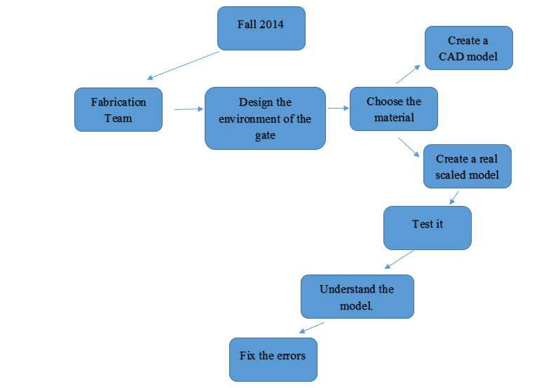

Task Map

Team Roles
Team Coordinator (Carl)
-The team coordinator will ensure that the tasks are completed in a timely and professional manner. The team coordinator will be responsible for organizing meetings and assigning work that is not already implicit in the role of the team member. The team coordinator is responsible for communicating with the team advisor and other aqua clara teams and leadership.
Design Coordinator (Adrian)
-The Design Coordinator will be responsible for all operations involving the design or conceptualization of the goals. The design coordinator will ensure that all members understand the design and have access to the most current CAD drawings of the design.
Materials Coordinator (Sara)
- The materials coordinator will be responsible for the ordering, organizing, and keeping track of the materials used throughout the semester. The materials coordinator will ensure that the team is provided with the materials needed as well as eliminating any unnecessary waste of resources.

Meeting Notes (9/22)
-What kind of materials are available?
-Paul/Tim
-Home Depot
-Internet
-MathCAD file for the weir dimensions?
-Ask Meghan
-Which dimensionless constants should be the same? what size should the model be?
-Ask Monroe?

