Turbidity Final Report

Primary Authors: Emily Clamp, Rohiverth Guarecuco, Julia Morris

AguaClara Reflection Report
Cornell University
School of Civil & Environmental Engineering
Ithaca, NY 14853-3501

Date Submitted: 05/04/11

Date Revised: 05/11/11
Abstract
The goal of the turbidity team was to create a low-cost turbidimeter that measures water turbidity within the range of 5 NTU to 250 NTU. Thus far, the team has brainstormed various turbidimeter designs and created several prototypes for simultaneously testing different LED display patterns. Many patterns have been assessed, including a dual-range LED diplay pattern for measuring a broad turbidity range. The dual-range LED pattern was tested using an experimental setup that allowed turbidity measurement of water that was constantly mixed with kaolin clay using a water pump. The team determined that only the fine pattern of the dual-range pattern was necessary, since the pattern alone could accurately measure turbidities from 5-200 NTU. This approach is based on resolution of the fine pattern within the turbidimeter as opposed to the use of contrast when using conventional Secchi disk patterns. The fine-resolution pattern was used to create a low-cost turbidimeter prototype equipped with an NTU scale based on the power-law equation derived from experimental results.

Keywords:low-cost turbidimeter, AguaClara, LED Display Pattern, turbidity, clay,

Introduction
The challenge faced by the turbidimeter team was to create a device capable of measuring turbidity over a wide range (5 NTU to 250 NTU) with greater than 50% accuracy at a cost of less than $20. Traditionally, low-cost turbidity measurements involve submerging a Secchi Disk in a water body and measuring the distance where the disk becomes indistinguishable, as there is an inverse relationship between depth and turbidity. Secchi disk turbidimeters require expensive transparent tubes and a light source. The light source requirement prevents Secchi disk turbidimeters from being used at nighttime. To improve on the Secchi disk turbidimeter, we created a portable, small-scale prototype using a PVC pipe that is 70 cm long with a 5 cm diameter. Varying patterns on the LED display were tested to replace the Secchi disk. A range of water samples with known turbidities were used to calibrate each prototype for determining the coefficients (a and b) of the following assumed power law relationship.
(1)

The challenge rests in measuring lower levels of turbidity with accuracy. At first, the team thought it would be impossible to cover a wide turbidity range (5-250 NTU) with one LED display pattern. The team proposed using a dual-range turbidity scale using both a fine pattern for measuring lower turbidities and a different pattern for measuring higher turbidities. In the end, the team discovered that the fine pattern alone allowed for measurement of turbidities from below 5 NTU to above 200 NTU. This result allowed the team to conclude that using a simple, fine pattern allowed measurement of a broader range of turbidities by resolution of the fine pattern at different depths in our turbidimeter. This is a different approach from the conventional Secchi disk pattern that uses contrast to relate the depth of Secchi disk disappearance to water turbidity, allowing measurement of a smaller range limited to higher turbidities. The results of our experiments with the fine pattern allowed the team to build a turbidity scale based on a power-law relationship that relates the depth of resolving the fine pattern to a known water turbidity.
Literature Review
The optically relevant substances contained in water sources include phytoplankton, organic detritus, suspended mineral sediment, algae, bacteria, and other dissolved organic matter. Each of these substance has specific absorptions and both backscattering and forward scattering properties of light. (Ferrari, et al., 2005) For this reason, modeling turbid water by using only dissolved kaolin clay does not give the same turbidity in a nephelometer as would an equal mass of a mixture of surface water particles. It follows that for different water samples of equal particulate mass in our turbidimeter the forward light scattered that reaches the observer’s eye is different due to the different light-scattering properties the particles in the samples.
A nephelometer uses these light-scattering properties to measure turbidity by passing a beam of light through the water sample and measuring the light scattered at a detector placed at a 90º angle from the source of the light beam. This is made possible by taking into account the absorbances and scattering properties of the different types of solids that are commonly suspended in natural water sources. However, if the scattering properties of the solids in two different water samples differs (which is often the case, since different aquatic biomes will contain different optically relevant substances in different proportions), a nephelometer can give different NTU values for two homogenous water samples containing equal masses of particles distributed in the water.
The different proportions of optically relevant substances in a turbidity tube are not as important for turbidity measurement because a turbidity tube uses the simplified correlation between visibility and turbidity for a turbidity measurement. Turbidity becomes visible to the eye at approximately 5 NTU in a clear container. With a white, nontransparent tube, the only direction of light scattering of a light source (i.e., LED light) being used to assess the turbidity is the forward scattering of the particles in the direction of the observer’s eye. Thus, for two different water samples with optically relevant substances taken from the same water source, a turbidity tube should give similar depths of non-visibility, since only the forward-scattering particles are contributing to the direction of light reaching the observer’s eye. In addition, certain particles in water, such as algae and colloidal particles, can be more easily distinguished by the eye when illuminated by the light source. Thus, looking into the water sample could also allow the observer to determine the need for disinfection in the water-treatment phase. Disinfection by chlorination is more effective at turbidities of less than 5 NTU, since at higher turbidities disinfection byproducts may form with the high concentration of organic matter present in the water source. (Myre, et al., 2006) The chlorine demand also tends to increase with turbidity and thus high turbidity samples tend to require excessively high chlorine dosages to maintain chlorine residual.

Experimental Design
The team’s ultimate goal was to be able to accurately measure turbidity from 5 NTU to 250 NTU. To do this the team needed to develop a display design optimal for detecting low as well as high levels of turbidity. Before the team considered using a dual-range overlay design, we tested the designs shown in Figure 2.
The basic design components of the AguaClara portable turbidimeter include: (1) a PVC tube as the turbidimeter body, (2) an LED display and overlay design used to test the criteria for visibility through the water sample, and (3) a measuring rod to lower the LED display into the tube body (Figure 1 & Figure 2).
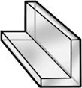
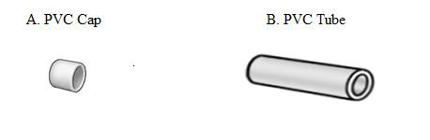
C. Lowering Rod
Figure 1: Turbidimeter Body Components: (A) PVC cap used to close the end of the PVC tube and (B) PVC tube that holds sample water volume to be tested (C) Polycarbonate material used as the lowering rod

A. LED light B. Testing Design #1 C. Testing Design #2
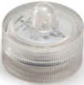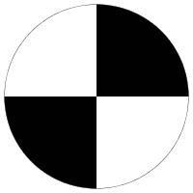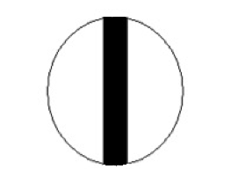
Figure 2: Turbidimeter LED display components include (A) a waterproof mini LED light with an acrylic diffuser; (B) top overlay testing design #1 featuring the classic Secchi disk “checkerboard” pattern; and (C) top overlay testing design #2 featuring a solid black line across the diameter of the LED light

Experimental Methods using a Portable Turbidimeter

To begin experimentation with the patterns in Figure 2, 2.5 L of distilled water was placed in the turbidimeter body. A first turbidity measurement of the sample was performed using a portable nephelometer (Figure 3) to generate a baseline NTU measurement (the water is too clear and therefore outside the range of the LED-depth measurement at this point).
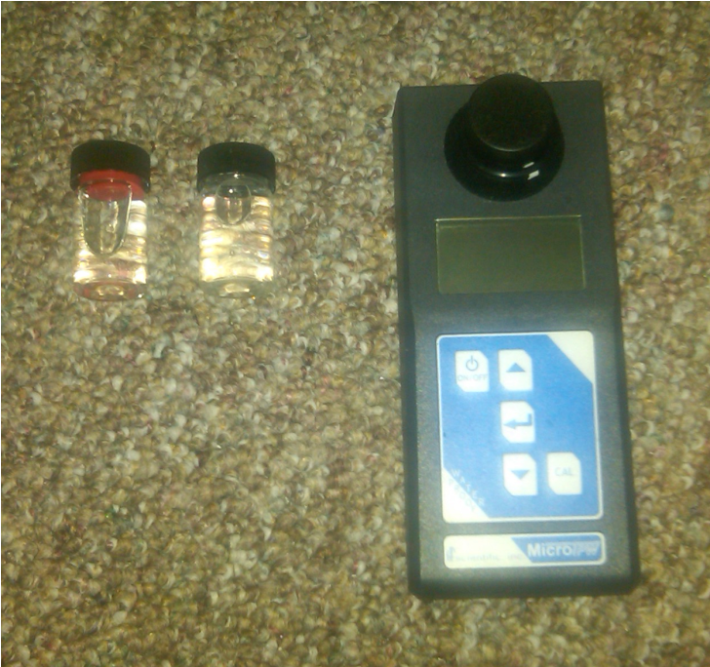
Figure 3: The portable turbidimeter used to generate reliable turbidity measurements

Then, the following procedure was repeated:
1) An incremental amount of Kaolin clay was added to the turbidimeter tube body.
2) A removable PVC cap was placed on the open end of the turbidimeter tube. The closed tube was then inverted five times to promote mixing and to suspend the clay particles in the sample.
3) The removable PVC cap was detached and the measuring rod was lowered into the tube. The lowest depth where the LED display was still visible was recorded in cm.
4) The actual turbidity of the water sample was recorded using the portable nephelometer.
The incremental addition of Kaolin clay allowed us to plot LED Depth (cm) vs. Turbidity (NTU). The constants a and b from equation 1 were then determined by fitting a power-law curve to the plotted data. The R² value of each fitted curve gave insight on the accuracy and reliability of the data fit. A comparison of the R² values revealed which LED design pattern gave the most accurate power law fit. The measuring rod could then be labeled incrementally with the appropriate turbidity scale using NTU values predicted with the derived power law equation, allowing a direct reading of the sample’s turbidity from the measuring rod.

Experimental Methods for Dual-range Scale using an Online Turbidimeter
When the team considered using a dual-range overlay design to measure both low (<5 NTU) and high (>200 NTU) turbidity ranges using two scales on one measuring rod, the design in Figure 4 was proposed.

LED
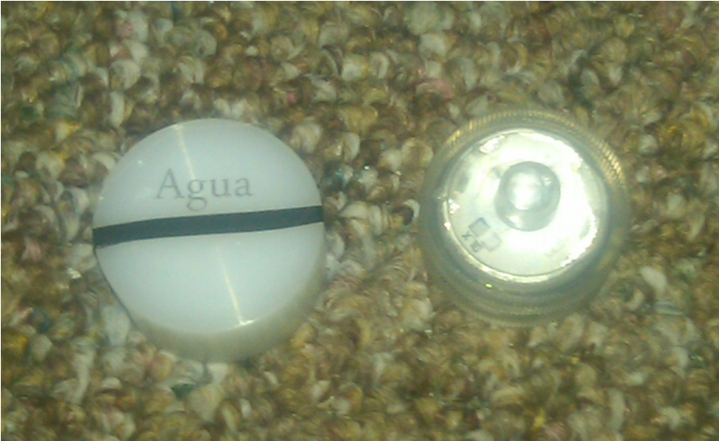
LED Fixture top piece LED Fixture bottom piece
Figure 4: LED light fixture setup including (A) high-density polyethylene diffuser with testing designs: the word “Agua” and a thick black stripe; (B) fixture bottom piece: the LED light

The design consists of a thick, circular, semi-transparent block of high-density polyethylene that was cut to be overlain on top of the LED light. The piece acts as a light diffuser for the strongly concentrated LED light. The word “Agua” was printed on transparent paper and placed on top of the light diffuser for measuring lower turbidy. Additionally, a thick black stripe was added across the diameter of the diffuser as well with black tape, for measuring higher turbidity.
The team felt that the prior method of adding Kaolinite clay particles, capping the turbidimeter body piece, and inverting the body piece multiple times to mix and suspend particles was possibly insufficient. Our hesitation to rely on this method arose when we discovered that turbidimeter measurements fluctuated depending on the lag time between mixing the body piece and taking the measurement- possibly due to the immediate settling of clay particles. To test the accuracy of our calibration method and evaluate whether there existed a significant error source, samples were taken “in the field” straight from Ithaca water bodies (Figure 5).

Figure 5: Field measurements being taken directly from Ithaca water bodies. This measurement was taken after a particularly heavy storm; the turbidity of this particular field measurement was 107 NTU.

The portable turbidimeter was used to generate a turbidity measurement for each field sample. This measurement was then compared against the measurement generated by the Team’s dual-range turbidimeter (which was generated using the equation from the calibration experiment). Keeping in mind the goal of measurements with greater than 50 % accuracy, an analysis was performed to evaluate the calibration technique.
It should be noted that the measurement generated by the portable turbidimeter was assumed to be the “true” turbidity value, although the team needs to further test the validity of this assumption, as there is reason to believe the portable turbidimeter is not 100% reliable and accurate. At present, the portable turbidimeter is our best resource for turbidity measurements in the field, so this assumption was acceptable for first round accuracy testing of the dual-range turbidimeter.
The team concluded that mixing the clay by inverting the tube several times does not mix the clay well enough to mimic the well-mixed turbidity of a river or stream. The team also noticed that when trying to get a reading from the portable turbidimeter the NTU values would fluctuate. This led the team to believe that the portable turbidimeter was not accurate. Thus, the team decided to use an experimental setup that allowed constantly-mixed water and clay to be cycled to an online turbidimeter using a water pump (Figure 6).

Figure 6: Schematic of the constant mix system currently set up in the AguaClara lab

Incremental additions from a stock solution of constantly-mixed clay and water were used to steadily increase the turbidity in the system. The pump was turned off to take a depth reading, and then turned back on for addition and mixing of another clay increment. The fine-print “AguaClara” design was used to measure increasing turbidity starting from 3 NTU. When water was turbid enough to use the black line design, depth measurements were taken with both patterns for comparison (Table 6).
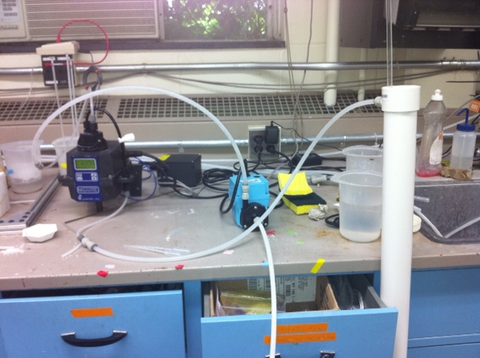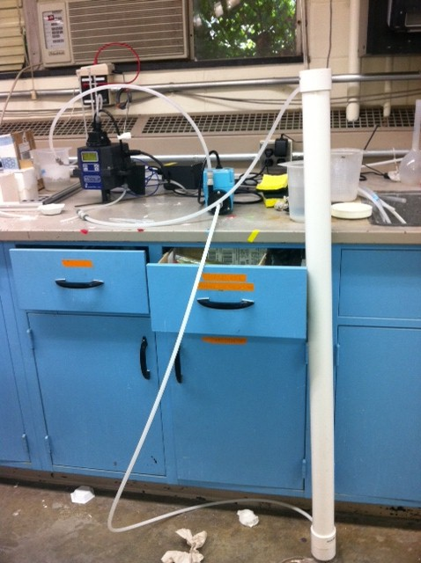

Figure 7: Pictures of the constant mix system currently set up in the AguaClara lab

Results and Discussion

Experimental Methods using a Portable Turbidimeter

The clay concentration and corresponding depth results for the set of samples at increasing turbidities are provided in Table 1 & Table 2. The first experiment (Table 1) used two batteries to power the LED light, while the second experiment (Table 2) used only one battery. LED batteries are easily removed by twisting off the bottom part of the LED, removing one battery, and replacing the bottom of the LED.

Table 1. Experiment 1- Two batteries
Clay Concentration | LED Depth
(mg/L) | (cm)
35.29 | 92.00
47.06 | 70.00
58.82 | 49.00
70.59 | 35.00
82.35 | 28.00
94.12 | 24.00
105.88 | 20.00
117.65 | 16.00
129.41 | 14.00
141.18 | 11.00

Note: The actual NTU corresponding to these concentrations still needs to be determined.
TABLE 2: Experiment 2 - One battery
Clay Concentration | LED Depth
(mg/L) | (cm)
19.61 | 91.00
39.22 | 63.00
58.82 | 42.00
78.43 | 33.00
98.04 | 24.00
117.65 | 18.00
137.25 | 16.00
156.86 | 13.00
176.47 | 11.00
196.08 | 6.00
215.69 | 5.00

The graph of LED depth vs. clay concentration is shown in Figure 8. At the time these experiments were performed, a properly-calibrated portable turbidimeter was unavailable to the Turbidity Team. In future experiments when a calibrated portable nephelometer is available, the actual turbidity of the water corresponding to these clay concentrations will be measured and used to generate a plot of LED Depth (cm) vs. Turbidity (NTU). These preliminary graphs were based on the general rule of thumb that 1 mg kaolin clay/ L of water is approximately equal to 1 NTU. In later experiments, the Turbidity Team tested this assumption of 1 NTU for 1 mg/L clay to validate the above experimental results. Data and results for this test are provided in a later part of the Results and Discussion section of this report.

Figure 8: The plot of the data in Tables 1 and 2 demonstrates whether one batter or two batteries is more accurate. The fitted line assumes a power law relationship between depth and concentration. Experiment 1 with two batteries in the LED gave the best R² value.

As displayed in the above figure, the R² value of 0.99 for the LED design with two batteries vs. the R² value of 0.92 for the LED design with one battery demonstrates that two batteries have much more successful and reliable results in regard to fitting a “turbidity predicting” equation.
Using what we learned from the first two experiments, the next experiment tested the thin black stripe design with two batteries. Additionally, the portable nephelometer was available and the Team used it to make measurements of the turbidity associated with each clay concentration. A power-law assumption was made and a line was fit through the data in Figure 3, generating an equation relating turbidity to depth for that specific prototype design. The results are displayed below in Table 3 and Figure 9.

TABLE 3: Experiment 3 data obtained using an LED powered with two batteries and using a thin black stripe design. The turbidity for each sample was obtained from the portable turbidimeter as LED depth measurements were taken.
Clay Concentration | LED Depth | Turbidity
(mg/L) | (cm) | (NTU)
20 | 91 | 8.09
40 | 49 | 25.02
60 | 32 | 30.47
80 | 23 | 44.71
100 | 18 | 53.8
120 | 14 | 58.76
140 | 10 | 84
160 | 8 | 106.8

Figure 9: Results for the calibration of the thin black stripe LED design, using two batteries to power the LED.

The Turbidity Team attempted to evaluate the relationship between clay concentration and turbidity by plotting the two parameters and fitting a line to the data (Figure 8). This was of interest for our team because the portable turbidimeter was unavailable for a period of time and we wanted to evaluate if our first few sets of experimental data containing only clay concentrations and depths were viable.

Figure 10: The plot of Turbidity vs. Concentration for the Secci disk design pattern and an LED light with one battery. A linear fit was used to generate the relationship between turbidity and kaolin clay concentration.

From the above figure, it can be estimated that 1 mg/L of Kaolinite clay in the sample is equivalent to 0.65 NTU, which is less than the “rule of thumb” that 1 NTU is roughly equivalent to 1 mg/L clay. Significant possible sources of error include insufficient mixing of the clay within the sample volume and imprecise clay weight measurements. The scale available to measure the clay additions was capable of making measurements of grams to two decimal places, while many times we need accuracy in mg (grams to three decimal places), creating a notable error source that was possibly compounded every incremental clay measurements.

Experimental Methods for Dual-range Scale using an Online Turbidimeter
The general steps in the first calibration experiment were again performed for the dual-range turbidimeter design and results used to generate the turbidity predicting equation are included below (Figure 11).
Figure 11: Dual-range calibration experiment to generate turbidity-depth relationship and equation

The generated equations from the above graph that relate turbidity to depth for the dual range system are provided again below:
$Turbidity \left(NTU\right)= 22626 × {Depth(cm)}^{-1.924}$ (2)

$Turbidity \left(NTU\right)= 710.64 × {Depth(cm)}^{(-0.893}$ (3)

The Team then defined the “high range” as turbidity values greater than 100 NTU and the “low range” as turbidity values less than 100 NTU. Using this definition, Equation 2 and 3 were both used in their applicable ranges to analyze the turbidity error and test the accuracy of the calibration method. The data and results for this assessment is provided below (Table 5).

TABLE 5: Turbidimeter Accuracy Test Data
Depth Measurement | Depth Measurement | Turbidimeter | Turbidimeter | Percent
("Agua Clara") | (black stripe) | Prediction | Reading | Error
(-------------------cm-------------------) |  | (------------NTU------------) |  | (%)
12.7 | 16.51 | 170.98 | 107 | 59.79
61 | 91.44 | 22.92 | 22 | 4.20
61 | 118.11 | 14.01 | 16 | 12.44
41.9 | 99.06 | 19.65 | 16.5 | 19.10
48.3 | 88.09 | 24.20 | 16.5 | 46.67

Comparing the turbidimeter prediction to the “true” turbidimeter reading, we were able to generate the percent error column in Table 5. Using the dual-range turbidimeter calibration setup, one out of five trial tests (Trial #1) from Ithaca streams went outside the goal accuracy range. Additionally we note that Trial #1 was in the “high range” of turbidity values, while lower values within the 10- 30 NTU were extremely accurate (in some cases <5 % error) with the present design and procedure. We realize it may be difficult to test extremely low range turbidity values based on the natural stream conditions in Ithaca. However, we plan to continue with these tests and acquire data for the lowest (< 5 NTU) turbidity ranges after longer periods without storms that would stir up the local streams and increase the turbidity levels.

Experimental Results with Online Turbidimeter
A novel approach was used to measure the turbidity. In this method, the use of resolution instead of contrast was employed by using an “Agua Clara” design which was attached to the LED light. Below are the results for the calibration using the constant mix system experimental setup combined with the fine print “Agua Clara” design. Measurements of turbidity level to < 5 NTU were achieved through this technique.

TABLE 6: Test 1 using Constant Mix system and dual-range turbidimeters.
NTU | Depth (cm) – “AguaClara” Letters
3.077 | 102.5
4.167 | 91
4.615 | 69
5.132 | 59
6.481 | 55
7.012 | 49
8.661 | 44
9.31 | 40
10.003 | 40
11.609 | 36
15.167 | 36
20.301 | 25
39.676 | 22
39.676 | 18
51.461 | 15
61.634 | 15
77.946 | 12
104.81 | 10
136.34 | 9
182.93 | 8
251.61 | 7
311.92 | 7

Figure 12: The Log-log plot for the data in Table 6.

Analyzing the above data, we noted that the first two data points (both <5 NTU) didn’t add great value to our calibration, and weren’t very accurately predicted by the power law relationship. For these reasons, we excluded these points and re-plotted the data, generated a better fit calibration equation. The results and equation generated to predict turbidity vs. depth for the final portable turbidimeter prototype are included in Figure 13 below.

FIGURE 13: Calibration values used to create Agua Clara prototype scaling equation.

As seen in Figure13, the equation used to calibrate the turbidity scale has an extremely good fit (R^2=0.99) after removing the first two unnecessary data points. This generated the equation was then used to calibrate the final prototype, with a range from <5 NTU to >250NTU (accomplishing one of the initial goals of the turbidity team!). The team decided the final prototype scale should include the following turbidity values: 5, 7, 10, 15, 20, 30, 40, 50, 70, 100, 150, 200 NTU, and 250 NTU. Using the calibration equation above, the final prototype calibration scale data in included below.

TABLE 8: Final calibration turbidity and corresponding depth used for scale on the measuring rod.
Turbidity Calibration Values (NTU) | Corresponding Depth (cm) – “AguaClara” Letters
5 | 60.00
7 | 49.73
10 | 40.75
15 | 32.50
20 | 27.68
30 | 22.08
40 | 18.80
50 | 16.60
70 | 13.76
100 | 11.28
150 | 8.99
200 | 7.66
Future Work

Test the accuracy of the turbidity scale.
Since the relationship between turbidity and depth is confirmed, the team will attempt to test the accuracy of this relationship by simulating measurements as would be done "in the field". The team will perform turbidity measurements with the prototype using a test sample that was not used in the prototype's calibration. These results can then be compared to generate an idea of the accuracy of each prototypes turbidity scale. Part of our goal is developing >50% accuracy. The error found between the two methods of measurements will help the team decide whether different prototypes or a different scale will need to be considered for greater accuracy. Additionally, it will give the team a basis of judgment between the designs parameters of cost and accuracy for the various prototypes.

Possible sources of operator error
In constructing the turbidimeter, the team tried to predict and eliminate sources of error that might take place in the field due to small variations in operator and operator handling techniques. Variable eyesight among operators and the effect of settling due to the time-delay between acquiring the sample and taking the actual turbidity measurement were identified are two possible sources of error. To resolve the issue of operator eyesight, the team will take depth readings from a large sample of people. Each person will be administered a simple eye test (ability to read certain text at a distance of 1 m). From this data the team should be able to set a vision threshold for the operator of the turbidimeter. The team plans to resolve the issue of solids settling by ensuring the LED light and rod component is capable of mixing the water sample through a manual, basic up and down movement. Furthermore, we plan to include simple operator instructions of how to use the measuring rod as a mixing device prior to taking the measurement.

Standardize materials used in the final design
Once the Turbidity Team has completed its research, design, and testing phases, the team will decide on a recommendation for the standardized construction of the turbidimeter. This decision will take into consideration turbidity measurement ranges, accuracy, ease of handling, and cost-effectiveness. The team will also strive to keep the construction parts at a minimum (only the pipe, LED, LED display, and pre-labeled scale connected to the LED should be necessary). Prior to use in the field, the scale will be calibrated and labeled at regular intervals with turbidity measurements rather than depth measurements. This eliminates the need for the operator to perform a conversion from depth to turbidity each measurement, reducing this potential source of error. Once the scale is determined, the team plans to create a sticker of the scale that will be placed on the lowering device. The team needs to choose a lowering device that is thin but rigid. The lowering device must also provide a surface to attach the scale.

Team Reflections
The team’s first task was to create a prototype. The team ordered the submersible LED lights February 2nd. Unfortunately, we did not receive the LED’s until February 13th. While waiting for the LED lights to arrive, the team tried to stay efficient by preparing the other parts of the prototype, which included locating the PVC pipe for the prototype. There was not much else to accomplish until the LED lights arrived, so this slightly delayed our start, although we tried to fill the time with planning and brainstorming ideas for future prototypes. Once the LED lights arrived, the team noticed that they were blindingly bright. Because the LED brightness was not expected, this presented another complication. To dim the light, a ping pong ball was placed over the LED light, which worked surprisingly well. Since a single battery can be used to power the LED, the final design will take advantage of this, and the ping pong ball may not need to be used. A single black stripe placed on the flat surface of a clear container covering the LED (as the ping pong ball originally covered it) will then suffice as the pattern to be distinguished.
With the new calibration samples in, the team was able to gather the turbidity readings seen in the Results and Discussion section. However, the relationship between kaolin clay concentration and turbidity is not as trivial as 1 mg clay/L = 1 NTU. One problem still faced when using the portable nephelometer is the settling of clay particles within the measurement container. Water samples are taken from the turbidimeter tube immediately after mixing the contents of the tube. The sample container is then cleaned and shaken again to keep the particles in suspension for the portable nephelometer measurement. However, even after the sample container is placed in the portable nephelometer, the sample has to been indexed before the measurement is taken and there is a small time delay before a turbidity reading is actually shown on the nephelometer. This time delay could be significant enough for some of the clay particles to settle in the measurement container. Support for this comes from the fact that sometimes the portable nephelometer will give lower turbidity readings even after an increase in the clay concentration of the water in the turbidimeter tube.
The team has continued collecting data as shown in the Results and Discussion, using the portable nephelometer that was calibrated with new calibration standards. It is clear that a power-law relationship can be fit to the data obtained. In the following weeks, the standardized materials for our turbidimeter will be confirmed, and the necessary materials for the construction of at least three turbidimeters will be ordered. This will allow the three team members to run experiments with the final design simultaneously. The results from this data will allow us to decide on a power-law equation (with constants) that best fits most of the data obtained using the final design. The only concern that remains is the accuracy of the turbidity readings given by the portable nephelometer because of the aforementioned reasons. These readings will be essential to determining the equation that can be accurately used with the standardized components. These will also be the readings used to incrementally label the LED-lowering component of the final design, so the team must be sure that these are accurate turbidity readings.
After Spring Break, the team ordered parts to make two more turbidimeters. The team currently has 3 working turbidimeters each of different heights. The team is still contemplating what to use as our lowering rod and scale. Currently a meter stick and a tape measure are being used. The team believes the best option would be a standard metal rod that wouldn’t displace too much water and is taller than the tube. A sticker of the turbidity scale must be able to be attached to this rod. The team has also come up with a new design for the LED. The LED light is covered with a cylindrical opaque material. This material dims the light as well as provides a flat surface for the pattern. The team came up with a new pattern. The pattern is a bold black line across the middle of the dimming material and the words “Agua” in fine print closer to the top. The fine “Agua” print will allow for lower turbidity measurements and the bold line will allow for higher turbidity measurements.
Recently, the team has decided to evaluate the method of mixing the clay and water used to obtain measurements in the lab. The team believes that the current mixing method does not mix well enough to mimic the well mixed turbidity of a river or stream. The team believes that this creates an unwanted source of error. Also, the team believes that there is an additional source of error using the portable turbidimeter. The team has reason to believe that the portable turbidimeter is not accurate enough. Therefore, the team discussed creating a constant flow setup in the lab that will constantly mix the water as well as be connected to a flow-through turbidimeter. This would help reduce the error that the team is getting from the portable turbidimeter and the current mixing method.
The past two weeks the team has focused on setting up a method to keep the water in the turbidimeter constantly mixing. The first task was to fabricate the tube so that water could be pumped into the top and out of the bottom of the tube. With help from Paul Charles in the CEE machine shop, the team was able to accomplish this the first day. Next step was to connect the turbidimeter to the pump and the pump to the tube (see Figure 6). The team discovered some faulty connections that led to leaking, but the team was able to quickly fix these leaks. The team was then able to run one test with the dual range turbidimeter. It was found that the “AguaClara” letters were able to detect turbidity from about 3 – 300 NTU. Therefore, the team will need to determine whether the black line is necessary.
The team also needs to find a better lowering rod. Currently the lowering rod is a wood meter stick. The team tried to use a measuring tape but found that it was too flimsy. Therefore, the team needs to find a lowering rod that doesn’t displace too much water but is also rigid. The team has contemplated using PVC strip (found of McMaster-Carr) that is 1/8” thick and 1” wide and can be cut to whichever length needed. This material is inexpensive, should be rigid enough, and will be able to hold a sticker containing the scale.

References
Ferrari, G.M., & Tassan, S. (2005, December 5). Proposal for the measurement of backward and total scattering by mineral particles suspended in water. Applied Optics, 34 (36).
Myre, E., & Shaw, R. (2006, April). The Turbidity Tube: Simple and Accurate Measurement of Turbidity in the Field. Michigan Technology University.

