Solar Lovin’ Weekly Update
11/7/2010

Insulation
Subteam Members: Sarah Clement, Harrison Ko, Julianne Schwartz
- Construction of Experimental Oven
  - Problem: How to attach the experimental wall to the experimental oven so it is still easily removable so the insulation material can be changed.
  - Solution: Situate the oven so the end with the experimental wall is the top; therefore, the experimental wall can be placed on the oven and held in place using heavy weights.
  - In order to turn the experimental oven, the wall on top originally had to be secured in place. The team secured the wall using brackets.
- Heat Source
  - Originally the team had discussed using a hot plate as a heat source; however, many issues arose with this idea. For example the plastic on the hot plate, as well as the power cord may melt at the high temperatures needed to test the oven.
  - The team determined the best heat source would be 500 watt halogen lights.
    - Four light sockets were attached to a piece of wood. This will be placed in the bottom of the oven.
- Heat Sensors
  - The heat sensors were connected to a computer and tested. The computer will record the temperature and will be programmed to turn on and off the lights (the heat source) depending on the temperature difference over time. This will be used to simulate the heating and cooling cycles.
  - The team determined that a heat sensor will record the air temperature inside the oven, the inside of the experimental wall, inside the experimental wall, outside of the experimental wall and the outside air temperature.
- To-Do
  - The lights need to be connected in parallel and to a power cord. The wires used to connect the lights, as well as the power cord will be able to withstand high temperatures
  - The heat sensors need to be attached.
  - Insulation needs to be put in the experimental wall.
  - Test the experimental set up and begin to run the experiments.

Concentrated Cooker
Subteam Members: Catherine Hanna, Margaret Ding
We have finalized the design for our parabolic cooker (minus the framework) and have also started building the cooker by cutting the aluminum sheet metal using the methods described below in section “Paraboloid: Construction Process.”
- Paraboloid: Design Specifics
We have decided to use a focal point of 25 cm since our parabola will contain a diameter between 3 and 4 feet (depending on the location of measurement). Based on research, we found that a focal point of 20 cm is recommended for dishes of 1 meter in diameter. Because our actual diameter is slightly more than 1 meter, we chose to use an approximate focal point of 25 cm which is slightly more than 20 cm.

A focal point of approximately a third of the way down from the top of the parabola will ensure and area where heat is collected and guarantee sufficient wind protection. In addition, a cooker of this magnitude is predicted to generate 800 Watts of solar energy. ¹

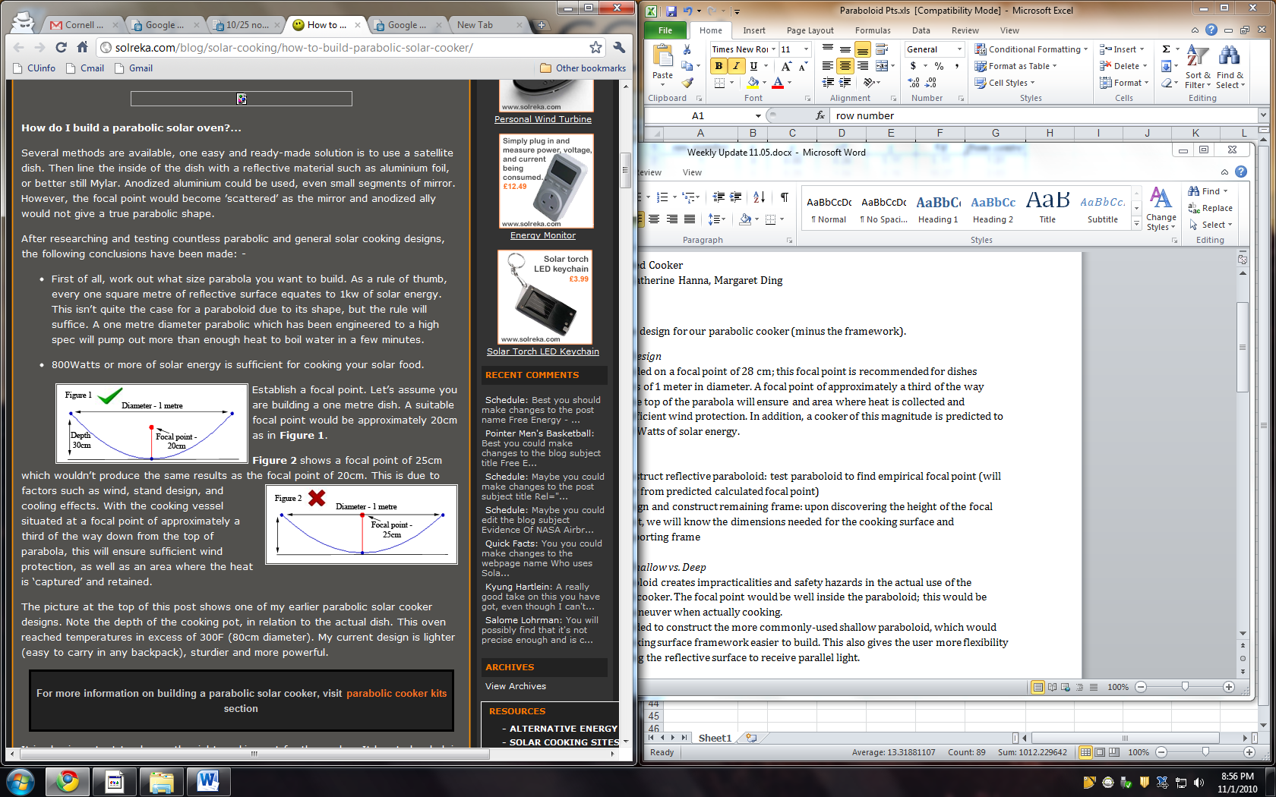
Figure 1. Approximate side cross-sectional view of proposed concentrated cooker

- Paraboloid: Construction Process
In order to create the paraboloid, the flat metal sheet will be cut into 16 pie piece partitions that can be curved upwards in the correct geometry. The partitions will be overlapped with the correctly calculated width to create a paraboloid shape. A table with specific dimensions for each individual partition is shown below (Figure 2 and 3).
row number | x | y | y1 | z | Vd | from centre
1 | 0 | 0.00 | 0.26 | 5.11 | 5.11 | 1.01
2 | 5 | 0.26 | 1.04 | 5.16 | 10.27 | 2.03
3 | 10 | 1.04 | 2.34 | 5.26 | 15.53 | 3.04
4 | 15 | 2.34 | 4.16 | 5.42 | 20.94 | 4.06
5 | 20 | 4.16 | 6.50 | 5.61 | 26.56 | 5.07
6 | 26 | 6.50 | 9.36 | 5.85 | 32.40 | 6.09
7 | 31 | 9.36 | 12.74 | 6.12 | 38.52 | 7.10
8 | 36 | 12.74 | 16.65 | 6.42 | 44.94 | 8.12
9 | 41 | 16.65 | 21.07 | 6.75 | 51.69 | 9.13
10 | 46 | 21.07 | 26.01 | 7.10 | 58.80 | 10.14
11 | 51 | 26.01
x increment | 5.1 | cm
f (focal length) | 25 | cm
sections | 16 | cm

Figure 2. Specific dimensions (coordinates) of each partition

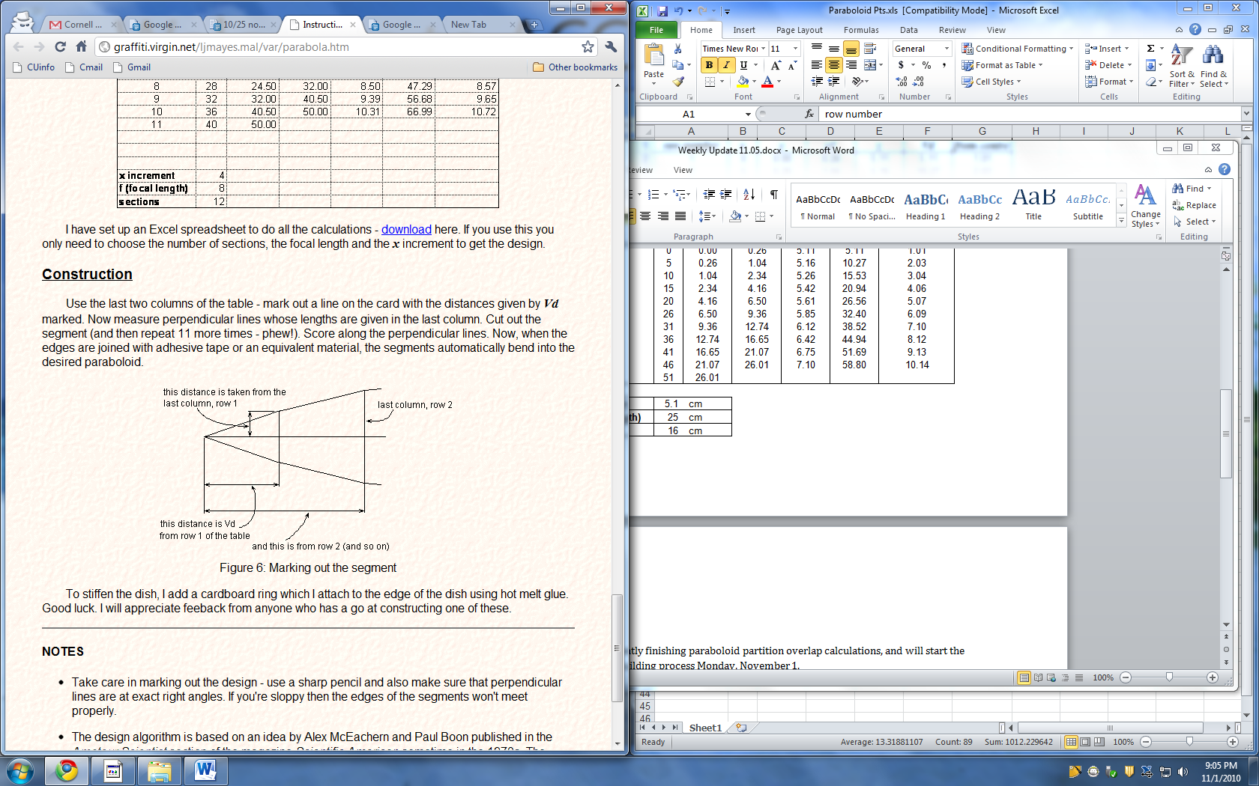
Figure 3. Marking out the segment

To easily trace 16 partitions of similar shape to the figure directly above, we traced one partition on a separate sheet of construction paper. This partition was placed along each center line of the 16 pie pieces, traced, and then cut on one side only. By cutting on one side, the middle section between each cut line and adjacent traced line will be easily overlapped once some sort of adhesive is applied to the material located in this “middle section.” See Figure 4 below.

= cutting line

= uncut region

Figure 4. Sample flat sheet and partition traces

- Paraboloid: Construction Specifics
Referring to the “from centre” column in Figure 2, we can see that the partitions only contain a 1 mm differential on each side. While we were cutting out an example partition to trace on our flat sheet, we noticed the segments were almost completely linear. The 1 mm difference in slope seems miniscule. However, when multiplied by the 32 sides of each partition, a 3.2 cm differential in the 3D paraboloid is clearly noticed.

- Paraboloid: Cutting Technique
The center of the cooker was not cut, but the outer tracings of the partitions were. This untouched center allows for greater stability within the structure.

We decided to leave the center circle of radius 10.3 cm uncut. The cutting lines between each juxtaposed partition were almost completely overlapped within a 10.3 cm radius. Only until a minimum of 15 cm away from the center of the flat sheet did the sides of each traced partition clearly run in non-parallel directions.

- To-Do:
We need to finish constructing the parabolic cooker by adding some sort of adhesive to hold the partitions together. In addition, we still need to design and construct the framework for our solar cooker. This should be relatively simple since we now know the exact dimenstions of the cooker itself. We will start designing and building this framework during the week of November 15.

Bibliography:
"How to Build a Parabolic Solar Cooker | SolReka - Alternative Energy, News, Conspiracy Blog." Solar: Panels, Chargers, Cookers, Gadgets, Lights, Accessories | SolReka - Solar Uk. Web. 01 Nov. 2010. <http://solreka.com/blog/solar-cooking/how-to-build-parabolic-solar-cooker/>.

Mayes, Lawrence. "Make Big Paraboloid Reflectors Using Plane Segments." 25 Dec. 2005. Web. 1 Nov. 2010. <http://graffiti.virgin.net/ljmayes.mal/var/parabola.htm>.

Small Solar Oven/Prop Rod
Subteam Members: Joe Beaudette, Lauren Neilsen, Leif Paulson, Joe Beaudette
- Small Solar Oven Construction
  - Met with the ESW chapter students who were interested in helping out with the construction of the small ovens. We got their contact information, and discussed their availability for helping out with construction.
  - Began construction of the frames. Cut pieces for frames for two solar ovens. From our design drawings, we listed out all 2X2" lengths of board for the frame, and cut out all pieces needed for two oven frames.
  - Materials needed for future construction were discussed with Tim, and we put together our technical update presentation.
- To Do
  - We will continue to work on building the two small solar ovens. We will assemble the frames this week and work on getting insulation and outside materials for the oven
  - We will also continue work with the prop rod by developing a way to test our designs to see which is the most effective.

