November 14, 2010
Team Solar Lovin’

Subteam: Insulation
Subteam Members: Sarah Clement, Harrison Ko, Julianne Schwartz
Completion of the construction of the experimental oven
- This week we completed the entire construction of the insulated experimental oven
- We placed thermocouples in seven places throughout the oven
  - Ambient
  - Inside the oven
  - Against the experimental wall (inside the oven)
  - On the bottom of the insulation inside the experimental wall
  - In the middle of the insulation inside the experimental wall
  - On top of the insulation inside the experimental wall
  - Against the experimental wall (outside the oven)
- We completed the setup of the heat source
  - We are using four halogen lights to heat the inside of the oven to the desired 200 degrees centigrade
  - The lighting system and thermocouples are controlled by a computer which sets the heating system to the desired temperature, and plots the temperature at the different sensor locations
Experimentation
- Before we set the experiment to run through heating cycles automatically, we wanted to test the oven to make sure each part can handle the heat, and that the computer system is running correctly
- We first started by experimenting with air as an insulator
- We began by running the experiment at 50 degrees centigrade and increased the temperature in increments of 50 as the system stabilized
Issues Encountered
- As we got up to 150 degrees centigrade, we noticed the temperature was taking longer to stabilize
- Smoke began to rise from the oven, so we immediately shut off the lighting system
- The halogen light bulbs are held by metal brackets which are nailed to a piece of wood
- The metal brackets were getting too hot for the wood to handle and began to burn the wood
Solution
- We instead decided to attach the metal brackets to a brick using fiberglass tape
- Brick are made in extremely hot kilns, and would therefore be able to handle the heat inside the experimental oven
- We tested the experiment again starting at 50 degrees centigrade and increasing by increments of 50
- This time, the experiment was successful, however the oven now takes longer to heat up, because it also has to heat the brick
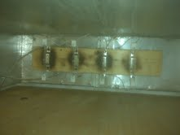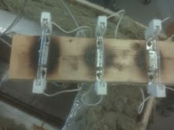
To-do
- This week, we will determine the length of the heating/cooling cycle and begin running the experiment cycles as many time as possible
- Do to the limited amount of time remaining this semester, we may have to adjust the length of time for testing each insulation
- However, if the experiment runs successfully, it will be very useful next semester when they have more time to implement it

Subteam: Concentrated Cooker
Subteam Members: Catherine Hanna, Margaret Ding
This week’s objective was to finish the construction of our first paraboloid reflector, and test to see if it effectively focused light at one focal point. Then we measured temperatures at that focal point to determine whether or not the reflector successfully heated the experimental metal piece to our desired temperatures (250 Celsius).
- Construction
In accordance to last week’s report’s construction process specifications, we completed our first paraboloid reflector. The metal petals were secured temporarily through different types of tape, enabling us to change the geometry if need be.
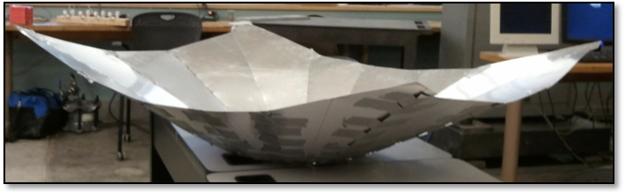

- Focal Point/Temperature Testing Results
Empirical focal point: 10 in.
Theoretical focal point: 9.8 in.
Temperature testing was not completely conclusive, because of time constraints and Ithaca’s bountiful cloudy days. Our most successful test run data is shown below:

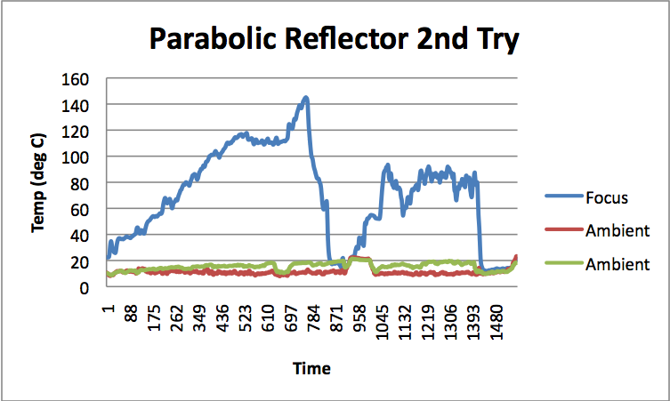
The peak temperature achieved (within minutes) was 145 Celsius, with ambient temperatures at around 11 Celsius.

- Testing System
Our experimental setup involved a propped wheelbarrow supporting the reflector shape/tilt. Tripods supported a wooden rod on either side, with a black metal piece (used to absorb the heat) hooked up to thermal couples attached to the rod.
The sudden drop in the data happened because the tape holding the black metal piece melted and came undone.
The bumpiness of the data is due to wind, and constant adjustments made to a crude reflector support system. The sun’s position is constantly changing and must be tracked to optimize the sunlight focused at the focal point.
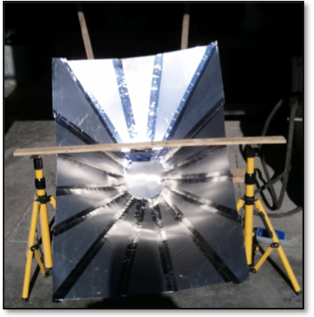
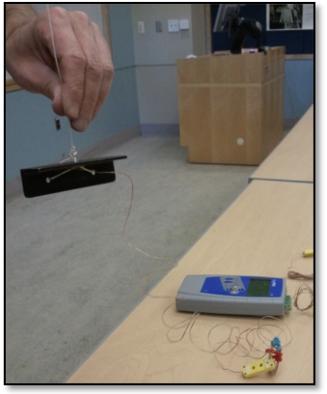

- To Do
  - Design and build a more reliable framing system which enables us to more accurately test the reflector
  - Determine how we will more permanently adhere the reflector’s petal pieces
  - Reach 250 Celsius at our focal point to prove our reflector reaches temperatures high enough to fry food

Subteam: Small Solar Oven
Subteam Members: Joe Beaudette, Lauren Neilsen, Lief Paulson, and Rachel Philipson
- Design and Construction
  - All work this week was focused on building the two small solar oven teams. We finished cutting and sanding all of the pieces for the frames of the ovens. We also cut out plywood to use as the base of the two ovens. We assembled the bottom part of the frames. This was done by using screws to attach all four pieces of the frame together. We measured the length of the diagonals of the rectangle to ensure that the bottoms of the frames were perfectly square. This is necessary because if the bottom of the frame is crooked, the rest of the oven will be difficult to assemble.
  - The rectangular frame was then glued to the plywood siding using wood glue. This connection will be reinforced with screws when other components of the framing are attached. We chose to use glue because it will provide a better sealed connection for insulation and it made assembly of the frame easier.
  - Design for how to hold in the insulation was also discussed. The way the frame was designed, it is impossible to connect the siding holding the insulation in place to the frame on all four sides. We decided to put in blocks on the bottom of the oven that siding would be attached to in order to provide this seal for the insulation.
- To Do
  - This week we will continue to work on construction of the small solar ovens, we will also be ordering additional components needed for completion of construction, mainly the glass for the window.

