Solar Lovin’ Technical Update | November 8  2010
Joe Beaudette, Sarah Clement, Margaret Ding, Catherine Hanna, Harrison Ko, Lauren Nielson, Leif Paulson, Rachel Philipson, Julianne Schwartz

Table of Contents

Introduction 2
Insulation Subteam 2
Concentrated Cooker Subteam 2
Small Solar Oven Subteam 2

Introduction
As this year’s Solar Oven team, we strive to continue the sustainable efforts of previous teams in improving the current solar oven design and looking at alternative types of solar ovens (such as concentrated cookers). During this process we are maintaining constant communication with the Nicaraguan women’s group Grupo Fenix to obtain feedback and suggestions concerning their needs.
We have chosen to split into three separate subteams, each with its own distinct focus. The Insulation Subteam is responding to the Nicaraguan women’s comments about the current solar oven’s insulation material, wood shavings. The wood shavings become less effective after one year of oven use, and the team is researching alternative materials. The Concentrated Cooker Subteam is designing and constructing a solar cooker that reaches higher temperatures than the current solar oven, enabling the frying of foods. The team is communicating with Grupo Fenix to measure local interest in this technology. The Small Solar Oven Subteam is building multiple smaller-sized ovens to be used for demonstrations here in Ithaca, educating others and raising awareness about the capabilities of solar energy.
This technical update outlines each group’s progress and the changes that have been made to the original plans, with detailed explanations of the rationale for the changes.

Insulation Subteam
The insulation used in the current solar ovens, wood shavings, has been deemed unsatisfactory by the women’s group in Nicaragua, Groupo Fenix, due to the lack of longevity of the material. The objective of this project is to investigate and identify materials of insulation that would be superior in performance and longevity. To investigate new insulation materials, we determined the best approach was to design a new experiment. This experiment would involve isolating the heat transfer of the system through a single wall of the cooker with interchangeable insulation. Observations from the experimentation will allow us to draw conclusions to improve the insulation in the solar box cookers.
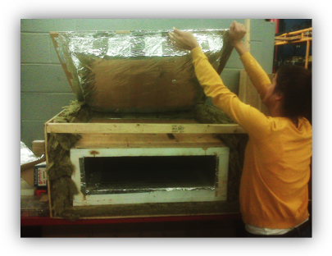

As previously stated, the idea of the insulation test is to isolate heat transfer through a single wall of an experimental solar oven. The experimental wall will be built to mimic the walls of a conventional solar oven; however, the main difference would be the interchangeable interior of the wall. The heat inside the box will travel the path of least resistance through this one wall since the insulated box is designed to have the five non-experimental faces that have a thermal resistivity far greater than that of the experimental wall.
Figure 1
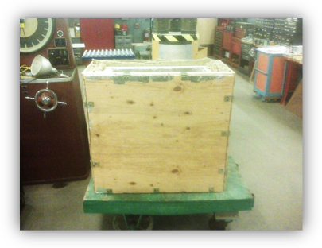

Originally, the insulated box would be set up in the same orientation that the ovens are meant to be used (see Fig. 1). In other words, the experimental wall would be perpendicular to the ground. However, as construction progressed, difficulties with attaching the removable experimental wall arose. Our solution to this difficulty was to rotate the entire insulated box 90 degrees so that the experimental wall would be located on the top (see Fig. 2). This would make attaching the experimental wall to the box easily manageable. By simply putting weights on the wall during experimentation, the wall would be firmly attached during testing and easily removable at any given time. Moreover, since heat is known to rise, this provides further justification for assuming that the vast majority of heat transfer in the box will travel through the experimental wall.
Figure 2
Figure 3
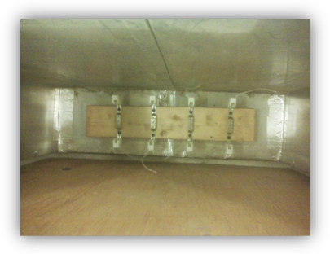

The heat source that would be used inside the box was originally planned to be something similar to a hot plate. However, after further investigation, it was determined that a hot plate would likely melt under the high temperatures (of approximately 200 degrees centigrade) that would be reached within the oven. Because of this inconvenience, we discovered that using a system of four 500W halogen lights would work much better (see Fig. 3). These lights would be connected together in parallel to obtain equal voltages in each of the lights. Furthermore, each light will be connected to a capacitor by a high temperature power cord that carries enough charge to power all the lights at once. This system, combined with the temperature sensors, is connected to a computer that can control the light system based on the temperature differential between the readings of the air in the oven and the surrounding ambient temperature.

Concentrated Cooker Subteam
Our team is designing a concentrated cooker which implements a 3d parabola (paraboloid) as its reflective surface. The previous solar oven team constructed a concentrated cooker prototype which had a 2d parabola reflective surface. The resulting cooker was ineffective in regards to reaching the 250 Centigrade temperatures needed to fry foods, so we decided to pursue the more effective 3-dimensional approach. This means that our design process has less in common with the previous years’, and we had minimal established design plans. Our design has evolved based on ongoing research and consideration of the demands on our concentrated cooker. We have no changes to the design to report, because we had no initial design.

In regards to our design and construction process, we have decided to split it into two phases: (1) Design/build the paraboloid reflector (2) Design/build the frame and cooking surface. Originally, the plan was to complete an optimal design of the entire cooker, and then start the construction process. Upon further consideration, we realized that the frame and cooking surface configuration heavily depends on the location of the focal point. Although we will have a calculated a theoretical focal point for the paraboloid, the actual location of the focal point is unknown until empirically confirmed. That is why we are splitting the concentrated cooker project into two phases. The location of the paraboloid’s focal point will determine the type and dimensions of the frame and cooking surface.

Due to time constraints from having to comprehensively design a 3d parabolic concentrated cooker, we will not be able to extensively redesign our prototype after testing. We will compile temperature testing results from the final product and write up future improvements/recommendations for next year’s team to review.

Small Solar Oven Subteam
In regards to the design and construction of the small solar oven, plans have had minor changes. We have based our design off of the oven Professor Vanek currently uses. We have used the basic dimensions from his oven (the length and width of the base), but have made some modifications. The most significant modification to his design thus far is the door. Currently, the door rests on the outside of the oven frame. The new door will fit into the oven frame, which will create a better seal, which will help with the minimization of heat loss. We have asked people from the ESW Club at Cornell to help us with construction so we can finish the ovens in a timely manner and begin with the demonstration aspect of our project. Previous tasks took exactly the amount of time we originally allotted, but the “build” part of our project is proving to be more involved than we originally expected. We have also decided to build two small solar ovens simultaneously: one for our use and one for the ESW club to use. The help provided by club members will help us finish our project in the time we have allotted.

Additionally, the Small Solar Oven team has taken on another project in conjunction with the small solar oven. The women in Nicaragua have reported that they are having trouble with the prop rods and hinges of the ovens. The prop rods are not strong enough to hold the lid of the oven in place, and torsion from wind eventually causes the hinges holding the lid to break. We have been developing ways to fix this problem. Our solution involves redesigning the prop rod and using two (current designs have one prop rod). Instead of the wood board with discreet holes that correspond to oven height, we will use a tee with a metal rod going through the straight part. The flat part of the tee will be screwed into the oven wall, and there will be a screw on the other side of the tee that holds the rod in place. The advantage of this design is that there are no discreet points on the prop rod, meaning the lid can be opened to any angle. Additionally, it should be more robust than previous designs. Our advisor, Tim Bond has been extremely helpful in procuring materials to use for this project, and this has enabled us to make quick progress. In upcoming weeks, we plan to test the effectiveness of the prop rods. The nature of the test has yet to be determined, but we would like to subject the prop rods to some sort of wind and see how they hold up.

