ANC Control Summer 2010 Final Report
Sang Hoon Song
Anna Lee
Roy Guarecuco
Drew Hart

Abstract
AguaClara plants rely on sweep flocculation to achieve high performance requiring a pH between 6.5 and 7.5 even after the dosing of alum. The low alkalinity of Honduran source waters requires the addition of acid neutralizing capacity to buffer against changes in pH from the precipitation of aluminum hydroxide after alum addition. The summer 2010 ANC Control team has continued to investigate the possibility of using a lime feeder with AguaClara plants to deliver saturated calcium hydroxide solution to the plant flow. The team now believes that the inability of the lime feeder to produce saturated effluent for long periods of time is primarily due to the precipitation of calcium carbonate which inhibits Ca(OH)₂ dissolution. Experimental runs with distilled water and Honduran lime have produced better results than those seen in past semesters, but only 15% to 20% of the total lime dissolves to give a saturated effluent, too little for the lime feeder to be economically viable compared to sodium carbonate dosing. The team has added effluent recycle to remove carbonates from the reactor influent, which will be tested by future teams. In addition, the team is closer to determining the composition of the lime using the Total Carbon Analyzer.

Introduction
AguaClara plants rely on efficient flocculation and sedimentation processes for high plant performance. A major constraint for effective flocculation is maintaining a pH range 6.5 to 7.5 so that aluminum hydroxide is the predominant species produced after alum addition. In addition, hydrogen ions are released as aluminum hydroxide precipitates form, lowering the pH of the water in the absence of acid neutralizing capacity. The low alkalinity of source waters in Honduras do not effectively buffer against changes in pH with alum addition resulting in less aluminum hydroxide precipitation and decreased flocculation performance. To maintain an appropriate pH range, we would like to add a high-alkalinity solution to the plant flow. Alkalinity, or acid neutralizing capacity (ANC), can be defined as the equivalents of carbonate and hydroxide species present in the source water:

$ANC=\left[HCO_{3}^{-}\right]+2\left[CO_{3}^{-2}\right]+\left[OH^{-}\right]-\left[H^{+}\right]$ (1)

Two major design constraints for adding alkalinity are that the chemical should be inexpensive and readily available and the apparatus easy to construct, maintain and operate with locally available materials. Calcium hydroxide (Ca(OH)₂), or slaked lime, is a chemical commonly used in Honduras in making tortillas, so it both cost-effective and easy to acquire locally. It is relatively soluble and a saturated solution has a pH of approximately 12.3, as calculated based on a K_{sp} value of 5*10⁻⁶ mol³/L³ and the AguaClara ANC team is investigating the use of a lime feeder to constantly produce a saturated effluent of calcium hydroxide. The apparatus consists of PVC pipes connected in series to provide a fluidized bed of suspended solids for maximum dissolution contact time. Solid particles are kept from escaping with the effluent through the use of a tube settler. Further detail is contained in Figure 1.
To monitor the performance of the reactor in the lab, the ANC team measures the effluent pH, which should remain at or near the saturation value of 12.3 for the planned length of a run. However, throughout all of the experiments run by past and present ANC teams, the effluent pH dropped prematurely. The goals of the team are to determine the primary reasons for the premature failure of the reactor, test possible solutions, and determine whether our lime feeder design can compete practically and economically with simpler methods of adding alkalinity such as dosing with a more expensive base solution like sodium carbonate. In addition to being able to produce saturated effluent for longer periods without the risk of premature failure, the lime feeder must be integrated with the rest of the AguaClara plant and require minimal regular maintenance.
Recent ANC teams have worked with two main hypotheses for premature failure. The first hypothesis is that a shift in particle size distribution towards larger particles over the course of an experimental run decreases water-surface contact. Particle-water contact area is directly related to the amount of time the lime has to dissolve and saturate the solution and is a function of both the number of particles in the water’s path and their surface area. The surface area to volume ratio is proportional to the reciprocal of the particle’s radius (Equation 2), so for a given quantity of lime, smaller particles have more available surface area.

$\frac{SA}{V}=\frac{4πr^{2}}{\frac{4}{3}πr^{3}} → \frac{SA}{V}∝ \frac{1}{r}$ (2)

There are several proposed mechanisms for why there would be a shift in particle size distribution towards larger particles over the course of an experiment. First, the smallest particles have the highest surface area to volume ratio and therefore contain the lime which dissolves most quickly. It is hypothesized that the smallest particles dissolve early in the run to produce saturated effluent, leaving only larger particles which have a lower surface area and may fail to provide sufficient contact area. Second, the smallest particles are those which are most prone to being carried out with the effluent because they have the lowest settling velocity. After modifying the reactor to effectively decrease its capture velocity by a factor of four, the team believes it has largely eliminated this effect, except when an excessive amount of lime is added at a high flow rate.
Finally, past teams have observed that large flocs form fairly early in the experiment which can have a dramatic effect on total available contact area, as the difference in diameter between the fine particles and the flocs may be very large. This seems to be the most plausible failure mechanism related to particle size, since small particles dissolving and escaping with the effluent early in the experiment would likely happen on a shorter time scale than the 15 hours of good performance we often see before failure. This summer after literature review has shed light on the reason for flocculation.
It is hypothesized that a significant portion of the surface area of the suspended solids is made up of calcium carbonate when flocculation is occurring, as related to our second failure hypothesis discussed below. It has been shown that calcium carbonate can exhibit different zeta potentials as time passes since its formation. Calcium carbonate formed in an excess of Ca⁺², as is the environment of our reactor, exhibits a positive zeta potential for long periods of time (Chibowski 2003). Old, pre-formed CaCO₃, on the other hand, has been found to exhibit a negative zeta potential. In addition, surface charge increases with pH after about 10 (Russel 2009). These differences in surface properties between a negatively charged calcium hydroxide particle and a positively charged calcium carbonate in the reactor may contribute to the coalescence. This idea of flocculation has thus become closely tied with our second failure hypothesis, which has been the focus of the summer2010 team’s research.
The second hypothesis is that solid calcium carbonate, a less soluble compound than calcium hydroxide, is interfering with dissolution. It is thought that the calcium hydroxide particles are being coated in solid calcium carbonate, which is insoluble in the high-calcium concentration environment and prevents further lime-water contact, causing the effluent concentration to drop well below saturation. Originally, this was thought of as a replacement reaction on the surface of the particles, where carbonate ions present in the solution replace dissolving hydroxide ions, as in Figure 3a.
However, a literature review has led the summer 2010 team to believe that actual precipitation of calcium carbonate on the surface of lime particles is the more likely mechanism (Figure 3b). Calcium carbonate has been shown to precipitate under supersaturated conditions, particularly in the presence of heterogeneous precipitation nuclei (Lioliou 2007). That is, calcium carbonate provides the best surface for further precipitation of calcium carbonate, which can be modeled as a second order reaction. It is thought that the more similar the structure of the nucleation site to calcium carbonate, the closer the precipitation will be to this second order process (LioLiou 2007). We believe that calcium hydroxide, the predominant solid surface in the reactor at the beginning of a run, provides a surface structure similar enough to calcium carbonate to provide an effective precipitation nucleus.

a.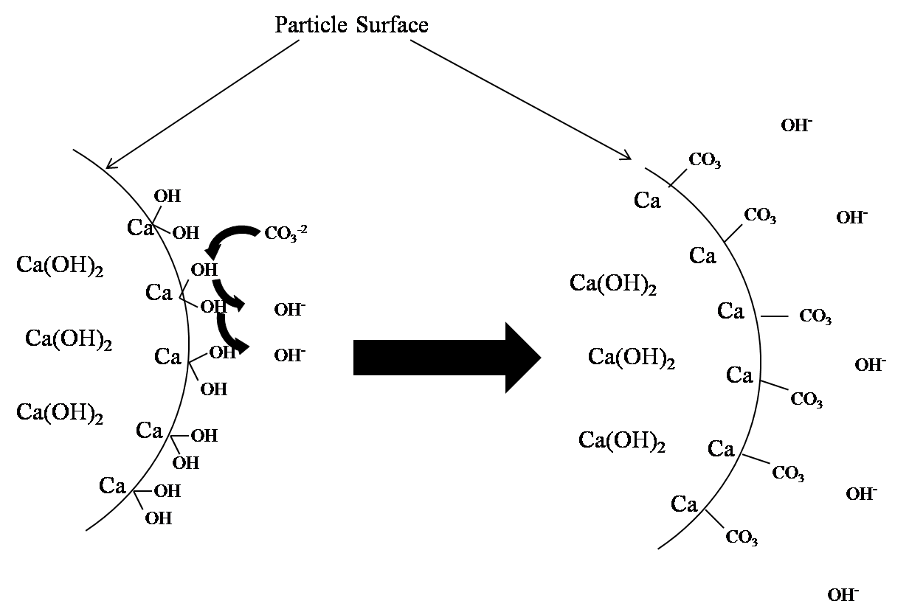 b.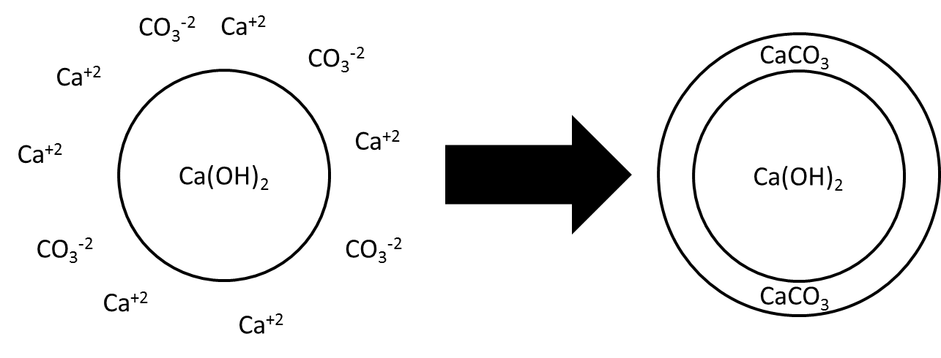

Figure 1. The first diagram above (1a) shows the surface replacement reaction process by which calcium carbonate was previously thought to coat particles. The team now believes the mechanism is actually more like calcium carbonate precipitating using the calcium hydroxide particles as precipitation nuclei, as in the second diagram (1b).

Calcium carbonate solution precipitates at a supersaturation index value of 1.6 under heterogeneous, or surface site mediated, precipitation conditions (Lioliou 2007). The supersaturation index, S, of calcium carbonate is defined as:

$S=\frac{γ_{{Ca}^{+2}}\left[{Ca}^{+2}\right]γ_{CO_{3}^{-2}}\left[{CO}_{3}^{-2}\right]}{K_{sp}}$ (3)

Because the reactor conditions are saturated or near-saturated with calcium hydroxide, which is much more soluble than calcium carbonate, calcium concentrations are very high relative to the solubility of CaCO₃. Therefore, it takes a very low concentration of carbonate ions to trigger precipitation in the presence of favorable nucleation sites. Ignoring the activity constants $γ_{{Ca}^{+2}}$ and $γ_{CO_{3}^{-2}}$ the team calculated that even with CO₃⁻² concentrations at the level of distilled water used for our source water, the calcium concentration from saturated calcium hydroxide resulted in a CaCO₃ supersaturation value of more than 35, as calculated with equations (3), (4), and (5), clearly enough to precipitate, perhaps even on less favorable surfaces. For this calculation we assumed the carbonate concentration in distilled water was in equilibrium with CO₂ in the atmosphere as described by Henry’s law (Equation 4) and at the pH of interest, the predominant carbonate species was in the form CO₃⁻². The calcium concentration was calculated using the solubility constant of calcium hydroxide (Equation 5).

$\left[{CO}_{3}^{-2}\right]=k_{H}×P_{CO2,atm}$ (4)

where k_{H} is the Henry’s law constant for carbon dioxide, equal to 3.4*10⁻² mol/L*atm, and P_{CO2,atm} is the partial pressure of carbon dioxide in the atmosphere.

$\left[Ca^{+2}\right]={\left(\frac{K_{sp, CaOH2}}{4}\right)}^{\frac{1}{3}}$ (5)

The team believes that the important source of carbonate ions is the influent water. Although we know that the lime itself contains some fraction of calcium carbonate, it is likely completely insoluble in the high-calcium reactor conditions. In addition, the reactor never fails immediately, but rather takes several hours before the failure mechanism takes effect, which suggests that the slow buildup of carbonates from the external source is the significant problem. One possible mechanism by which the lime-based calcium carbonate could be having an effect is if particles sink down to the low-calcium bottom portion of the reactor, dissolve, and re-precipitate on the lime surface as the solution climbs back up.
Until more data is obtained on the quantity of carbonates in lime, the team believes that removing a significant amount of carbonates from the reactor source water may eliminate the problem. One proposed solution which the team is investigating is to recycle some fraction of the reactor effluent back to a pre-treatment reactor where the high-calcium flow is mixed with the source water in order to cause the carbonates to precipitate out before reaching the main lime feeder.
Another significant part of the summer 2010 team’s work was to determine the composition of the Honduran lime. One of the primary reasons is to determine what fraction of the powder we have is useful calcium hydroxide. In addition, we would like to know the fraction that is made up of calcium hydroxide so that we can determine the potential effect on the reactor if it were to dissolve relative to the carbonate ions from the influent. Finally, the presence of soluble carbonates may have a preliminary effect on the lime which leads to faster reactor failure. However, this effect is likely insignificant.

Design and Economics
Apart from being inexpensive to construct, the lime feeder must be easy for the plant operator to maintain. It should be able to operate such that fresh lime need not be added more than once every 24 hours and the effluent remains saturated throughout that time. It should not require frequent unclogging, and there should be an easy way to add fresh lime during plant operation. In addition, the reactor should be scalable to accommodate large and small plants and possible fluctuation in plant flow.
The team’s most recent lime feeder design uses PVC tubing in an arrangement which consists of a vertical fluidized bed column and a larger-diameter tube settler in series (Figure 2). Water enters from the bottom of the lower vertical column and leaves through the top of the slanted tube settler. The upper vertical small-diameter column is open to the atmosphere at the top and is used to feed in lime slurries while the apparatus is running. The solid lime settles down through the still water and joins the flow in the fluidized bed portion of the reactor. The tube settler portion is at a 22.5° angle to the vertical tubes because of common PVC pipe fittings.

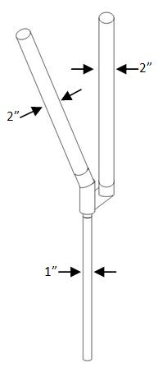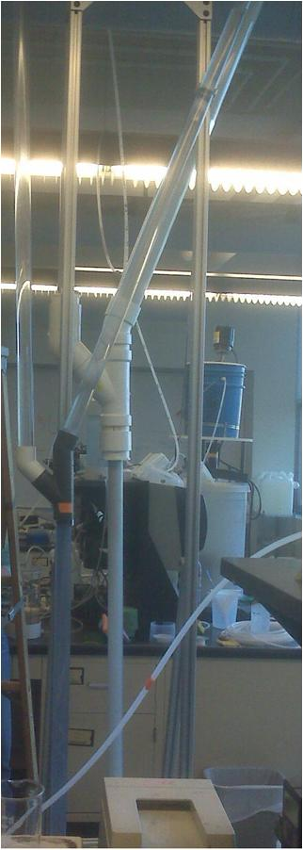
1”
Figure 2. The ANC team’s lime feeder design features a vertical 1-inch diameter column and slanted 2-inch diameter tube settler connected in series, along with a vertical column open at the top to feed lime. The smaller reactor in the picture at right is the older design, which has a 1-inch diameter tube settler.

Because the solid lime must remain in the reactor and not be carried out with the effluent for the lime feeder to continue to produce saturated effluent for long periods of time, the tube settler acts analogously to the AguaClara sedimentation tank plate settlers to lower the capture velocity of the reactor so that smaller particles are retained. In addition, the larger diameter upper arm lowers the capture velocity by a factor of four compared with the old 1-inch diameter tube settler design, which further decreases the size of particles the reactor can capture.
Unless the lime feeder is ultimately designed to perform such that all lime dissolves before the effluent concentration falls below saturation, a significant portion of lime will be wasted. Efficiency of the reactor can be thought of as the fraction of lime actually used to add alkalinity to the plant flow. A measure of lime feeder efficiency, explained below in the results section, is useful for economic comparisons with other solutions to the ANC problem. In the case of a highly soluble base like sodium carbonate, with which we would make a concentrated stock solution and use a chemical doser, we can assume 100% efficiency. Multiplying the price per unit of a given base by the efficiency of the dosing apparatus and normalizing for the number of equivalents of ANC provided per mole (equal in the case of calcium hydroxide and sodium carbonate) allows a rough but direct comparison of the cost per ANC equivalent (Equation 6).

$\frac{Cost}{Equivalent}=\frac{Cost}{Unit Mass}×\frac{Molecular Weight}{Equivalents/Mole}×η_{Feeder}$ (6)

Sodium carbonate can be bought in Honduras at the rate of 25kg for 293.25 Lempiras. The price of hydrated lime is approximately 58 Lempiras for 40 pounds. Converting to cost per equivalent of ANC, sodium carbonate and lime come out to 0.49 Lempiras/eq and 0.12 Lempiras/eq, respectively. Practically speaking, sodium carbonate is a factor of four more expensive. Thus, assuming a sodium carbonate doser works with 100% efficiency, our lime feeder must be more than 25% efficient to be economically viable in comparison. This does not account for differences in the cost of implementation of the two methods. For lime, this may include a relatively expensive series of lime feeders and the cost of disposal of waste solids left in the reactor.
A further design consideration is the scaling of the lime feeder as it is constructed to accommodate the range of flow rates seen in AguaClara plants. The important variable in lime feeder performance is not flow rate but upflow velocity, as this is what determines what particles remain suspended in the reactor, the residence time of the feeder, and how well the fluidized bed is maintained. Thus, when the optimal range of upflow velocities is determined by future ANC teams, the reactor must be designed with cross sectional areas which produce those velocities given the possible range of plant flow rates and associated feeder flow rates. In determining the lime feeder flow rate, the important variables are plant flow rate, raw water pH, raw water alkalinity, and the alum dose, since the appropriate amount of base solution must be added to raise the plant pH into the optimal range for flocculation. The ANC team has developed a model from which the feeder flow rate can be calculated given values for those parameters.
The following example is for AguaClara’s newest plant, Agalteca, which has a flow rate of 6.3 L/s. If we take typical values of 40mg/L for the alum dose and a raw water pH of 5.5, a saturated lime solution flow rate of 0.086L/s is necessary to maintain the pH at 7. In order to keep the same upflow velocity used in the lab when the reactor flow rate is only 30mL/min, which is about 0.90 mm/s, a vertical tube diameter of about 14 inches is necessary. This becomes a significant design issue because PVC pipe in large diameters is very expensive. The necessary pipe diameter will increase with plant flow rate, alum dose, or as raw water pH decreases. In addition, if we wish to keep the upflow velocity in the tube settler portion of the reactor a factor of four lower to facilitate settling of small particles, we must double the diameter for the tube settler segment. This then limits the effectiveness of the tube settler in capturing small particles. It is likely that for plants with large flows, several smaller lime feeders would need to be used in parallel in order for the construction to be practical and affordable. Multiple feeders would have the added benefit that a plant operator could take one or more offline to obtain a more desirable upflow velocity in the feeders that were running.

Experimental Design
The ANC Control team works with several experimental setups: the lime feeder apparatus with pH measurement, lime composition testing including a furnace and the Total Organic Carbon analyzer, the ANC titration test, and a recycle system which was added to our original lime feeder setup in order to remove carbonates from the influent.

Lime Feeder Experimental Setup
The lime feeder apparatus that we worked with consisted of three polyvinyl chloride pipes that were joined together to form a standing “Y” (Figure 2, Introduction). This apparatus was adopted for its ease of feeding lime during operation, ability to keep suspended solids in the reactor, and the maintenance of fluidized beds. For all of the team’s experiments during summer 2010, distilled water was pumped through the bottom at a rate of 30 mL/min, which corresponds to an upflow velocity of 0.90 mm/s in the fluidized bed column, and flowed out through the top of the tube settler into a separate reservoir where pH was measured. The effluent dripped out of the outflow tube so that the pH measurement reservoir was electrically isolated from the rest of the system (Figure 3).

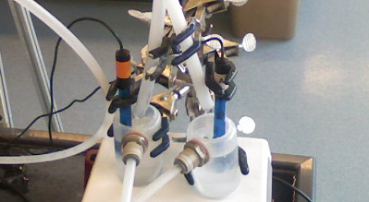
Figure 3. The setup for measuring effluent pH involves electrically isolated reservoirs so that voltage in the water system is not picked up by the pH probes.

This set-up was implemented in order to eliminate the voltage in the system which may be picked up by the pH probes, making the readings less reliable. However, this later became irrelevant when it was recognized that the calibration range of the pH probes did not include our range of interest and the readings must be regarded as somewhat inaccurate.
The lime was blended in order to reduce particle size and increase the surface area over which the lime and water could interact. This slurry-like solution was then poured into the top of the upper vertical column which is open to the atmosphere. For all experiments conducted by the summer 2010 team, 100 grams of Honduran lime was mixed with 300 mL of distilled water to make the slurry.

Lime Composition
The team tried several techniques to determine the composition of lime. We first conducted a volatile suspend solids test in which the lime was fired in the furnace at 900°C. It was believed that any calcuim carbonate would decompose at this temperature and that the resulting change in mass would give us its corresponding percentage in the lime. Althought calcium hydroxide would also decompose, forming calcium oxide and releasing water vapor, we believed that the powder would rehydrate upon contacting the atmosphere and this lost mass would be restored. However, we since realized that calcium oxide can exist as a solid in contact with the atmosphere, and that the rehydration process takes place on a longer time scale. Moreover, the more dominant reaction of calcium oxide with the atmosphere may be with CO₂, forming additional calcium carbonate which was not present before the test. For the volatile suspended solids test to work, the calcium hydroxide must be decomposed first at 580°C and the water removed before subsequently breaking down the calcium carbonate. This step-by-step process may be valuable in confirming the results obtained with the TOC analyzer.
The Total Organic Carbon (TOC) analyzer measures either total carbon or the inorganic component of total carbon by converting the respective component to carbon dioxide and running it past an IR sensor. The machine senses carbon dioxide and plots the level measured versus time. The area under the plot is then proportional to the total mass of carbon released, which can be calculated using a calibration curve built from a sample of known composition. The team attempted to employ the TOC analyzer’s liquid sampler in order to determine the carbon composition of a small dissolved sample of lime. After obtaining questionable results, however, we recognized that calcium carbonate is highly insoluble in the presence of concentrated calcium hydroxide due to the common calcium ion. Therefore, calcium carbonate would not dissolve proportionally and each sample would not be representative of the actual composition of the lime powder.
The TOC analyzer’s solid sample machine is more appropriate for the ANC team’s purposes because the samples we have are already in solid form and there is concern about having a representative sample, assuming the powder is well-blended. Because the organic carbon component of our lime is believed to be negligible, the total carbon and inorganic carbon component are equal. Because total carbon does not require sparging with acid, it is easier and more reliable to measure, so we used it for both for the solid sampler and a calibration curve that was built using pure calcium carbonate sample. From that, the carbonate composition of a lime sample can be calculated using the peak area produced by burning the sample at 900°C.

ANC Testing
Due to our inability to precisely measure the pH of a near saturated solution of lime, the pH data is not useful for determining exactly how much lime dissolved. Rather, the plots of the data allow us to analyze the amount of time for which the effluent is saturated. Moreover, since the acid neutralizing capacity (ANC) of a sample is conservative and the pH is not, ANC tests provide a more useful parameter and can be performed with the procedure found on the following website: [http://ceeserver.cee.cornell.edu/mw24/cee453/].
As each titration began, relatively large titration increments were used. The pH of the solution after each titration was recorded after it stabilized. The titration increment was decreased as the pH of the solution decreased. More specifically, for a sample of approximately 50 mL, the titration increment was decreased to 0.1 mL in order to determine the volume of equivalency as accurately as possible. Each sample was titrated beyond its point of equivalence, and the measured pH data was used by the software to create a Gran plot for each titration. This plot was then used to calculate the equivalent volume of titrant, from which the ANC was calculated.

Pretreatment Reactor
The most recent proposed solution to the calcium carbonate failure hypothesis described in the introduction section above is to include a pretreatment reactor in which carbonates precipitate with calcium to remove them from the influent water before it reaches the lime feeder. This reactor consists of a vertical column into which flow both the influent water and the saturated calcium hydroxide solution from the reactor effluent, followed by a slanted column which acts as a tube settler to keep the suspended solids in the reactor. The vertical column is seeded with a solid, either calcium carbonate or hydrated lime, in order to provide initial nucleation sites to begin precipitation as early into the run as possible. Figure 4 shows the full experimental setup including this proposed pre-treatment reactor.

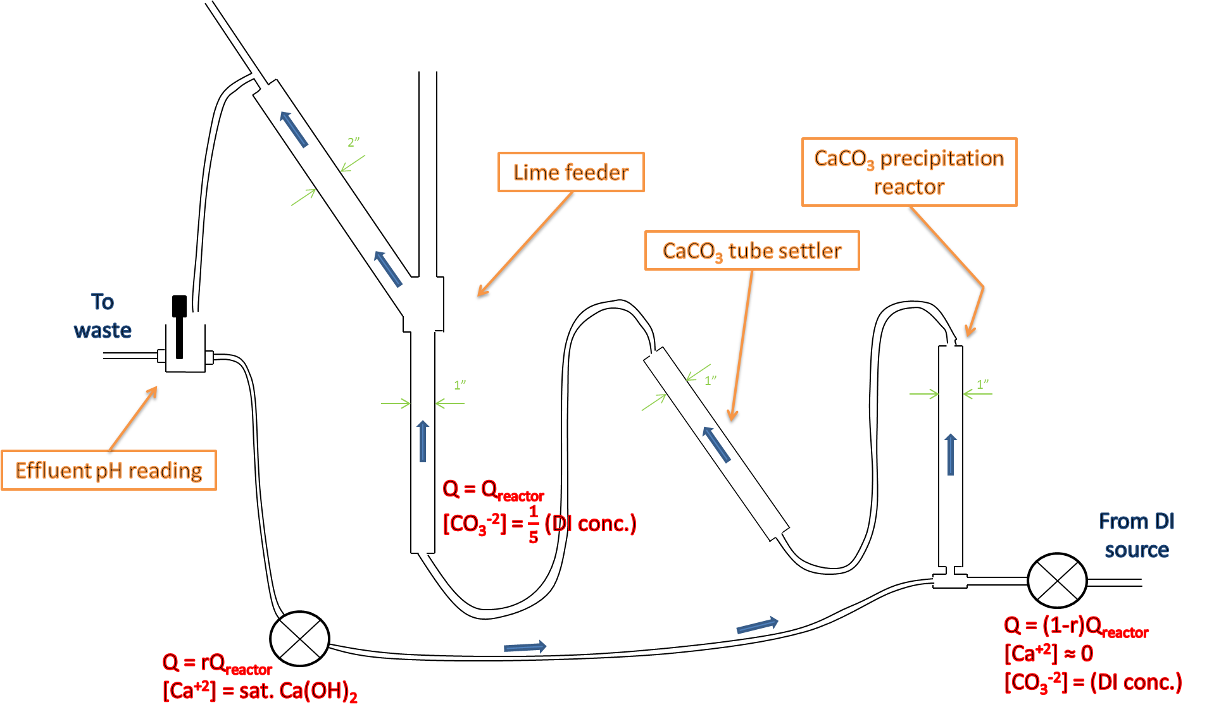
Figure 4. The propsed setup with a recycle line delivering concentrated calcium hydroxide to a pre-treatment reactor is meant to cause carbonates to precipitate from the source water before it reaches the main reactor.

Calculations to determine the recycle rate and the appropriate drop in carbonate concentration which could be achieved found that we could theoretically cut the carbonate concentration of the influent down by a factor of five with a recycle rate of approximately 22%. For this calculation, we assumed that calcium carbonate would continue to precipitate if the supersaturation index were at or above 1.6. Therefore, we calculated the recycle rate which gave a supersaturation index of 1.6 when the carbonates were at the goal concentration. The team believes that cutting the influent carbonate concentration by a factor of five may delay the reactor’s failure long enough to make it viable. For these calculations, we assumed that the drop in calcium concentration from precipitation in the pre-treatment reactor was negligible. Thus, the desired concentration of carbonate at the end of the reactor and calcium concentration going into the reactor, which is multiplied by the recycle ratio, can be plugged into Equation 3 for supersaturation index. We can then solve for the recycle rate in order to design our apparatus (Equation 7).

$Recycle=\frac{S×K_{sp}}{{\left[Ca^{+2}\right]}_{CaOH2 Sat}×{\left[CO_{3}^{-2}\right]}_{desired}}$ (7)

Where S is the supersaturation index, equal to 1.6, and K_{sp} is the solubility constant for calcium carbonate, approximately equal to 4.8*10⁻⁹ mol²/L².

Results and Discussion

Lime Feeder
One of the major changes we made in analyzing our data this summer is the method of calculating the efficiency of the lime reactor. Previously we had used standardized sum of total lime dissolved reflected by effluent pH data. However, the inconsistency in calculated values which had resulted in multiple trials of running the same experiment, revealed flaw in the pH measurement. We had to come up with a new standardized method of calculation that involves reasonable and measureable parameters. We decided to use the length of time at saturation over length of time expected given lime mass and flow rate. This makes sense because the length of time when the effluent is saturated is the measure of how useful a run is. Only saturated effluent can be dosed effectively with the plant flow. The time spent at saturation can be estimated from the slope of the effluent pH plot, which shows a steady horizontal line over the time of interest. Reading the plot, one can roughly gauge the time that the plateau begins and the time when the pH starts to decline and subtract the two values. Given the noise present in the areas of rapidly changing slope in some pH plots, this method is certainly subject to interpretation and human error. A sample calculation is show below.

$T_{Theoretical}=\frac{M_{Lime}}{{MW}_{Lime}\left[{Ca}^{+2}\right]Q}=69.7hr$ (8)

Where M_{Lime} is the initial mass of lime added, equal to 100g, MW is molecular weight, and Q is the flow rate, 30 mL/min. The calcium concentration is that of saturated calcium hydroxide solution, used in this calculation because it is equal to the number of moles per liter of dissolved lime. Dividing this calculated theoretical time by the run time at saturation, we get our efficiency, as given with the experimental runs below.
The summer 2010 ANC team ran three experiments with the lime feeders. The first two employed both the large (5cm) and small (2.5cm) tube settler reactors, labeled A2 and A1, respectively, which the third used only the larger reactor. The third experiment was intended originally to check what seemed to be faulty data based on our original method of calculating efficiency. However, the numbers we were getting were due to flawed technique rather than faulty data. With our current method of calculating efficiency, we get fairly consistent results across the three experiments.
The first experiment run was the first ever by the ANC team using Honduran lime. As expected because of its lower capture velocity, the reactor with the larger tube settler outperformed the smaller one, although the longer residence time results in a lag in reaching saturation (Figure 5). The efficiencies calculated from the run times taken from the pH plot are 16% for the 2.5cm tube settler and 19% for the 5cm tube settler.

Figure 5. From the effluent pH data from the first experiment run by the summer 2010 team starting June 30th it can be seen that while the effluent takes longer to reach saturation due to the longer residence time, the reactor with the larger tube settler remained at saturation for longer, approximately 14 hours compared with the 11-hour run time of the smaller reactor.

The second experiment run this summer was an exact replica of the first, attempted originally to obtain better pH data. Because we now believe that it is both difficult and unimportant to obtain accurate effluent pH data, the follow-up experiment serves as confirmation of results. Other than differences in the specific pH values measured, which are simply due to inconsistencies in pH measurements well outside the calibrated range, this experiment ran remarkably similar to the first, with calculated efficiencies from the 2.5cm and 5cm tube settler reactors of 16% and 21%, respectively. The noise in the data and the gradual rise to saturation make the time spent at saturation with this experiment subject to human error.

Figure 6. With the effluent pH data from the summer 2010 team’s second experiment, we see again that the reactor with the larger tube settler (A2) outperforms the smaller (A1) with a 15-hour run at saturation versus A1’s 11 hours.

The third and final experiment, run with only the 5cm tube settler, was otherwise an exact replica of the first two, originally meant to serve as a re-run of the other data sets produced by A2 which are not acceptable given that measured pH values are unreliable. In the final experiment we see a slightly worse reactor performance than with the first two, with a calculated efficiency of 17%. A difference like this may again be partially due to measurement error and human error in interpreting the charts.

Figure 7. The plot shows the pH data from the summer 2010 team’s third experiment, where only the larger 5-cm tube settler reactor was used. The data shows a run time at saturation of approximately 12 hours.

TOC Analyzer
At the end of the summer the team successfully built a calibration curve using the TOC analyzer’s solid sample TC machine. Calibration samples of pure calcium carbonate were used in order to build a relationship between peak area measured by the machine and the mass of carbon present in the sample (Figure 8).

Figure 8. The TOC analyzer’s solid sample total carbon calibration curve was built based on pure samples of calcium carbonate, which have a known carbon content. Because it is believed that the only significant source of carbon present in our lime samples is in carbonates, the relationship is left in terms of mass of carbonates in the sample, rather than mass of carbon.

Although there was insufficient time for a large set of samples to be analyzed, the team was able to obtain results for two samples of Honduran lime (Table 1).

Table 1. Data obtained for two sample runs with the TOC solid sample total carbon analyzer using Honduran lime. The mass of carbonate in each sample was calculated from the peak area using the relationship from the calibration curve (Figure 8).
Sample Mass (mg) | Peak Area (mV*min) | Mass CO₃ (mg) | Fraction CO₃ | Fraction CaCO₃
1614 | 636.1 | 37.4 | 0.0232 | 0.0386
542 | 293.3 | 16.8 | 0.0311 | 0.0519

The calculation for the fraction of calcium carbonate in the lime assumes that 100% of the carbonates present are in the form of calcium carbonate. The results from the two samples in Table 1 are inconsistent enough that replication of the experiment is clearly necessary before conclusions are reached about the carbonate content of the lime. However, they do provide a rough preliminary estimate which suggests that calcium carbonate is indeed present and makes up less than 10% of the total mass, as expected.

Future Work
One of the primary tasks for future ANC control teams is to finish determining the composition of the Honduran lime. Progress using the TC solid sample analyzer should make this process easier. For future experiments using the lime feeder, the team should use the effluent pH data as an indicator of when the reactor is producing saturated solution using the slope of the plot. We no longer believe that pH is a reliable indicator of the amount of lime dissolved because the readings are inaccurate in the range of interest. To measure actual effluent pH indirectly, a sample can be tested for ANC and total carbonates, from which the pH can be calculated. For future teams, we believe effluent alkalinity is a more useful and reliable measure of effluent quality than pH.
In addition, the team has hypothesized that a significant source of the carbonates causing failure may come from the source water itself. The team will experiment with the possibility of altering the current lime feeder to include a pre-treatment reactor that removes carbonates from influent water using a fluidized bed of lime before it reaches the lime feeder. Future teams should also experiment with parameters such as upflow velocity and the initial mass of lime in order to reliably determine the ranges of values which produce the best results. Additionally, past experiences with the addition of lime are not sufficient to show the best way for lime to be added to the reactor. Future teams should run experiments to determine conclusively whether performance improves when lime is added as a blended slurry instead of dry powder.
The 24-hour run should no longer be the singular goal of the team. Rather, achieving a viable efficiency should be the most important goal for future teams. We would like the lime feeder to run for as long as possible without the need for maintenance and to use a higher fraction of the initial lime, which would both boost the economic viability and minimize costs and efforts associated with cleaning the reactor. The 24-hour timeframe is somewhat arbitrary with respect to reactor performance, although it is still an important benchmark that must be achieved for the technology to be practically viable.

