2010
Prepared by: Yoon Choi Advisor: Dr. Monroe Weber-Shirk
Civil and Environmental Engineering Cornell University
5/30/2010
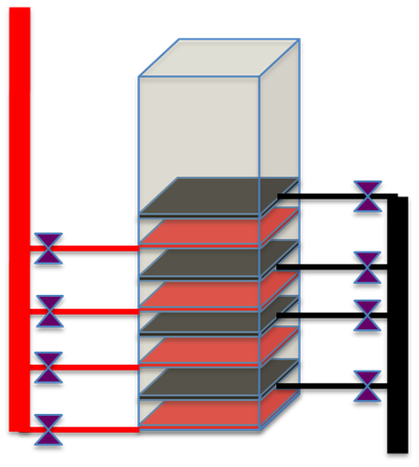
AguaClara Filtration Research: Vertically Stacked Filtration
Table of Contents
Page

Executive Summary 3
Introduction
Background 4
Design Objectives 4
Research Methodology 6
Theory behind Stacked Filtration Design 6
Calculation of Design Parameters 11
Result and Discussion 14
Conclusion 17
Future Challenges 18
Works Cited Page 19

Executive Summary
The purpose of this report is to: 1) document the design selection methodology and criteria for a filtration system for AguaClara and 2) present the initial parameters and assessment of the stacked filtration design. For our design purposes, the stacked filtration system is meant to supplement the AguaClara plant at Agalteca, Honduras. This research was part of a semester long research on filtration by the Spring 2010 AguaClara Filtration Research Team.
For this research, a review of existing of research and technology was first conducted. The incompatibilities of existing filtration technology with AguaClara were identified and taken into account during the design and selection process. This report also builds on the general guidelines for AguaClara systems, such as the requirement for no electricity use, with additional requirements for filtration systems, such as the requirement for the system to be open for observation.
The key components of our stacked filtration design consist of 1) using the effluent water from the sedimentation tank, the same that is filtered by the filter, to backwash the filter and 2) designing the filter so that the flow of filtration is equal to the flow required for backwash. A plant scale, stacked filtration model for the current AguaClara Agalteca is relatively small compared to the sedimentation tank. Our stacked filtration design, however, is based on three assumptions to be covered later that need to be verified first through bench scale model testing before it should be considered for implementation in actual AguaClara plants.

Introduction
Background
AguaClara is a project of the Civil and Environmental Engineering Department at Cornell University that strives to improve drinking water quality through innovative research, knowledge transfer, open source engineering and design of sustainable, replicable water treatment systems. Open source engineering means that we share our knowledge and research with everyone openly. Currently, six water treatment plants have been built in Honduras and they are producing, on average, an effluent water NTU standard of 5-10. The current Honduran and World Health Organization standard is 5 NTU. All six water treatment plants utilize flocculation and sedimentation technology to achieve this standard.
The purpose of supplementing the current AguaClara water treatment process with filtration technology is to lower the effluent NTU to 1 or lower. Most conventional water treatment plants utilize filtration technology to achieve this standard as well. The current granular filtration technology used will enable us to achieve 1 NTU or lower effluent standard. Our challenge is to adapt that technology to AguaClara constraints of economic and environmental sustainability. In other words, the filtration technology for AguaClara, like other AguaClara technology, must have the capacity to endure and be easily replicated because it is environmentally sound, reliable, efficient, and cheap.
Design Objectives
In order for our design to be sustainable, it must meet the following objectives:
- Achieve effluent standard of 1 NTU or lower.
- Do not use electricity. Electricity is costly and not consistently available in a country like
Honduras, where our technology is meant for.
- Make minimal use of specialized components that would be difficult to acquire in remote
communities. Again, our technology is meant for the countries that cannot afford conventional water treatment.
- Make the system open to the atmosphere. The operator needs to be able to observe the
backwash process, so the filter media must be visible. This is likely to be impossible with pressure filters.
- Make it easy for an operator to operate and maintain.
- Costs less than the costs of sedimentation tank and flocculation tank. The improvement
in water quality from filtration is perceived by the community to be small compared to the improvement from the flocculation and sedimentation processes, so the filters need to be less expensive than the flocculation and sedimentation equipment.
- Minimize use of water. Many of the communities that will be using our water treatment
plants do not have enough water to meet their needs, so the quantity of water that is wasted to clean the filters must be minimized.
- A large tank to hold water for backwashing is not economically feasible.
- The distribution tank is not a viable source of water for backwashing because
it is impossible to guarantee that there will be enough water in the distribution tank.
- If we cannot use stored water for backwash, then the maximum flow of
water required for backwash must be at most 50% of the design plant flow rate. This will make it possible to run the water treatment plant at a lower than design flow rate and still be able to operate the filters. This requirement means that if we use 7 filters to backwash 1 filter, then we would need to have another set of 8 filters that could potentially be turned off so that plant could function at 50% of design flow capacity. The requirement of being able to backwash at 50% of design flow rate makes the option of using multiple filters to backwash a filter impractical.
Research Methodology
Our research and design methodology consisted of the similar steps. My research team first conducted a review of the existing technology and research with regards to general granular filtration, current use of clear wells, and stacked filtration. Our major source of existing research was Surface Water Treatment for Communities in Developing Countries by Christopher R. Schulz and Daniel A. Okun.
After developing a basic concept of operation and design, we calculated basic design parameters to supplement to currently existing Agalteca plant. We then assess the plant design in accordance with the criteria mentioned in the Project Objective section. If the design passes, the next step would be develop a bench scale model to test for assumptions made and also to see if the sustainability criteria still holds. If possible, we would recommend a pilot scale model testing prior to actual implementation in an AguaClara plant.
Theory behind Stacked Filtration Design
A vertically stacked filtration system meets many of the AguaClara Project constraints. First of all, both normal filtration and backwash operations are gravity driven and requires no electricity. It is an open system. The construction material, PVC pipes, sand, concrete, and rebar are relatively cheap and abundant in Honduras. Most importantly, sand filtration gives us the ability to consistently lower the effluent NTU standard to below 1 NTU.
The premise of the stacked filtration system is that the flow of filtration is equal to the flow of backwash so that we can use normal plant flow to backwash the filter. A conservative estimate of backwash velocity requires that it be 10 times the normal filtration velocity. We achieve this requirement by stacking layers of filtration on top of each other. Each layer, or plane, consists of a set of inlet tubes that introduce water to a layer of 20 cm of sand. The water once filtered is then collected by a set of outlet tubes. Each layer is essentially its own filtration system. When you stack the layer of filtration on top of each other, area for backwash stays the same and you can backwash all of them with the same backwash water. This should reduce the backwash water requirements by a factor equal to the number of filters in a stack. Figure 1 Basic Concept of Stacked Filtration Operation and the mathematical derivations demonstrate this relationship.

Where
BW=Back Wash
Q=Flow rate of filtration, backwash, or entire plant depending on the subscript.
V=Velocity of either filtration or backwash depending on the subscript.
A=Area of either filtration or backwash depending on the subscript.
N=Number of any system, pipe, and etc which in this case is the number of filtration unit that receives the plant flow rate.
For our design, we chose a conservative available backwash flow rate of only half of the plant flow rate.
We want the backwash flow rate to equal the filtration flow rate. So we arrange the first two equations for the plant flow rate and set them equal to each other.

When we substitute the 10 to 1 relationship between backwash and filtration velocity into the above equation, we derive the following relationship with regards to area.

With the velocity of filtration cancelling each other, we learn that in order to use the same flow rate to backwash and filter we need the area of the filtration to be 10x the time area of backwash. Consequently, if we were to have two filters, then we would need 10 filters stacked of each other. If we were to have four filters, like our design, then we would have 5 layers for each filtration system.
There is a tradeoff between the height of the individual filtration unit and the number of filtration units employed. When you decrease from four to two filters, the height of the individual filter essentially doubles. This relationship exists because, in order to have a geometry that allows same flow rate to filter as well as backwash, the total ratio of filtration area versus backwash area must be kept constant. Essentially, the number of filtration planes to backwash planes is set. For our example, the ratio is 10 to 1 because our backwash velocity is ten times greater than the filtration velocity. Consequently, when we select a two filter system, we reduce the number of backwash planes to two, which means that there must be a total of twenty filtration planes which now must be split between two filter units. The height of the individual filter increases as a result.

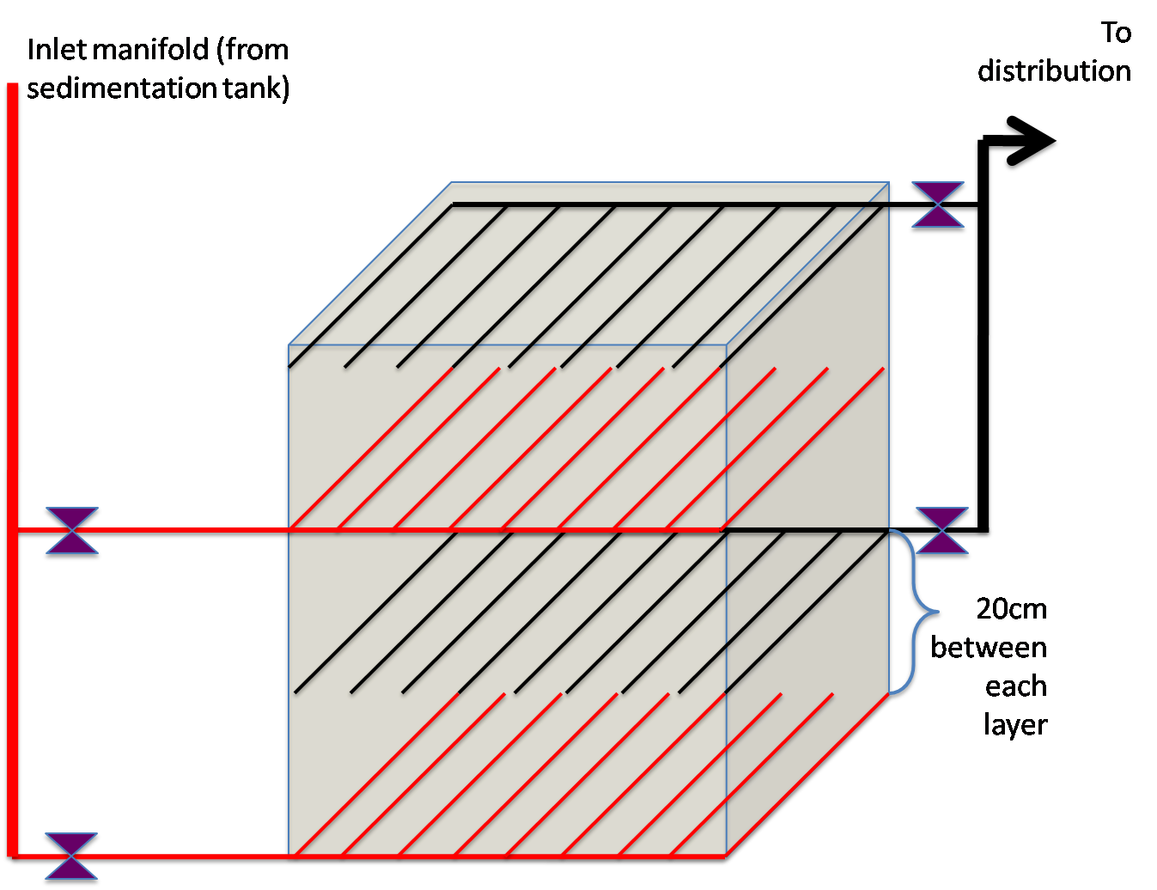
Figure 1: Basic Concept of Stacked Filtration Operation
As shown in Figure 1, there are gate valves to introduce or restrict water to the individual filtration unit. For example, if plant flow decreases to a point where one filter unit can handle the flow rate, we can shut down flow to three of the filter units so that we can perform maintenance on them. During backwash operations, we will first use valves to close off the water leading to the distribution tank. As shown in figure 1, we would only need to close off the valves on the outlet manifold. Then we would introduce back wash water from the sedimentation tank through the inlet tubes. As the first layer expands, we would close off the water to the top layer of influent tubes. Once the top layer expands we will close off the top inlet manifold. Now all of the backwash water will be pouring through the bottom inlet manifold. These tubes will be designed to handle that flow and, since they are purposely located at the bottom, they would be able to fluidize the entire sand bed.
In order for our design to work, we made the following assumptions. First we assumed that 20 cm of sand will effectively filter 5-10 NTU effluent water from the sedimentation tank to lower than 1 NTU without clogging at a reasonable rate. Second, we assumed that the unfiltered water from the sedimentation tank would be able to backwash the filter so that it can continuously filter water to 1 NTU or lower standard. Third, we assumed that, as long as the distance between the filtration tubes in a layer, is small compared to the depth of a layer of sand, the flow of water coming out of the tubes will converge and form a plane of filtration. For our purposes, we assumed that a ratio of 1 to 10, comparing the distance between the tubes and the sand layer, would be small enough. One of the future challenges for the filtration team would be test these assumptions. Consequently, a layer of inlet tubes sandwiched between two layers of sand would effectively have two plane areas of filtration (Figure 2).
Figure 2: Plane Area Concept
Calculation of Design Parameters
Our design process consisted of 3 major steps. First we designed the individual filter bed itself based on the relationship equations mentioned in the theory section. Second, we sized the pipe in our system so that the head loss experienced by the pipes is never greater than 10% of the head loss experienced by the sand. If the head loss in the sand is not greater than the head loss in the pipes, there will be preferential flow and not all of the pipes in the manifold will have equal flow. The third step was to design the minimum distance between the entrance pipes from the sedimentation tank to the height of the gutter to ensure proper back wash.
In our first step, we chose a conservative back wash velocity 14 mm/s that we know empirically to raise a layer of sand bed 30%. We also chose a conservative back wash flow rate of 3.15 L/s which is half of the maximum plant flow rate at Agalteca. Based on that given parameter, we solved for the area of the filtration bed as shown below.
We made the design a square with a side length of 0.474m which would also be the length of the filtration inlet and outlet tubes.
In our second step, we solved for the head loss that occurs in the 20 layers of sand using the Carmen-Kozeny Equation (Okun, 121) shown below:

Where

h=head loss

L=length of layer which in this case is 20 cm.

K=Kozeny constant of 5.

=porosity of sand=0.4 for our case.

g=acceleration of gravity.

d=diameter of sand which in this case is 0.55mm.

V=velocity of the fluid passing through the filter

ν=kinematic viscosity=10⁻⁶ m²/s

We find that the head loss is around 10cm. Since we want the head loss in the sand to dominate, we design all of our pipes to have large enough diameter so that their head loss never exceeds 10% of the sand’s head loss.
We utilized the manifold equation as shown below:
As the MathCAD file (AguaClara, Stacked Filtration Page) shows, we calculated the inlet and outlet tubes to be ½ inch and the manifold connecting them to be 3 inches in diameter. Because during back wash, the entire back wash flow rate must pass through them so the inlet tubes for the bottom plane need to be 0.75 inch in diameter. The rest of the pipe system needs to be 3 inch in diameter.
Our last step was to determine the minimum distance between the entrance pipes from the sedimentation tank to the gutter of the filtration unit. The minimum distance must be greater than the head loss that occurs through the pipes and the expanded bed during head loss as shown below in Figure 3 Distance from Entrance Tank to Gutter and in our MathCAD file. We first calculated the head loss in the pipes during back wash to be 0.5 cm. Most of the head loss occurs in the expanded bed calculated as shown below (Okun, 161):

Where the previously undefined variables are
h= Head Loss
H=Height of Unexpanded Bed
SG=specific gravity

Figure 3: Minimum Distance from Gutter to Entrance Pipe
Results and Discussion
Our complete filtration system for Agalteca consists of a four rapid sand filtration system (Figure 6). When arranged side by side with concrete wall with a thickness of 20 cm, the total width will be 2.90 m and the total height will be 1.5 m. Each filtration unit will be 1.5 m in height and the sand portion will be square with a side of 0.47 m. Each filter will have 5 layers with each layer, consisting of a set of inlet pipes, 20 cm sand layer, and a set of outlet pipes. Please see Figure 4 Top View Comparison of Agalteca versus Stacked Filtration and Figure 5 Side View Comparison of Agalteca versus Stacked Filtration. Each layer will hold 18 perforated pipes except for the bottom inlet layer which will hold only 12 because they are bigger tubes. Such arrangement will leave 0.5 in between each upper tube and 0.75 in between the bottom filtration tubes. This is a very conservative design because it maximizes the number of filtration tubes which we believe would do a better job of acting as a plane of filtration than fewer tubes. The future challenge for the filtration team is to test this assumption and find out how much space we can have between tubes and still achieve a plane like effect.
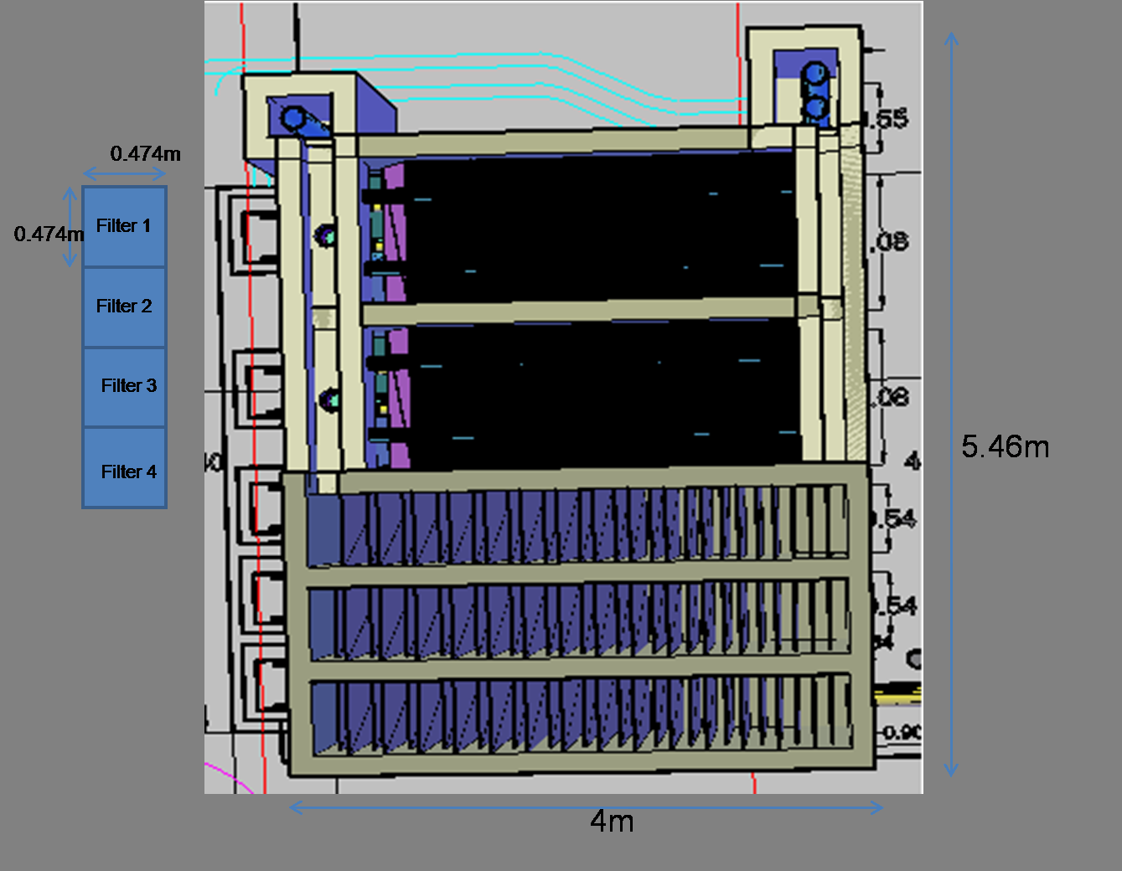
Figure 4 Top View Comparison of Agalteca versus Stacked Filtration
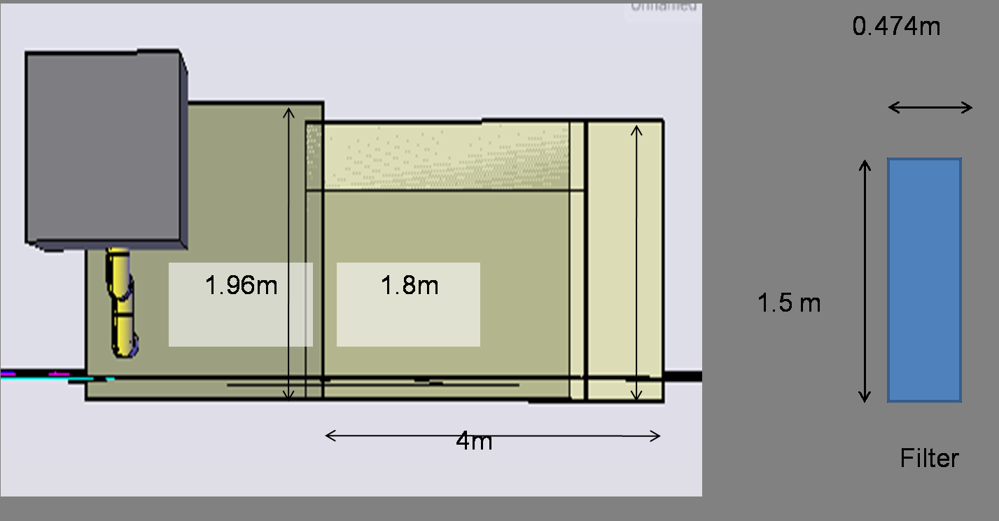
Figure 5 Side View Comparison of Agalteca versus Stacked Filtration
All of the inlet and outlet tubes are 0.5 inch while the bottom is 0.75 inch in diameter. All of the manifold that connects to these filtration tubes will be 3 inch in diameter. All pipes and tubes used are schedule 40. This filter is designed for sands with typical characteristics of D60 of 0.55mm, porosity of 0.4, and specific gravity of 2.65. It will filter at rate of 1.4 mm/s and backwash at 14 mm/s with the expected 30% bed expansion. The filtration system should be located so that there is at least 1.1 m distance from the entrance pipe from the sedimentation tank to the gutter and the effluent pipe of the filtration unit should be slightly higher than the sand bed where it discharges into an elevation control box on its way to the distribution tank.
Figure 6: Vertically Stacked Filtration Design
Conclusion
Vertically stacked filtration is a very viable option to improve the efficiency of the current AguaClara treatment process to achieve effluent standard lower than 1 NTU. Required construction materials are readily available and cheap. Expected size is smaller than the rest of the plant. It will be easy to operate and maintain is open to observation during normal filtration operations as well as during backwash.
Our design should work as long as the following assumptions hold. First, we need to effectively backwash the sand filter with unfiltered water from the sedimentation tank so that it can continue to filter water to 1 NTU or lower. If there is decreasing filtration efficiency, as evident by high effluent NTU, then this design cannot work. Also we need to know whether or not 20 cm of sand is enough to lower the effluent NTU to 1 or lower. Also we need to find the clogging time of 20 cm of sand. If the 20 cm of sand clogs too frequently then that would be a weakness of this design. Lastly we are depending on the layer of inlet tubes to function as a plane of filtration instead of tubes of filtration if the distance between them is significantly smaller than the distance to the outlet tubes. Modeling the layer of tubes as a single layer that has a top and bottom plane area of filtration has enabled us to greatly reduce the size of our system.
Future Challenge
The future challenge for the Filtration Team is to test the validity of our three assumptions mentioned above. We need to test the efficiency of 20 cm of sand with regards to clogging time and filtration efficiency. Our modeling of the area of filtration as a plane instead of a row of tubes needs to be tested as well. Finally, we need to find out the implications of back washing the sand filter with water that is normally used as an influent. Does the filtration efficiency eventually decrease over time? Our immediate goal would be to design and build a bench scale model of our filtration unit. Instead of a square unit, we will use a 4 inch diameter PVC pipe. Once this prototype is built, we can push 5-10 NTU water through and check to see if the effluent NTU is lower than 1. We can also measure the clogging time during this experiment and model the effectiveness of filtration versus time. Using this model, we can also simulate backwash with 5-10 NTU water and then rerun the first experiment to see how backwashing with the unfiltered water effect the filtration efficiency as backwash cycles are repeated. Finally, we can also vary the number of inlet and outlet tubes per plane to see if our modeling of the layer of tubes as planes of filtration is accurate. We can slowly decrease the space between the tubes to see what the necessary ratio between the sand layer and the space between the tubes needs to be to allow us to model the layer of tubes as a plane.
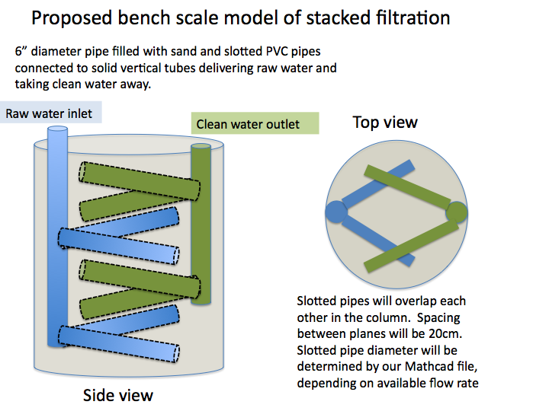
Figure 7: Bench Scale Model

Works Cited Page
AguaClara, Official Webpage, “Methods – Stacked Filtration – Spring 2010 Stacked Filtration
Page”, MathCAD File Downloadable at https://confluence.cornell.edu/display/AGUACLARA/Methods
Okun, Daniel A. and Christopher R. Schulz. Surface Water Treatment for Communities in
Developing Countries. Intermediate Technology Publications, Chippenham, Britain,
1984.

