Standard Form 424

Key Contacts

Table of Contents
I. Standard Form 424 1
II. Key Contacts 1
III. Table of Contents 2
IV. Executive Summary 4
V. Body of the Report 7
A. Summary of Phase I Results 7
1. Background and Problem Definition 7
2. Purpose, Objectives, Scope 8
3. Data, Findings, Outputs/Outcomes 8
4. Discussion, Conclusions, Recommendations 12
B. Proposal for Phase II 15
1. P3 Phase II Project Description 15
2. Project Schedule 20
3. Partnerships 22
C. References 23
VI. Supporting Letters 23
A. Agua Para el Pueblo 23
VII. Budget and Budget Justification 25
VIII. Resumes 27
A. Monroe Weber-Shirk, Advisor 27
B. Karen Swetland, PhD candidate 27
C. Dale Johnson, M.Eng 27
D. Akta Patel, B.S. c/o 2010 27
E. Kayti Curtis, B.S. c/o 2010 27
F. Harrison Ko, B.S. c/o 2011 27

Table of Figures
Figure 1: Nonlinear dose controller being installed in Agalteca, Honduras 3
Figure 2: Photo of dose controller 7
Figure 3: Schematic of nonlinear chemical doser 7
Figure 4: Nonlinear dual scale (all values have units of mg/L of alum). 8
Figure 5: Forces acting on the lever arm 9
Figure 6: Prototype of Dose Controller 9
Figure 7: Schematic of the rapid mix pipe showing the locations of the small- and large-scale mixing orifices. 10
Figure 8: Influent and Effluent Turbidity from Cuatro Comunidades, Honduras 13
Figure 9: University students visiting the AguaClara plant at Cuatro Comunidades Honduras. 21

Executive Summary
NCER Assistance Agreement Project Report Executive Summary
Date of Project Report: March 23, 2010
EPA Agreement Number: SU834338
Project Title: Chemical Doser for AguaClara Water Treatment Plants
Faculty Advisor(s), Departments, and Institutions: Monroe Weber-Shirk, Civil and Environmental Engineering, Cornell University
Student Team Members, Departments, and Institutions: Karen Swetland, Dale Johnson, Akta Patel, Kayti Curtis, Harrison, Ko, Civil and Environmental Engineering, Biological and Environmental Engineering, Cornell University
Project Period: 8/15/2010 – 8/14/2012

Description and Objective of Research:
Currently 1.2 billion people do not have access to clean water. This staggering statistic demonstrates the overwhelming need for improved access to potable water, especially in low income rural areas in the Global South (or “Developing World”). The reduction in water borne diseases is a major public health priority nationally and internationally. AguaClara is a program in Civil and Environmental Engineering at Cornell University committed to improving access to improved drinking water quality in the Global South. After numerous failed attempts at using technologies developed for the Global North to provide water treatment to the Global South, a new alternative for the delivery of sustainable water systems is being explored. AguaClara is committed to the sustainable, locally available, and replicable model of water treatment design delivery. There are currently nine research and design teams in AguaClara committed to expanding our current understanding of water treatment.
The primary objectives of an AguaClara plant are to remove much of the suspended dirt particles present in the source water and to kill disease causing pathogens through disinfection. Turbidity is a measure of the cloudiness of the water and is a key indicator of water quality. A chemical coagulant, alum, is added to the raw water intended to improve the turbidity of water by causing suspended solids to stick together and settle out. The agglomeration of suspended solids decreases the turbidity of the water and has significantly reduced incidences of water borne illnesses.
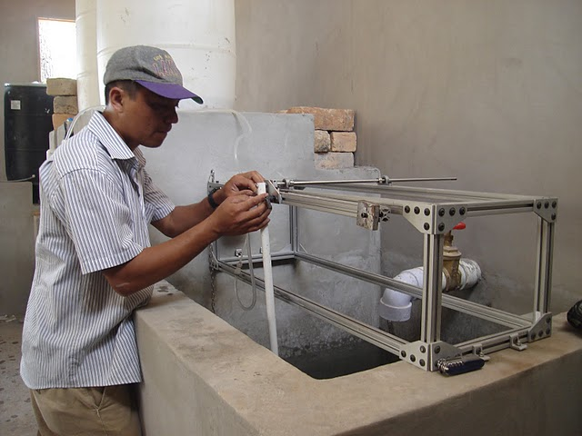
Figure 1: Nonlinear dose controller being installed in Agalteca, Honduras
The nonlinear chemical dose controller provides a means for alum to be accurately dosed regardless of the size of the plant. Previous designs for the dosing of alum in AguaClara plants were using a linear orifice meter, with its accuracy limited by the plant flow rate. The orifice-controlled nonlinear chemical doser allows AguaClara plants to be scaled up to much higher flow rates without a loss of the accuracy of alum dosing. In addition, the doser automatically adjusts the flow of alum to maintain a specified concentration in alum in the influent matter, even with changing plant flow rates. All of this is done without electricity. The accurate and reliable dosing of alum will greatly improve the flocculation and sedimentation process and improve the overall quality of treated water.
Summary of Findings (Outputs/Outcomes):
Since the phase I award in the EPA P3 competition, many strides have been made towards the successful implementation of a robust design for the dosing of alum in AguaClara plants. We set out to make a doser which might serve as a model for future AguaClara plants and provide proof of the applicability of the conceptual theory behind the orifice-controlled nonlinear chemical dose controller. Many of the design constraints bounding the implementation of the project have been identified and explored as to their potential impact on the effectiveness of the doser.
The nonlinear chemical dose controller is able to dose over a much higher range of plant flow rates than previous linear models of alum dosing systems. This feature will allow future AguaClara plants to scale up to any desired plant flow rate, and accurate dosing can still be consistently achieved. The scalability of the dosing apparatus is extremely important since AguaClara is committed to providing the capability for anyone in the world to automatically generate a design for a water treatment plant, regardless of the size. In addition, the nonlinear doser has been designed to greatly increase the accuracy to which alum is dosed. The dual scaled lever arm allows for a much broader range of dosages to be reached, spanning from 5 mg/L to 100 mg/L. The operator of an AguaClara plant will be able to have much greater flexibility to dose at the alum range that is most appropriate, based on varying levels of influent water turbidity. The selected concentration will be maintained regardless of variations in the plant flow rate. A float connects the lever arm of the doser to the water level in the entrance tank of the plant so the flow of alum corresponds to the flow of raw water. As the water level in the entrance tank increases, so does the flow rate of alum. This allows for an automated dosing system which will significantly reduce errors caused by the operator and increase overall performance of the plant by providing reliable, accurate alum dosing.
A nonlinear chemical doser has been constructed and installed in an AguaClara plant in Agalteca, Honduras. The testing of our doser in a fully operational water treatment plant will provide useful ‘real world’ verification of our doser design as well as assist in the identification of unforeseen problems which might occur in the course of its operation. In this regard, future designs might be adapted to accommodate identified problems. Close contact is maintained with designed AguaClara plants long after the construction has been completed for each plant. A communication loop is created whereby problems are identified at a plant and relayed back to Cornell, where our design and research teams actively work to solve those problems. This contact not only improves the performance of existing plants but provides feedback to inform future designs.

Conclusions:
The accurate dosing of alum in any water treatment system is essential to maintain high quality of treated water. In this respect, the nonlinear chemical dose controller, with a nonlinear dual scale and orifice-controlled flow, facilitates accurate, reliable dosing regardless of the plant flow rate. This innovation will allow AguaClara plants to scale up in flow rate to any size without adverse affects in alum dosing reliability. Many improvements have been made over previous linear AguaClara alum dosers, and will provide a viable means of alum dosing for any future planned treatment plants.
A working model of the nonlinear chemical doser has been created and installed in an AguaClara plant in Agalteca, Honduras. The real world application of the doser will provide valuable insights into the long term reliability of the doser as well as potential failure mechanisms. Much progress has been made in the development of the nonlinear chemical doser yet significant testing remains. Future research will focus on validation testing, failure mode mechanisms, and the conversion to alternative locally available materials.

Proposed Phase II Objectives and Strategies:
Many important strides in the design of the nonlinear chemical doser have been made yet there exist many more challenges to overcome. Rigorous testing and verification of the dosing apparatus still need to be performed to determine the reliability and the potential failure mechanisms while in operation. Certain assumptions were made in order to simplify the design of the doser. As in any rigorous scientific process, the extents to which the assumptions in a design process affect the accuracy of the solution need to be fully investigated. The next phase in the doser will be to analyze the accuracy and reliability of the current design and to modify and adjust the doser based on feedback from the Agalteca plant as it begins operation in late March 2010. In order to streamline the testing of the doser as well as provide immediate feedback on any tentative designs, the creation of laboratory scale research and demonstration facilities at Cornell is being proposed. One of the main drawbacks of our current laboratory set ups is that our flocculators are laminar flow rather than turbulent flow and our sedimentation tanks don’t capture the geometry of full scale facilities. The constraints which dictate the proper functioning of a laboratory experiment often vary significantly when the design is placed in a full flow water treatment plant. The improved laboratory facilities will allow us to test, and receive immediate feedback on the affect of different design propositions on the quality of water being produced. The laboratory test facilities will, in addition, serve as an educational tool for AguaClara students and will greatly improve the quality of future designs.
AguaClara has firm commitment to empowering local communities to be responsible for their own water supply systems and take pride in availability of clean potable water made accessible to its people. The availability of free water treatment plant designs via the Automated Design Tool (ADT) on the AguaClara website merely facilitates the first step in the process of empowering local communities by providing water treatment systems. Furthermore, the materials, labor, and operation of an AguaClara plant are all locally available. The design of the nonlinear doser will be no different. The doser is currently made from 80/20 extruded metal, which is not available in Honduras. Installing one of these dose controllers requires that it be flown into the country as a complete unit, which is unsustainable over the course of operation of a plant. The ability to fix problems onsite, rather than relying on foreign assistance is critical to the sustainable use of the doser. Further research will be done to be able to make the doser completely replicable in locally available materials such as PVC and aluminum.

Publications/Presentations:
Civil & Environmental Engineering Research Symposium – February 12, 2010
Cornell Engineering Research Conference (CERC) - March 17, 2010

Supplemental Keywords: chemical dose controller, surface water treatment, turbidity, gravity powered, sustainable, alum, Global South

Relevant Web Sites: AguaClara Wiki Homepage: aguaclara.cee.cornell.edu
Chemical Dose Controller Wiki page (1):
https://confluence.cornell.edu/display/AGUACLARA/Nonlinear+Chemical+Dose+Controller

Body of the Report

Summary of Phase I Results

Background and Problem Definition
AguaClara is a program in Civil and Environmental Engineering at Cornell University that is improving drinking water quality through innovative research and design of sustainable, replicable water treatment systems. The reality that over 1 billion people do not have access to safe drinking water provides the motivation and context for the AguaClara program. With the majority of population growth happening in the Global South (or “Developing World”), the need for a resilient surface water treatment technology has never been greater. Continuing population growth is also placing a large strain on municipal systems that were built in the previous 30 years and are now inadequate.
The AguaClara approach is in response to a request by Agua Para el Pueblo (APP), our partner organization in Honduras. APP has been building water supply systems in rural Honduran communities since 1984. In 2004 they requested that we assist them in developing a technology that would be able to remove the turbidity from the surface waters that they use for gravity powered water supply systems. The process sequence needed to solve this problem in the Global North, or “Developed World,” (using conventional water treatment technologies) is well established. However, repeated failed attempts have shown that conventional surface water treatment plants do not perform well in the Global South and there were no sustainable designs available for small communities.
The design of water treatment systems should be an application of the best sustainable technology for the community in which it will be implemented. Though often overlooked, the disparity between the Global North and the Global South must be reflected in their respective water system designs. In the Global North, local labor is both costly and skilled, leading towards a capital-intensive and highly mechanized and automated system design. However, in the Global South local labor is inexpensive and the supply chains for specialized components are dysfunctional. These circumstances prescribe a water treatment system that depends on local labor for both construction and daily operation (1). Developing resilient, sustainable, low carbon footprint designs that are easy to maintain, that are powered by gravity instead of electricity, provide excellent feedback to the operators so that they are easy to operate, and can be fixed using local labor and materials is the only way to provide a high level of service to communities in the Glob al South.
“I have come to the conclusion that the single biggest thing we can do to improve plant performance is to make the dosing (by technology and good operation) as accurate, precise, and consistent as possible.”
-Dan Smith, AguaClara Engineer in Honduras
Accurate alum dosing is vital for plant operation as it has a great impact on the effectiveness of flocculation and sedimentation. The linear chemical dose controller (CDC) requires that the chemical flow in the dosing tube is laminar. In contrast, the nonlinear CDC in conjunction with the newly designed Rapid Mix Tube is designed to handle turbulent flow chemical dosing. This research group is redesigning the chemical dose controller, including the flow controller, the doser, and the flow measurement device. We are also designing the rapid mix tube for large-scale and small-scale mixing. These innovations will make it possible for the AguaClara design to be used by larger communities (10,000+).

Purpose, Objectives, Scope
Providing clean water for communities in the Global South is expected to have several profound consequences. The rapid migration of the rural poor to mega cities is due to a combination of push and pull factors. The environmental infrastructure supporting the mega cities is being stressed and the prospect of droughts that cause widespread water shortages and the potential for breakdown of order in these cities is a real threat. Small communities in Latin America often have access to abundant water with the only limitation being their water treatment and supply infrastructure. AguaClara is committed to improving the quality of life in small communities to help reduce the migration pressure and to reduce the magnitude of suffering caused by future droughts.
The AguaClara program also addresses the challenge of preparing the next generation of environmental engineers to take on the challenge of maintaining, upgrading, and replacing the water supply infrastructure in the Global North. Students with experience designing real facilities, making decisions with incomplete information and with an understanding of the interaction between technology and society will be well-prepared to help design and implement the next generation of water treatment infrastructure in the Global North. Students who work on AguaClara projects get to visit water treatment facilities in Honduras and are able to critically evaluate water treatment plant design and learn why most conventional designs do not work well in Honduras.
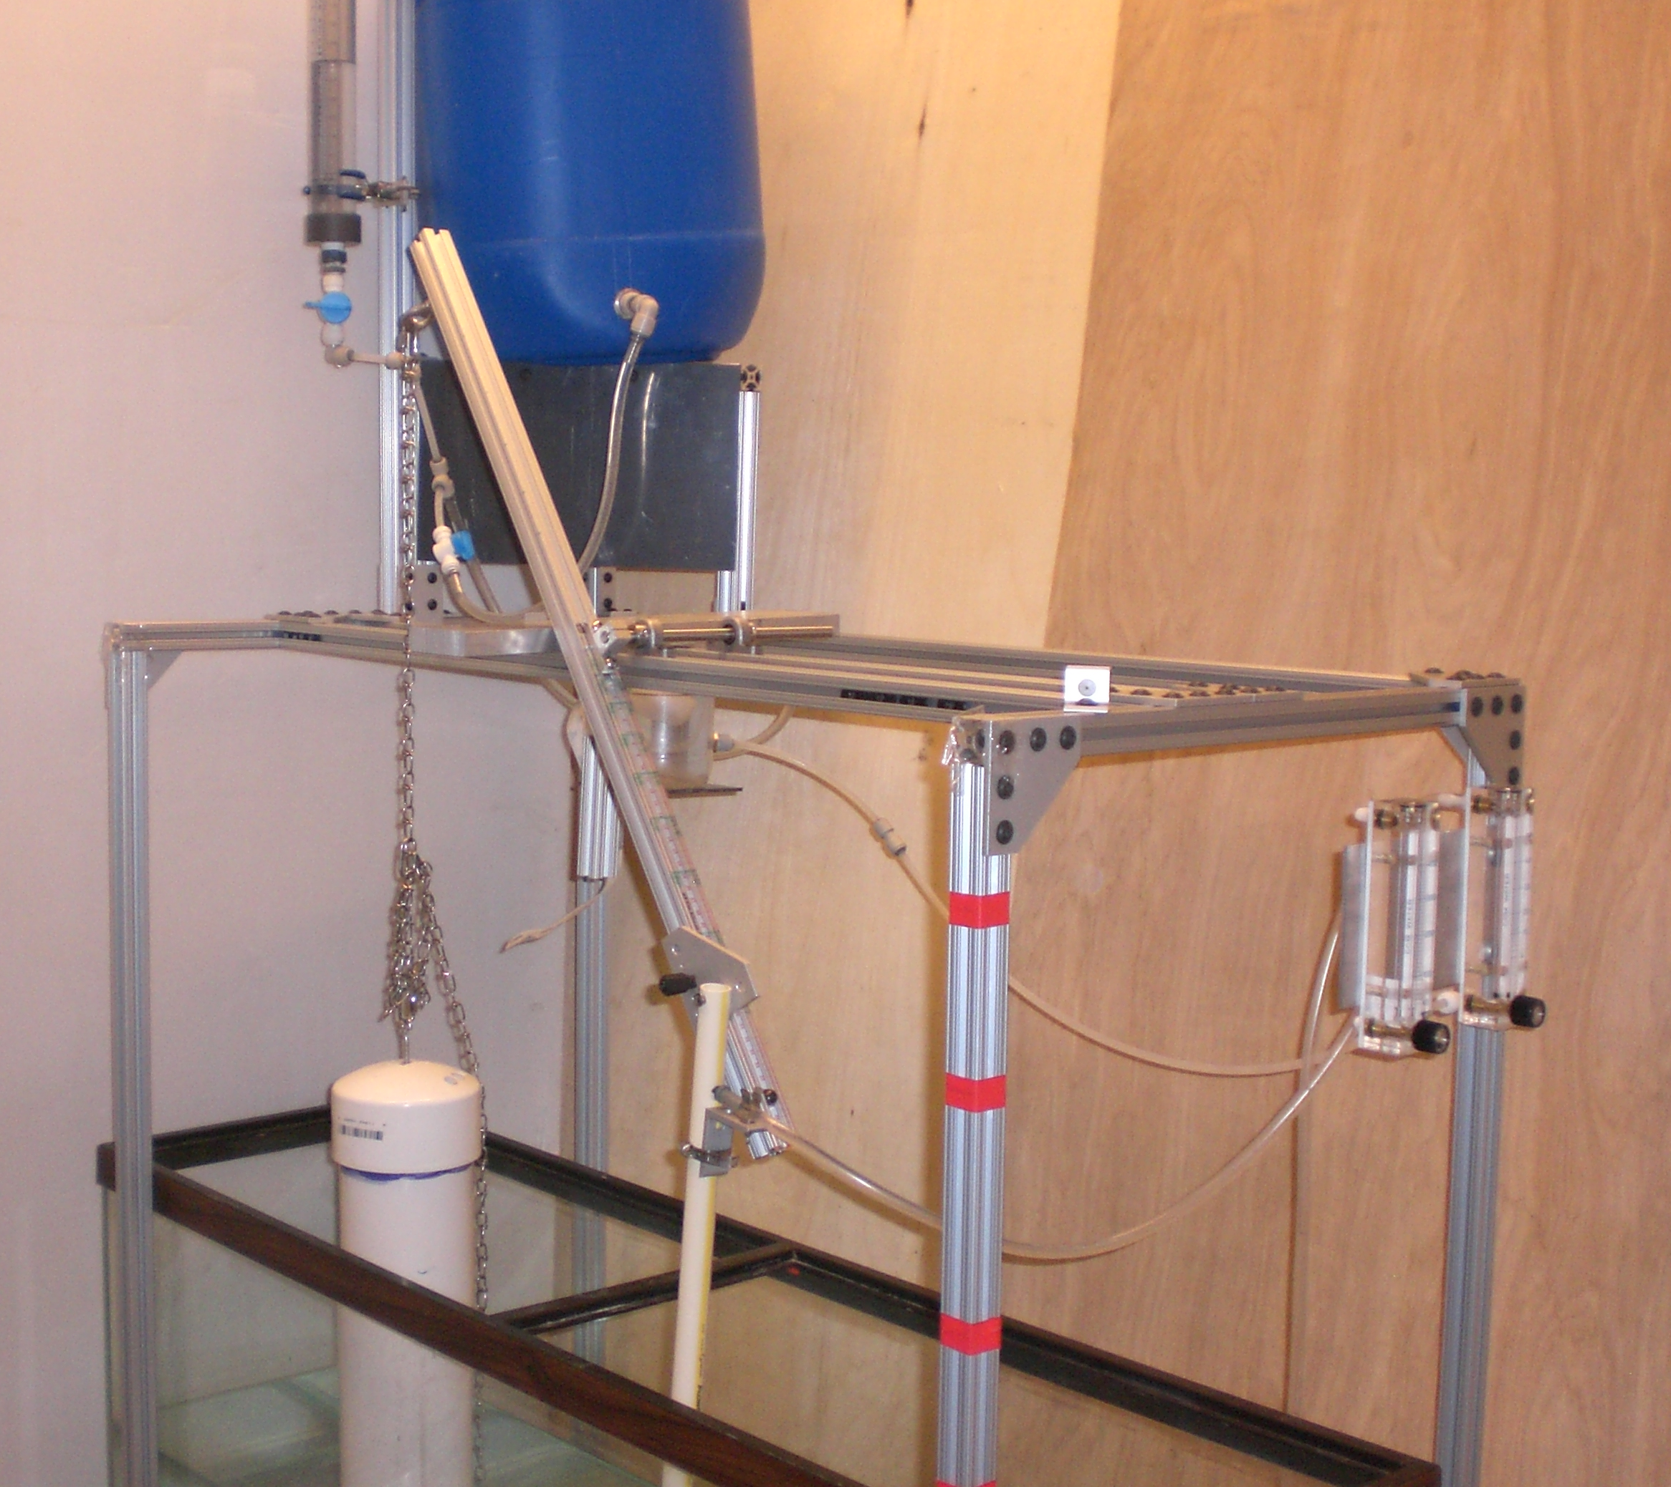
Figure 2: Photo of dose controller

Figure 3: Schematic of nonlinear chemical doser

Data, Findings, Outputs/Outcomes

Design of the Dual Scale System
Like its linear predecessor, the nonlinear chemical doser automatically increases or decreases the alum flow rate to maintain a target dosage specified by the operator. The float attached to one end of the lever arm provides a response to the quantity of influent water to be dosed, as measured by the height of water in the entrance tank. The target concentration chosen by the operator by sliding the orifice along the lever arm reflects the quality of the influent (Figure 2). The orifice-controlled nonlinear doser is able to deliver accurate alum dosages under both laminar and turbulent flow conditions in the dosing tube. This allows for the design to be scaled up to plants with much higher flow rates without any loss in dosing consistency. The apparatus has been designed with two different dosing orifice sizes which correspond to two different scales on the lever arm. A dual scale with a low (5-25 mg/L) and a high (20-100 mg/L) alum dosing range allows for more accurate dosing. The operator will decide, based on the turbidity of the raw water, which of the two scales to use ( Figure 4). If, for example, highly turbid waters are present, the larger orifice corresponding to the 20-100 mg/liter scale will be used. The components of the nonlinear doser can be seen in Figure 3. In order to create the dual scales on the dosing arm, the relationship between plant flow rate, alum dosage and the movement of the lever arm have to be characterized.

A fundamental relationship which controls the flow through the water treatment plant as well as the doser is the orifice equation, shown below.
$Q=K_{vc}A\sqrt{2gh}$ (1)
Where:
Q = Flow rate, m3/s
K_{vc} = Vena Contracts coefficient = 0.63
A = Cross-sectional area of orifice, m²
g = Gravitational acceleration = 9.81 m/s^{s}
h = Head loss, m

The head loss caused by the flow of water through an AguaClara plant is controlled by minor losses in the rapid mixer, flocculator, launder, and a weir. The two flows can be linked mechanically by a lever because the relationships between head loss and flow rate are similar. The rise and fall of the water height in the entrance tank caused by the change in plant flow rate is nonlinearly proportional to the alum flow of the orifice based doser (Equation 1).
The plant and alum flow can be linked using a mass balance approximation shown below.
$Q_{p}C_{t}=Q_{a}C_{a}$ (2)
Where:
Q_{p} = Plant flow rate, m³/s
C_{t} = Target concentration in the plant, mg/L
Q_{a} = Flow of alum out of the dosing orifice, m³/s
C_{a} = Concentration of alum in the stock solution, mg/L
Using equation (2), the flow of alum required to achieve a specified alum concentration in the plant at a given plant flow rate can be determined. Then, using the orifice equation (1), the head loss required to achieve that flow of alum can be found. The head losses are then converted to points along our scale, creating the nonlinear scale shown in Figure 4:
Figure 4: Nonlinear dual scale (all values have units of mg/L of alum).
The distance from the pivot point represents a specific alum dose that corresponds to an alum flow rate needed to produce the target alum concentration in the rapid mix pipe.

Float Design
A float connected to the end of the lever arm transfers the water level height in the entrance tank to the dosing arm. This float ensures that the angle of the lever arm will be kept at the proper position to enable accurate dosing of alum as the plant flow rate is varied. The float design parameters can be determined using a moment balance around the pivot of the lever arm. As seen in Figure 5, the major forces acting on the lever arm are the weight of the lever arm on either side of the pivot, the dosing slide, the alum dosing tube, the tube connecting the lever arm with the rapid mix tube and the components of the float. For a more detailed analysis of the float specifications please refer to the AguaClara website (2).

Prototype Doser

Figure 5: Forces acting on the lever arm
While the nonlinear chemical doser has been theoretically proven, it is important to test its ability to dose alum properly. A prototype was constructed that is comprised of two main components: the structural frame work and the hydraulic components. The frame components are constructed using a modular aluminum framing system manufactured by 80/20 Inc. With an AutoCAD plug-in for 80/20 parts, the team was able to design and evaluate multiple prototype designs digitally before ordering the components (Figure 6).
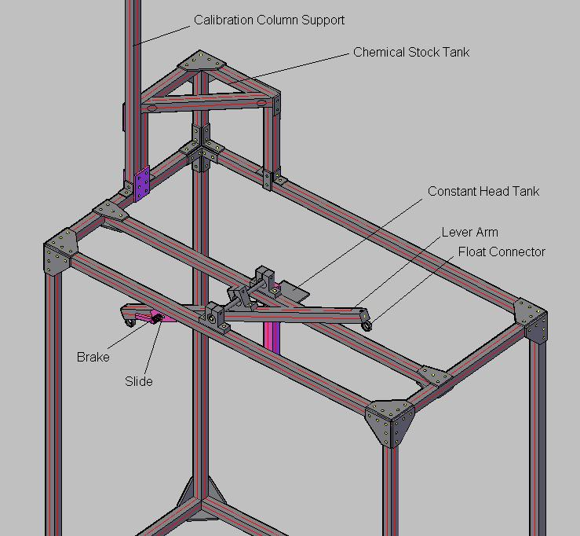
Figure 6: Prototype of Dose Controller

The design is a full scale nonlinear chemical doser as it will operate in AguaClara plants. The slide mechanism is used by the plant operator to select the alum dose. The hydraulic components include the chemical stock tank, constant head tank, calibration column, dosing tube, and rapid mix tube. The chemical stock tank feeds a concentrated solution of alum, usually 120 g/L to the constant head tank, a small 1L container with a float valve to keep the chemical level constant. Alum dosing tubes extend from the constant head tank to the slider, which anchors the active dosing tube to the lever arm. A long, small diameter PVC pipe attaches to the slider and guides the alum into the rapid mix pipe.

Rapid Mix Pipe
Once alum is dosed into the plant using the nonlinear doser, it is essential that the alum be mixed uniformly with the untreated water before reaching the flocculator. The goal of rapid mix is to create a homogenous mix so that all particles make contact with aluminum hydroxide. The aluminum hydroxide increases the probability of attachment during particle collisions in the flocculator, leading to better flocculation and plant performance.
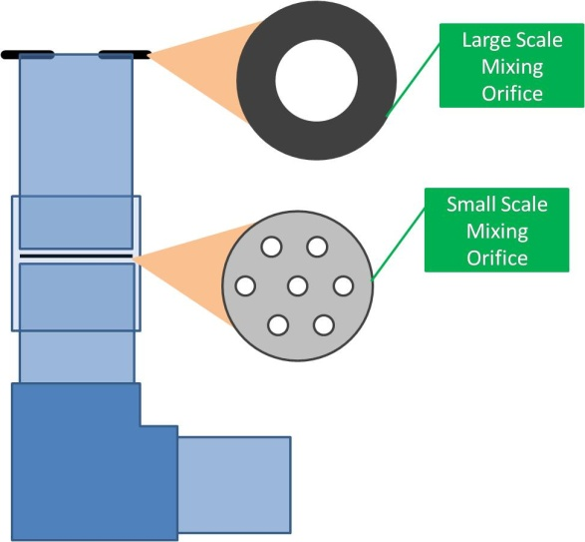
The rapid mix pipe is designed to have two stages: macro-scale mixing and micro-scale mixing (Figure 7). Water from the plant entrance tank enters the top of the rapid mix pipe through the large-scale mixing orifice, where it is dosed with the aluminum sulfate and begins the rapid mix process. This orifice is in place to create large scale mixing in the first section of the pipe to ensure that the raw water entering each of the micro-scale mixing orifices contains aluminum hydroxide. The design of this orifice size is based on the minor loss coefficient through the orifice. The target minor loss coefficient value for this orifice is two, which provides adequate turbulent mixing in the first section of the pipe. To calculate the necessary area and diameter of the macro-scale mixing orifice, the following equation was used:
Figure 7: Schematic of the rapid mix pipe showing the locations of the small- and large-scale mixing orifices.
$A_{LargeScaleOrifice}=\frac{A_{out}}{{Pi}_{VC}\left(1+\sqrt{K_{ex}}\right)}$ (3)
Where:
A_{out} = The inner area of the pipe used to construct the rapid mix pipe
Pi_{VC} = The vena contracta coefficient, which accounts for contraction of flow through an orifice
K_{ex} = The minor loss coefficient through the large-scale mixing portion of the pipe
After water flows through the top section of the pipe to achieve large-scale mixing, it reaches the small-scale mixing orifices. The small-scale mixing orifices are designed to produce a specific amount of head loss proportional to the flow rate through the plant. The equation used to calculate the total area of the small-scale mixing orifice is:
${Area}_{SmallScaleOrifice}=\frac{A_{out}}{\left(\sqrt{\frac{2*g*HeadLoss*{A_{out}}^{2}}{{Q_{plant}}^{2}}}+1\right){Pi}_{VC}}$ (4)
Where:
A_{out} = The inner area of the pipe used to construct the rapid mix pipe
Pi_{VC} = The vena contracta coefficient, which accounts for contraction of flow through an orifice
Q_{plant} = Flow rate of water traveling through the plant
HeadLoss = The target head loss to be created through the micro- scale mix orifice
g = gravitational acceleration = 9.8 m/sec²
To calculate the diameter of the round orifices that will be drilled into the small-scale mixing orifice to comprise the total orifice area, the following equation is used:

$Diameter= \frac{{\left(2*g*HeadLoss\right)}^{1.5}}{20*ε}$ (5)
Where:
ε = The target energy dissipation rate through the orifice to achieve a sufficiently small Kolmogorov length scale so that molecular diffusion can finish the blending process in about 10 s = 1 W/kg.

Discussion, Conclusions, Recommendations

Did the project balance the elements of people, prosperity and the planet?
One of the main goals of AguaClara and the Chemical Dosing Team is sustainability. AguaClara plants use local resources including materials (sand, gravel, locally manufactured brick) and labor. The nonlinear doser, like the entire AguaClara plant, requires no electricity; it is completely gravity-driven. In these ways, AguaClara is sustainably using the world's resources to improve quality of life while making a minimal impact on the environment. An important aspect of AguaClara is the education and empowerment of the community members through extensive operator training and community participation. Providing communities with sustainable tools that enable them to improve their quality of life is empowering and motivating. Increasing the availability of safe drinking water will not only improve the health of the millions of people, but also will make it possible for more children (especially young girls) to attend school and thus there are multiplying factors that extend the impact of safe drinking water.

Was your project successful? If so, what was crucial to achieving success? If not, what were the critical barriers and impediments?
Phase I objectives have been achieved- there is now a completed design for a nonlinear chemical dose controller. The design is coded in AutoCAD and the design team is incorporating it into AguaClara’s Automated Design Tool (ADT). The design for the dose controller originated as a linear dose controller, but as problems with dosing at higher plant flow rates were discovered at current AguaClara plants in Honduras, another design was sought. The new design is being implemented and tested in the newly constructed plant in Agalteca, Honduras.

Did all disciplines represented by the team members contribute in a substantive and constructive manner?
Though all team members are studying either Civil and Environmental Engineering or Biological and Environmental Engineering at Cornell, many different skill sets were represented. Two team members were graduate students with professional experience in MathCAD and construction of models. Three team members were undergraduate students with extensive knowledge of the lab facilities and software. One graduate student contributed extensive AutoCAD modeling skills. The organizational and leadership skills of one student helped her fill the team leader position. The organization and distribution of work played a key role in our team’s ability to make so much progress in the past year. In order to handle the workload, teams of two or three were created to work in areas such as AutoCAD modeling, MathCAD programming, experimentation, and documentation. Tasks were divided based on the team members’ strengths. Weekly meetings helped unite the team and assess the progress of the assigned tasks.

Does the project have potential to bring about positive impacts in making progress toward sustainability?
In terms of community sustainability, the plants are very effective and supported by the community members. Because the AguaClara plants are designed to treat and distribute water strictly using gravity, electricity is not required to treat water or run the plants, which is a great advantage to these rural, mountainous communities that may not have reliable electrical service or the economic resources to support a conventional electric plant. This independence from electrical supply thus drastically reduces monthly operating costs and reduces impact on both local and national resources. These hydraulically-powered plants also reduce the environmental impact; they use no electrical power, and thus require no fuel, eliminating any possible emissions, providing a sustainable solution, easy to use and maintain, to the problem of producing clean, safe, and healthy drinking water in these communities and others like them.

Are the potential impacts broadly applicable and transferable?
The AguaClara program has designed five fully-functional water treatment plants in Honduras. We believe there are many thousands of communities in Latin America, Asia, and Africa that could benefit greatly from an AguaClara designed plant. Furthermore, as electricity prices increase and as cities look for resilient designs that can withstand interruptions in electrical power water treatment plants with advanced hydraulic designs becomes more attractive in the Global North. AguaClara plants produce effluent water at turbidity of 3NTU or lower. As the design becomes more refined and as filtration is added, this will decrease even further, making it possible to introduce this technology in areas of the world with more conventional designs for water treatment plants.

How many external partners were involved in the program? How much external funding was leveraged for the project?
The AguaClara program involves extensive partnerships between academic, public, and private sectors. The primary implementation partner is Agua Para el Pueblo, a Honduran NGO headquartered in Tegucigalpa, Honduras. AguaClara also works with several Honduran governmental organizations, including the Honduran national water and sewer service (SANAA), the Honduran equivalent of the EPA (ERSAPS), a Honduran national program for modernization of the water and sanitation sectors (PROMOSAS), and the Honduran fund for social investment (FHIS). For more information on the partners involved with the AguaClara program please refer to the “Partnerships” section of this report.
Table 1: Financial Donors
Financial Donors | Amount, $
- Supporting AguaClara program:
Cornell University College of Engineering | 100,000
Sanjuan Fund | 15,000
- Nonlinear chemical doser:
EPA P3 phase 1 grant | 10,000

AguaClara relies on financial support from Cornell’s College of Engineering and the Sanjuan fund. The financial donors from 2009 are listed in Table 1. The support for the design, construction, and implementation for the nonlinear chemical doser was completely provided by the EPA P3 Phase 1 grant.

What are the quantifiable benefits of the project?
There are currently four AguaClara-designed plants operating in Honduras, in the communities of Ojojona, Marcala, Tamara, and Cuatro Comunidades. These plants operate with a linear dose controller, as the nonlinear model is still in testing. Data quantifying both water turbidity (NTU) and fecal coliform counts were collected from three of these plants (Tamara, Cuatro Comunidades and Marcala) at various times over a three month period by Dan Smith, an AguaClara engineer currently working in Honduras, and by on-site plant operators. The data provide values for the NTU and fecal coliform count of the untreated water entering the plant and of the water delivered to the faucets at the first house served by the plant’s distribution system. The turbidity data is presented in Figure 7. Fecal coliform counts varied from zero to 2850 colonies/100mL, with an average of 337 colonies/100mL over 22 data points taken over three months. For more information on the effects of fecal coliform on public health, please see the following sub-section (viii).
The green line on the turbidity plot represents the Honduran national standard of five NTU for water delivered via a central distribution system. Prior to AguaClara all of these communities delivered raw directly to the tap without any treatment to reduce turbidity. The AguaClara treatment plants deliver water below the 5 NTU standard 68% of the time over three months in which data were provided. Fecal coliform counts were reduced to zero in all cases of testing, indicating the elimination of these organisms from the distributed water. This data detailing influent and effluent NTU and fecal coliform counts were collected between late August and early December in Honduras. Influent NTU can be significantly higher or lower, with a positive correlation to rainfall. Plant operators at each of the plant sites have stated that the effect of aluminum sulfate dosing is more dramatic at higher NTUs and has a more drastic effect on the influent water during the rainy season, when the NTU of the untreated source water entering some of the facilities is routinely 150 NTU or higher.

Figure 8: Influent and Effluent Turbidity from Cuatro Comunidades, Honduras

“The maximum recorded effluent turbidities represent times when the optimal dose of alum was not being applied.”
-Dan Smith, AguaClara Engineer in Honduras

Can the benefits of the project to people, prosperity and the planet be qualitatively determined?
The reduction in the NTU and fecal coliform counts of the water treated in the AguaClara treatment plants has many qualitative effects on the communities receiving this water. The elimination of fecal coliforms from drinking water indicates the removal of the pathogens that frequently cause waterborne illnesses in these communities. One of the main health concerns in the communities is diarrhea caused by frequent ingestion of these organisms that can lead to chronic dehydration, fatigue, and death especially in children under 5 years of age. This reduction in pathogen load will reduce the frequency of these illnesses and increase the overall health of the community. The reduction in turbidity and organic matter makes it possible, for the first time, for these communities to maintain chlorine residual.
Because the treated water can be visually differentiated from untreated water, residents learn to be more selective about the quality of the water they are using. Community members also gain a sense of pride and ownership over the treatment plant and are more willing to take measures to protect it. When asked if they drink the water the plants are producing, many of the operators and community members respond “Yes!,” citing their satisfaction with the quality of the water being produced in the existing plants and their relief that the water distributed to their homes is much less likely to make them or their families sick.

Can the project’s impacts contribute to improved quality of life?
Over large parts of the world, humans do not have access to clean water and use sources that are contaminated with pathogens, high levels of chemicals, and unacceptable amounts of sediment. The use of such sources for drinking and preparation of food is a major cause of illness and death in many countries. AguaClara water treatment plants provide a sustainable solution for treating sediment and pathogen contaminated surface water. Proper coagulant dosing is one of the first steps in surface water treatment. If the dosing rate of the coagulant is too low, then significant quantities of sediment will not settle out in the sedimentation tank. The presence of sediment in the treated water prevents chlorine from properly disinfecting the water. Proper dosing of coagulant leads to clean drinking water, which in turn improves the quality of life of all the people in the community.

Was the project focused on original discoveries or an adaptation of existing knowledge to result in innovative approaches?
The AguaClara program combines original inventions with adaptations of existing knowledge to create new solutions. The dose controller is an innovative adaptation of fluid dynamics and kinematics to create a new device that can essentially perform multiplication to maintain a set chemical concentration while flow rate varies. This device is a resilient and robust alternative to computer controlled pumps and flow sensors that are used in conventional facilities.
This nonlinear dose control system is a significant extension of the linear chemical dose controller design that was developed by a previous research team. The linear dosing system also used a lever arm with a float that operated mechanically. However the linear design only worked for chemical flow rates less than about 7 mL/s and it involved free falling jets of water that cause air entrainment and foam production. By using orifices and a nonlinear scale, the AguaClara team was able to take the original idea and improve it. This approach to dosing coagulant and liquid chlorine could be applied in water treatment plants throughout the world in resource poor communities.

Proposal for Phase II

P3 Phase II Project Description

Proposed Phase II Activities
One year after receiving Phase I funding, we have designed, constructed, and begun testing a prototype nonlinear chemical dose controller. In January 2010, a student team travelled to Honduras to visit AguaClara-designed plants. A prototype doser was delivered to the newest plant in Agalteca, Honduras, which is scheduled to begin operation in late March 2010. AguaClara Engineer Sarah Long is on-site in Honduras to calibrate the dose controller and gather performance data to relay back to the team at Cornell. The nonlinear dose controller requires additional validation testing and design refinements. We are applying for Phase II funding to continue our research to improve chemical dosing performance and to enhance overall performance of the AguaClara water treatment plants.
        - Validation Testing
In Phase II we will focus our efforts on optimizing the dose controller’s performance under various conditions, increasing reliability and ease of construction, as well as integrating it into the overall AguaClara water treatment plant design. We will perform a series of validation tests on the dose controller in the lab at Cornell to ensure that it is dosing accurately and errors have been minimized. To improve alum dosing accuracy, the factors which might contribute the most error need to be recognized through rigorous testing. Once the variables which cause high dosing errors are identified, these errors can be minimized, creating an optimized, robust dose controller. The first step in performing a validation process will be to measure the flow rate of alum at the specified distances from the pivot point and determine if the actual flows are as the theory predicts. Once the actual flows are compared with theoretical values, the discrepancies can be assessed and the magnitude of the differences can be identified. Preliminary results suggest that there are some small errors that may be caused by surface tension effects. We will evaluate the feasibility of using a submerged orifice to minimize surface tension effects. There are also well characterized errors caused by the change in the moment from the weight of the slide assembly, laminar flow major losses at low flow chemical dosing, and constant head tank response to changing levels in the stock tank.
The dose controller calibration and setup procedure requires multiple steps and must be done carefully. The effects of calibration and setup errors on performance will be assessed to give appropriate guidance on the level of precision needed in each setup step.
        - Failure Mode Analysis
We will analyze and mitigate dose controller failure modes to achieve improved reliability. From experience at AguaClara plants currently in operation, float valve orifices clog with chemical precipitates and insoluble material that comes along with the alum. We will explore options for trapping this sediment efficiently to protect the flow control devices. We will also add systems to make it easy for the operators to routinely verify that the doser is performing correctly so they can take steps to clean it when necessary. The previous generation of flow controllers require cleaning approximately once per week. We would like to reduce the frequency of cleaning by adding an efficient sediment trap.
        - Conversion to Locally Available Materials
We will research different materials that are locally available in the Global South from which AguaClara implementation partners can construct the doser. It is essential that the final design be made almost entirely from locally available materials to ensure that, should any component of the doser fail, it could be easily replaced and operation could resume quickly.
The prototype version of the dosing frame was made using engineered prefabricated 80/20 (The Industrial Erector Set) components. 80/20 components are relatively expensive and are not easily obtained in Honduras. AguaClara is committed to providing sustainable water treatment plant designs that can be fabricated and maintained using materials that are available in the local market. As a result we want to redesign the dose controller using generic locally available materials such as PVC pipe, aluminum bars, and bicycle wheel bearings. These locally available materials will not only reduce the overall cost of the dose controller, but will also ensure that when a component fails, it can be easily replaced.
        - Laboratory scale test facilities
Currently, the lag time between technology development by the AguaClara research and design teams at Cornell and full scale testing in Honduras takes approximately 1 year. A completed design must be sent to Honduras and a new facility constructed implementing the designs. After the plant is in operation the students at Cornell receive feedback on the performance of the design. In order to reduce this lag time, appropriately scaled research facilities need to be constructed at Cornell to help determine the validity of proposed designs more quickly and at greatly reduced effort. The research facilities will extend our capabilities for investigating performance of each of the subsequent unit processes. Although we have small scale analogs of rapid mix, flocculation, and sedimentation, we do not have facilities that are scaled to effectively capture the important fluid/particle interactions that occur in full scale facilities.
The requirements for effective hydraulic rapid mix are poorly characterized. A full scale hydraulic rapid mix unit (2 m long, 15 cm diameter pipe with orifice plates) could be easily built, but testing is not trivial given the need to characterize concentration gradients at the sub millimeter scale. For the time being we will assess rapid mix performance indirectly by measuring overall process performance with different rapid mix units.
We have developed preliminary designs for laboratory reactors that would enable us to study turbulent flow hydraulic flocculation. The preliminary design for a turbulent tube flow hydraulic flocculator with significant minor losses calls for a 3 cm ID pipe (to achieve turbulent flow) with a string of approximately 100 obstacles that each take up approximately 60% of the pipe cross sectional area to replicate the contractions that occur in baffled hydraulic flocculators. The maximum required pipe length would be 100 m and the pipe could be mounted vertically and use a series of elbows to make the apparatus compact. This would significantly extend our research capabilities and allow us to directly evaluate the relationship between energy dissipation rate and settled water turbidity after flocculation.
We are also developing the design for a laboratory scale sedimentation reactor that incorporates the geometry and velocities of full scale facilities including sloped bottom geometry, inlet manifold, and plate settlers. The critical upper and lower reactor boundary conditions will be matched precisely to full scale facilities. The lower boundary condition will incorporate sedimentation and potential energy induced return of settled flocs to a resuspension zone created by a low Reynolds number inlet jet. The reactor upper boundary condition will incorporate low capture velocity plate settlers to return settled micro flocs back to the main reactor. This reactor could be 1.5 m tall (the depth of the shallowest AguaClara sedimentation tanks), 0.54 m wide (half the width of a sedimentation tank to take advantage of centerline symmetry) and 1 to 2 cm thick. Preliminary tests revealed that this geometry is conducive to rapid formation of a floc blanket that can be used to significantly enhance overall plant performance. The thin reactor geometry of 1 to 2 cm allows excellent optical access and we anticipate using a computer controlled digital camera and National Instruments image analysis software to characterize floc blanket growth rates and densities as a function of raw water characteristics and upflow velocities.
The laboratory scale test facilities that will be fabricated as part of this research proposal will not only serve as an invaluable resource for optimizing design parameters and testing design modifications but will also be an educational tool for Civil and Environmental Engineering students.

Overall Potential Impact and Adoption of the Project Results
The nonlinear chemical dose controller (CDC) has the potential to make a significant improvement in AguaClara water treatment plant performance. As previously discussed, accurate alum dosing is strongly correlated to optimal performance of the overall water treatment plant. The CDC should help operators reduce the effluent turbidities further and increase the facility reliability. The health and societal benefits of improved dosing have already been discussed in the Phase I report.
All research and design performed for the AguaClara program, including the CDC, is open-source and available to the public via the program wiki (4). The chemical dose controller research team page contains all the research described in this report (3). The wiki serves as a platform for knowledge transfer between research teams as well as conduit through which our designs can be freely shared with the world. AguaClara is not interested in controlling the technology we develop, but rather sharing it freely to empower others. The current CDC design is being incorporated into the automated design tool (ADT) and should be available to the public by December 2010. Clearly, the adoption rate of the CDC will grow as the demand for AguaClara facilities grows. The potential impact of the CDC, in tandem with the rest of the AguaClara plant is significant given the level of interest in Central America.
The web-based automated design tool (ADT) (5) delivers detailed, three-dimensional drawings for AguaClara water treatment plants. The design tool incorporates algorithms for all aspects of the plant, including pipe sizing, hydraulic-flocculator baffle spacing, gravity-powered chemical dose control, hydraulic manifold designs for sedimentation tank inlet and outlet, channel and port designs to prevent floc breakup, and plate settler design. An engineer will select flow capacity, wall thickness, and a small number of other parameters. A customized design is then created in approximately five minutes of computation time and emailed to the engineer. All dimensions are calculated using algorithms implemented in MathCAD. We will continue to upgrade the scaling algorithms that are used to design these plants and will integrate the findings from this research project. This web-based tool significantly reduces engineering design costs for water treatment facilities.
We are currently developing a fully customized and automatically assembled design specifications document for each design that is delivered by the ADT. This report will include a description of the design equations, detailed specifications of critical dimensions, and CAD drawing cross sectional views. Initially this documentation will be created in English, but we already have plans and an implementation method for multilingual versions.

Challenge Definition and Relationship to Sustainability and Pollution Prevention
The second phase of this project will continue to address the challenges of clean drinking water for medium and small cities including rural communities and adaption of water treatment technologies to the context of the Global South. The Phase II proposal will also continue AguaClara’s commitment to resilient and sustainable systems (see section V.A.4.iv).

Innovation and Technical Merit
It’s a short walk to the edge of knowledge. This observation describes the underlying philosophy which motivates the AguaClara research into the fundamental particle/fluid/chemical interactions that govern turbidity removal in drinking water treatment plants. AguaClara is expanding the knowledge base surrounding water treatment in the context of resource poor communities without access to reliable sources of electricity. However, the results of this research are universally applicable. The context and the additional requirements of resilient designs have revealed knowledge deficiencies where more experimentation has the potential to significantly improve facility performance. The tight coupling of research, design, and full scale implementation guides the innovation process and ensures that the research is focused.
AguaClara has eight research teams focusing on different aspects of water treatment. The teams study varying topics including flocculation modeling, sedimentation tank design, plate settlers, and filtration. The fundamental knowledge of particle/fluid interactions and fractal geometry of flocs is shared by the research teams. Each team provides research and discoveries which improve a certain aspect of the plant and lead to overall improvement in water quality. Ongoing research challenges include:
- Assessing the optimal energy dissipation rate to be used in hydraulic flocculators.
- Investigating the geometry and fluid flow requirements for floc blanket formation. A floc blanket is a fluidized floc bed which acts like a filter and significantly lowers the residual turbidity. The formation of a floc blanket, which has been a significant area of research at Cornell should aid in getting AguaClara plants close to our one NTU effluent goal (4).
- Characterizing the failure modes of plate settlers and their performance characteristics. This research has already allowed the AguaClara facilities to use plate settlers that are much more compact than conventional design.
- Development of a hydraulic saturated lime feeder. Increased alkalinity is needed especially in many tropical surface waters to counteract the alum. The lack of a resilient design for this unit process provides an opportunity to explore the hydrodynamics and chemistry required to produce a saturated lime feeder.
- Exploration of processes that could efficiently and economically reduce the turbidity from 5 NTU to less than 1 NTU. AguaClara plants do not include filtration currently because there are no economical, resilient designs for filters that work for small resource poor communities and that don’t require the use of electricity.

Measurable Results, Evaluation Method, and Implementation Strategy
The results of the AguaClara program can be quantified in many ways. The total number of people receiving safe water from AguaClara facilities will be 15,000 by the end of March of 2010. That number will likely more than double in the next two years given that a project is already underway to build an AguaClara facility for a city of 15,000. In addition to the number of people served, the impact can also be characterized based on the performance (turbidity, coliform counts, and chlorine residual) of individual facilities.
A nonlinear dosing apparatus has been set up in Agalteca, Honduras. This system will serve as the first prototype of its kind being used in a fully functioning treatment plant. A local operator has been trained on the proper utilization of the doser and AguaClara engineers will work with the plant operators during the plant startup phase and will continue to provide technical assistance as needed. Any problems will be addressed by the AguaClara research and design teams at Cornell. The doser will be evaluated based on the frequency of treatment upsets caused by doser malfunction. The overall plant performance as measured by the percentage of time that the plant produces water that meets drinking water standards will also be used to evaluate the dose controller.

Integration of P3 Concepts as an Educational Tool
The hands-on AguaClara team research and design experience with an international context creates an engineering education that changes lives. Students learn the value of questioning and evaluating design assumptions. They learn how to identify design guidelines that do not scale correctly. They learn to identify critical constraints and to express those constraints in dimensionless form so they can be scaled. They routinely develop new algorithms to optimize the design of various components of the water treatment plants. Employers of former AguaClara team members are impressed with their emphasis on optimizing performance and reducing energy consumption. In addition, students learn the dangers of group think. As we explore new, more economical, surface water treatment plant designs, we take the time to seek out dissenting views. We create a careful balance between testing the limits of our knowledge and exercising our ethical responsibility to design facilities that perform well and protect public health.
Approximately 20 AguaClara team members per year participate in a two-week cultural and engineering immersion field experience by visiting Honduran communities with AguaClara treatment plants. One focus of the educational trip is to illustrate the cost to society represented by the poorly engineered “high tech” and highly energy-dependent infrastructure that has too often been the only option available to resource poor communities. The economic, political, and social context provides an incredibly rich educational experience that galvanizes the integration between engineering and society. Another goal is to encourage students to value the knowledge and experience of our partners who do the structural engineering and of community members who construct and operate the AguaClara water treatment plants. All students come away with a renewed appreciation for the value of resilient engineering designs that make an ongoing difference, especially in the health of children.
The laboratory scale facilities proposed for Phase II would serve to further the educational purposes of the AguaClara program. The fluid/particle interactions that are key to the water treatment processes are generally new to students when they join the AguaClara team. The laboratory scale facilities will be designed with excellent optical access for both digital image analysis and so students can observe the processes to begin developing a more fundamental understanding of particle transport and aggregation processes.

Interdisciplinary Teamwork
The research performed under this project is integrated into the AguaClara program in the School of Civil and Environmental Engineering at Cornell University. This integration ensures a high level of undergraduate involvement in the research and rapid transfer of the research results to Honduran communities in need of safe drinking water. Over the past 4 years, the team has steadily grown to its current size of over 50 students - 11 Master of Engineering, 1 Master of Science, 2 Ph.D., 1 Post Doc, and 35 undergraduate students. Though the majority of the students come from Civil and Environmental Engineering, Chemical Engineering, Biological and Environmental Engineering, Mechanical and Aerospace Engineering, Agriculture and Life Science, and Operations Research and Information Engineering are also represented. 41% of the current AguaClara team are women. Student members are divided into teams that work on research, design, public relations, and fundraising. Research is by far the largest component with teams working on all aspects of chemical dosing, flocculation, sedimentation, and filtration.
The AguaClara program provides a holistic perspective on the interaction of engineering and society. The close collaboration with our primary implementation partner, APP, enriches the program with expertise in community development, public health, community participation, and capacity building. By collaborating with an organization that has over 25 years of community development experience we increase the probability of community buy in and ultimate pride of ownership. That pride of ownership is evident in the flower garden that is carefully tended by the plant operators in front of their water treatment plant at Cuatro Comunidades and in the house that was constructed by one of the communities for a plant operator so he can live close to the plant.
The teams at Cornell and APP have open and easy communication using Skype to connect to cell phones in Honduras, Gmail chat, and email. We also share photos online through Picasa so the team at Cornell can see the evolution of the project in Honduras (see Agalteca construction photos as an example). The design team routinely checks design changes with APP engineers to ensure that modifications are compatible with Honduran construction techniques. APP is our connection with plant operators and communities as well as with Honduran government agencies and other organizations working in the water sector. These relationships ensure that the project has government oversight and approval and that appropriate checks are in place to safeguard public health.

Project Schedule
The proposed Phase II activities incorporate the Chemical Dose Controller research team, the AguaClara program as a whole, and the AguaClara Engineers working with our partner APP in Honduras at various stages. Table 2 is color coded to depict how each group is involved in Phase II.
Dose Controller Team
AguaClara Research
AguaClara Engineers & APP
.
Table 2: Tentative Project Schedule
 | Fall 2009 | Spring 2010 | Summer 2010 | Fall 2010 | Spring 2011 | Summer 2011 | Fall 2011 | Spring 2012 | Summer 2012
Designing prototype | X
Building prototype | X
AguaClara student trip to Honduras |  | X |  |  | X |  |  | X
Verification experiments with doser |  |  | X
Implementation in Agalteca |  |  | X
Experiments in Agalteca (pre rainy season) |  |  | X
Incorporation of doser into Automated Design Tool (ADT) |  |  |  |  | X
Final replicable design |  |  |  | X | X
Study of failure modes and experimentation to increase doser reliability |  |  |  | X | X
Conversion of doser to locally-available materials |  |  |  |  | X | X
Implementation of doser in new plants |  |  |  |  |  | X | X | X | X
Expanded study of dosers in new plants |  |  |  |  |  |  | X | X | X
Design of Scaled Process Reactors |  |  |  | X | X | X
Construction of Scaled Process Reactors |  |  |  |  | X | X | X | X
Experimentation to improve overall plant performance |  |  |  |  | X | X | X | X | X

Partnerships
AguaClara is not only a major research and design team that incorporates graduate and undergraduate students; it also includes long-term collaboration with its partners. AguaClara’s principle partners are: Agua Para el Pueblo (APP), the Sanjuan Fund, and the School of Civil and Environmental Engineering at Cornell University. These partners support AguaClara in a variety of ways whether it is with funding, implementation, or helping to provide facilities and a positive educational environment to conduct research. Without these partners AguaClara would not be as successful as it is today.
The AguaClara Team’s principle implementation partner, Agua Para el Pueblo (APP), is a Honduran NGO. This collaboration includes 2 full time AguaClara Engineers–Cornell University graduates who had worked on the AguaClara team and are currently employees of APP–serving as intermediaries between the AguaClara team at Cornell and APP staff. An APP civil engineer provides structural design and construction supervision for the AguaClara plant construction. An APP technician provides training and assistance to plant operators and helps identify Honduran communities that need safe water and meet the requirements for an AguaClara facility. APP also provides feedback to the team at Cornell on facility performance and potential areas for improving the designs. The feedback from the field, coupled with the team’s ability to move quickly through the design, construction, and testing phase with full scale municipal water treatment plants, enables the team to rapidly test and improve our design algorithms.
To date, APP has built four of the AguaClara water treatment plants in Honduras (one additional facility was built by the International Rural Water Association) and is encouraging AguaClara to develop even more economical designs. The goal is to get costs low enough so that communities can self-finance the AguaClara plants. APP is currently negotiating with three municipalities, with populations over 10,000 each, that are interested in acquiring AguaClara plants. APP has been extremely supportive in the past, and the AguaClara team anticipates a strong relationship with APP for many years to come.
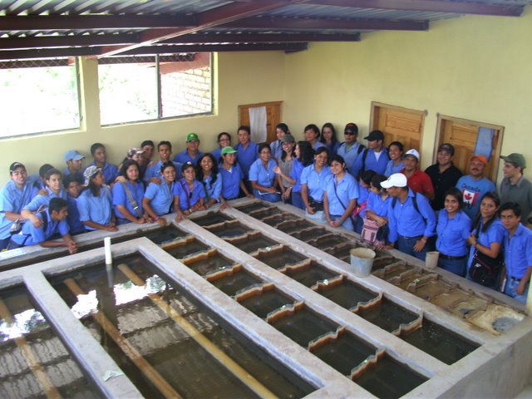
Figure 9: University students visiting the AguaClara plant at Cuatro Comunidades Honduras.
Another one of the AguaClara team’s partners is the Sanjuan Fund. The Sanjuan Fund supports the efforts of selected charities and educational institutions with respect to their programs that are aimed at assisting Hispanic communities to help themselves. The Sanjuan Fund has been very generous in providing ongoing support for AguaClara research, graduate student support, and support of the AguaClara Engineers in Honduras.
The AguaClara Team operates out of the School of Civil and Environmental Engineering (CEE) at Cornell University in Ithaca, New York. The School of CEE has been very supportive in facilitating the research that is conducted at Cornell. The School allows students at any level to obtain academic credit for working with the AguaClara team. In addition, the school provides the team with the facilities and space that are necessary to conduct research.
The AguaClara Team anticipates establishing new partnerships with organizations in other regions that also have inadequately treated surface waters used as drinking water. The team has had meetings with the cabinet level officials from the government of Guatemala, and has been approached by the water and sewer authority of Costa Rica. Dr. Weber-Shirk was invited to organize an intensive one-week training seminar for engineers and water treatment professionals in Honduras last summer. Plans are underway for training sessions in Guatemala during the summer of 2010.

References
1. Swetland, Karen. Nonlinear Chemical Dose Controller. AguaClara. [Online] December 13, 2009. [Cited: March 17, 2010.] https://confluence.cornell.edu/display/AGUACLARA/Nonlinear+Chemical+Dose+Controller.
2. Schulz, Christopher R and Okun, Daniel A. Surface Water Treatment for Communities in Developing Countries. United Kingdom : Wiley Interscience, 1984.
3. Choi, Yoon. Float Calculation. AguaClara. [Online] December 8, 2009. [Cited: March 17, 2010.] https://confluence.cornell.edu/display/AGUACLARA/Float+Calculation.
4. Home page. AguaClara Wiki. [Online] [Cited: March 17, 2010.] aguaclara.cee.cornell.edu.
5. Reed, Heather. AguaClara Design Tool. AguaClara. [Online] June 24, 2009. [Cited: March 17, 2009.] https://confluence.cornell.edu/display/AGUACLARA/AguaClara+Design+Tool.
6. Hurst, Matthew. Evaluation of Parameters AffectingSteady-State Floc Blanket Performance. Ithaca : Cornell University, 2009.

Supporting Letters

Agua Para el Pueblo

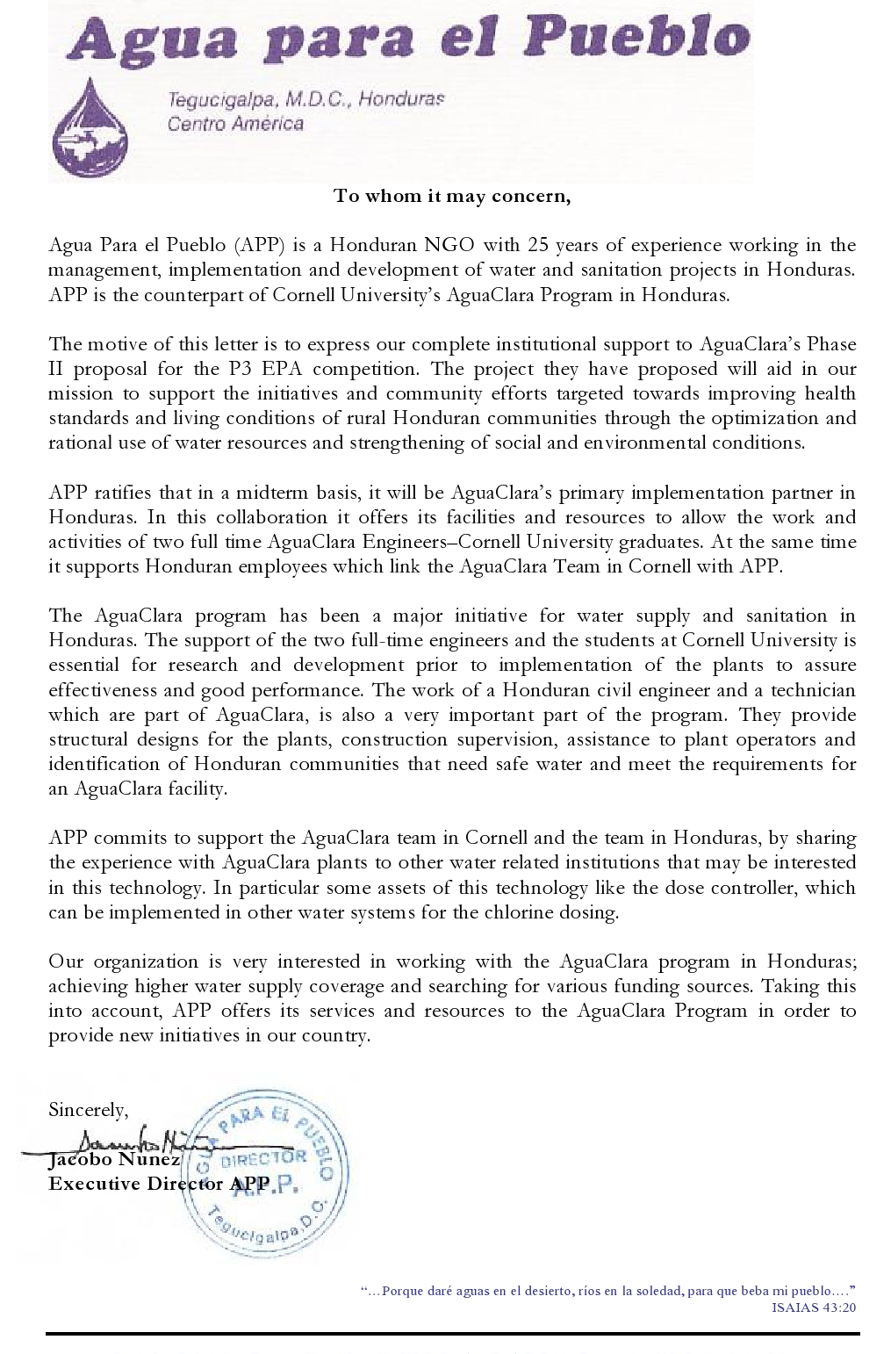

Budget and Budget Justification

Resumes

Monroe Weber-Shirk, Advisor

Karen Swetland, PhD candidate

Dale Johnson, M.Eng

Akta Patel, B.S. c/o 2010

Kayti Curtis, B.S. c/o 2010

Harrison Ko, B.S. c/o 2011

Note that the student team will continue to evolve and that new students will be joining the team at the beginning of each semester (summer, fall, spring). The full roster of the student team is available at https://confluence.cornell.edu/display/AGUACLARA/Team+Members+Spring+2010.

Monroe L. Weber-Shirk
Senior Lecturer/Research Associate
Cornell Center for Sustainable Futures Faculty Fellow
115 Hollister Hall
Cornell University
Ithaca, NY 14853-3501
Phone (607) 255-8445
Fax (607) 255-9004
E-mail mw24@cornell.edu

Professional Preparation | Goshen College, Goshen, IN  B.A. in Physics 1985  Cornell University, Ithaca, NY  M.S. in Agricultural Engineering 1987  Minor: Environmental Engineering  Ph.D. in Environmental Engineering 1992  Minors: Hydraulic Engineering and Agricultural Engineering  Post doc in Environmental Engineering 1992 - 1994
Appointments | Senior Lecturer/Research Associate at Cornell University 2004 – present  Lecture/Research Associate at Cornell University 1994 – 2004

Publications
Tse, I.; Weber-Shirk, M.L.; Lion, LW (Submitted for publication Nov. 2009) Method for Quantitative Analysis of Flocculation Performance, Water Research.
Tse, I.; Weber-Shirk, M.L.; Lion, LW (Submitted for publication Nov. 2009) Fluid Shear Influences on the Performance of Hydraulic Flocculation Systems, Water Research.
Weber-Shirk, M.L.; Lion, LW (Submitted for publication Dec. 2009) Fractal Models for Floc Density, Sedimentation Velocity, and Floc Volume Fraction for High Peclet Number Reactors, Water Research.
Weber-Shirk, M.L.; Lion, LW (Submitted for publication Dec. 2009) Flocculation Model and Collision Potential for Reactors with Flows Characterized by High Peclet Numbers, Water Research.
Lin, Po-Hsun; Weber-Shirk, M.L.; Lion, LW (Submitted for publication April 2009) Comparison of the Ability of Three Coagulants to Enhance Filter Performance, Journal of Water Supply: Research and Technology-AQUA.
Other Publications
Hurst, Matt; Weber-Shirk, M.L.; Lion, LW (Accepted for publication Dec. 2009) Parameters affecting steady-state floc blanket performance, , Journal of Water Supply: Research and Technology-AQUA.
Weber-Shirk, M. L. (2009) Gravity Powered Flow Controllers for Chlorine and Alum Dosing. Journal of Water Supply: Research and Technology—AQUA 58 (2):147–152.
Weber-Shirk, Monroe L and Chan, Kwok Loon. (2007). "The Role of Aluminum in Slow Sand Filtration." Water Research 41 (6), p.1350-1354.
Weber-Shirk, M. L. (2002). "Enhancing Slow Sand Filter Performance with an Acid-Soluble Seston Extract." Water Research 36(19).
Weber-Shirk, M. L. and R. I. Dick (1999). "Bacterivory by a Chrysophyte in Slow Sand Filters." Water Research 33(3): 631-638.

Synergistic Activities
International Experience | (2004-present) Director of the AguaClara program to design and disseminate the technologies for municipal gravity-powered surface-water treatment plants. Led teams of students on annual fact finding/education trips to Honduras. Worked with partner organizations to develop their capacity for building and maintaining the AguaClara water treatment plants.
Teaching Awards | (2009) College of Engineering Academic Achievement Award  (2007) Douglas Whitney ’61 College of Engineering Excellence in Teaching Award
Software Development | Authored client-server model to interface MathCAD, AutoCAD, and Microsoft Word for automated creation and dissemination of AguaClara designs.  Authored user configurable process control software to allow students to monitor and control automated water and wastewater treatment plants (plug and play SCADA system).

Scientists with whom Dr. Weber-Shirk has collaborated in the last 48 months (at Cornell University): Dr. Leonard Lion (Env.,Eng.), Dr. Rajesh Bhaskaran (MAE)

Graduate and Postdoctoral Advisors (all at Cornell University):
Professor Richard I. Dick, Env.
Professor Gerhard Jirka, Env. Eng.
Professor Leonard Lion, Env. Eng.,
Professor Michael Walter, Bio and Env. Eng.,

Thesis Advisor, Postdoctoral Scholars/Research Associates/Visiting Scientists
Kwok Loon Chan
Mimi Perez-Falcon
Matthew Hurst
Rodrigo Labatut
Po-Hsun Lin
Karen Swetland
Ian Tse
The total number of graduate students advised is 7.

Karen A. Swetland
karen.swetland@gmail.com
Current Address: Permanent Address:
301 Dryden Rd Apt. 303 13324 Lakeside Terrace
Ithaca, NY 14850 Cooper City, FL 33330
Cell: 954-336-1700

EDUCATION Cornell University Ithaca, NY
PhD Candidate, Environmental Engineering, Began August 2009
GPA: 3.7/4.00
Vanderbilt University Nashville, TN
Master's of Science, Environmental Engineering major, May 2009
GPA: 3.9/4.00
Vanderbilt University Nashville, TN
Bachelor of Engineering, Civil Engineering major, May 2009
GPA: 3.92/4.00

HONORS Dean's List, Fall 2005, Spring 2006, Fall 2006, Spring 2007, Fall 2007, Spring 2008
Chi Epsilon, Civil Engineering Honor Society, 2007-2009
Tau Beta Pi Engineering Honor Society, 2008-2009
National Merit Finalist, 2004-2005

ACTIVITIES Cornell Women’s Water Polo Team – Goalie, 2009-2010.
Vanderbilt BCM – Baptist College Ministry. President, 2008-2009.Service Team Leader and
leadership Coordinator, 2007-2008. Organized a service trip to San Francisco for 33 students
during Spring Break. Freshmen Team Leader and Leadership Coordinator, 2006-2007. Led
and organized a 30 Hour Famine to benefit World Vision, to fight world hunger.
Vanderbilt American Society of Civil Engineers – Treasurer of 2009 ASCE Southeastern
Conference Competition Committee, 2008-2009. Active Member, 2006-2008.

EXPERIENCE Foundation for Sustainable Development Cochabamba, Bolivia
Intern, Volunteered at the Water and Sewage Cooperative of Quintanilla, May 2008-August
2008. Worked to renovate an Imhoff settling tank. Designed an effluent discharge pipe.
Educated the community on safe use of the sewage system and the necessity of treating
wastewater. Worked effectively in a different culture, language, and environment.
Vanderbilt School of Engineering Nashville, TN
Student Worker, Engineering Media Center, January 2008-Present. Managed
multimedia equipment, including the set-up of projectors, laptops, and projection screens.
Assisted students with minor laptop repair problems and facilitated ITS support.

COURSEWORK Basics: Chemistry, Accelerated Calculus, Physics, Intro. to Matlab, Physics and Chemistry Labs, Thermodynamics, Statistics
Civil Core: Surveying and AutoCAD, Statics, Mechanics of Materials, Dynamics, Structural
Analysis, Construction Project Management, Transportation Eng., Geotechnical Eng.
Water Resources: Water Resources, Fluid Mechanics, Hydrology
Graduate Level: Environmental Chemistry, Biological Unit Processes, Environmental Characterization, Chemical Reaction Engineering, Risk Management Studies, Environmental Assessments, Environmental Fluid Mechanics, Environmental Quality Systems Engineering

SKILLS Computer Experience: AutoCAD, MATLAB, MS Word, Excel, and PowerPoint.
Intermediate Spanish Skills.
Dale Elliot Johnson

Current home address: University apartment:
811 Blacks Hill Road 504 East Buffalo St.
Great falls, VA 22066 Ithaca, NY 14850
Cell phone: (703) 774-4256
Email: dejohn86@gmail.com

Objective: Seeking an entry to mid level Environmental Engineering position

Education: Currently pursuing a Masters of Engineering in Environmental and
Water Resources, Cornell University. GPA: 3.98/4.0 Expected graduation date May 2010.

B.S. Civil Engineering, Virginia Tech (graduated May 2009)
GPA (in major): 3.4/4.0 financed 80% of academic expenses.

Computer software AutoCad 2009, WaterCAD, Matlab, MathCad, and HEC-RAS

Work Experience: -AguaClara Masters of Engineering project (currently involved),
designing low cost sustainable water treatment facilities for the developing world.

-Intern at GeoConcepts Engineering, Inc. (Summers of 2008 and 2009)
Experience in the fields of Environmental and Geotechnical Engineering. Responsibilities include soil classification, geotechnical proposal writing, and construction site technician work.

-Seneca Ridge Incorporated (2000-present)
Designed and constructed animal enclosures for the Leesburg Animal Park zoo. Completed projects include a Bengal Tiger exhibit and a Lorikeet bird aviary.

-Senior Design Project (2008)
Designed a water/wastewater treatment scheme in the most economical feasible and technically sound manner possible for a town in the western US.

Professional Certifications
-Engineer in Training (EIT) -WACEL Soils level 1
-WACEL Concrete Level 1 certification

Academic Activities
-Study abroad, Stellenbosch, South Africa (2007)
- American Society of Civil Engineers- served as the treasurer and a captain of the concrete canoe team (2007 to 2008)
-Engineers without Borders, (2006-2008)
-Volunteer abroad, Students Helping Honduras (2008), Ikayha Music foundation in South Africa (2007), Hurricane Katrina cleanup-Gulfport MS (2005)
Current Address  114 Summit Avenue Apt. 13  Ithaca, NY 14853 | Akta P. Patel  app37@cornell.edu • (908)-235-8537 | Permanent Address  1431 Morningside Drive  Orefield, PA 18069
Education
Cornell University, College of Engineering, Ithaca, NY 05/2010 Bachelor of Science in Biological and Environmental Engineering, Double Major
G.P.A.: 3.8/4.0 • Dean’s List seven semesters
Invited to Tau Beta Phi Engineering Honor Society • Awarded Cornell Tradition Fellowship

École Centrale Paris, Paris, France 07 - 08/2009

Relevant Courses
Environmental Quality Engineering • Environmental Systems Analysis • Watershed Engineering • Hydrology Thermodynamics • Mechanics of Solids • Fluid Mechanics • Heat and Mass Transfer
Experience
AguaClara, Cornell University, Ithaca, NY 09/2009 - present
Chemical Dose Controller Team Member
- Engineer a chemical dose controller prototype for the 2010 Phase II EPA P3 competition.
- Experiment with constructed prototype to determine cause of clogging issues in current plants.

Department of Biological Engineering, Cornell University, Ithaca, NY 09/2008 - 05/2009
Undergraduate Researcher
- Designed and conducted experiments to optimize growth of a potential algae biofuel source.
- Utilized problem-solving skills to identify and resolve issues, such as loss of flow due to head loss and pump malfunction.

Amanacer Solar Oven Team, Cornell University, Ithaca, NY 01/2009 - present
Data Analysis Team Member, Research Team Member
- Determined important variables in cooker operation through experimentation and the analysis of tests from the past 3 years.
- Exchanged test results with the community of Sabana Grande, Nicaragua and the Universidad Nacional de Ingeniería in Managua, Nicaragua.

Department of Chemistry, University of Iowa, Iowa City, IA 06 - 08/2008
Nanoscience and Nanotechnology REU Intern
- Performed experiments to determine the most effective zeolite for lead removal from water.
- Presented findings at a poster session and at the REU final presentation to over 50 people.

Shoals Marine Laboratory, Appledore Island, ME 07 - 08/2007
Engineering Intern
- Cooperated with 5 other interns to monitor the wastewater, freshwater, and energy systems.
- Collected and analyzed data for the wind turbine and solar systems using MatLab and Excel.
- Prepared a final report of the systems’ analysis with personal suggestions to expand the solar energy system and to implement a constructed wetland for wastewater treatment.
Activities
Engineers for a Sustainable World, Cornell University, Ithaca, NY
VP of Membership and Finance (2007-8), VP of Outreach and Education (2008-9),
President (present)
- Coordinate activities, outreach events, and two project teams, Solar Ovens Team and The Veggie Van for a group of 35.
- Represented ESW Cornell with three other members at the 2008 ESW National Conference in San Francisco, CA.

EARS (Empathy, Assistance, and Referral Services), Cornell University, Ithaca, NY
Trainer (2009-present), Counselor (2008-present)
- Enhance interpersonal communication skills through 3 semesters of training to become a peer counselor.
- Collaborate with eight trainers to teach the EARS communication model through weekly presentations to over 150 students.

Skills
Lab skills: Light microscope, precision balance, centrifuge, X-Ray Diffraction, Dynamic Light Scattering, BET, Spectrophotometer
Computer: Matlab, Java, AutoCad, MathCAD, Minitab, Microsoft Office 2003 and 2007

Katherine L. Curtis
klc72@cornell.edu
(708)707-5743
Current Address: Permanent Address:
108 Lake St. Apt.5 629 William St.
Ithaca, NY 14850 River Forest, IL 60305

Education
Cornell University: College of Engineering
Candidate for Bachelor of Science Degree, May 2010
Major: Civil and Environmental Engineering
Concentration: Architecture
Cumulative GPA: 3.67

Work, Leadership, and Research Experience
Chemical Dose Controller Team: Cornell University AguaClara August 2009-present
Part of a team of students designing a non-linear flow chemical dose controller for sustainable, electrically independent water treatment plants throughout Honduras. Research the fluid dynamics theory determining the doser design, as well as build scale models of both the entire plant as well as the chemical doser.

Administrative Assistant: Cornell Center for Materials Research May 2009-present
Assist in the financial office of the center, creating and managing databases for financial records; also prepare fiscal year expense reports and assist in the development of bi-lingual lesson plans and program descriptions for international students.

Program Participant: Instituto Intercultural del Caribe May 2009
Participated in Spanish language courses 5 hours/day with cultural immersion program in the Dominican Republic. Also volunteered in a local school teaching English to 10-15 year olds. Improved Spanish level from intermediate to advanced.

Structural Engineering Intern: Robert Silman Associates, Structural Engineers
December 2008-January 2009
Performed structural analysis on new and current buildings, modeled structures for analysis and presentation. Ran site visits for obtaining information and dimensions of existing structures being renovated as well as new construction.

Tutor: Cornell University Academic Tutoring Program September 2007-present
Tutored fellow undergraduate students in multiple subjects, including calculus, introductory physics, mechanics, thermodynamics, and organic chemistry.

Research Assistant: Metabolic and Signal Engineering Lab, Cornell University
June 2007-August 2008
Worked closely with two post-doctoral fellows on their main projects using ELISA immunoassys, cell culture and co-cultured bacteria, other microtiter plate-based assays, liposome preparation and conjugation.

Prefect, Proctor: Asheville School, Asheville, NC August 2004-May 2006
Student leader for underclassmen during the school day, on dorm, and around campus. Ran study hall, acted as part of the Conduct Council board, and acted as a constant leader for students.

Publications
Edwards, Katie A.; Curtis, Katherine L.; Sailor, Jessica L.; Baeumner, Antje J. Universal liposomes: preparation and usage for the detection of mRNA. Analytical and Bioanalytical Chemistry. Published 8 March 2008.

Duan, Faping; Curtis, Katherine L.; March, John C. Secreting insulinotropic proteins from commensal bacteria: rewiring the gut to treat diabetes. Applied and Environmental Microbiology. Published 3 October 2008.

Honors
College of Engineering Dean’s List (Fall 2006, Spring 2008, Fall 2008, Spring 2009, Fall 2009) ∙ Cornell College of Engineering Global Fellow ∙ Cum Laude Society (2006) ∙ Ranking Scholar (2006) ∙ AP Scholar with Distinction (2006) ∙ AP National Scholar (2006) ∙ Jack W. Bonner, IV Award for Excellence in the Senior Demonstration (2006) ∙ Book Prize in AP Statistics (2006) ∙ National Honor Roll (2005, 2006) ∙ 3rd Ranking Scholar (2004)

Activities
Varsity Women’s Polo (2007-present) ∙ AguaClara Water Treatment Plant Design Team (August 2009-present) ∙ D+E|E+D Vice President (2008-present) ∙ Women’s Novice Crew (2006-2007) ∙ Society of Women Engineers, Member ∙ Engineers for a Sustainable World, Member ∙ Editor-in-Chief of school newspaper (2003-2006) ∙ Varsity Women’s Basketball (2002-2006), letter winner (2003-2006)

Computer and Language Skills
Advanced Spanish language and intermediate Italian language skills, including reading, writing, and spoken word. Proficient in AutoCAD, 3D StudioMax, TransCAD, MathCAD, RAM, RISA 3D, Probe 2.1 Microsoft Word, Excel, Outlook, PowerPoint, and Publisher. Also proficient in the MATLAB programming language.

Harrison Ko
htk5@cornell.edu
Current Address: Permanent Address:
709 Stewart Ave. Apt A27 1954 Sunburst Terrace
Ithaca, NY 14850 West Linn, OR 97068
(503)758-7417

EDUCATION Cornell University, College of Engineering, Ithaca, NY
Intended B.S. Biological Engineering w/ bioenvironmental Concentration
Expected graduation May 2011 Cumulative GPA 3.36

RELEVANT COURSES Hydrology ● Coastal Engineering ● Environmental Systems Analysis ● Water and Landscape Engineering Applications ● Renewable Energy Systems ● AguaClara: Sustainable H₂O Supply Project ● Fluid Mechanics ● Biological and Environmental Transport Processes ●Bioengineering Thermodynamics & Kinetics ● Engineering Probability and Statistics ● Introduction to CADD

RELATED EXPERIENCE Chemical Dose Controller Team Fall 2009/Spring 2010
AguaClara: Sustainable H₂O Supply Project, Cornell University, Ithaca, NY
Worked with team to design, construct, and test an energy-free chemical dosing system for water treatment plants designed for rural regions of Honduras.

Solar Cookers Team Spring 2009/Spring 2010
Engineers for a Sustainable World: Solar Cooker Project, Cornell, Ithaca, NY
Worked with team to design, construct, and test various solar box oven and concentrated solar cooker designs. Traveled to Nicaragua in Spring 2009 to implement box oven designs in the field.

WORK EXPERIENCE Research Assistant, Thaler Lab Summer 2009
Department of Entomology, Cornell University, Ithaca, NY
Assisted with various research projects pertaining to the study of plant-insect interactions. Performed many laboratory and data collection techniques.

Park Attendant Summer 2008
City of West Linn, Parks Department, West Linn, OR
Performed many gardening tasks to maintain the parks of West Linn

Dining Hall Worker Spring 2008
Robert Purcell Marketplace Eatery, Cornell University, Ithaca, NY
Performed many of the tasks associated with food service

VOLUNTEER EXPERIENCE Community Building Works! Ithaca, NY 2008-2010
Volunteer Labor
Assisted with construction of sustainable houses meant for low income families.

Dilmun Hill Student Farm, Ithaca, NY 2008-2010
Volunteer Labor
Performed various organic farming practices to help the farm prosper.

Engineers for a Sustainable World: Cornell, Ithaca NY 2007-2010
Co-President, previously served as VP of Outreach and Education
Organized and coordinated various community service and outreach projects for club members.

ACTIVITIES Engineers for a Sustainable World: Cornell Chapter, Co-President ● AguaClara: Sustainable H₂O Supply Project ● Solar Cooker Project ● Cornell Longboarding Club ● Cornell Running Club

COMPUTER SKILLS Microsoft Excel ● Microsoft Word ● Matlab ● AutoCAD ● HTML

LANGUAGE SKILLS Mandarin (Proficient) ● Spanish (Proficient)

