According to Morrow and de Lamos (Circulation, 2007), what are the 3 criteria a biomarker should fulfill to be useful clinically:
- Accurate, repeated measurements at reasonable cost and short turnaround time
- Must provide information not available from clinical assessment
- Knowing the measured level should aid in medical decision making

List 10 biomarkers of cardiac disease which have diagnostic and prognostic significance in CHF:
- Fas
- CRP
- TNF-α
- Plasma myeloperoxidase
- Isoprostane excretion
- Uric acid
- Procaollagen type III
- NE
- Big endothelin-1
- Arginine vasopressin
- cTnI
- cTnT
- myosin light chain 1
- heart fatty-acid binding protein
- creatine kinase MB fraction
- BNP
- NE
- Big-endothelin-1
- Endothelin
- NE
- ST2
- Chromogranin A
- Galectin-3
- Osteoprotogerin
- Adiponectin
- Growth differentiation factor 15
- Cystatin C
The most powerful predictor of morbidity and mortality for heart failure is ___________.
BNP (followed by Big endothelin-1, NE)

Draw the RAAS including site of synthesis:
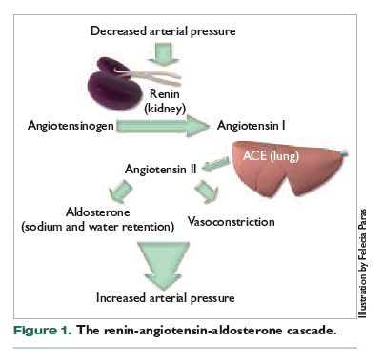
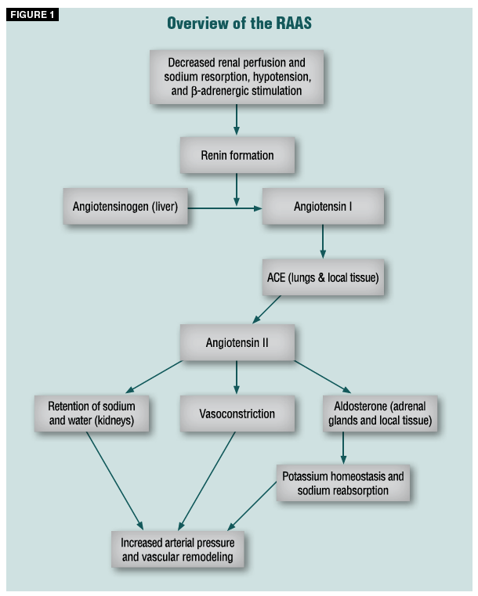

True of False: The use of NT-proBNP together with troponin achieves better risk stratification than that obtained with either biomarker alone for CHF.
True
The progression of heart failure includes an imbalance in vasoconstrictors and vasodilators. List 5 vasoconstrictors and 5 vasodilators that are imbalanced in CHF:
Vasocontrictors:
- NE
- Epi
- AngII
- Aldosterone
- Endothelin-1
- Arginine vasopressin
Vasodilators:
- NO
- Bradykinin
- BNP
- ANP
- Adrenomedullin
- Prostacyclin

