QUESTIONS FOR CARDIAC PHYSIOLOGY
Section 1: Neurohumoral Control of Circulation
1) Both the carotid sinus and aortic arch have baroreceptors that transmit sensory information to the medulla. Which nerve(s) carry this information?
-Carotid: glossopharyngeal n.
- Aorta: vagus n.

2) Please fill in the blanks for the following table regarding the SNS and PNS

Question | SNS | PNS
Site of origination | Lateral horn, spinal grey matter | midbrain, medulla, mid-sacral spinal segments
Location of ganglia (heart) | First 8 Cervical to 3rd Lumbar | In the heart wall
Major Neurotransmitter | ACH and NE | ACH
Receptors | α1, α2, β1, β2, β3 | Muscarinic

3) How does the SNS ganglionic anatomy (in terms of innervations to the heart) differ between the dog and the cat?
- In the cat, most of the synapses that eventually reach the heart are in the stellate ganglia, whereas in the dog they are in the middle, or caudal, cervical ganglia

4) Review the intracellular mechanism for α1 stimulation.

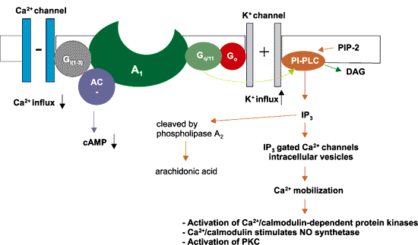

5) What 3 intracellular enzymes are altered by stimulation of the muscarinic receptors
-decreased cAMP, stimulation of PLC and increases cGMP

6) Name 3 circulating hormones that lead to vasoconstriction.
-Angiotensin II, vasopressin (antidiuretic hormone), and endothelin

7) Angiotensin II has all of the following actions except:
a) increases the reuptake of NE
b) smooth muscle vasoconstriction
c) positive inotrope
d) stimulates myocardial growth

8) What are the 2 main receptors of AVP and what is the main physiologic action that results with their binding of AVP?
-V1: vasoconstriction and V2: renal water retension

9) What hormones can increase endothelin release?
-NE and Angiotensin II

10) What types of endothelins are known to exist? And which is predominately responsible for vasoconstriction?
-ET1, ET2, ET3. ET1 is the most potent vasoconstrictor

11) In heart failure, blood volume is typical increased by what percentage?
-25-30%

12) Name the 2 stimuli for secretion of ADH. Of these which is has a stronger effect on its release?
-Decreased atrial volume and high levels of Na. The volume receptors in the body produce a stronger effect on ADH release

13) All of the following lead to Renin release EXCEPT:
a) decreased renal blood flow
b) increased sympathetic nervous stimulation, and
c) decreased sodium flux by the macula densa
d) elevated aldosterone levels

14) Fill in the blanks regarding Angiotensin II and renal sodium retention.

Angiotensin II also has an indirect effect on renal sodium retention. When cardiac output decreases, renal blood flow and glomerular filtration rate ______(1)_______. This leads to an _____(2)____ in blood urea nitrogen and serum creatinine concentration. To bring filtration back to or toward normal, the efferent arteriole leaving the glomerulus ______(3)______ secondary to angiotensin II stimulation. The afferent arteriole is constricted ____(4)___ than the efferent arteriole. The net effect is an increase in the pressure above normal within the glomerular capillaries, which _____(5)____the percentage of filtrate squeezed from the blood (the filtration fraction) to maintain a normal glomerular filtration rate, despite a reduction in total renal blood flow. The change filtration fraction that occurs when renal blood flow is reduced results in the blood within the efferent arteriole and peritubular capillaries being relatively _____(6)_____, compared with normal

-1) decrease, 2)increase, 3) constricts, 4) less, 5) increases, 6) hyperosmolar

15) What is the target organ of ANF?
-Kidney

16) What is the mixed venous oxygen tension in the pulmonary artery?
- around 40mmHg

Section 2: Oxygen Delivery, Oxygen Consumption, and Venous Oxygen Tension

1) Give the equation for oxygen content.
-O2 content = (Hb x SaO2 x 1.34) + (.003 x PaO2)

2) What is the lowest the oxygen tension can go before cellular metabolism is switched to anaerobic?
- 24 mmHg

3) Which tissue bed has the highest oxygen consumption and therefore the lowest venous oxygen tension? Which has the highest venous oxygen tension?
-Coronary (lowest), Kidney (highest)

4) A true mixed venous blood sample must be collected from where?
-Pulmonary artery

Section 3: Normal Pressures, volumes and flow

1) Give the normal values for the following:

a) Systolic pressure of the left ventricle 90-150 mmHg
b) Systolic pressure of the right ventricle 15-30 mmHg
c) Diastolic pressure in the aorta 60-100 mmHg
d) Diastolic pressure in the pulmonary artery 5-15 mmHg
e) Pulse pressure 40-80 mmHg
f) LV diastolic pressure 4-12 mmHg
g) RV diastolic pressure 0-5 mmHg

2) What is the dicrotic notch seen on the Wigger’s diagram?
-rapid decrease and then increase in aortic pressure that occurs when the aortic valve closes and the cardiohemic system oscillates

3) In any give heart chamber the pressure is determined by what 2 things?
-blood volume and compliance

4) Stroke volume can be divided by body surface area to create an index to compare animals of different sizes. What is the normal stroke volume index?
- 41 mL/m², with a range of 30-50 mL/m²

