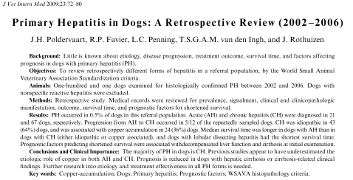

Take home messages:
- Copper accumulation higher etiology than previously documented
- AH has a 50-50% to either resolve or progress to CH
- LDH have shortest outcome, AH longer than CH

Primary hepatitis: diagnosis: histology determine acute vs chronic vs lobular dissecting vs granulomatous vs eosinophilic and +/- cirrhosis
Etiology:microorganism, toxins, drugs, immune mediated, breed associated metabolic errors, copper.

Purpose of the study:
- Describe the different forms of hepatitis and the clinical and pathologic findings associated
- Assess frequency of Copper accumulation and the different causes
- Determine the progression from AH to CH and CH to cirrhosis
- Describe clinical outcome and prognosis factors

Materials and methods:
Retrospective study from Utretch. Dig 2002-2006 w histopathlogy of the liver
Exclusion: secondary hepatitis (ischemic or non specific inflammatory response)
Histo: obtained by US guided biopsies (at least 2). Graded the level of apoptosis, fibrosis, copper content and distribution and steroid induced hepatopathy
Classied as Acute hepatitis (AH), chronic hepatitis (CH), lobular dissecting hepatitis (LDH), granulomatous (GH) or eosinophlic (EH).

Results:
Primary hepatitis: 0.5% of the cases presented to the hospital. 101 cases total
Chronic hepatitis 67/ is more common than acute hepatitis 21/101
Etiologies CH: Idiopathic, Copper 29/88 , Leishmania 1/67
LDH, GH: no etiologies were found.
Progression: based on histology obtained 6 weeks after the initial visit:
AH: 50-50% chance of getting better or progression of disease towards chronic hepatitis.
Breed : English and American Cocker Spaniel, Lab, Golden, WHWT, JRT, German Pointer
AH: female neutered most represented
CH: female intact
Age: LDH were significantly younger than the other categories of primary hepatitis
Clinical signs: lethargy, anorexia, vomiting, PUPD, weight loss, pigmenturia, icterus, diarheaa, abdominal distension, hepatic encephalopathy, hepatomegaly, urinary incontinence, pruritus, abdominal pain.
Concurrent disease: epilepsy, DM, hyperadrenocorticism, hypothyroidism, arthritis, arthrosis, CKI, diarrhea, KCS, pseudopregnancy.

Clinical pathologic findings: LDH: lower TS, CH: lower glucose
US: can document any abnormalities, to WNL –hepatomegaly, microhepatica, nodules, ascites, enlarged lymph nodes

Histo: LDH: higher degree of fibrosis. Copper accumulation in zone 1 (periportal) in idiopathic CH, and zone 3 in CH due to copper accumulation. Cirrhosis: documented in CH and LDH.

Treatment: AH: antibioticsm hepatosupport diet, ursodeoxycholic acid. AH due to Copper: pred, penicillamine, oral zinc, hepatic diet.
CHi: pred +/- antibiotics. CHca: pred, penicillamine, oral zinc, hepatic
LDH: symptomatically

Outcome: mean survival time: longer AH vs CHD. LDH shortest median survival time.
Prognostic factors associated w short survival: hypoalbuminemia, left shift, microhepatica, ascites, cirrhosis, enlarged lymph nodes.

