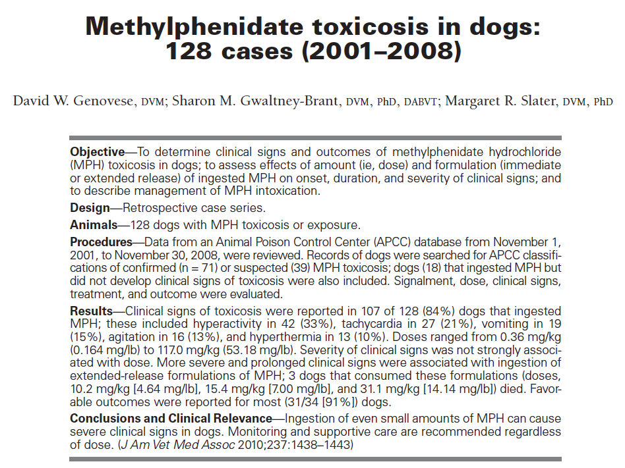
Key Points:
- Minimum toxic doses noted was 0.59 mg/kg of the IR version an 0.39 mg/kg of the ER version
- Most common clinical signs are hyperactivity, tachycardia, vomiting, agitation and hyperthermia
- ER version has clinical signs for longer and all deaths were from ER versions
- Treatment by sedation w/ acepromazine vs. chlorpromazine, beta blockers, propofol for seizure (no diazepam), and methacarbamol. Due to serotonin syndrome cyproheptadine may be of benefit, hypertension can be treated with prazocin
Questions
- Methylphenidate works by blocking:
  - Chloride channels in the synapse
  - GABA transmission
  - Dopamine transporters
  - Serotonin reuptake
- Minimum dose with toxicity signs with extended release tablets was:
  - 0.29 mg/kg
  - 0.39 mg/kg
  - 0.49 mg/kg
  - 0.59 mg/kg
- The most commonly seen clinical sign:
  - Tachycardia
  - Hyperthermia
  - Agitation
  - Hyperactivity
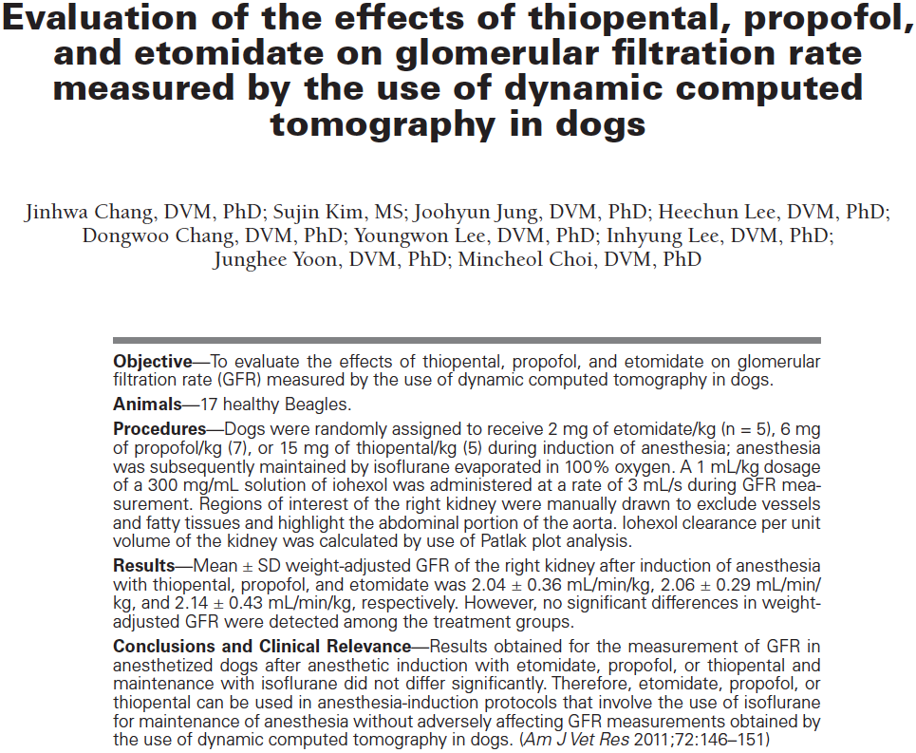
Key Points:
- Gold standard GFR measurements by inulin quantification, but that is an annoying test to run
- Nuclear scintigraphy has been used but the image quality is not as good as CT
- No significant differences in the GFR was noted between the dogs despite changes in hemodynamic variables
Questions
- Criterion-referenced standard GFR measurements are done by use of:
  - Nuclear scintigraphy
  - Congrast radiography
  - Contrast CT
  - Inulin quantification
- Reported factors influencing GFR include:
  - Isoflurane
  - Hyperventilation procedure
  - Contrast
  - All above
- Etomidate’s effect on GFR is:
  - Increase
  - No change
  - Decrease
  - Eliminated
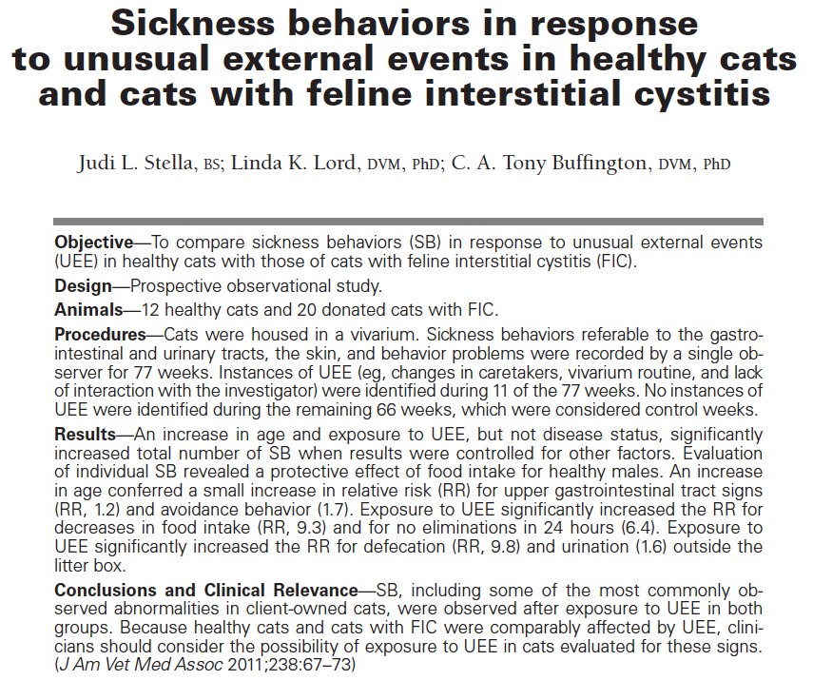

Key Points
- Suggestion is that interstitial cystitis is a bladder manifestation of systemic disease
- Sickness behaviours have been documented in both sick and healthy cats
- sickness behaviours were not significantly increased in cats with FIC either with or without external stimulation
- increased age was associated with increased sickness behavior
- all cats received dry diet and none blocked, author suggests we stop recommending moist diets
- most common noted sickness behavior is decreased eating and inappropriate eliminations
- results also suggest that frequent litter box maintenance may not alleviate inappropriate elims
- authors state that sickness behaviours are probably due to both external and internal factors
- since both healthy and sick showed sickness behaviours, all cats need environmental enrichment
Questions:
- The author saw significance in the sickness bahaviors with
  - Cats with interstitial cystitis
  - Older cats
  - Cats with dirty litterboxes
  - All above

