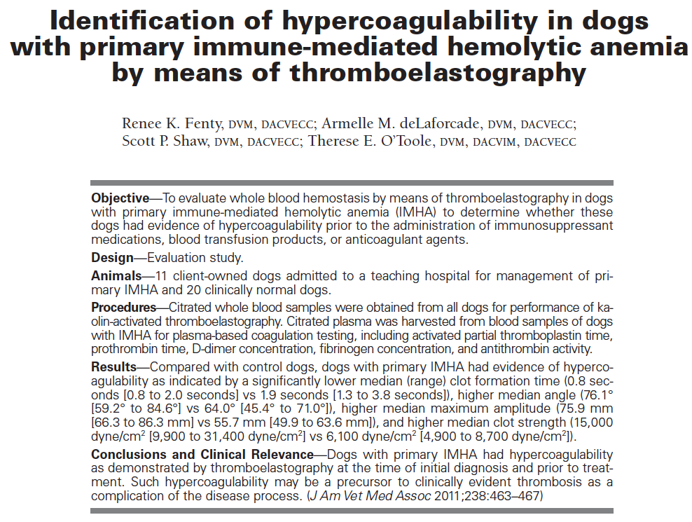
Key points
- Thromboembolism complications reported as high as 80% of IMHA at necropsy
- Previous studies showed hypercoagulobility but after treatment started
- Patients with IMHA were signfiiciantly more hypercoagulable then controls based on K, alpha, MA, and G values but not the R value
Questions
- What is the technique employed by the TEG machine?
  - Measures the viscoelastic changes occurring during coagulation based on interactions between fibrinogen, platelets and protein coagulation cascade
- True/false, the hypercoagulability of IMHA is due solely to corticosteroid treatment-FALSE
- Which of the following were significantly higher in IMHA?
  - R
  - K
  - Alpha
  - MA
  - G

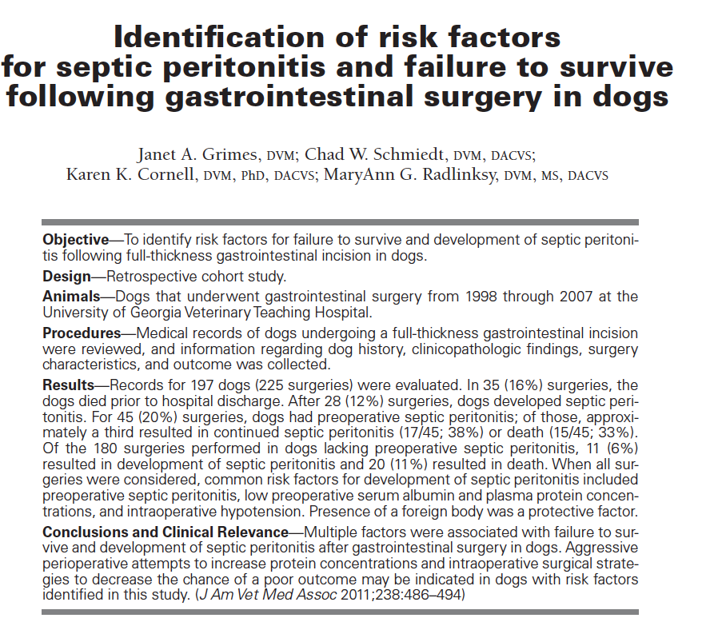

Key points
- Significantly associated with survival: presence of foreign body, use of antimicrobials,
- Significant risk factors identified: low plasma protein, low serum albumin, preop anemia, preop leukocytosis, low intraoperative blood pressure, pre-operative sepsis, long surgical duration, GI with biliary surgery, use of steroids post-operatively,
- Non-survival rate for patients with pre-op sepsis was 33%, if pre and post op septic survival rate is 47%
- Of patients undergoing GI sx without preop sepsis 6% developed post-op sepsis, 11% died
Questions
- What is the abdominal effusion to blood glucose concentration ratio consistent with septic peritonitis?
- Which of the following is not a risk factor in gastrointestinal surgery?
  - Low serum albumin
  - Intra-operative hypotension
  - Steroid use post-operatively
  - Foreign body surgery
- The survival rate for patients undergoing gastrointestinal surgery for treatment for septic peritonitis is
  - 50% if no post-operative sepsis
  - 67% if no post-op sepsis
  - 67% if post-op sepsis happens
  - 90% with no post-op sepsis

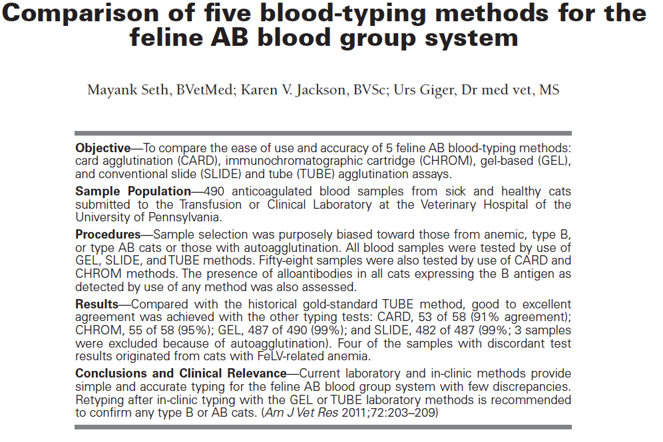
Key Points
- B type cats have strong anti-A antibodies, A type cats have weak anti-B antibodies
- Typically in the past the tests used B cat natural alloantibodies, and a manufactured anti-B antibody, now both are manufactured
- Overall agreement between the various methods was good
- TUBE method considered gold standard
- SLIDE and GEL methods had 99% agreement, the CHROM method 95% and the CARD method 91%
Questions
- Which test was considered easiest to use?
  - GEL
  - TUBE
  - CHROM
  - SLIDE
- Which of the following was reported as a factor leading to inaccurate results in this study?
  - Autoagglutination
  - FeLV infection
    - Also anemia
  - Mycoplasma hemofelis infection
  - All above
- Which is true
  - Type A queens mated to type B toms risk neonatal isoerythrolysis
  - Type A cats have strong anti-B antibodies
  - GEL method appears most standardized for lab use
  - The prevalence of type B cats is much higher than type A

