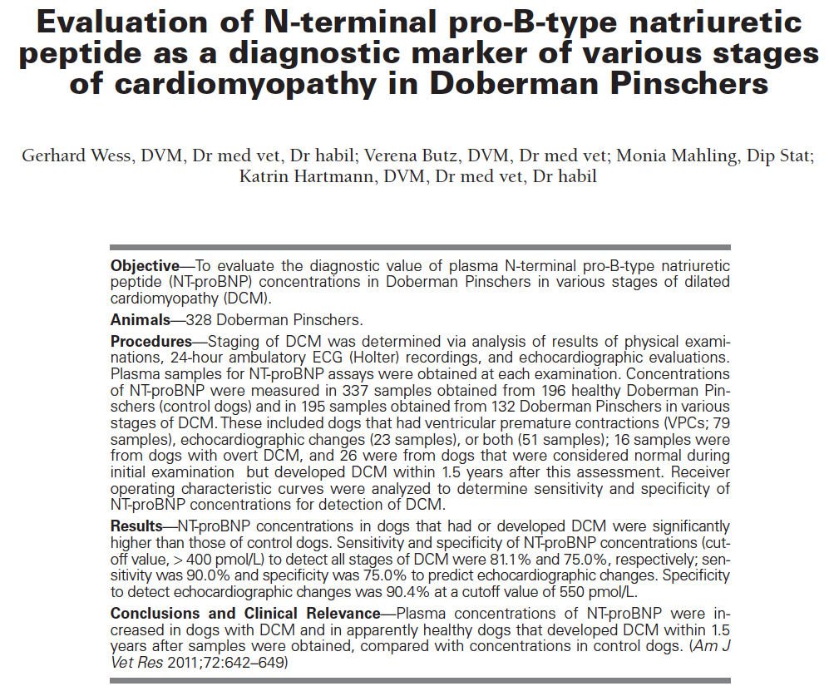

Key Points
- NT-proBNP is significantly higher in control dogs >8
- NT-proBNP is significantly higher in dogs w/ DCM compared to control
  - Either with VPC or increased LVID
- Cut off value >550 gave sens/spec for DCM of 78.6/90.4%
- Dogs initially enrolled in control group which went on to develop DCM had significantly higher NT-proBNP
Questions
- Signs consistent with occult DCM include all of the following except
  - No evidence of heart change
  - Increased LVID
  - Presence of heart failure
  - Presence of VPC
  - B, C and D
- True/false NT-proBNP can be used as a highly sensitive test for occult DCM
- True/false, healthy Dobermans with age >8 were more likely to have elevated NT-proBNP

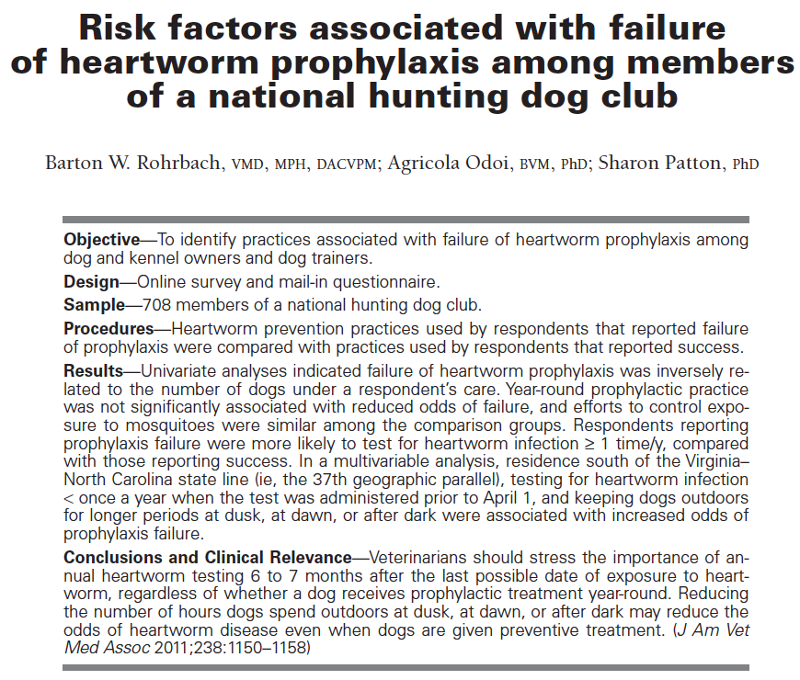
Key points
- You should give heartworm prophylaxis.
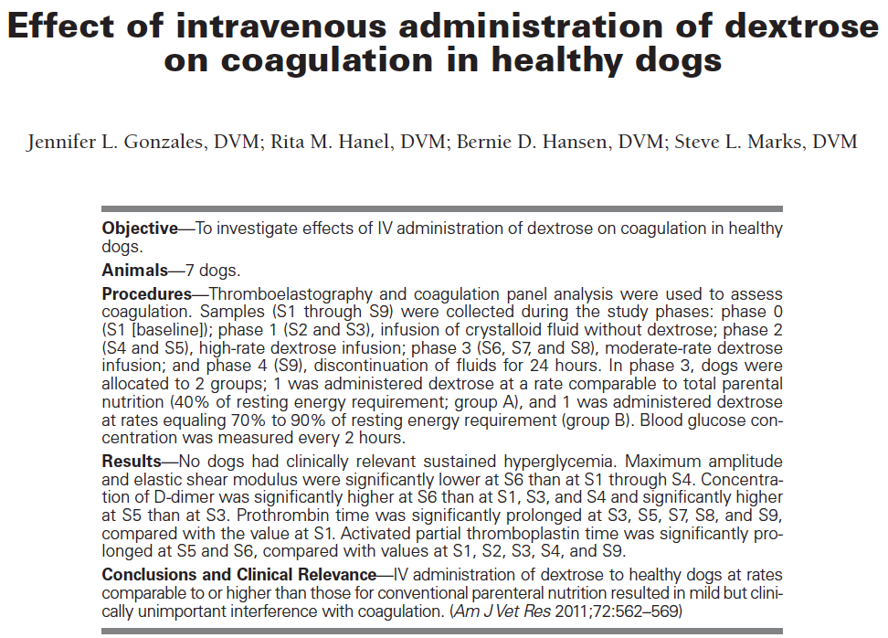
Key Points
- Human studies show w/ hyperglycemia: increased risk of infection, increased oxidative stress, release of proinflammatory cytokines and activation of coagulation
- Hyperglycemia present in 16% of dogs in ICU
- Significantly greater number of hyperglycemic dogs develop sepsis
- Dextrose administration to healthy dogs at rates comparable to or higher than TPN resulted in mild but clinically unimportant hypocoagulability based on TEG and standard coagulation analysis
Questions
- What percent of dogs in the ICU had hyperglycemia?
  - 14%
  - 16%
  - 17%
  - 15%
- Administration of dextrose resulted in
  - No change in glucose concentration
  - No change in coagulation
  - Hypercoagubility
  - hypocoagubility

