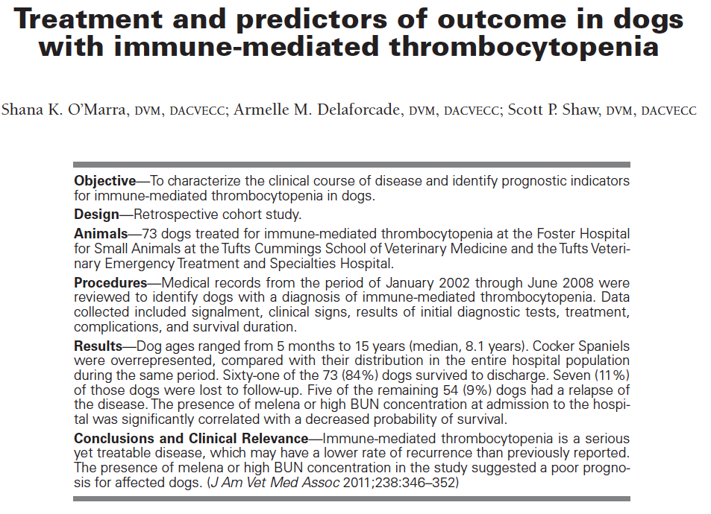
Key Points:
- Only cocker spaniels over-represented, females more than males, median age of onset 8.1 y
- Melena at presentation significantly associated with failure to survive to discharge and need for blood
- Elevated BUN was significantly associated w/ failure to survive
- No association b/t megakaryocytic hypo or hyperplasia and survival
- Treatment with all: steroids, cyclosporine, vincristine and mycophenolate is significantly less likely to survive than treatment with other drug combinations
- Treatment with gastroprotectants was not significantly associated with survival
- 84% survived to discharge
- median hospital stay was 4 days-5 days for survivors and 3 days for nonsurviors, median bill was 2,222
- 3% of patients surviving to discharge developed a thromboembolic event following
- 9% had relapse of signs, median time was 1,743 days
- median interval to weaning from immunosuppresives: 123 days

Questions:
- What factors were associated with failure to survive? BUN and melena at presentation
- What percent of patients developed a thromboembolic event?
  - 2%
  - 4%
  - 3%
  - 6%
- What was the percent survival to discharge?
  - 35%
  - 45%
  - 65%
  - 85%

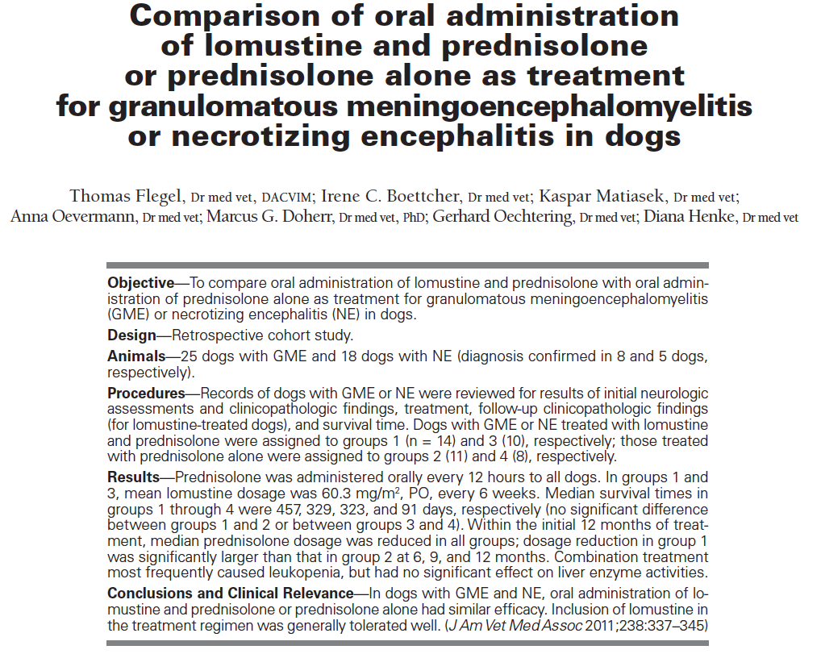
Key points:
- CCNU is a alkylating agent w/ low MW and lipophilic properties-presumed to penetrate to brain
- No significant difference in sex of effected animals, GME dogs were significantly older than NE
- GME dogs tx w/ lomustine and pred were on a significantly lower pred at 6, 9 and 12 months
- Prednisolone was discontinued for 4 dogs in the GME lomustine group, none of just pred group
- No significant difference in pred doses b/t tx groups of NE
- 4 dogs w/ NE were able to be taken off pred, and 2 off lomustine,
- survival times did not differ significantly b/t GME treatment groups
- age was a significant predictor of survival in GME
- survival times did not differ significantly b/t NE treatment groups

Questions
- True/false-the GME dogs with lomustine and pred had a significantly higher survival time
- Which of the following were predictors of survival time in GME?
  - Sex
  - Age
  - ALT
  - All above

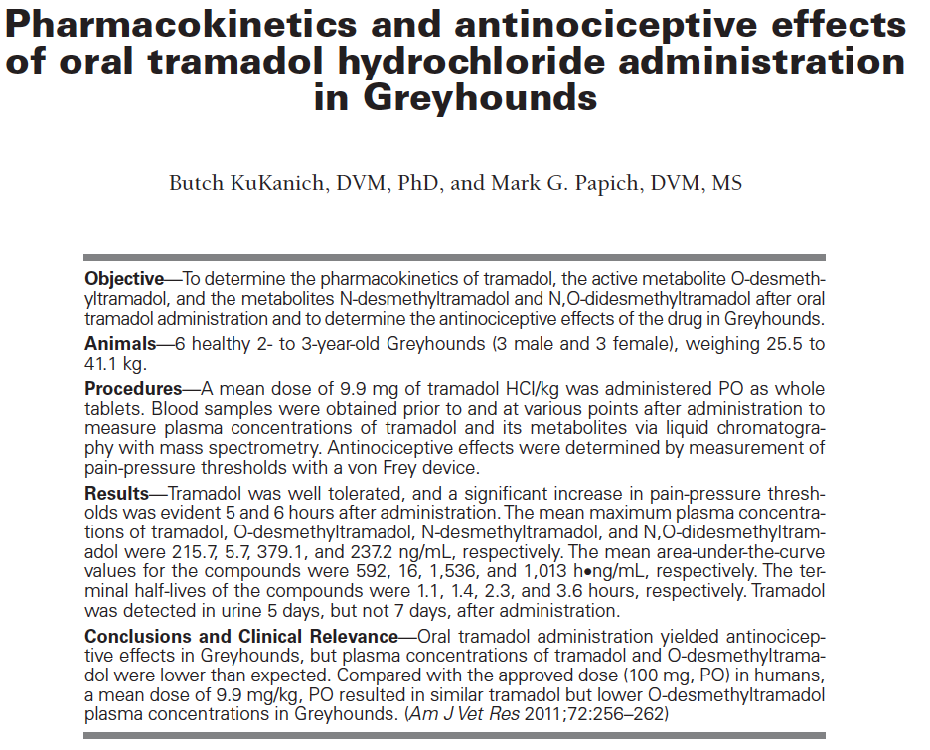
Key Points
- Previous studies: 11 mg/kg, 4 mg/kg, identified low levels of O-desmethyltramadol and high levels of a different one called N-desmethyltramadol
- Significant increases in the pain threshold was seen at 5 and 6 hours, no other time points, though
- Levels of the N-desmethyltramadol were higher than other metabolites in this study
- Low levels of metabolics suggest other MOA (norepi reuptake inhibition or serotonin reuptake inhibition) may be the primary antinociceptives in tramadol
- Large intersubject variability exists between all subjects in all studies

Questions
- What are the sites of action of tramadol?
  - opioid
  - norepinephrine
  - serotonin
  - all above
- True/false: Tramadol gives a predictable and reliable drug distribution and time to distribution

