Guyton & Hall Textbook of Medical Physiology
Chapter 74: Introduction to Endocrinology

1. Endocrine hormones are secreted by cells into the extracellular fluid and affect:
a. The function of the same cells that produced them by binding to cell surface receptors
b. The function of neighboring cells of a different type than the cells that produced them
c. The function of cells at another location in the body
d. Local nerve cell functions

2. Paracrine hormones are secreted by cells into the extracellular fluid and affect:
a. The function of the same cells that produced them by binding to cell surface receptors
b. The function of neighboring cells of a different type than the cells that produced them
c. The function of cells at another location in the body
d. Local nerve cell functions

3. Autocrine hormones are secreted by cells into the extracellular fluid and affect:
a. The function of the same cells that produced them by binding to cell surface receptors
b. The function of neighboring cells of a different type than the cells that produced them
c. The function of cells at another location in the body
d. Local nerve cell functions

4. What are the three general classes of hormones?
a. Proteins and polypeptides
b. Steroids
c. Derivatives of the amino acid tyrosine

5. Which of the following are true regarding polypeptide and protein hormones?
a. Synthesized on the rough endoplasmic reticulum of different endocrine cells
b. Packaged into secretory vesicles and are released via exocytosis
c. Water soluble
d. All of the above
e. None of the above

6. All of the following are true of steroid hormones EXCEPT:
a. Generally synthesized from cholesterol
b. Lipid soluble
c. Enter circulation via simple diffusion across the cell membrane
d. Stored in high concentrations within muscle and fat

Steroid and thyroid hormones circulate in the blood mainly bound to plasma proteins and are not highly stored. Usually less than 10% of steroid or thyroid hormones in the plasma exist free in solution.

7. Match each of the following hormones to their gland/tissue of origin:

Thyroid-stimulating hormone (TSH) Kidney

Renin Adrenal medulla

Aldosterone Anterior pituitary

Adrenocorticotropic hormone (ACTH) Hypothalamus

Antidiuretic hormone (ADH) Posterior pituitary

Norepinephrine Adrenal cortex

8. Which of the following hormones are derived from the amino acid tyrosine?
a. Prolactin and oxytocin
b. Aldosterone and testosterone
c. Thyroxine and norepinephrine
d. Insulin and glucagon

9. Down-regulation of hormone receptors can occur as a result of:
a. Inactivation of some of the receptor molecules
b. Inactivation of some of the intracellular protein signaling molecules
c. Sequestration of the receptor to the inside of the cell
d. Increased destruction or production of receptors
e. All of the above

10. Neurotransmitters, such as acetylcholine and NE, combine with receptors located on the __________ membrane, causing a change in receptor structure which opens or closes one or more ion channels.
a. Presynaptic
b. Postsynaptic
c. Presynaptic and postsynaptic
d. Intracellular

11. Many hormones activate receptors that indirectly regulate the activity of target proteins by coupling with groups of cell membrane proteins call heterotrimetric GTP-binding proteins, or G-proteins. Binding of hormone with G-proteins can then stimulate formation of the second messenger cAMP inside the cell membrane. Use the space provided to illustrated the mechanism of activation of a G-protein-couples receptor and the Adenylyl Cyclase-cAMP second messenger system:
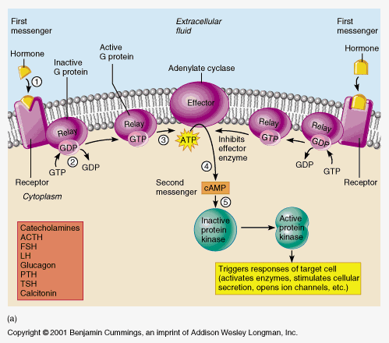

12. List 5 hormones that exert their effect via the Adenylyl-Cyclase-cAMP second messenger system
Adrenocorticotropic hormone (ACTH)
Angiotensin II (epithelial cells)
Calcitonin
Catecholamines (β-receptors)
Glucagon
Parathyroid hormone
Secretin
Somatostatin
Thyroid-stimulating hormone (TSH)
Vassopressin (V2 receptor, epithelial cells)
Corticotropin-releasing hormone (CRH)
Follicle-stimulating hormone (FSH)
Human chorionic gonadotropin (HCG)
Luteinizing hormone

13. Use the space provided to illustrate the cell membrane phospholipase C second messenger system used by some hormones to exert their control of cell function.
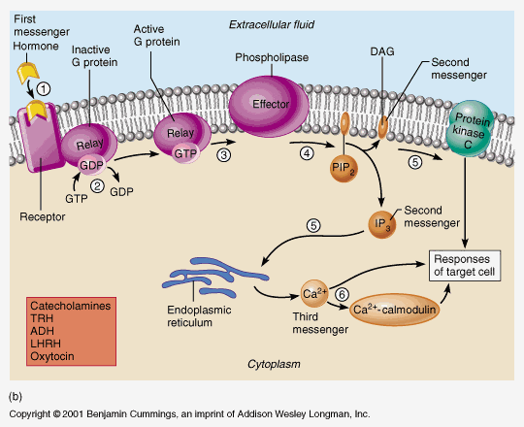

14. List 3 hormones that exert their effect via the phospholipase C second messenger system.
Angiotensin II (vascular smooth muscle)
Catecholamines (α-receptors)
Gonadotropin-releasing hormone (GnRH)
Growth-hormone-releasing hormone (GHRH)
Oxytocin
Thyroid-releasing hormone (TRH)
Vasopressin (V1 receptor, vascular smooth muscle)

15. Blood hormone concentrations can be measured using which of the following diagnostic tests?
a. ELISA
b. Radioimmunoassay
c. IFA
d. A and B
e. B and C

