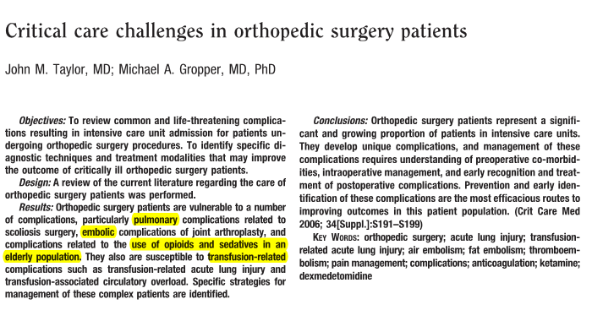
Preoperative risk factors for death for human patients undergoing orthopedic surgery incude all of the following EXCEPT:
- chronic renal failure
- chronic obstructive pulmonary disease
- older than 50 yrs of age
- congestive heart failure
- atrial ﬁbrillation
answer: c—should risk increases if patient is older than 70

Postoperative risk factors for death for human patients undergoing orthopedic surgery include all of the following EXCEPT:
- chronic renal failure
- atrial fibrillation
- chronic obstructive pulmonary disease
- hip fracture
- age of 70 yrs old
answer: b—CHF is a risk factor, not a-fib

The risk factor associated with highest postoperative mortality rate is_____________.
answer: renal failure, with a mortality rate of of 27.6% with ARF and 9.2% with CRF

Predictors of ICU length of stay for human patients undergoing corrective spinal surgery include al of the following EXCEPT:
- age
- American Society of Anesthesiology status
- surgical procedure
- ﬂuid administration
- cardiomyopathy
answer: e—not a risk factor, all others are

Risk factors associated with airway complications for human patients undergoing anterior cervical spine surgery include all of the following EXCEPT:
- exposure of three or more vertebral levels
- exposures involving C2through C4
- length of surgery
- operative blood loss of >300mL
- operative time of ≥5 hrs
answer: c—not a risk factor, all others are; however, length of surgery (≥ 3 hours) is a risk factor for pulmonary compications

Factors associated with postoperative mechanical ventilation requirements include al of the following EXCEPT:
- preexisting neuromuscular disease
- severe restrictive pulmonary dysfunction with a vital capacity of ≤35% predicted
- congenital heart defects
- left ventricular failure
- obesity
- blood loss of >30 mL/kg
answer: d—right ventricular failure is a risk factor, NOT left ventricular failure
Define ALI and TRALI:
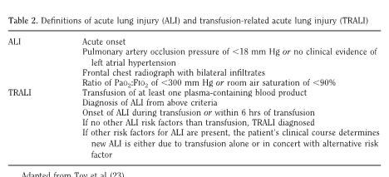

TRALI: acute hypoxia with noncardiogenic pulmonary edema after blood product administration (within 6 hours). “two-hit” hypothesis model, in which the ﬁrst hit is the underlying condition of the patient, with the second hit being transfusion of blood products. The ﬁrst hit is the priming of pulmonary neutrophils, and the second hit activates the primed white blood cells that release oxygen radicals that cause capillary leak leading to pulmonary edema. Two theories exist, which differ in the origin of the second hit. The ﬁrst theory implicates transfused antibodies to human leukocyte antigens (class I and II) that set an inﬂammatory cascade into motion. The problem withthe ﬁrst theory is an absence of antibody found in donor or recipient in 10% of the TRALI cases. The second theory states that cellular breakdown products, biologically active lipids, incite neutrophil activation. The limitation to the second theory is that fresh frozen plasma has been associated with TRALI, and fresh frozen plasma has no cellular component. It is possible that these theories are not exclusive of one another. There is a deﬁnite association between multiparous donors and the prevalence of TRALI. This is likely due to human leukocyte antigen antibodies that have developed to the fetus in utero. This theory is further supported by the increased prevalence of TRALI seen in transfusion between close relatives.
Diagnosis of TRALI is typically clinical and one of exclusion. Once cardiogenic pulmonary edema and blood group incompatibility are ruled out, TRALI should be suspected. Pulmonary edema ﬂuid will show a high protein content, as opposed to hydrostatic pulmonary edema seen in left atrial hypertension, in which the protein concentration relative to plasma protein is low. Complete blood count may demonstrate leukopenia or thrombocytopenia. A chest radiograph typically shows bilateral interstitial inﬁltrates. As seen in acute lung injury, the ratio of PaO2 to FIO2 will be <300.

Fat embolism syndrome has been reported in human patients undergoing orthopedic surgery. Define its symptoms, proposed etiology and diagnosis.
-triad of symptoms including respiratory distress, neurologic changes, and petechial rash.
- two leading theories: biochemical and mechanical
- The biochemical theory proposes that free fatty acids in the circulation directly injure pneumocytes. A large pulmonary fat burden may result in pulmonary hypertension, right ventricular dysfunction, and resultant hypoxemia.
- The mechanical theory states that small fat droplets (10 m)enter the circulation, pass through the pulmonary capillaries or pass through a patent foramen ovale, and deposit in the end organs where the deposition results in local cellular and organ dysfunction.
- Diagnosis of FES is based on identiﬁcation of major and minor criteria. Major diagnostic criteria are respiratory distress, change in neurologic status, and petechial rash (rash is pathogneumonic); minor criteria are pyrexia, renal insufﬁciency, hyperbilirubinemia, and tachycardia
- Other symptoms include dyspnea, fever, cough, hemoptysis, chest pain, hypoxia, alveolar hemorrhage, and altered consciousness
- Signs and symptoms may manifest immediately or in 24–48 hrs
- BAL shows fat-laden MACS

Risk factors for pulmonary emboli in human patients undergoing orthopedic surgery include all of the following EXCEPT:
- advanced age
- obesity
- cardiac disease
- cancer
- bedrest
answer: c—not a risk factor; however, previous DVT/PE is the risk factor missing from this list

The most common hereditary blood disorder associated with VTE and PE is:
- sickle cell anemia
- hemophilia A
- hemophilia B
- factor V Leiden
answer: d

Prophylaxis for VTE is of paramount importance in the orthopedic surgery patient. Which of the following prophylactic VTE therapies provides the greatest risk reduction:
- aspirin
- low-molecular weight heparin
- low-dose unfractionated heparin
- graded compression stockings
answer: b—has been associated with a 68% risk reduction

As outlined in the American Society of Regional Anesthesia 2003 Consensus Statement, ff a patient has an epiduralcatheter in place and requires systemic anticoagulation, it is recommended that removal of the epidural catheter is safe iwhen:
- 2 hrs after unfractionated heparin drip is stopped
- 2 hrs before the ﬁrst dose of low molecular weight heparin is administered
- when the international normalized ratio is 1.5 for those patients receiving warfarin therapy
- all of the above
answer: d

