Chapter 2 kittelson

- Label the following picture:
  - Z line
  - Sarcomere
  - Actin filament
  - Myosin filament
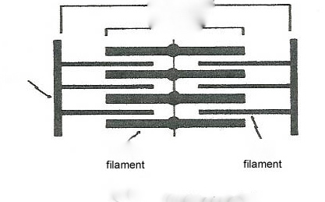

- Troponin C :
  - Binds to calcium and causes conformational change in tropomyosin
  - Inhibits the magnesium-stimulated actomysin ATP ase
  - Attaches troponin to tropomyosin

- List the events happening in excitation coupling:
  - Opening of voltage regulated L type calcium channel during phase 2 of the action potential
  - Entering of calcium in the myocyte via T tubules
  - SR release of calcium via the ryanodine receptor
  - Increase in intercellular calcium concentration
  - Activation of troponin C: conformational change of tropomyosin: allows actin to interact with myosin and contract in the presence of ATP
  - W ATP: sliding of the thin filament over the thick filament: contraction.

- Describe the 2 cellular mechanism for cardiac relaxation:
  - SR pumps the calcium back: sarcoplasmic calcic ATPase pump (SERCA): 1 ATP permits recapture of 2 Ca2+.
  - Sodium/ calcium echange pump: 3 Na+ goes in / 1 Ca2+ goes out

- What molecules regulate the amount of calcium pumped back into the SR?
  - Phospholamban
  - Cathecolamines (via beta adrenergenic receptor, G protein, cAMP, protein kinase)

- What are the 6 factors that determine the heart’s ability to pump blood to the peripheral tissues?
  - Preload,
  - Afterload
  - Contractility
  - Heart rate
  - Hypertrophy
  - Leaks

- What factors determine systolic wall motion also known as contraction seen on echocardiogram?
  - Preload
  - Afterload
  - Contractility

- TSV=
  - EDV-ESV
  - ESV-EDV
  - EDV-ESV/EDV (= ejection fraction)

- Shortening fraction=
  - EDD-ESD
  - ESD-EDD
  - EDD-ESD/EDD

- Enounce Laplace’s Law:
  - Sigma= P ed x r ed/ 2hed
  - Assessement in afterload

