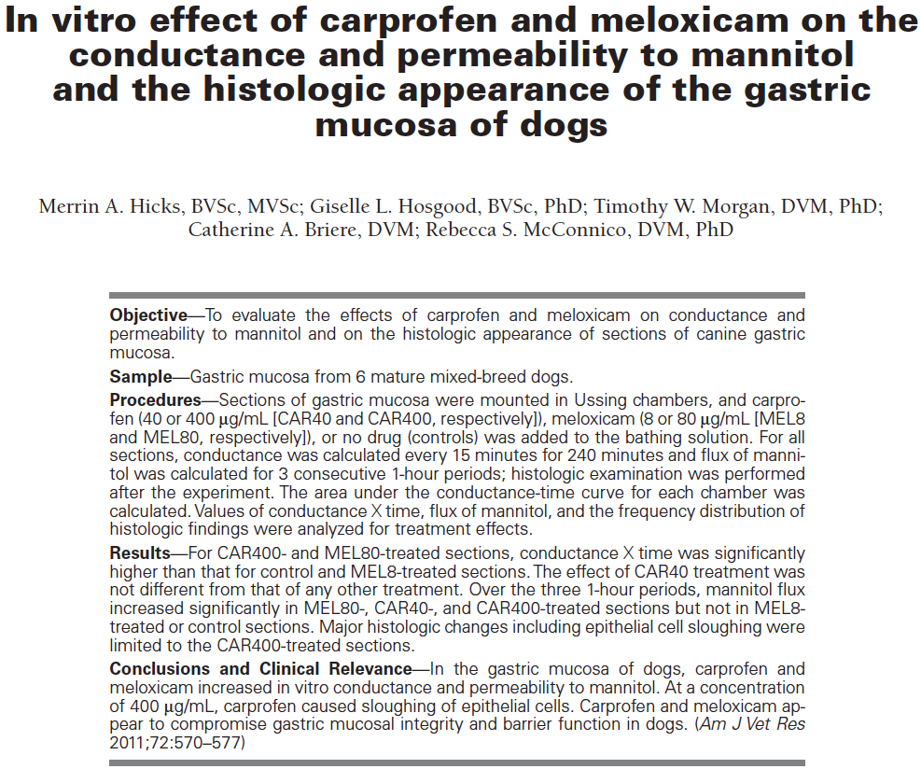

Key points
- Mechanisms for GI injury with NSAID theories:
  - Reduction of prostaglandin synthesis by inhibition of COXs
  - Oxygen free radical-mediated lipid peroxidation
  - Nitric oxide production
  - Altered permeability of gastric mucosal cells to hydrogen ions
  - Uncoupling of oxidative phosphorylation in mitochondria and depletion of ATP
  - Induction of platelet aggregation and neutrophil adherence in GI tract
  - Increased leukotriene synthesisischemia and inflammation
- Carprofen caused sloughing of epithelial cellsloss of viability of these cells
- Carprofen and meloxicam both increased electrical conductance and permeability to mannitol, however meloxicam only in highly above therapeutic doses

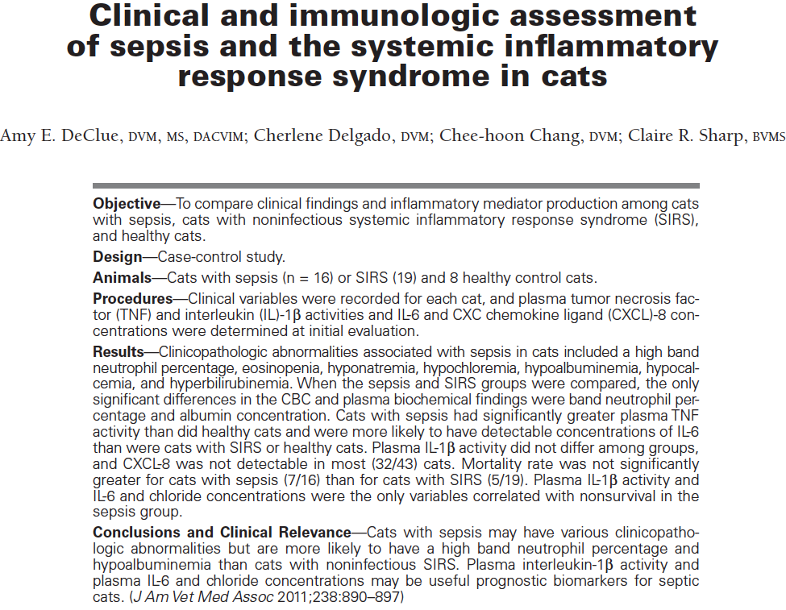Key points
- Sepsis group: 43% mortality rate, average 2.9 days in hospital
- SIRS group: 25% mortality rate, average 2.1 days in hospital
- Significant results:
  - Sepsis group higher band percentages than SIRS or control
  - Sepsis group lower eosinophil count than control
  - Sepsis and SIRS lower sodium and chloride than control
  - Sepsis lower albumin than control and SIRS
  - Sepsis lower calcium and ALT than control
  - Sepsis higher total bilirubin than control
  - Sepsis higher plasma TNF activity than control
  - Sepsis greater number of cats with detectable IL-6 than SIRS and control
  - Sepsis and positive correlation between nonsurvival and IL-1B activity and IL-6 concentration
  - Sepsis and negative correlation between plasma chloride concentration and nonsurvival
  - Sepsis/SIRS and positive correlation between IL-1B activity and nonsurvival
  - Sepsis/SIRS and negative correlation between lymphocyte count, chloride concentration, protein concentration and survival
- What were the SIRS criteria used for diagnosis in this paper?
  - Temp <100, >103.5, heartrate <140, >225, RR>40, WBC <5k >19.5K or >5% bands
- Which was the only predictor of nonsurvival in septic patients?
  - Chloride
  - Sodium
  - Calcium
  - Albumin
- What is the role of TNF in the inflammatory cascade?
  - Activation of secondary inflammation
    - Endothelial cell permeability
    - Neutrophil release
    - Expression of adhesion molecules
    - Lymphocyte apoptosis
    - Acute phase protein production
    - Pyrexia

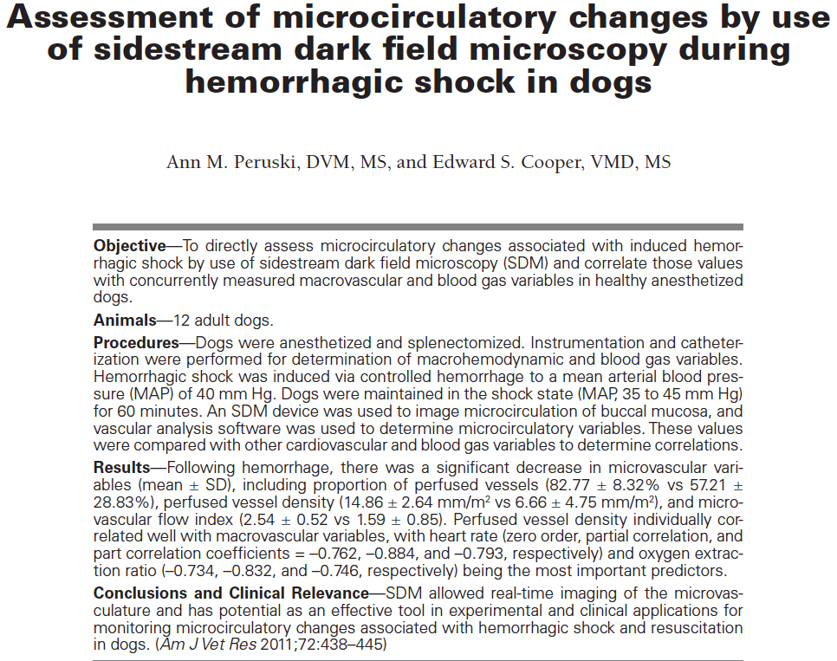
Key points
- Perfused vessel density, microvascular flow index, total vessel density, and proportion perfused vessels were all significantly lower during hemorrhagic shock compared to baseline
- Significant differences b/t time periods were also detected for several other macrocirculatory variables as well as the arterial/venous blood gas analysis
  - There was not a significant change in systemic vascular resistance
  - All those studied were significant predictors of PVD
  - Heart rate and systemic oxygen extraction ratio were most predictive of PVD
- No difference between measures of microcirculation and macrocirulatory variables
Questions
- Which of the following is not considered a potential limitation to the use of microcirculatory flow in veterinary patients according to this paper?
  - Obtaining quality images for assessment is limited by patient factors
  - Significant cost limits routine use of the machine
  - Time frame for analysis is approximately 1 hour
  - Significant learning curve to use machine
- Which measured variables were most predictive of the microcirulatory flow
  - Heart rate and O2ER

