Fill in the chart with the following: ↑ if you expect the pressures to increase compared to normal, ↓ if you would expect the pressures to decrease or NC if there you expect no or minimal (<10%) change

 | normal | PDA (Rl) | VSD (large)  lr | VSD (rl)  eisenmenger | PS | SAS
RA | 4/2/3 (70) | 8/4/5 (50) | 10/5/7 (70) | 8/4/5 (45) | 8/2/3 (62) | 4/6/5 (62)
RV | 20/4 (70) | 120/8 (50) | 120/10 (90 after) | 120/8 (45) | 140/8 (62) | 20/5 (62)
PA | 20/8 (70) | 120/80 (50) | 120/40 (90) | 120/80 (45) | 20/10 (62) | 20/10 (62)
LA | 8/4/6 (98) | 10/6/8 (98) | 21/12/15 (98) | 8/4/5 (98) | 6/10/8 (98) | 20/15/12 (98)
LV | 120/8 (98) | 120/10 (98) | 120/20 (98) | 120/8 (8560 after) | 120/6 (98) | 120/15 (98)
Aorta | 120/80 (98) | 120/80 (65-after) | 120/80 (98) | 120/80 (60) | 120/80 (98) | 120/80 (98)

 | normal | PDA (Rl) | VSD (large)  lr | VSD (rl)  eisenmenger | PS | SAS
RA | 4/2/3 | 8/4/5 | 10/5/7) | 8/4/5 | 8/2/3 | 4/6/5
RV | 20/4 | ↑ | ↑ | ↑ | ↑ | nc
PA | 20/8 | ↑ | ↑ | ↑ | nc | nc
LA | 8/4/6 | 10/6/8 | 21/12/15 | 8/4/5 | 6/10/8 | 20/15/12
LV | 120/8 | 120/10 | 120/20 | 120/8 | 120/6 | 120/15
Aorta | 120/80 | nc | nc | nc | nc | nc

- In response to an acute rise in arterial blood pressure, which of the following occurs as part of the baroreflex?
  - decreased glossopharyngeal afferent nerve activity
  - decreased stretch of aortic arch baroreceptors
  - increased stimulation of parasympathetic nerves to the heart
  - increased stimulation of sympathetic nerves to the blood vessels?

- Which of the following statements is FALSE regarding pimobendan?
  - it is a benzimidazole-derivative phosphodiesterase inhibitor
  - it inhibits phosphodiesterase II by increasing intracellular calcium sensitivity in the cardiac contractility apparatus.
  - it is inotropic, but not chonotropic
  - it has vasodilatory activity

- Label the axes
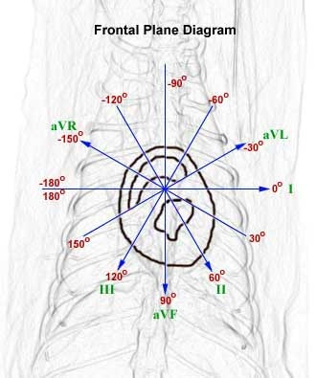

- What are the 2 major factors affecting pulse pressure
  - stroke volume and arterial compliance
  - cardiac output and arterial elasticity
  - stroke volume and venous compliance
  - cardiac output and venous elasticity

- Which of the following is not considered a vasodilator substance?
  - adenosine
  - potassium
  - calcium
  - bradykinin

- Which of the following is the corresponding symbol for initiation of ventricular contraction in an atrial pressure curve?
  - a
  - c
  - v
  - l

- Label which sounds you would expect (S1, S2, S3, S4) along the cardiac cycle

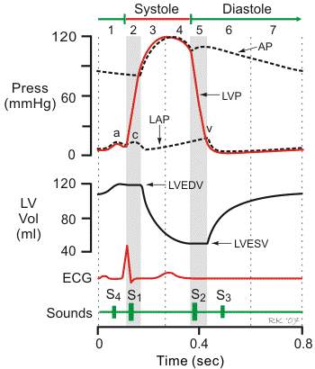

- What is the best interpretation of the following EKG?
  - AV Block (high 2nd and 3rd degree)
  - Sick Sinus Syndrome
  - Ventricular premature contractions
  - Respiratory Sinus arrhythmia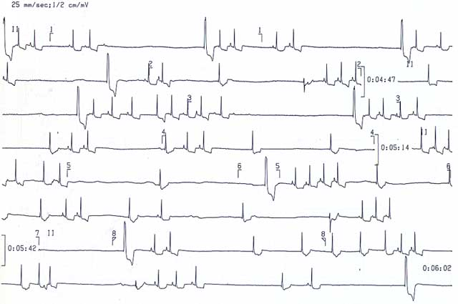

- Heartworm disease, pulmonary hypertension, aortic stenosis or left bundle branch block may result in which canine heart sound abnormality:
  - split S3
  - split S1
  - split S2
  - split S4

- Which is most true regarding feline HCM:
  - eccentric hypertrophy results in diastolic dysfunction
  - concentric hypertrophy results in systolic dysfunction
  - increased ΔP/ΔV
  - increased ΔV/ΔP

- Actions of angiotensin II in heart failure include all except:
  - expansion of blood volume but decrease pulmonary capillary pressure
  - promotes down-regulation of beta-adrenergic receptors
  - increases circulating levels of aldosterone
  - increases circulating levels of vasopressin

- Significant PPA toxicity (including mental depression) is best treated with:
  - nitroprusside and atropine
  - propanolol and atropine
  - nitroprusside or a phenothiazine
  - decontamination and propanolol

- Which of the following would be inconsistent with an increase in cardiac output?
- increase in preload, decrease in afterload, increase in myocardial contractility
- increase in stroke volume or increase in heart rate
- increase in cardiac index
- use of dobutamine, digitalis, or propanolol

- An increase in myocardial contractility would be involve all except:
- increase in stroke volume, decrease in ventricular end-diastolic volume, increase in ejection fraction
- activation of the sympathetic nervous system and inotropy
- change in ventricular pressure divided by time during isovolumetric contraction
- time divided by the change in ventricular pressure during isovolumetric contraction

- Estimation of an increase in afterload could involve all except:
- decrease in ventricular wall thickness
- law of Laplace
- decrease in chamber size
- increase in ventricular pressure
afterload is the sum of all loads against which the myocardium must develop tension during systole to shorten; it can be estimated using the law of laplace, which says that wall stress is equal to (pressure times radius) divided by wall thickness. Thus, a decrease in wall thickness (inversely) increases afterload, and an increase in ventricular would also increase afterload. Decreasing the chamber radius would decrease afterload.

- The period in the cardiac cycle in which pressure increases with no change in volume within the ventricle is known as:
- the isovolumetric contraction and occurs between phases II and III
- the isovolumetric relaxation and occurs between phases II and III
- the isovolumetric contration and occurs between phases IV and V
- the isovolumetric relaxation and occurs between phases IV and V

- Diastolic heart failure is associated with all of the following except:
- decrease in ventricular wall compliance
- decrease in the relationship: change in the end-diastolic volume divided by change in end-diastolic pressure
- ventricular hypertrophy
- increase in stroke volume
compliance is the distensibility of the ventricle and is defined as change in ventricle volume divided by change in change in pressure; decreased compliance causes an increase in end-diastolic pressure, which decreases venous flow into the heart resulting in decreased end-diastolic volume. Decreased end-diastolic volume leads to a decrease in the force of contraction and hence decreased stroke volume. This phenomenon is referred to as diastolic heart failure

- Each of the following would be expected to increase blood flow (Q) except:
  - decrease in resistance
  - increase in a change in pressure
  - increase in arteriolar radius
  - increase in aortic radius
according to ohm’s law, and pouiseulle’s equation, Q is proportional to vessel radius and pressure change, and inversely proportional with resistance. The major site of systemic resistance is in the arterioles, and the aorta has little ability to provide resistance

- Which of the following is true regarding a normal blood flow state in arteries and veins:
  - laminar and flow is inversely proportional to change in pressure
  - turbulent and flow is proportional to change in pressure
  - laminar and flow is proportional to change in pressure
  - turbulent and comparable flow requires increased pressure
according to pouiseulle, ohm and Bernoulli, normal blood flow is laminar and proportional to change in pressure; when turbulence occurs, flow is proportional to the square root of pressure, and more pressure energy is required to achieve a normal flow rate—however, turbulence is not a normal state

- What is the MAP if systolic blood pressure is 120 and diastolic blood pressure is 60?
- 80 mmHg
- 83 mmHg
- 100 mmHg
- 90 mmHg

- Which of the following is not a cause of elevated pulmonary artery occlusion pressure?
  - Volume overload
  - high PEEP
  - cardiac tamponade
  - tricuspid regurgitation

- How long does Angiontensin II persist in the blood before being inactivated by angiotensinases?
  - 1-2 hours
  - 1-2 minutes
  - 1-2 days
  - 1-2 seconds

- Which of the following is not an effect of ACE inhibitors in heart failure?
  - Reduction of preload
  - Decreased bradykinin
  - Reduction of afterload
  - Decreased vasopressin

- With the following information in a 30 kg dog: CI: 150 mL/kg/min; SBP 120 DBP 80, HR 100, CVP 3 mmHg. Calculate the following: Systemic vascular resistance.
  - SVR: MAP-CVP/CI= ___ mm Hg/ml/kg/min
  - 93-3/150= 0.6

- Name 5 Leakage markers
  - CTnI
  - CTnT
  - Myoglobin
  - CK isoenzyme M
  - CK
  - LDH (isoenzymes 1 & 2)
  - AST
  - Heart fatty acid binding proteins
  - Glycogenphosphylase isoenzyme BB
  - Myosin light chain
  - Myosin heavy chain
  - Plasma oxidase

- Name 10 Functional markers
  - BNP
  - ANP
  - Endothelin-1
  - Epinephrine
  - Norepinephrine
  - Renin
  - Angiotensin II
  - Aldosterone
  - AVP
  - TNF-alpha
  - Adrenomedullin
  - CRP

- How does myocardial contractility and end-systolic volume compare between DCM and MR?
  - Mycocardial contractility and ESV stay normal in MR. both volume overload hypertrophy.

- A dog that you suspect having endocarditis has the following predisposed conditions. Is this definitive endocarditis? What is the definition of definivitve versus possible IE based on the Duke Criteria? 1. Staph aureus on 2 blood cultures within 1 hour; central line, fever of 104.4, proteinuria.
  - No, definitive: 2 major or evidence on histopath. Possible: positive echo and 1 minor, 1 major and 3 minor or 5 minor.

- What is the proposed theory of using glucagon in calcium channel blocker toxicity?
  - Binds to cardiac receptors that are unaffected by CCBincrease in intracellular cAMP increase in transcellular flux of calciumincrease in intracellular myocyte calcium increased contractility and impulse generation.

- Amiodarone _____ (increases/decreases) plasma concentration of digoxin.
  - Increases-amiodarone inhibits P-gp (??) thus increasing serum digoxin concentration.

- Fill in the chart. The following substances have what affect on the afferent arteriole? The efferent arteriole? (r=relax, c=constrict, NE=no effect)
SUBSTANCE | AFFERENT ARTERIOLE | EFFERENT ARTERIOLE
ACH | R | R
NITRIC OXIDE | R | R
BRADYKININ | R | R
NOREPI | C | C (MORE)
ENDOTHELIN | C | C
VASOPRESSIN | NE | C
ANP | R | C

- Which of the following factors contributes to increased risk of digoxin toxicosis?
  - Hyperkalemia and hypercalcemia
  - Hypokalemia and hypercalcemia
  - Hyperkalemia and hypocalcemia
  - Hypokalemia and hypocalcemia
Digoxin binds preferentially to na/k atpase following phosphorylation. Extracellular k promotes dephosphorylation at the site and leads to a decrease in glyocaide binding affinity for the enzyme. Low k increase risk of toxicity by facilitation the attachment of glycosides to na/k aptase. Serum k inepdnely will also affect rmp leading to altered automaticiaty and AV noda condution. Hypolakemia increases myocardial update nad decreases renal excretion fo digoxin. Hypercalcemia potentiates arrtythmias by increasseing ventricular automaticity and worsening the intracellular calcum overload. May also affect rmp leading to altered impulse generation and conduction.

- What is the formula for fractional shortening? For ejection fraction? Would 50% be a low value for FS? For EF?
  - FS: edd-esd/edd (25-45%); EF: edv-esv/edv (~70%)

- Pulmonary vascular resistance is _20__% that of systemic vascular resistance after birth

- Which of the following is not normally a feature of a rightleft PDA?
  - Continuous heart murmur
  - Polycythemia
  - Split S2
  - Differential cyanosis

- Name 7 possible complications of Swan-Ganz catheter placement.
  - Arterial puncture
  - Hematoma
  - Hemothorax
  - Pleural effusion
  - Nerve injury (more in humans)
  - Air emboli
  - Cardiac perforation
  - Arrhythmias
  - Knotting of the catheter
  - Injury to the tricuspid or pulmonic valves
  - Thrombosis
  - Thromboembolic disease
  - Infection/sepsis
  - Endocarditis
  - Pulmonary artery rupture
- What does a calculated Reynold’s number >2500 suggest?
Turbulent blood flow.

