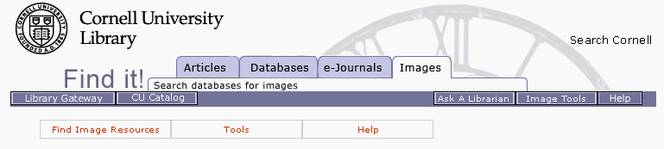

Help
For additional help using ARTstor or Luna Insight, please see the list of online documents and tips below.
- ARTstor
- Luna Insight®
System Requirements
ARTstor's recommended system configurations for the optimal use of the ARTstor Digital Library and the Offline Image Viewer (OIV) presentation software.
ARTstor Help
Overview of help from ARTstor
ArtStor & Luna Insight Comparison
An introduction to ARTstor and a capabilities comparison with Luna Insight. This resource was compiled by the Knight Visual Resources Facilty at Cornell University. Topics included: searching for images, saving images to groups, creating class folders, levels of accessibility, downloading images to Powerpoint.
Image Instruction Blog
A blog containing more recent changes to ARTstor and community practice issues about digital images at Cornell University. Topics included: remote access, how to get an image from ARTstor, ARTstor registration, ARTstor + Blackboard, etc.
Off-campus access for the Cornell community
If you experience a connection issue, please try to access the ARTstor database through the library's catalog.
Help & instructional sessions about using ARTstor for the Cornell community
Please contact Karen Brummund (kmb222), Digital Image Instruction Assistant, Knight Visual Resources Facility
:: top ::
- Technical Assistance for the Cornell community
Please make sure that you have disabled any pop-up blocking software. PC users may hold down the control key while launching collections to disable pop-up blocking or other users can adjust the toolbar preferences to allow pop-up windows within your browser.
If you continue to experience difficulties, please report your problem by sending an email to , during Monday -Friday, 8-5pm. For night and weekend support, please click here. Please state your name and briefly describing the problems you encountered. All emails will be answered
System Requirements
The recommended system configurations (platforms, browsers, monitor, internet connection) for the optimal use of Luna Insight.
Luna Imaging Help
Overview of help from Luna Imaging for the Insight Java Client
ArtStor & Luna Insight Comparison
An introduction to Luna Insight and a capabilities comparison with ARTstor. This resource was compiled by the Knight Visual Resources Facility at Cornell University. Topics included: searching for images, saving images to groups, creating class folders, levels of accessibility, downloading images to Powerpoint.
Image Instruction Blog
A blog containing more recent changes to Luna Insight and community practice issues about digital images at Cornell University. Topic included: remote access, how to install Luna Insight software, Luna Insight on wireless, ARTstor Luna Insight + Operating Systems.
Instructional sessions about using Luna Insight for the Cornell community
Please contact Karen Brummund (kmb222), Digital Image Instruction Assistant, Knight Visual Resources Facility
Luna Insight pages from other institutions:
Brown University: http://dl.lib.brown.edu/luna/guides.html
California Digital Library: http://arch.ced.berkeley.edu/resources/avrl_cdl/insight/insight.html
Virginia Tech: http://www.lib.vt.edu/services/branches/artarch/services_insight.html
Washington University: http://library.wustl.edu/subjects/art/luna.html
Yale University: http://www.library.yale.edu/eli/instruction/INSIGHThandout1.pdf
