Library Directors Leadership Team
March 26, 2012
703 Olin Library
9 – 10:00am

Attendees: Bonna Boettcher, Curtis Lyons, Kornelia Tancheva, Mary Ochs, Steve Rockey, Femi Cadmus

Guests: Kathy Chiang

Note Taker: Tiffany Howe

Liaison program and the impact of staff in our areas: (Kornelia and Kathy)
- Group members: Jill Wilson, Drew Wright, Patrizia Sione, Virginia Cole, Dan McKee, Fiona Patrick, Kathy Chiang, Kornelia Tancheva
- Reviewed charge of liaison program: Formalize the network of library liaisons to departments and academic programs across the University to strengthen relationships. Build liaisons’ subject and information expertise to enhance ongoing dialogue with researchers.
- Expectations and purpose of liaison program
  - Help the library itself understand what kinds of services we need to provide in the future
  - Connect our patrons to our services and collections that are of better use to them
  - Help patrons build more sophisticated picture of what the library is today
- How can liaisons actually achieve that?
  - Need to know who in the library does what?
  - Who is your audience and how do they overlap?
  - Make front line contact with researchers, build communication loops
- Group has been working on deliverables
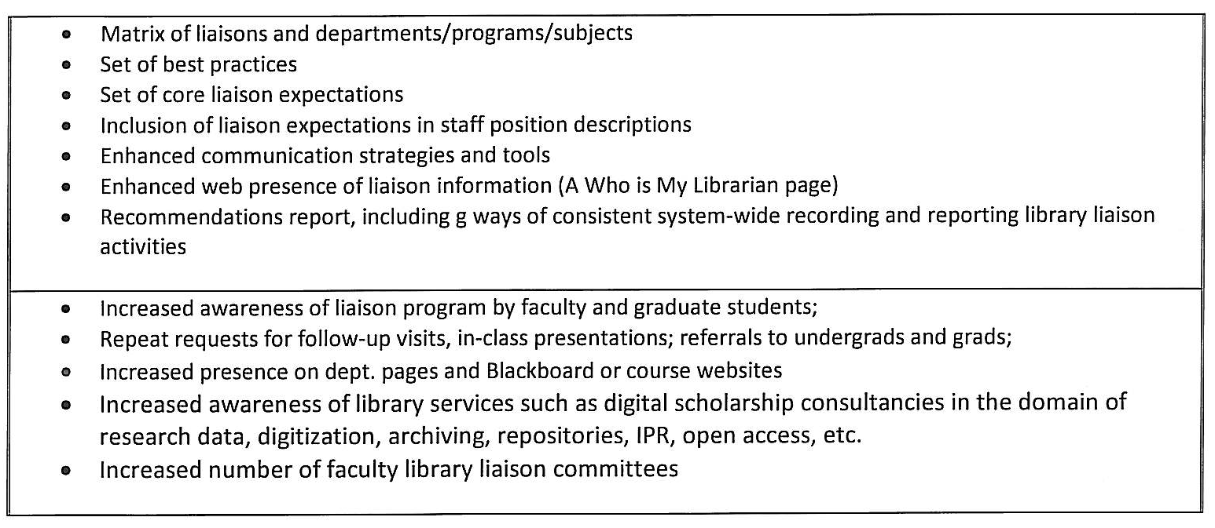
- Here to ask for inclusion of liaison responsibilities in job descriptions; and talk in general terms about core liaison general responsibilities; discuss the relationship between core expectations and correct practices
- Ideas/conversation on job descriptions
  - Like the idea of a detailed list of best practices, but don’t make it overwhelming for liaisons
  - Similar to collection development manual online – tool kit online
  - Training programs for liaisons (like with selectors)
  - Continuing education program (like selection or public services spaces)
  - Embed in culture, rather than mandated
  - Some of these items will take time (“increased number….”) – concern about time intensity; what will the library stop doing to make time/room for this?
  - Formalize liaison program/infrastructure; ask people where they are lacking expertise, and creating training programs for those areas
  - Differences around campus on how many library staff are serving different colleges
  - Make sure things don’t fall through the cracks in communication Approval for general language in job descriptions; everyone look at their job descriptions and send the language to Kathy and Kornelia for examples of how it’s included
  - Should someone from your group visit with the instruction committee (Jaron)?
  - Timeline: something(training program) in place for fall semester; bulk of work should be done by the end of the fall semester as well; figuring out how to maintain this afterwards

Announcements:
- Kornelia –
  - Annex: Cammie is out on family leave starting today, contact Kornelia with any questions
  - stats compiled every month (handout)
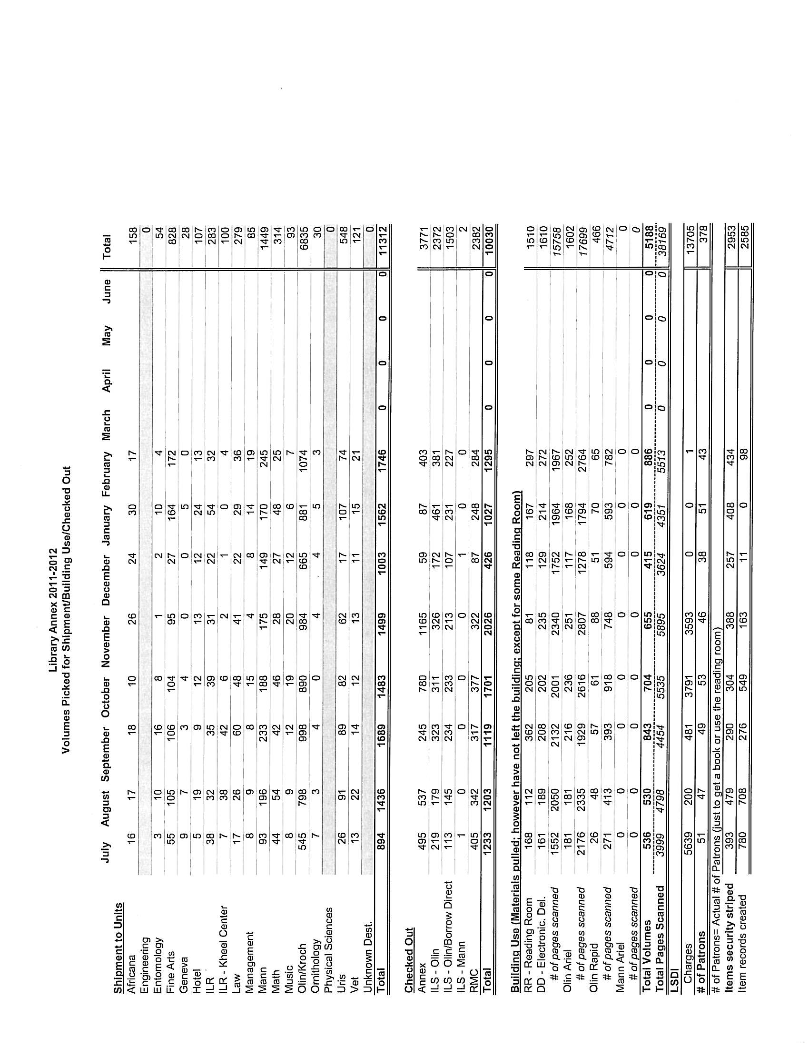

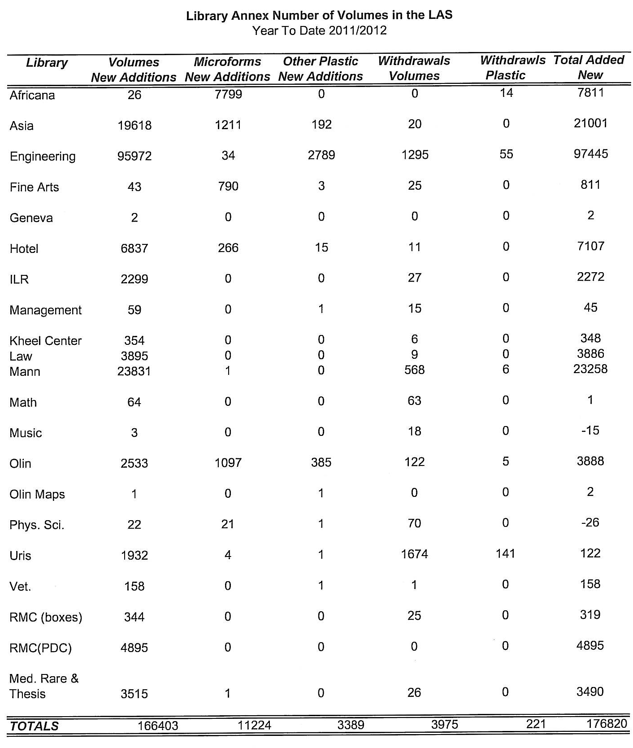

  - Olin/Uris – full time hire in ILS, not successful hire for part time position
  - 2CUL reciprocal privileges, starting April 1, visitors from Cornell in NYC for longer than 2 weeks can use their borrow direct privileges to Columbia
- Mary – visiting fellow from Nepal; here for 6 weeks on fellowship, Shorba.
- Femi – Technology Services Library position open, receiving applications, close mid-April, hoping to have someone in by July 1
  - Law Library has started putting barcodes on outside of all new books
- Curtis – moving all Hotel books out by end of April; clear out Hotel Library site by Slope Day
- Janet – email from Janet/Dean of Faculty Office – 174 signatures received so far
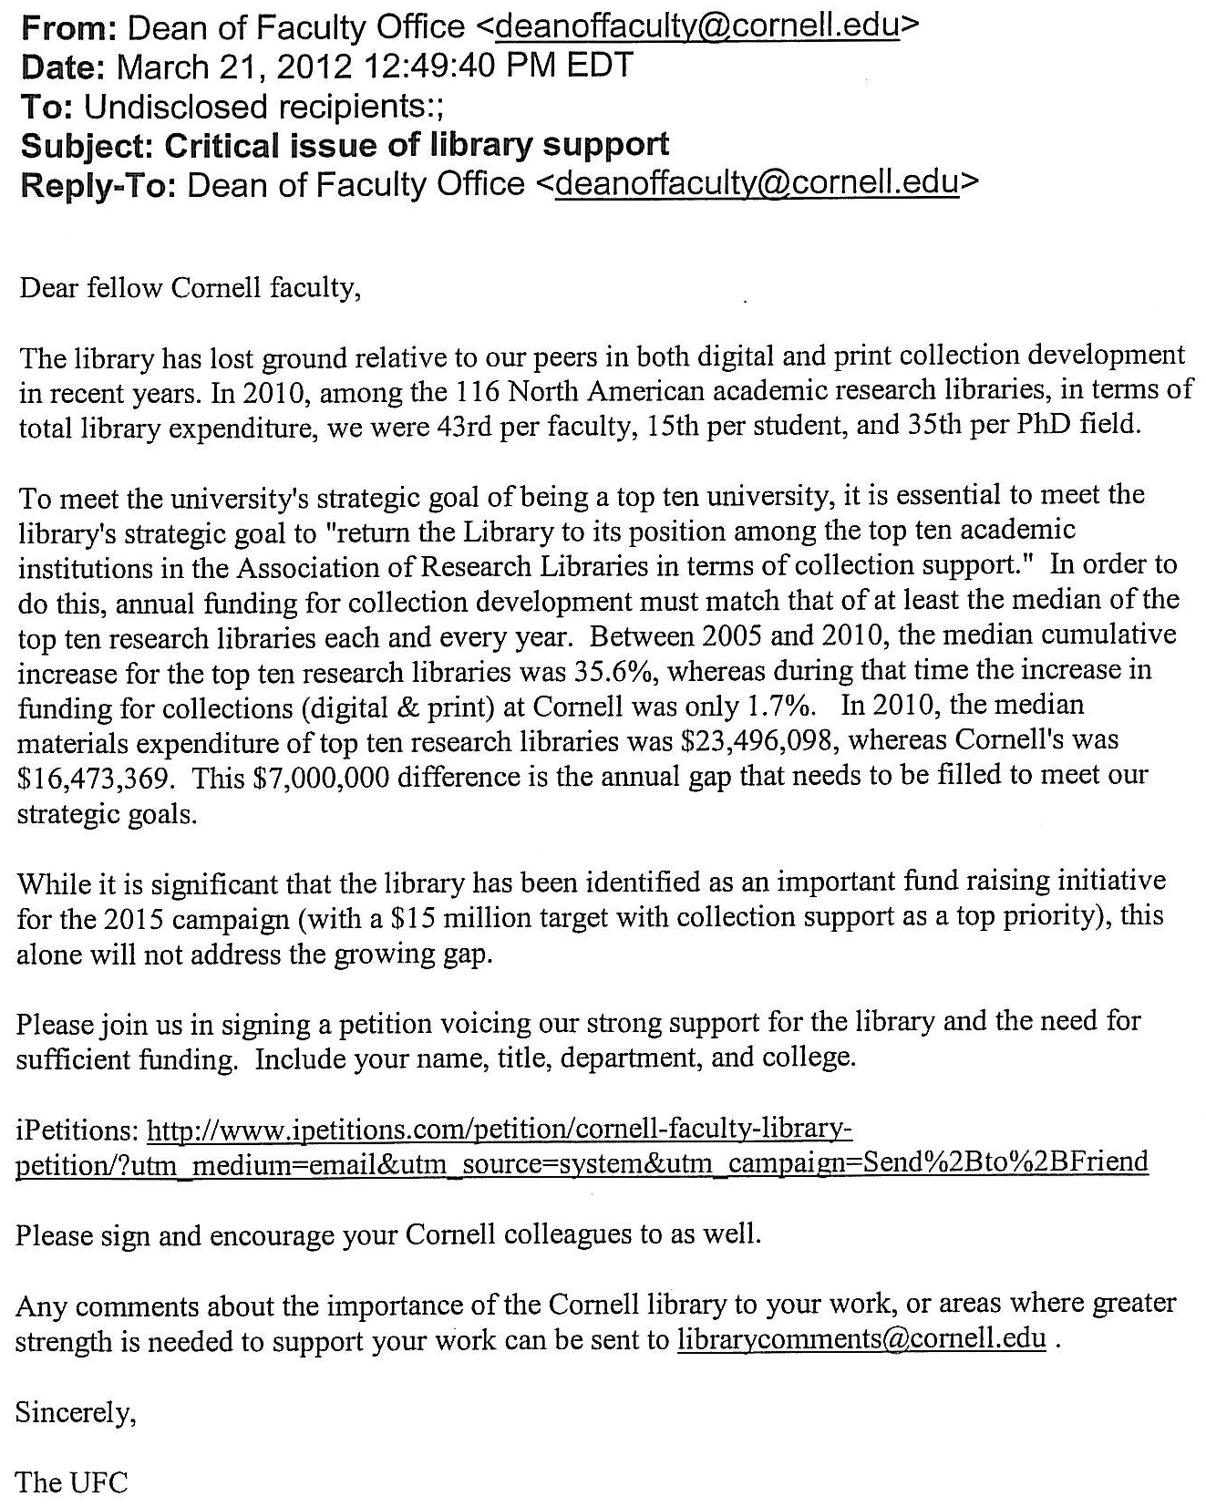

Proposal for barcodes on the outside of books (Kornelia)
- See handout below
- Special cases: multi-parts, RMC materials
- Access services committee loved the idea of having the barcodes on the outside of the books
- Also talking about doing away with date due stamps; provide print out slips with due dates (like at public libraries); Access Services will be talking with PSEC tomorrow about this
