Cornell University Annual Report (FY2011) for ALA Public Services “Big Heads”
Submitted by Janet McCue, June 2012

Transforming & Moving Libraries

Engineering joined the physical sciences library as Cornell’s second virtual library & this summer the Entomology Library will be consolidated into Mann, the life sciences library.

Hospitality, Labor, and Management Library: Three separate libraries consolidated their organizational structure & this summer will consolidate collections in the Catherwood Library (ILR). Subject specialists will remain onsite in three locations (as will reserve services in the Johnson School of Management).

Fine Arts Library: After sweltering for decades, students, faculty, and staff were happy to move to air-conditioned quarters in Rand Hall, the first of a two part refurbishment.

Supporting the research & teaching environment—from data to artifacts

Faculty/Researcher Data Support: The Research Data Management Service Group (RDMSG), a partnership between the library, the Center for Advanced Computing, CISER, and CIT held 10 information sessions on the NSF Data Management Plan (DMP) requirements, attracting 300+ attendees, and conducted 48 data consultations.
Undergraduate Research: The Library is partnering with the Office of Undergraduate Research and the Vice Provost for Undergraduate Education to offer a research institute for undergraduates in the humanities and non-data-driven social sciences.
Graduate Students: An IMLS grant provided funding for an intensive four-day program for Ph.D. students in the humanities. The idea grew out of a study conducted by Cornell and Columbia University Library, as part of their 2CUL partnership.
Teaching Librarians: 38 teaching librarians and instructional staff in the library participated in the first institution-wide ACRL Immersion program @ Cornell. The ACRL faculty focused the 3.5 day workshop on student learning, teaching and pedagogy, and program design and change.

Discovery & Access: Cornell launched Summon and this summer will begin implementing Blacklight. The virtual sciences libraries are using a new discovery tool dubbed CuLLR (Currated List of Library Resources) to annotate and display both print and electronic resources to create custom virtual library services. (http://engineering.library.cornell.edu/)

Outreach—near & far

ACS on Campus: More than 100 students attended the ACS on campus program which was co-sponsored and hosted by the physical sciences librarians, academic depts., and the local section of the American Chemical Society (ACS). Launched to support the professional development of graduate students, modules include the peer review process, publishing, resume review, alternate careers, etc.

MLK Read & Cornell Read: The Africana Librarian now holds research & consulting office hours in the Office of Academic Diversity Issues and launched a major community read (MLK Read) of King’s last book, “Where do we go from here: Chaos or Community.”

Enhancing Higher Ed for Agriculture in India: Mann librarians worked with faculty in Cornell’s International Programs to develop a series of workshops at several institutions in India as part of this USAID funded project. Librarians conducted workshops that focused on how the academic library can enrich agricultural education.

Llamas in the library: The new Law Librarian, Femi Cadmus, brought a bit of stress relief to the law school by co-sponsoring with the CLS Student Animal Legal Defense Fund a visit by the Cornell Companion Animal program which brought therapy dogs and well-behaved llamas.

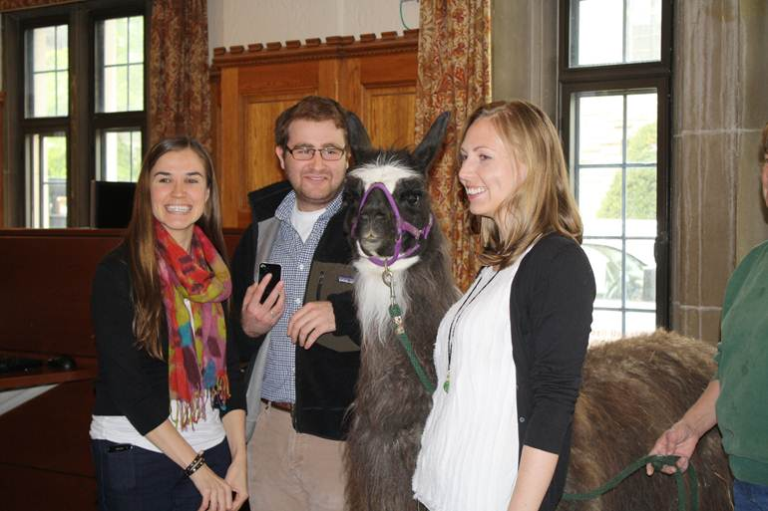

Janet A. McCue
Associate Univeristy Librarian for
Teaching, Research, Outreach and Learning Services
201 Olin Library
Cornell University
Ithaca, NY 14853-5301
p: 607-255-5181
http://www.vivo.cornell.edu/display/individual8779

