Nonlinear Chemical Dose Controller
Overview
Abstract
Accurate alum dosing is vital for plant operation as it has a great impact on the effectiveness of flocculation and sedimentation. The nonlinear chemical dose controller (CDC) is designed to handle turbulent flow chemical dosing used in conjunction with the newly designed Rapid Mix Tube. In contrast, the linear CDC requires that the chemical flow in the dosing tube is laminar.
The linear CDC uses the linear relationship between laminar flow and major losses in the doser tube to maintain a constant chemical dose with varying plant flow rates. However, when the flow in the dosing tube is turbulent, the linear relationship no longer exists. In this case, a nonlinear CDC, one that uses minor losses to control flow rates, can be used to maintain a constant chemical dose with the varying plant flow rates. By using an orifice to control chemical flow, the CDC will have the same nonlinear response to increasing flow as the plant flow rate, which is controlled by an orifice. A dual scale system on the lever arm will increase accuracy in dosing at smaller doses.
Figure 1 shows a conceptual design of the dosing system. A float in the entrance tank is connected to one end of the lever arm and allows for the arm to move up or down based on varying plant flow rates. As plant flow rates increase, the float rises, and the lever arm connecting the dosing orifice falls increases the elevation difference between the constant head tank and dosing orifice to power chemical flow. As the flow rate decreases the elevation difference decreases and the chemical flow rate slows down.
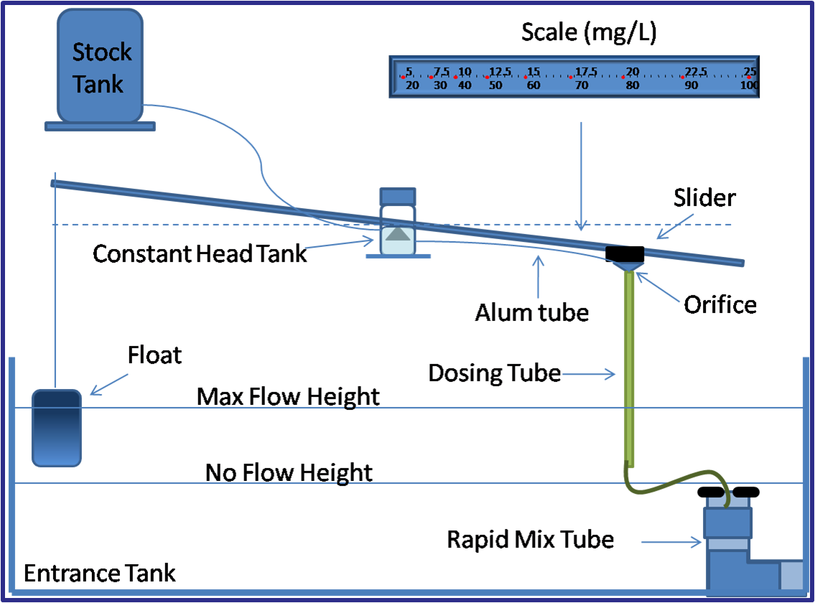
Figure 1: Nonlinear chemical dose controller schematic
There are two dosing tubes coming out of the constant head tank each with a different size orifice fitting attached to the end. The two different sized orifices allow for the plant operator to dose alum at two different scales, a high and low scale. The operator will choose which orifice will be used based upon the desired alum dose the operator wishes to apply to the water, a parameter that depends on raw water characteristics. The two scales on the lever arm, as seen in Figure 1, correspond to one of the dosing tubes; for instance, the higher scale (20-100 mg/L) will be used when the larger orifice size is needed. The dosing tube which is not in use is merely lifted to a higher elevation than the constant head tank level and is clipped onto a hook to prevent the flow of alum through this unused orifice.
After the alum exits the dosing orifice it flows down through a rigid tube which then injects the alum over a rapid mix conduit which connects the entrance tank and the flocculator. The rapid mix tube has two orifices which create macro and micro eddies to ensure the uniform distribution of coagulant into the raw water.
Introduction and Objectives
As the AguaClara project grows, larger plants are being designed. These larger plants have a greater flow rate and thus there is a need for the linear dose controller to be redesigned for accurate dosing for these higher flow rates. The Non-linear Dose Controller Team is redesigning the dose controller, including the flow controller, the doser, and the flow measurement device. We are also designing the rapid mix tube for large-scale and small-scale mixing.
After the new design was completed, the non-linear dose controller was constructed. Experiments were done to verify the accuracy of the dose controller compared to theoretical results. This new design was presented at the EPA's P3 competition in Spring 2010 and was awarded a Phase II prize of $75,000. The design was also implemented at the new Agalteca plant in Honduras.
As the team worked through the research and design process, many challenges were encountered. For a more detailed account of the how the design came to be, see the Fall 2009 goals and meeting minutes and the meeting minutes.
Theory
The theory behind the development of the nonlinear chemical dose controller is explained in detail.
Methods
Designing the Orifice Sizes and Dual-Scale for the Lever Arm
The dosing orifices and dual scale were designed to produce the head loss that correlates to the proper dose for each given change in head based upon minor head loss through an orifice:

where
- h _{l} the difference in head loss between the maximum CDC head loss and the actual head loss in the flexible dosing tube
- K _{DoseOrifice} is the required minor loss coefficient through the orifice
- V _{DoseTube} is the velocity in the dosing tube
Designing the Float
A float on the lever arm was designed so that the dosing system would automatically react to changes in water height in the entrance tank based on varying plant flow rates. The float size was calculated by summing the moments of forces of the components in the lever arm system around the central pivot point. The weight of the float was calculated in order to have the sum of the moments around the pivot point be zero at the maximum plant flow and lever arm angle.
Designing a Prototype Doser Frame
A prototype of the doser framewas designed in Auto-cad and built using components from 80/20 Mfg. This prototype allows full scale testing and representation of the actual nonlinear doser that will be used in the Agua Clara plants.
Designing the Rapid Mix Tube
A rapid mix tube was designed for large-scale and small-scale mixing of alum with water before flocculation.
Constructing a Small-Scale Model of the Plant
A model of the plant is being constructed using acrylic plastic for use in educational and promotional presentations.
Future Challenges
Though much progress has been made in the development of a reliable and fully-functional nonlinear chemical dose controller, many challenges still remain. On the whole, the current designs need to be validated by various experiments. The clogging experiment is the first step in ensuring that the orifice sizes we designed are feasible for the given alum doses. Further clogging experiments will be done to reproduce the results and isolate the cause of the clogs. The dual scales on the lever arm currently do not include major head loss in the dosing tubes. The team will investigate the effect this head loss could have on dosing accuracy. The float sizing calculations are also looking further into potential margins of error. The rapid mix tube design will be validated using the newly constructed model tube. Furthermore, the full-scale prototype will be built and used in further tests to ensure concurrent function of all components in the system.
Presentations
All Presentations, Posters, and Reports are available from both the Fall 2009 and Spring 2010 semesters.

