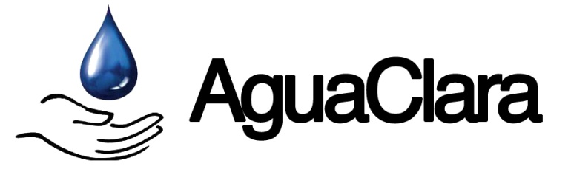
A Project of Civil & Environmental Engineering at Cornell University

Month Year
Volume #, Issue #

Newsletter Title

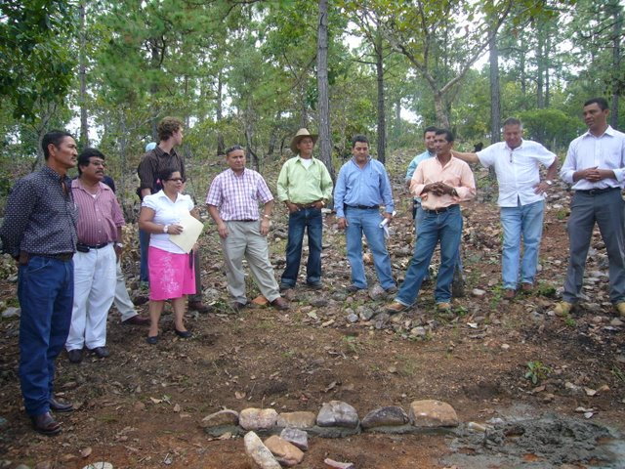
Newsletter Template*
Created with Microsoft Word 2007 on Windows 7
Paragraph allignment = justified (Ctrl+J)
Fonts:
Blue banner and body text = Arial (pt.16 and pt.11)
Vol, Issue, Mon, Yr = Calibri (pt.8)
Newsletter Title = Myriad Pro Light (pt.16)
Photo captions = Calibri (pt.10)
Disclaimer in footer = Calibri (pt.8)
Text Colors:
Blue banner = white
Body text = black
Newsletter Title = blue
Links = blue
Agua Para el Pueblo staff and community members from Agalteca gather to lay cement and stones to symbolize the start of construction.
Disclaimer = light grey
Photos:
Border = “Simple Frame, White”

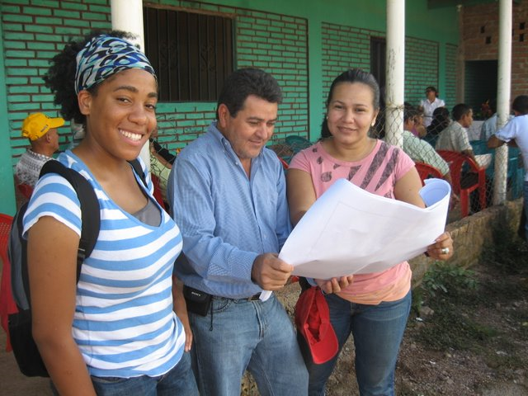
*Italics are only used here as emphasis; this text should not be italicized in actual newsletter.

Donations for Agalteca can be made by sending a check made out to The Resource Foundation. Write “AguaClara” in the memo field. Checks may be sent to:

The Resource Foundation
237 West 35th Street, Suite 1203
New York, NY 10001

…or you may contribute directly at the AguaClara website:

https://confluence.cornell.edu/display/AGUACLARA/Donate
Sarah Long (an AguaClara engineer), Wilfredo Serrano, and Meliza Ordóñez review the designs for the Agalteca plant.

We look forward to bringing you more news of AguaClara’s progress.

