


Solar Ovens - Distillation Team

Final Report 05.17.13
Kevin Keene, Joanna Cherches, Dias Nurgazy, Kristy Macias, Deanna Steers

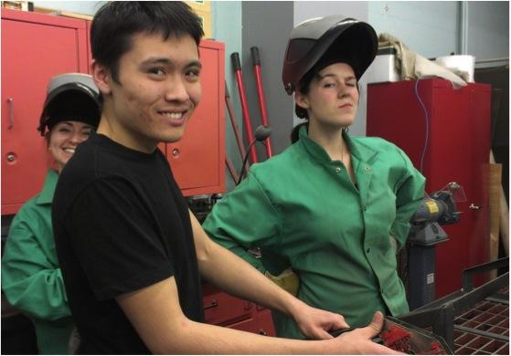

The objective of The Solar Water Distillation Team is to design and fabricate a device that uses energy from the sun to purify and distill water. Our device has sunlight pass through glass and be absorbed by a black surface on which the water is placed. The black surface will heat up, the water will evaporate and rise to the underside of the glass above, which will be cool enough to condense it to water. The glass surface is inclined so that the water runs down into a collection device.
We have been collaborating with Las Mujeres Solares de Totogalpa and Grupo Fenix from Totogalpa, Nicaragua throughout the year and during spring break in Nicaragua when we built a prototype with them. We modified our design upon returning to Ithaca to include aspects of the design that we made together. We constructed the distiller during the second half of the semester, but haven’t tested yet.
We have been considering another design, the eliodomestico design (pictured below). This design is claimed to have greater efficiency than a typical water distiller, be easier clean, and be cheaper and easier to manufacture. Because we had already put in a lot of work on our original design, we wanted to finish this before starting a new project, but we hope to look into this design more next semester.

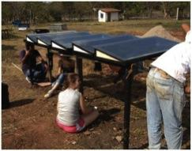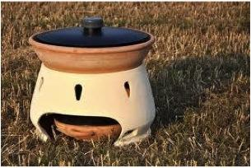
Left: Finishing the distillation system in Nicaragua
Right: Picture of the Eliodomestico distillation system

At the end of last semester we had started the construction of the frame. Our goal for this semester was to finish building the frame, design and construct a system that allows the entry and collection of water. This included adding hinges, adding a rubber seal, installing a lock system, finishing welding the frame together, insulating the distiller, building a stand, installing the piping, and adding a collection device. We hoped to finish this before our trip to Nicaragua so that we would have enough experience to optimize the improvement of the design during this trip.
Upon finishing the distiller, we planned on testing the system after break. These tests would make sure that the system can effectively distill water, compare the efficiency of distillation to a typical water distiller, and test the cleanliness of the water using a pH test and an electrolysis test. If we were able to accomplish all of this, then we would consider the eliodomestico design.
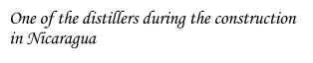
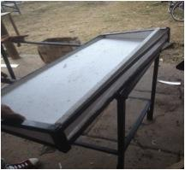

Our original design was based on schematics that were given to us in a design booklet of the solar distillers used in Nicaragua. The schematics were difficult to interpret, so we modified it with our own ideas. The schematics sent to us had the sides of the design open in order to clean the device. We changed this to have the device to open at the top, so that it would be easier for the user to access the inside and clean. The schematics didn’t include information on how to insulate or seal the distiller, so we decided to use a rubber seal and wood for insulation.
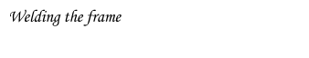
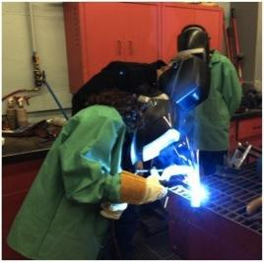
Throughout the construction process, we ran into various design issues. The first came with the cutting and welding of the metal frame. Our design was structured in a rectangular frame with four corner posts to support the top panel. We had not at first taken into account how the angle would affect the shape and placement of the top, and we had to change the cuts of the support posts to meet the needs of the rectangular shape of the top. In Nicaragua, they didn’t include hinges in their design, but rather placed the glass directly on top. The weight of the glass was enough to seal the distiller. We found this much more convenient that our idea with the hinges, so we decided to adopt it into our design.
Our collaborators in Nicaragua informed us during the trip that the black paint that the water touched would corrode after just a few weeks, which meant that it was necessary to repaint the tray frequently. [I think the real problem with the paint is that the heat and water cause the latex paint to blister, then bubble with evaporated water behind the paint. This is messy and hard to clean.] After brainstorming with our group in Nicaragua, we came up with two ideas. The first was to put a sheet of glass between the paint and the water so that the water would no longer be in contact with the paint. The second was to use black tiles instead of paint. We built distillers with both ideas in Nicaragua and they both effectively evaporated the water. We reconstructed the piping system in order reduce possible contamination sources. We made a device that holds the water before entry from a 10-gallon jug and painted it black so that the water will be preheated before entering the distillers. We also made a makeshift filter from cloth in order to reduce further possibilities of contamination.

We completed the construction of a frame for the system. We learned how to weld, which gave us more versatility and independence in the construction process and will be a useful skill to have for future projects.
After constructing a model in Nicaragua, we were much more familiar with the design, which made the construction process easier. The blueprints we were given were not very clear, but after having a first-hand experience in building a still in Nicaragua, we were able to quickly complete our model in the lab.
In Nicaragua, we completed a model with a glass base and a ceramic tile base. We tested both for effectiveness, but not efficiency. Therefore, we are not sure which one distills water at a faster rate.

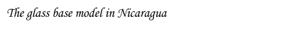
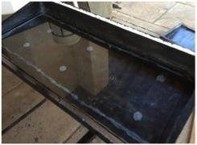

Next semester we would like to build a model with the glass base and then test it and the black tile model and compare the results. We would also test the purity of our distilled water by introducing brackish water into the system and test the pH of the resulting water in order to make sure that the system can distill the water to a pH of 7.0.
We would also like to design a system based on the eliodomestico model and build a model. We would run tests on this model too and compare it to the ceramic tiles and glass base. Whichever proves to distill water at the fastest rate would be the one that we would invest the most of our time in in the future.
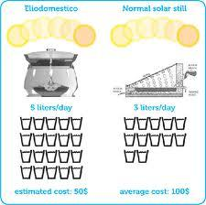
Above: The schematics of the eliodomestico design

This course has allowed us to learn practical, engineering related problem solving skills that can’t be obtained in a lecture hall. The lack of stringency in structure of the class has encouraged us to think independently and come up with creative solutions for a variety of problems. It seems that we have encountered more than our fair share of issues that have arisen, but eventually we overcame them, either by ourselves or with the help of Tim or other outside resources. This semester has been a great learning experience and we are excited to continue work on our distiller next fall!

