AguaClara: Gravity powered chemical dose controller system for aluminum sulfate and chlorine dosing

Abstract (Do this next so you know what you want to include)

For LFOM:
A non-electrical technique for the regulation of chemical dose in water treatment plants was tested at pilot scale and then implemented in a full scale water treatment. A Linear Flow Orifice Meter (LFOM) based on the concept of the Sutro weir was added to the entrance tank of the water treatment plant. The LFOM was evaluated for linearity and flow measurement accuracy over a range of flows from 20 to 140 L/min. The flow rate was shown to be linearly related to water height. The linear response of the LFOM was coupled with the linear output of a flow controller to create the chemical dose controller. This innovation eliminates the need for plant operators to adjust the chemical feed when the flow rate through the plant changes.

Introduction

Adaptation of conventional drinking water treatment technologies for use in the Global South is a concern of growing urgency. Conventional water treatment technologies that have been imported into the Global South frequently fail and are abandoned for three reasons.
- Conventional technologies rely on customized components that are not available in the Global South
- The reliance on electricity to power pumps, mixers, and valves results in excessively high operating costs
- Conventional technologies are often not designed to facilitate operator monitoring and regulation of the flocculation process. For example the control panel for the plant is inside an office building and the flocculation process is out in the open and far from the control panel.
The lack of clean drinking water provides avenues for infection by waterborne pathogens which are currently one of the major causes of mortality for children under five years old. The AguaClara team is working to bring clean water to communities with a flocculation-sedimentation water treatment design. The design requires the addition of aluminum sulfate (alum) as a coagulation agent. Plant operators manually adjust the alum dose based on the daily flow rate of the treatment facility. In the first AguaClara plants that were constructed, the dosage of aluminum sulfate and chlorine by the operators was imprecise. There was no specific system to allow the operator for the AguaClara plants to accurately dose the alum and chlorine as the turbidity or through the plant changed. Therefore, it became absolutely necessary to implement a chemical dosing system that would allow the AguaClara plant operators to accurately dose chemicals based on the conditions throughout the plant. In the first AguaClara plants the operator adjusted the chemical flow rate and thus indirectly controlled the dose. Plant operators would manually adjust the chemical flow rate based on the incoming turbidity.

- A useful innovation is necessary in the regulation of aluminum hydroxide into the system as the flow changes without the use of electrical devices. Currently options for the control of chemical additions to water treatment plants are either an electric pump or manual adjustment of chemical flows. The AguaClara plant operators would set the alum dose in the initial AguaClara plants. However, the operators would become accustomed to setting a flow rate for the dosage of chemical, but lose the connection with coagulant concentration.

- Computer controlled water treatment plants are not robust or sustainable in the Global South because of the lack of a reliable supply chain for specialized components and because of frequent power outages and surges. Five gravitationally powered plants researched and designed by AguaClara are currently operational in Honduras, but chemical dosing without electric pumps is still inconsistent at the plants. Alum (aluminum sulfate) dosing must be adjusted regularly because it depends on the influent turbidity, a function of season and rainfall. Chlorine dosing must be consistent, and both chlorine and alum doses must be easily controlled. Here we describe the research and development of an effective flow controller that can tie into AguaClara systems between the alum stock tank and the flocculator inlet at the rapid mix and between the chlorine stock tank and the system. The flow controller dampens the effect of the chemical level changes in the stock tanks, using a simple manufactured float valve to maintain a near-constant chemical level in the flow controller, which acts as a constant head tank. The height at which the outflow tubing from the flow controller connects to the system can be adjusted to change dosing flow. The flow controller is both inexpensive to produce and simple to operate.
Objectives

Chemical Dose Controller
- Easily adapted for a range of flow rates
- Completely gravity powered
- Open source so that anyone can build it and use it
Flow Controller
Calibrated to easily vary the flow rate.

- Maintain a constant flow rate independent of the chemical level in the stock tank
- Handle corrosive chemicals
- Incorporate a linear scale to facilitate setting the flow
- without need to use trial and error
- Resistant to clogging
- Easy to maintain and operate
- Economical, small and easily used to replace existing
- flow control devices

Linear Flow Orifice Meter (LFOM)

- Regulate the flow of alum into the rapid mixer according to changes in flow rate.
- Keep alum dose as close to constant as possible.
- Be able to install device into existing plants.
- Include a simple way for the plant operator to change the dosage.

Chemical Doser
- Must be flexible.
- Automatically adjust the head loss in the chemical dosing system in response to plant inflow changes

Theory

Overall Design
The chemical dose controller is currently comprised of three components, the linear flow orifice meter, the flow controller, and a chemical doser (Figure 1). These components of the system act together to allow the plant to respond to changes in inflow by both linearizing the change in plant flow and automatically adjusting chemical dosing to the plant. With this system AguaClara plants should be more resilient because operators are only required to adjust chemical dosing settings based on incoming turbidity, not based on flow rates.
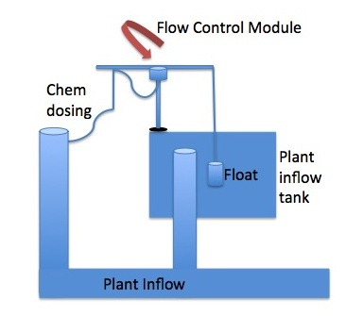

Figure 1: Overall design schematic of chemical dose controller

Linear Flow Orifice Meter (LFOM)
The purpose of our project is to design a mechanism to regulate the flow of alum into the rapid mixer according to changes in flow rate. Currently the existing plants require manual adjustment of the alum flow rate when the plant flow gets too high or too low. Correct alum dose is very important to the performance of the flocculation and sedimentation processes, and as it exists the job of keeping a constant alum dose is left open to human error. Automation of this process would improve the performance and efficiency of the plant and simplify the operator's responsibilities. The Linear Flow Orifice Meter would need to meet the goals stated earlier.
Regarding the overall goals of the Chemical Dose Controller, all the goals of its separate components will need to be integrated along with the goals for their combined use. First, the Chemical Dose Controller will need to
maintain the alum dose as close to constant as possible. Second, the system must be able to be installed and integrated into existing AugaClara plants easily.
Finally,
the Chemical Dose Controller needs to include a simple way for the plant operator to change the dosage.
During the design of the overall Chemical Dose Controller, various questions arose that guided the direction of the design of the regulated alum flow system. The design will be based around the plant operator taking a relative measurement of the plant flow rate and using that to regulate the alum flow into the rapid mixer. Then, this information will need to be transferred automatically using simple and non-electronic methods. In addition, this system will need be an efficient method to accurately regulate the alum flow without the use of valves or pumps.
The method used to keep track of the plant flow rate is a measurement of the water level in the grit chamber. This showed itself to be a major complicating factor, as the head in a tank and the flow rate into that tank are not linearly related. The main equation used to model this is the orifice equation:
The equation shows how flow rate is related to the square root of the change in head.

Chemical Doser (CD)
The design for the chemical doser proposed uses an entrance tank as a way to transfer information about the flow rate to the aluminum hydroxide flow control module through a float system. The system accurately delivers consistent aluminum hydroxide dosing into the incoming water based on the height of the water in the entrance tank. Without intervention the flow rate through the entrance tank is proportional to the square root of the pressure head, height of the water in the entrance tank, as shown in equation 1.
Insert orifice Equation
This research is focused on designing an automated chemical doser that can automatically adjust the head loss in the chemical dosing system in response to plant inflow changes. Currently plant chemical dosing is determined based on plant inflow and turbidity. The chemical doser (CD) will eliminate the need for plant operators to dose for inflow, reducing the number of variables and therefore opportunities for error.
One main reason for the focus on this doser is that it will allow plants to be more flexible. Plant inflow is largely variable with weather, both seasonally and hourly. For instance, if there is a high frequency of late night rain storms, then there will be an increase in plant inflow. Ideally the automated chemical dosing system will allow plants to respond to these weather-driven changes without an operator's presence.

Design

Linear Flow Orifice Meter
Because flow into the grit chamber is proportional to the square root of head, there is a non-linear relationship between head and flow rate must be accounted for in this design as well. The relationship between water height and flow rate create a problem when transferring of data to other mechanisms. A predictable linear relationship between the height of the water in the entrance tank and the flow rate through the plant allows for a system of floats to meter the aluminum hydroxide flow rate.

Sutro Weir Analog Theory
The Sutro weir developed by Victor Sutro in 1915 can be used to create a linear correlation between head and flow rate. In order to account for the non-linear relationship between head and flow rate, a Sutro weir was designed to create a linear relationship between head in a tank and flow rate into the grit chamber. The configuration is shown below in Figure 1.

Figure 1: Sutro weir with constraining equations (Murthy and Prakash, 1994)
- Note: The rectangular base is present in the design merely to simplify evaluation and analysis. Flow proportional to water height begins above the rectangular weir.

Variables
W = base of rectangular weir
s = height of rectangular weir
h = weir height above rectangular weir
c = constant of proportionality
= coefficient of discharge, ranges from 0.0597 to 0.619
= Flow through rectangular weir
= Flow through upper portion of weir
= vena contracta area ratio, average value is 0.62
g = acceleration due to gravity

The bottom width of the Sutro weir is relatively large and the width gradually decreases as the height increases. As the height of the water in the tank increases the pressure created by the weight of the fluid causes the flow rate through the bottom of the weir to increase. By minimizing the weir width as height increases the change in the total flow through the weir as height increases is kept in a linear relationship. Therefore, we are approximating the Sutro weir analog with a riser pipe added onto the pipes that connect the entrance tank and the flocculation tank. For AguaClara plants, Sutro Weirs are impractical because they are relatively difficult to fabricate and construct on the project sites. Therefore, the LFOM, a Sutro Weir analog, is simpler to construct because it involves only drilling a series of holes.
Using this shape, we decided to construct our own analog using a series of orifices drilled into the grit chamber outlet pipe (Figure 2). The pipe would be easily introduced into previously constructed plants and new plants at low cost. Holes would be drilled into the riser pipe that would mimic the Sutro weir basics of design. The drilling of holes as specified heights doesn't require skilled labor. The water is forced to flow through the riser pipe in order to leave the entrance tank and enter the flocculation tank. Experimental tests were conducted to evaluate the accuracy of the simulated Sutro weir in a pilot plant application.

Chemical Doser
The chemical doser has three principle components: a float, a lever arm, and a dosing ring.
The float currently used in the lab for data collection is a 45.5 cm long 10 cm (4 in) PVC tube capped at both ends and partially filled with sand so that it weighs 8 lbs. It rests 33.5 cm below and 12 cm above the water line in a virtual grit chamber, which is a deep bucket with a pressure sensor at its base. This pressure sensor provides readings of the water level in the bucket. The float is connected via low-elasticity fishing line to the lever arm. The lever arm is a 68 cm length of 1 1/4 in schedule 40 PVC pipe with a pivot point at 34 cm (the center). Opposite of the pivot there are notches cut into the pipe at 5 cm length intervals. The chemical doser hangs from these notches.
The chemical dosing tube is a tube with an open T connection at the top, which allows the FC outflow tubing to drain through a pressure break T. The tubing exiting the pressure break T has a larger diameter than the tubing entering it. The pressure break and larger outflow tubing allow a free surface at the same height as the discharge to the rapid mix (minus head loss) to form inside the larger tube while air can also flow through the tube.

Materials and Methods

Linear Flow Orifice Meter (LFOM)
For our program, the user selects whether a metric or English series of drill bits will be used to make the orifices, thereby giving the area of each orifice. The program sets the flow rate through the first row of holes when the head is one orifice spacing above the holes.
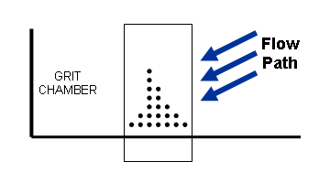
Figure 2: Illustration of flow rate through the first row of holes when the head is one orifice spacing above the holes
This is done by dividing the given maximum plant flow by the desired number of orifice rows. The orifice equation can be used to find the number of orifices needed in this first row. We now have the total orifice area of the first row, allowing us to do a check to see if the given drill bit is too large or too small. We define too large as a diameter larger than our given orifice row spacing. An orifice diameter that is too small creates a situation where more than half the circumference of the pipe is taken up by holes, and we do not want to significantly weaken this pipe. If the bit size is increased, the number of holes would decrease.
The next element of the program is a function which gives the flow rate at any grit chamber head. This then allows us to find the number of orifices in each row which would generate our linear goal. For example, if flow through the first row is 10 L/min, then flow through the first two rows should be 20 L/min, and so on. The program finds the number of holes by first calculating Q for all of the rows of orifices below the current level. If the total calculated flow is less than the desired flow, it adds a tenth of a hole. Once the linear goal is met, the number is rounded to the nearest whole number of orifices, and this repeats for each row of orifices. We can now find the expected flow out of the grit chamber using these orifice sizes, spacing, and numbers, but only when the head is exactly at the height of each row. Our last step, therefore, is to calculate the flow rate for intermediate heads.
MathCAD Methods
Inputs

Linear Proportionality
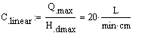
= linear proportionality, L/min/cm

Rectangular Base Width
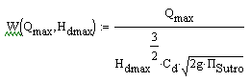
W = rectangular base width, cm
g = gravity, 9.8 m/s^2

Rectangular Base Height
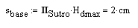
s_base = rectangular base height, cm

Profile of curved portion of weir
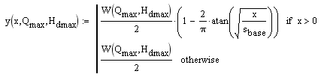
y = the profile of the curved portion of the weir, cm
x = corresponds to the vertical height of weir from -s_base to, cm

Y-axis of the graph
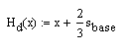
= this is the variable that corresponds to the height of the entire weir from the bottom of the rectangular base to the top of the curved portion of the weir, cm

Sutro Weir Graph: Illustrates the shape of the weir.
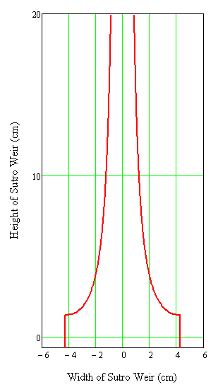
Figure 3: Shape of the Sutro Weir after input of equations on MathCAD.
Y-axis =
X-axis = y

The height of the rectangular base
s_base = rectangular base height, cm

The flow through the rectangular base
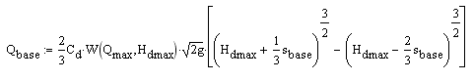
= The flow through the rectangular base, L/min

Initial Momentum of Water Entering Riser Pipe
If the riser pipe diameter is too small for the flow rate then the water will back up in the bottom of the pipe and the water entering the weir won't experience free fall anymore. Balance of momentum in and out helps us achieve these values. The equations used in Figure 1 are described below. They are the background for the development of the minimum cross sectional area equations listed below:
- vertical velocity of the water from any height when it reaches the bottom of the weir
- velocity through the weir in the vena contracta (point in a fluid stream where the diameter of the stream is the least)
- Effective area of a differential weir element as a function of height given the effect of the vena contracta , y is the width of the curved portion of the weir and it is dependent on , and, x (the incremental height up the weir)
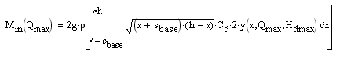
= momentum into the Sutro weir, N
= the density of water, 1,000 kg/m^3
g = gravity 9.81 m/s^2

Exit Velocity of the Sutro Weir
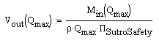
= exit velocity of water from Sutro weir, m/s
= A safety factor, so there is no risk of flooding the pipe. Set equal to 2.

Minimum Area of Riser Pipe
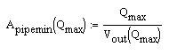
= the minimum area of the riser pipe

The Diameter of the Riser Pipe
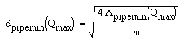
= the minimum diameter of the riser pipe

Graph of the Riser Pipe Diameter as a Function of Flow Rate
Point of Failure Experiment
The Point of failure experiment will evaluate the point at which the diameter of the LFOM is too small to accommodate the flow through the riser pipe. At a certain point the water will back up in the pipe and then there won't be free flow from the orifice into the riser pipe. The small diameter riser pipe was tested at the pilot plant. The hypothesized results are a relationship that is the same as the target relationship until failure. The results showed a linear relationship with a lower ratio of flow/depth than the predicted for all flow rates. The hypothesis for these results is that instead of a point of failure there is total failure. If the pipe is inappropriately sized then the LFOM fails for all flow rates.
In order to accurately calculate the optimal LFOM diameter, it is necessary to know the point at which the diameter is too small and will achieve failure. The point of failure experiment will test a prototype design under predicted failure conditions. The point of failure is predicted assuming conservation of momentum.
Prototype Design
Parameters:
* Qmax = 125 L/min
* Hdmax = 20 cm
* pi Sutro = 0.1
* Cd = 0.62
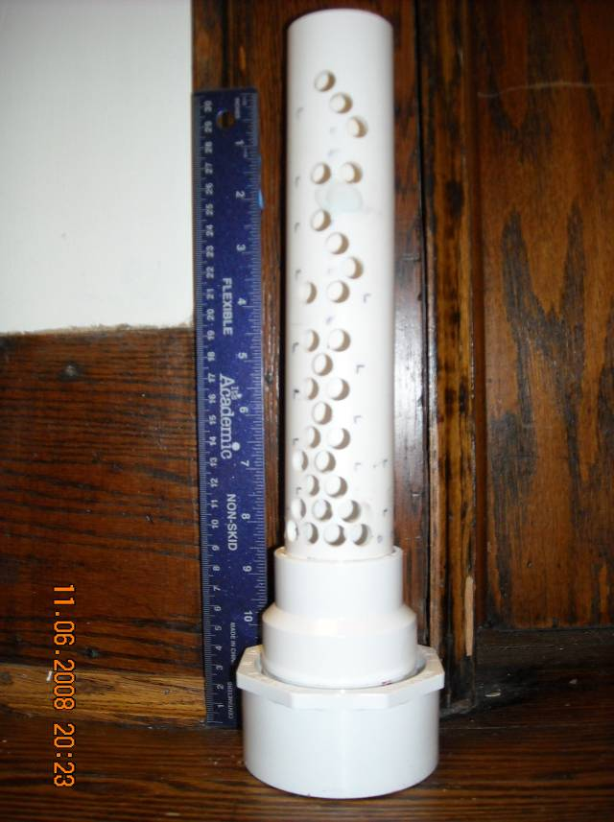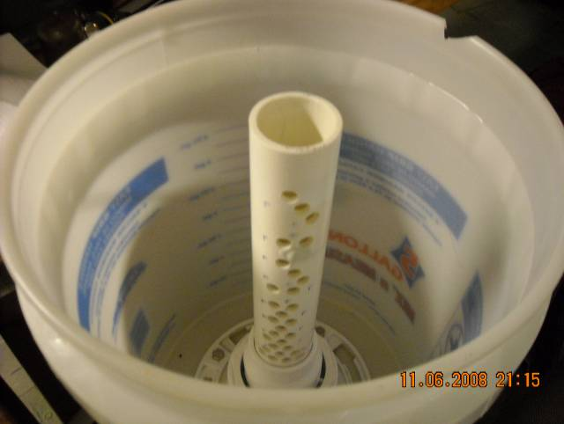
Figure 4: Prototype designs
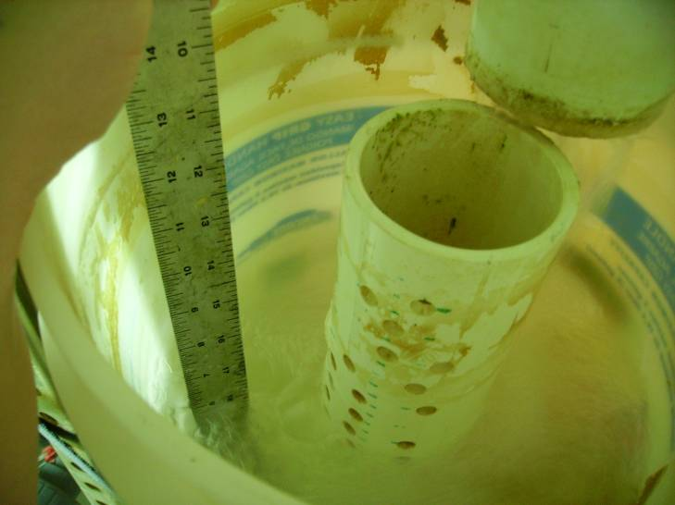
Figure 5: LFOM Failure Experimental pipe failure half flow

After using the following calculations the Pipe Diameter necessary to guarantee failure was found to be 1.5 inches, the flow rate for the failure with the 1.5 in diameter pipe is half the Qmax (125 L/min), 62.5 L/min. The new diameter of 1.5 in was used in calculating the hole spacing below, while the drill bit size is still 3/8 in. The riser pipe will be constructed from PVC pipe and a reducer will be used to connect the new riser pipe to the old apparatus flange. The PVC supplies used for this experiment include PVC pipe of 1.5 inch diameter and a length of 24.5 cm, PVC pipe with 2 inch diameter and 3 cm, fitting connecting of 3 in pipe to a 2 in pipe and fitting connecting 2 inch pipe to 1.5 inch pipe
Completed Design
The completed design is shown in Figure 4. The original entrance tank was used and a series of reducers were used to connect the smaller diameter pipe to the existing hole (that was created for the 3" diameter riser pipe). Note that the LFOM and entrance tank were clear of obstructions after the experiment which ensures that the data collected weren't affected by orifice obstruction.

The design for the flow controller illustrated by Weber-Shirk (2009) is the design that was used in the development of the chemical dose controller.

Chemical Doser
The top of the pipe is cut in a saddle shape to fit the lever arm through it and create the pivot. The height of this base pipe depends on the design constraints of the plant it will be built for.
The FC should be attached to the base pipe with two clamps that are interconnected so that they firmly anchor the FC at the appropriate height for [zeroing the CD|CD Calibration]. Only one clamp was used during experimental testing because the FC was being continually checked and re-zeroed, and it was being used in a very controlled environment. Additional clamps would be necessary for a robust design.
Currently ¼ inch outer diameter tubing is used to connect the flow controller to the pressure break T, but it is not known what size tubing is necessary to allow air to flow after the T. Experience has indicated that ½ inch outer diameter tubing is large enough, but it is possible that tubing with an outer diameter as small as 3/8 inch could work as well. The larger tube is then connected to 1/4 in outer diameter tubing, which connects the CD to the rapid mix. It is unclear if this final connection is needed, though, and it may be removed so that the larger tubing connects the T to the rapid mix directly.
For laboratory testing, water flows from the bottom of the chemical dosing tube to a plastic column with a pressure sensor at the bottom. This pressure sensor gives readings of water height in the column, which can be converted into flow rates from the FC.
Chemical Doser Lever Outflow

To test the full range of motion of the CD efficiently the experiment was modified so that the lever arm was held in place by a ringstand and clamp. The ringstand was marked with a centimeter scale with zero being marked where the clamp help the lever arm such that no liquid came out the pressure break T, but any lower clamp position caused flow to occur.
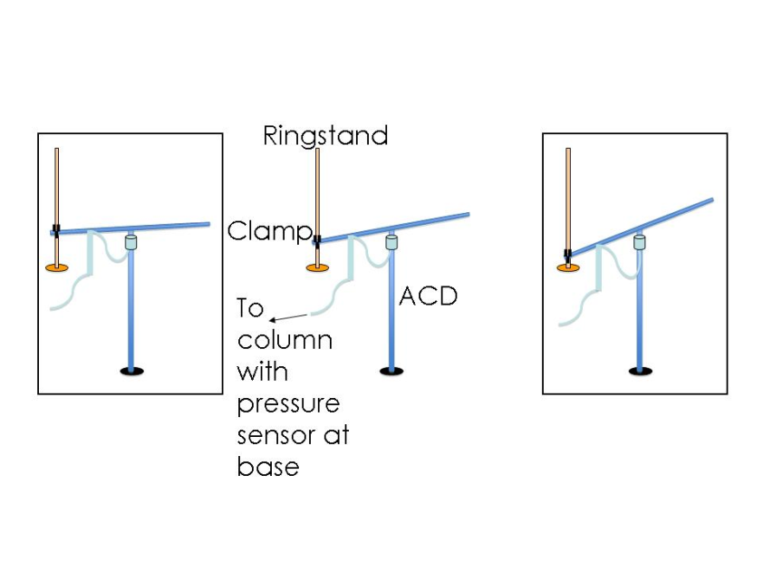
Figure 6 Laboratory Setup for the Chemical Doser
By securing the lever arm at precise heights, an exact float height could be simulated. Namely, the chemical dosing tube was positioned at 5 cm intervals along the lever arm while outflow was measured by the pressure sensor in the base of the collection column. Data from the sensor was recorded in centimeters of water by using the Easy Data software.
The lever arm was positioned at heights of 5 cm, 10 cm, 15 cm, and 19 cm, and the doser was positioned at a distance from the pivot of 5 cm, 10 cm, 15 cm, 20 cm, 25 cm, and 30 cm. Data was collected at every combination of those parameters, producing 24 flow rate data points.
Results
The LFOM mimics the Sutro weir with a series of holes positioned vertically on a riser pipe. Due to the approximation, and rounding errors, it is currently assumed that several preset designs are more accurate than a program that accepts any plant flow rate. The pre-set designs will ensure the optimal orifice configuration. A common error is an orifice pattern of 1, 1, 0, 2, and 1. This occurs because in the second row the number of holes requested was a fractional amount and then in the subsequent row the program calls for 1 and a fractional hole which rounds to two holes. Installation of a LFOM for a higher flow rate than necessary won't degrade the performance and it is a way to ensure quality in the design. Criteria by which the designs are evaluated include: maximum error, number of rows, and the presence of the rounding error.
Point of Failure
h1. Linear Flow Orifice Meter Point of Failure Experiment
The entrance tank with riser pipe was installed in the plant and measurements were taken on the efficiency and accuracy of the design. There is an in-line flow meter that will provide flow rate data that can be compared to the flow rate recorded based on height in the entrance tank. There will be readings at incremental flow rates where the electronic flow meter flow rate and water height will be recorded.
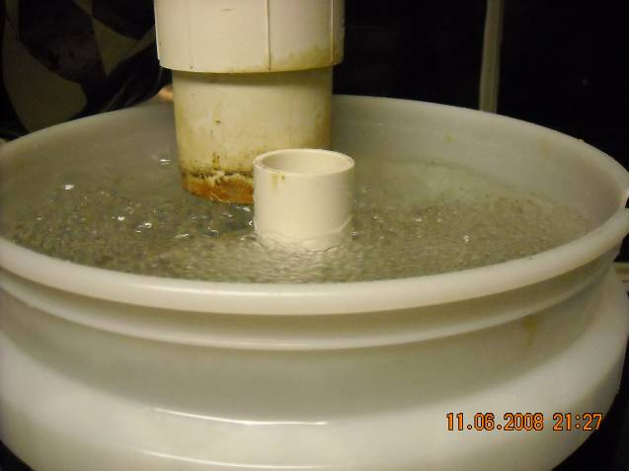
Figure 6: Photograph of Point of Failure for LFOM
There is a correction factor for the water heights because the first hole isn't at the bottom of the bucket. There is an offset of 4.875 inches. Also the lengthy decimals result from using English units with eights and sixteenths inches.

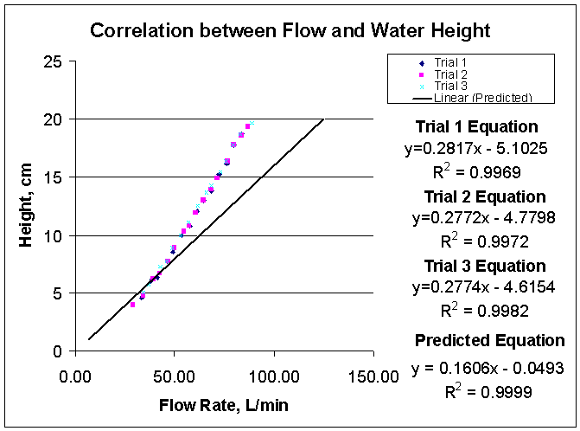
Figure 8: Correlation between Flow and Water Height

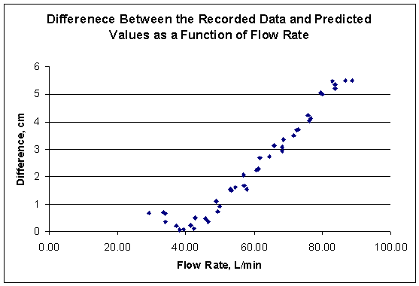
Figure 9: Difference between the Recorded Data and Predicted Values as a Function of Flow Rate

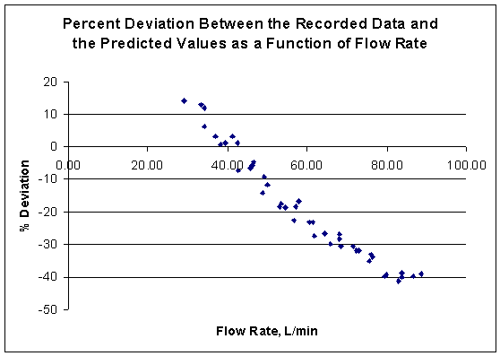
Figure 10: Percent Deviation between the Recorded Data and the Predicted Values as a Function of Flow Rate
The linear trend line from Excel of the data is y = -0.9653x + 38.22, with an R-squared value of 0.9556 (Figure 8). This allows us to calculate the flow rate where the error between the predicted and measured flow rates differ by more than 10% (Figure 9). The flow rate of failure is 49.95 L/min which is less than the expected flow rate of failure, 62.5 L/min (Figure 10).
Chemical Doser Lever Outflow
The results for this experiment show data that is mostly consistent with theoretical projections (Figure 11). The data sets for each distance away from the pivot show a clear linear trend, with the slope increasing by a constant factor with each 5 cm increment of distance added. When projected leftward, the data all approaches the origin. The only unexpected data point is at (19, 1.777) in the 30 cm data set.
Figure 11: Chemical Doser outflow vs. vertical lever position
Similarly to data collected with the lab prototype and the robust CD with the float attached, the system appears to be less responsive when used farther away from the pivot. The graph below replaces data points with lines, which shows this trend more clearly (Figure 12). The lines of data further from the pivot (20 cm, 25 cm, 30 cm) are closer together than the lines representing data close in to the pivot (5 cm, 10 cm, 15 cm). This inconsistency is relatively small, though, and indicates that the robust design of the CD may be capable of dosing relatively precise amounts of fluid.
Figure 12: Trendline of Chemical Doser outflow as a function of vertical lever position
Overall Data Analysis of the Chemical Doser
All data was corrected in MathCAD so that float heights and lever arm positions were converted into chem doser heights at each position out from the pivot. The chem doser height is actually the change in height downward from the zero level, which corresponds to the driving head on the system being applied by the moving lever arm. This was then plotted on a graph to show the relationship between doser height and outflow measured, which can be seen in Figure 13.
Figure 13: Chemical Doser outflow as a function of doser height above zero
The data fall along a nearly-linear path with a spread of about 0.2 mL/sec that appears to fall off around 1.1 mL/sec outflow. There is relatively little data collected at the heigher flowrates, though, so this conclusion is not very concrete. It is important to note that the data clusters very strongly around the theoretical performance for the system using head loss equations for both major and minor losses in the FC outflow tubing (Figure 13).
To make sure that the system was tested in the laminar flow range, the following Reynold's Number analysis was performed. As can be seen in the graph, the system should not have approached the turbulent transition during testing with head losses of 0-20 cm (Figure 14).
Figure 14: Reynold’s Number for the Chemical Doser
Conclusions
LFOM
The results of the experiment were contrary to the expected results. Originally it was assumed that there was a certain maximum flow rate for a pipe, if the flow rate exceeded a maximum value the water entering the riser pipe wouldn't be able to leave quickly enough and the water would back up in the pipe. The results showed an alternative situation. The pipe was sized to reach the failure point at 62.5 L/min (half the maximum flow rate of the pilot plant - 125 L/min). The results showed a linear relationship between flow rate and height for all of the flow rates, the difference was that the slope for the pipe had a different slope than the predicted values. The lack of agreement between theory and experimental values over the entire range suggest that the LFOM failed over the entire range of flows.
Discussion
LFOM Future Research
The perplexing results may be due to the fact that there we were not witnessing a point of failure, a flow rate at which a LFOM will fail, but a complete failure. If the pipe is sized too small to accommodate the flow rate which the orifice pattern is designed to support then the LFOM will fail for all flow rates. This hypothesis would agree with the results. It would be beneficial in future research to test the LFOM created above with a diameter of 1.5 inches with an orifice pattern designed to handle the maximum flow rate for the pipe, 62.5 L/min. It would also be interesting to apply a flow rate in excess of the 62.5 L/min and watch the system for evidence of failure.
References

Practical Constant-Accuracy Linear Weir K. Keshava Murthy and M. N. Shesha Prakash, Journal Irrigation and Drainage Engineering 120, 550 (1994)
Weber-Shirk M, 2009, Gravity powered flow controllers for chlorine and alum dosing. Journal of Water Supply: Research and Technology---AQUA Vol 58 No 2 pp 147-152 © IWA Publishing 2009

